**ERD**

**Sample:**

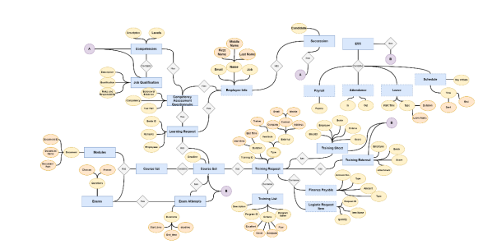

**Class Diagram**

**Sample:**

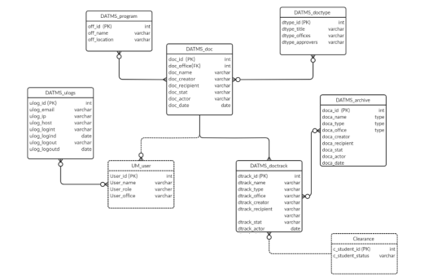

**Data Dictionary**

**Yung 5 modules**

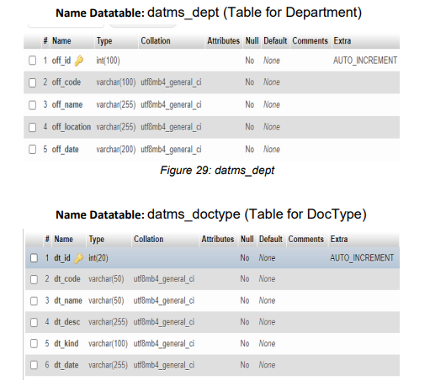

**DEPLOYMENT DIAGRAM**

**Pili ka lang alin sa mga dito**



