# DOCUMENT TRACKING

Table Name: **log2_dt_documents**

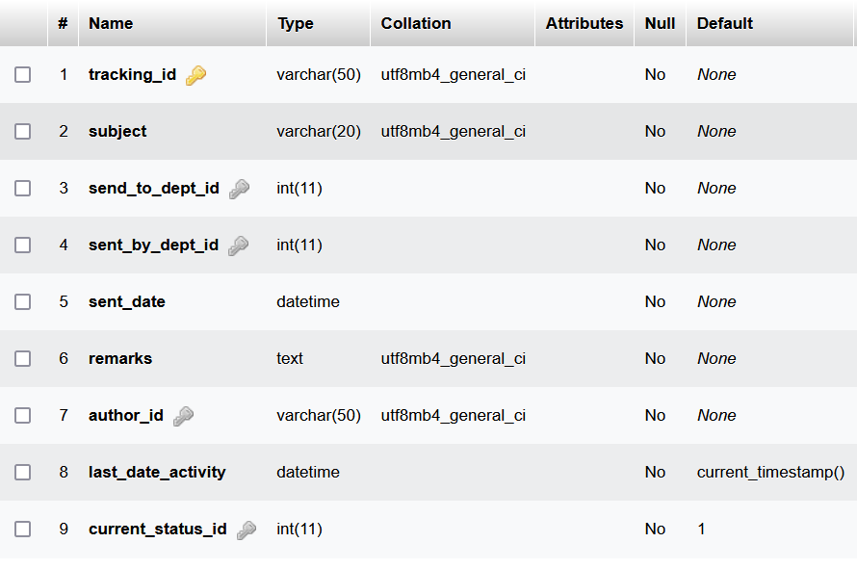

Table Name: **log2_dt_track**

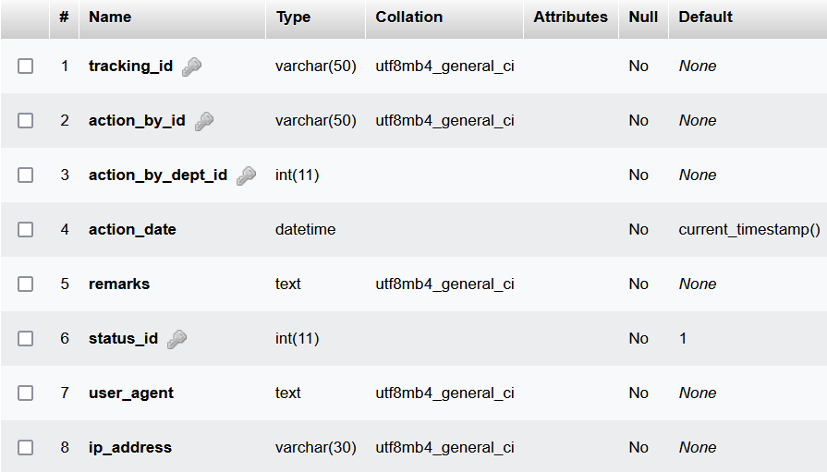

Table Name: **log2_dt_status**

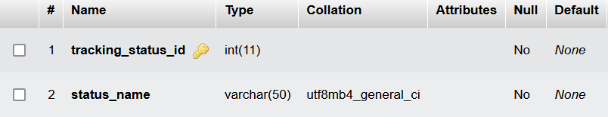

# VENDOR PORTAL

Table Name: **log2_vp_vendors**

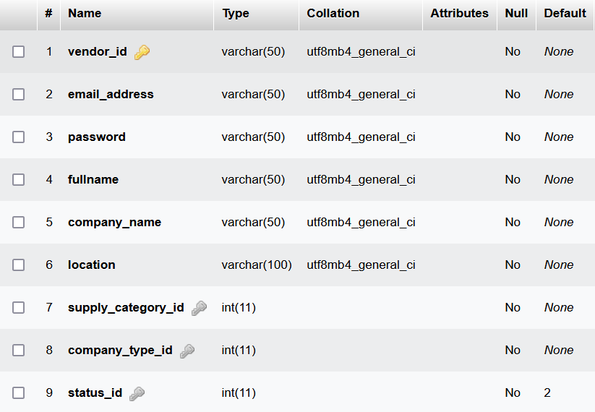

Table Name: **log2_vp_user_status**

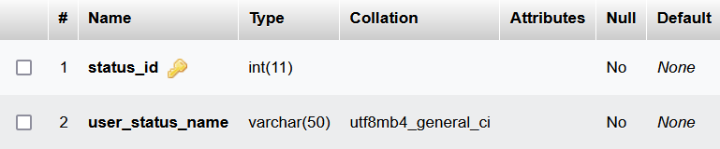

Table Name: **log2_vp_tenders**

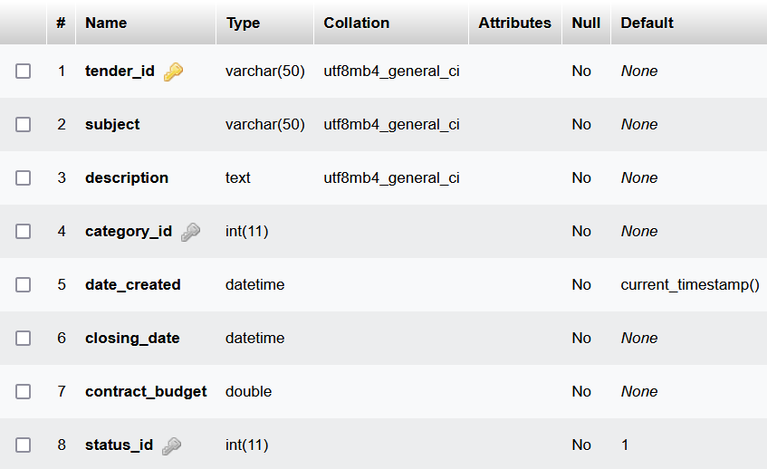

Table Name: **log2_vp_tender_bids**

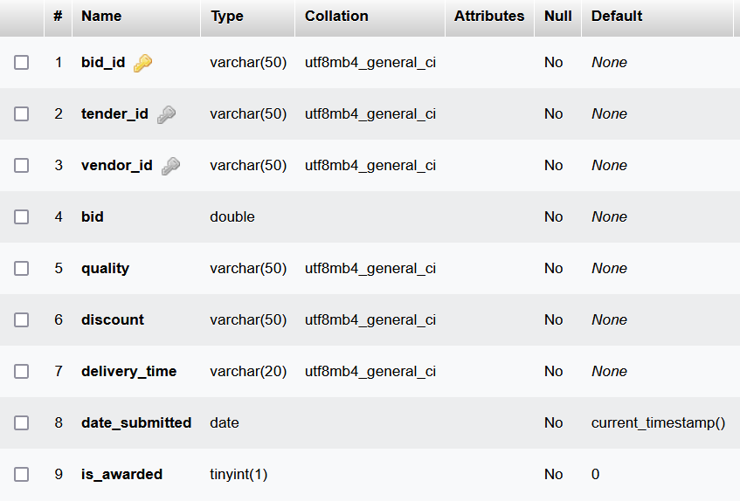

Table Name: **log2_vp_tender_status**

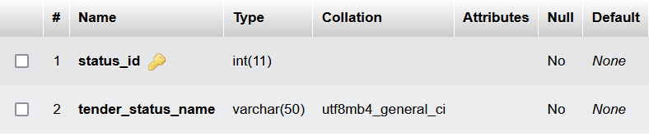

Table Name: **log2_vp_supply_category**

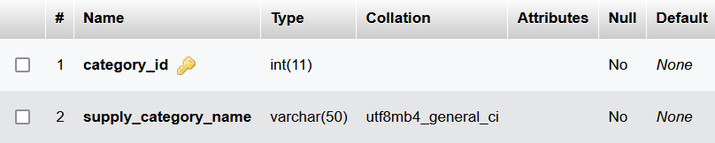

Table Name: **log2_vp_invite_templates**

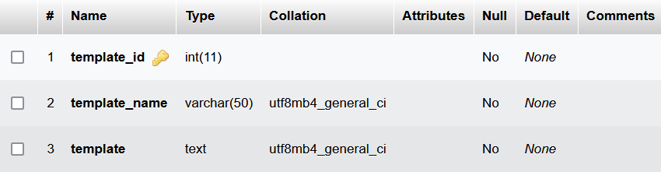

Table Name: **log2_vp_invites**

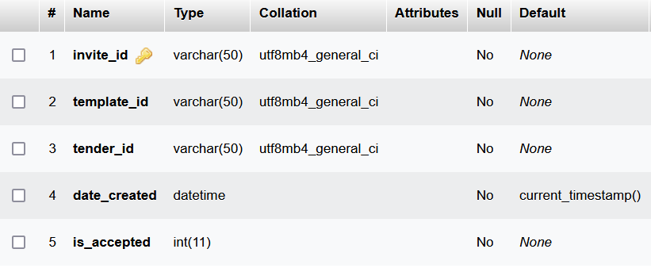

Table Name: **log2_vp_company_types**

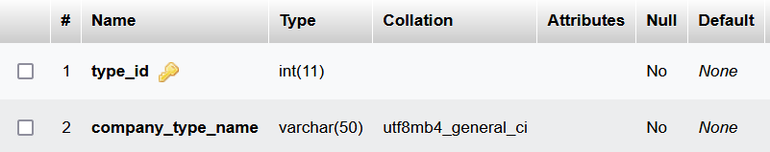

Table Name: **log2_vp_award_status**

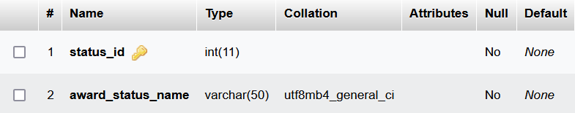

Table Name: **log2_vp_awards**

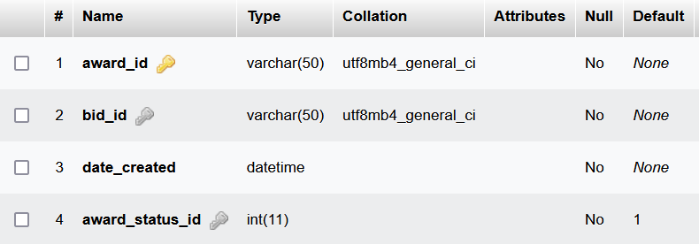

# AUDIT MANAGEMENT

Table Name: **log2_am_reports**

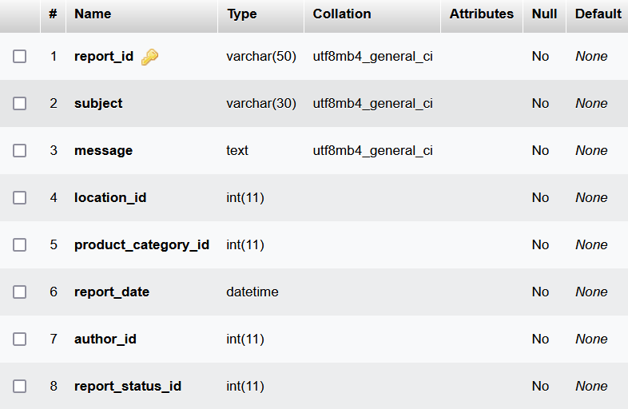

Table Name: **log2_am_report_attachments**

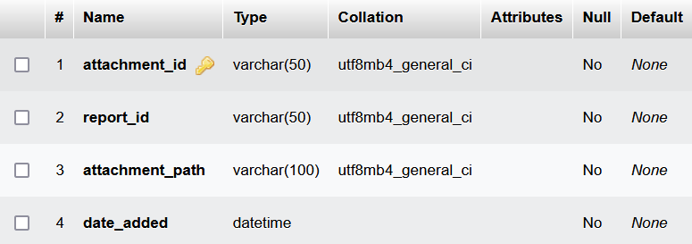

Table Name: **log2_am_line_items**

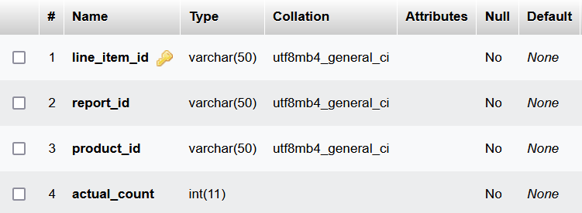

# VEHICLE RESERVATION

Table Name: **log2_vr_reservations**

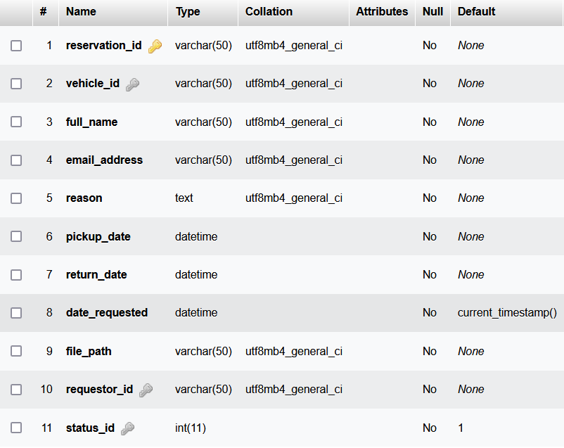

Table Name: **log2_vr_reserve_status**

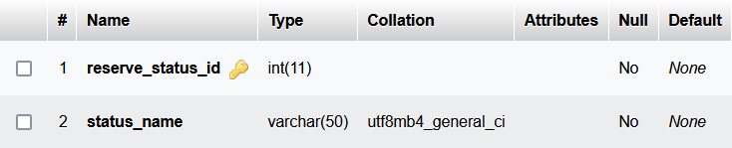

Table Name: **log2_vr_reports**

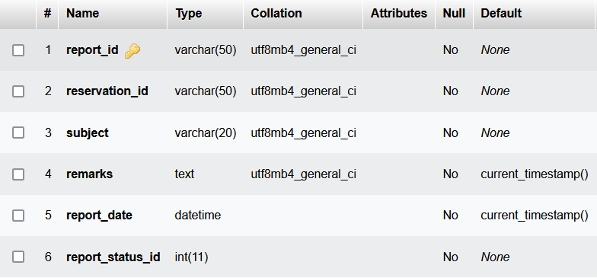

Table Name: **log2_vr_report_status**

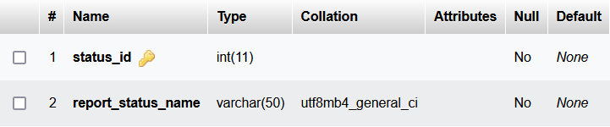

# FLEET MANAGEMENT

Table Name: **log2_fm_vehicles**

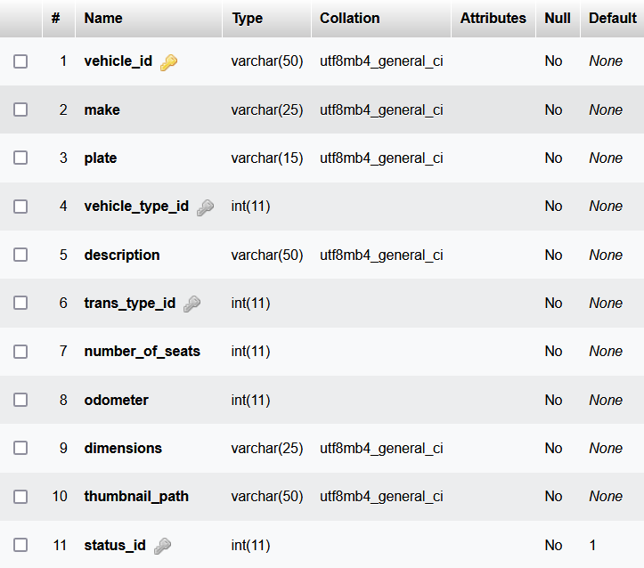

Table Name: **log2_fm_vehicle_status**

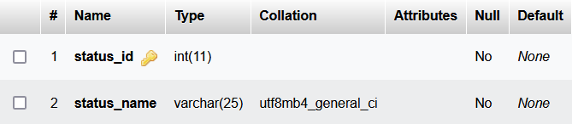

Table Name: **log2_fm_vehicle_types**

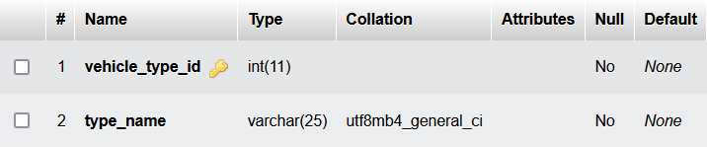

Table Name: **log2_fm_trans_types**

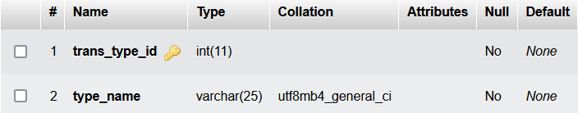

Table Name: **log2_fm_maintenance**

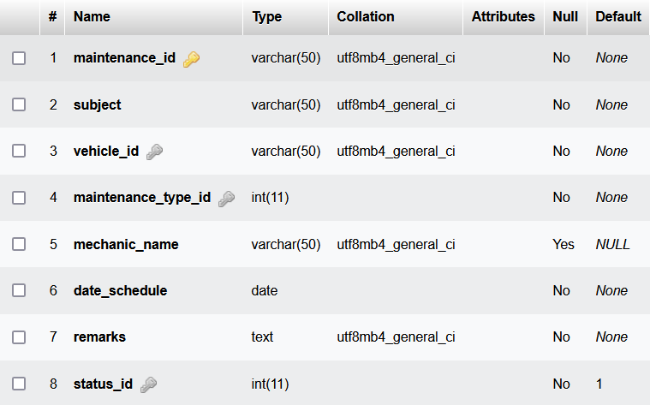

Table Name: **log2_fm_maintenance_type**

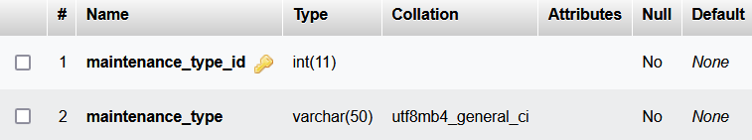

Table Name: **log2_fm_maintenance_status**

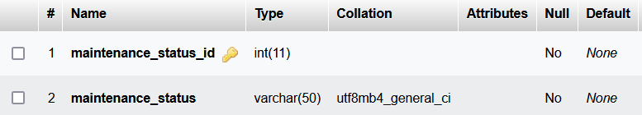

Table Name: **log2_fm_drivers**

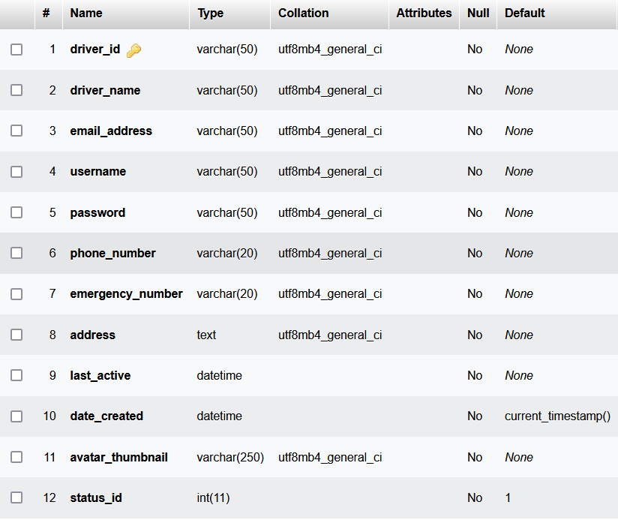

Table Name: **log2_fm_driver_status**

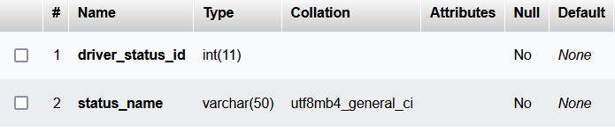

Table Name: **log2_fm_drivers_attachments**

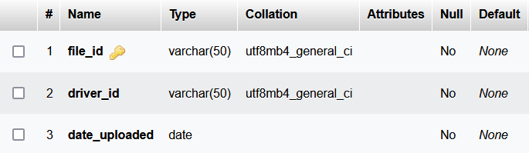

Table Name: **log2_fm_delivery**

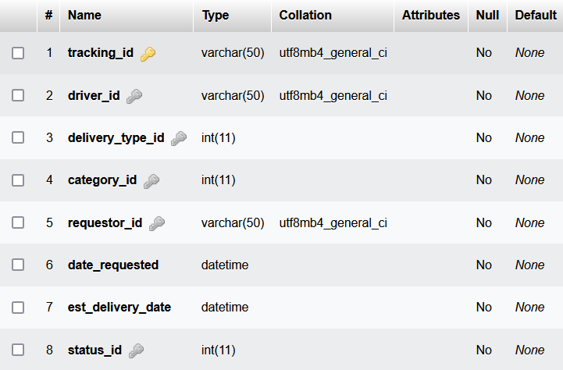

Table Name: **log2_fm_delivery_status**

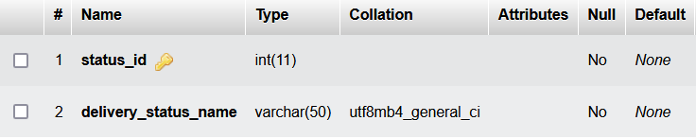

Table Name: **log2_fm_delivery_type**

