BESTLINK COLLEGE OF THE PHILIPPINES

A Documentary Report of On-The-Job Training

Undertaken At Veterans Memorial Medical Center

**Presented To:**

**Bestlink College Of the Philippines**

**College Of Computer Studies**

**Bachelor Of Science in Information Technology**

**In Partial Fulfillment of The Requirements**

**For The Practicum**

**Submitted By:**

**Jhamir G. Tacusalme**

**May 2023**

**APPROVAL SHEET**

This narrative report attached hereto entitled “A Documentary Report of On-the-Job Training Undertaken at Veterans Memorial Medical Center” presented and submitted by Jhamir G. Tacusalme in partial fulfillment of the requirements for the Practicum Program of Bachelor of Science in Information Technology is hereby endorsed for approval.

**VINCENT CARLO T. GARADOS**

Practicum Coordinator

Accepted and approved in partial fulfillment of the requirements for the Practicum Program of Bachelor of Science in Information Technology.

**ROMMEL J. CONSTANTINO, MSIT.**

College of Computer Studies, Program Head

**ACKNOWLEDGMENT**

The student would like to express profound gratitude to the following people for their valuable contributions that helped in the completion of this portfolio:

**Dr. Rosicar E. Escober,** Dean of the College of Computer Studies Bestlink College of the Philippines, for her guidance and suggestion to make the project become successful;

**Mr. Rommel J. Constantino,** Program Head of the College of Computer Studies, for the constant supervision as well as for providing necessary information regarding the project and also for his support in completing this portfolio;

**Mr. Vincent Carlo T. Garados,** Practicum Coordinator of the On-the-job Training program, for their unwavering guidance, support, and mentorship throughout my training period. Their dedication and commitment to my professional development have truly made a significant impact on my learning journey.

**Mrs. Pia Peralta Barua**, Head of Management Information System Office, for continuous support and supervision also providing useful experience and necessary knowledge that I can apply to the IT Industry.

**The Parents,** for the financial assistance, for guiding and giving words of encouragement and inspiration so they will exert their best in accomplishing this portfolio;

And above all, to the **Almighty God** for all the blessings and for giving the strength to complete this portfolio.

**TABLE OF CONTENTS**

Page No.

Title Page. i

Approval Sheet ii

Acknowledgement iii

Table of Contents v

Preliminaries. vii

Parents / Guardian’s Certification of Waiver / Permission.

Endorsement Letter

Acceptance Letter

Student Deed of Undertaking

**I. Important Points in Practicum**. 1

1.1 Objectives of the Practicum 1

1.2 Guidelines / Policy before Practicum 2

**II. The Workplace**. 3

2.1 Company Profile. 3

2.1.1 Company History 3

2.1.2 Company Mission and Vision 5

2.1.3 Company Core Values 5

2.1.4 Company Organizational Chart 6

2.2 Department Profile. 6

2.2.1 Department History 6

2.2.2 Department Mission and Vision. 8

2.2.3 Department Core Values 8

2.2.4 Department Organizational Chart 9

2.3 Product/Services Description. 9

2.3.1 Company / Department Logo and Its Meaning 10

2.3.2 Company / Department Partner / Affiliation 11

2.3.3 Company / Department Target Clientele 13

2.4 Location of Company 15

2.5 Thrusts and Policy Directions. 16

2.6 Company Rules and Regulations 17

**III. Activity Report**. 19

3.1 Daily Accomplishment Report 19

3.2 Performance Appraisal Report. 30

**IV.** **Reflection** 31

4.1 Practicum Learning 31

4.2 Problems Encountered 32

4.3 Suggestions and Recommendations. 33

Appendices.  
 Daily Time Record  
 Certificate of Completion  
 Resume.

**PRELIMINARIES**

**I.** **Important Points in Practicum**

In this section will define the Objectives of the Practicum, and Guidelines / Policy before Practicum

# **Objectives of the Practicum**

A. The student successfully completing this course will, in the area of knowledge

1. Make application of knowledge obtained in majors’ courses directly to the field placement;

2. Gain a clear understanding of job opportunities available with a degree in their field of study;

3. Read and interpret research specifically related to their field placement.

B. The student successfully completing this course will, in the area of attitudes:

1. Adopt an attitude of lifelong learning in the area of their chosen work;

2. Display and support high ethical standards in the profession;

3. Demonstrate a sensitivity to and respect for human diversity

C. The student successfully completing this course wilt, in the area of skills:

1.Enhance their individual and group communication

2. Develop their personal style of leadership for work in the field of their major;

3. Demonstrate the skills necessary to be successful in their particular field placement.

# **Guidelines / Policy before Practicum**

By the requirement. of Bestlink College of the Philippines to the award degree and diploma certificates, it is a pre-condition that every student upon moving to the final year undertakes an industrial attachment with a selected organization of their choice. The practicum provides students the opportunity to gather some work experience relevant to their studies and their professional work field.

It helps the student to learn discipline end principles of working ethics.

* + - * Student who will take internship must be evaluated by registrar
      * Student should attend ail his/her subjects whether major or minor along with the practicum.
      * The number of hours spent in Work Immersion is 250 hours for Practicum 1 and 250 hours for Practicum 2.
      * All Work Practicum agreements at the school: private/public companies or government entities level must be covered by a Memorandum of Agreement (MOA) for the security of all parties involved.
      * The number of hours rendered by a student who has started the practicum but is not yet enrolled will be voided.
      * Student who wishes to transfer to other department or company needs to be evaluated and get a certificate of completion prior transfer.
      * Transfer to other department or company without permission will be voided.

# **II. The Workplace**

In this part, it will provide overview about Veterans Memorial Medical center (VMMC) which is the workplace of the intern.

# **Company Profile**

This section of the document will provide company profile about the Veterans Memorial Medical Center (VMMC).

# Veterans Memorial Medical Center - Wikipedia**Company History**

**Figure 1: Veterans Memorial Medical Center**

The Veterans Memorial Medical Center (VMMC) was established in 1978 as a result of the Veterans' Programs Extension Act of 1978. The Act authorized the construction of a new medical center to replace the existing Veterans Administration (VA) hospital in Manila. The new medical center was built on a 100-hectare site in Quezon City, and it was officially opened in 1981.

VMMC is a tertiary care hospital that provides a wide range of medical services to veterans and their dependents. The hospital has a staff of over 1,000 employees, and it has a bed capacity of over 500. VMMC is also a major research center, and it has a number of ongoing research projects in areas such as cancer, HIV/AIDS, and mental health.

In 2003, VMMC was designated as a National Center of Excellence in HIV/AIDS by the Department of Health. The hospital has since played a leading role in the fight against HIV/AIDS in the Philippines. VMMC has also been involved in a number of other initiatives to improve the health of veterans and their dependents, such as the development of a veterans' health promotion program and the provision of home-based care services.

VMMC is a major asset to the Philippine healthcare system. The hospital provides high-quality care to veterans and their dependents, and it is also a major research center. VMMC is committed to providing its patients with the best possible care, and it is constantly striving to improve its services.

Here are some of the key events in the historical background of VMMC:

* 1978: The Veterans' Programs Extension Act of 1978 is passed, authorizing the construction of a new VA hospital in Manila.
* 1981: The new VA hospital, now known as VMMC, is officially opened.
* 1995: VMMC becomes a designated National Center of Excellence in HIV/AIDS.
* 2003: VMMC launches a veterans' health promotion program.
* 2005: VMMC begins providing home-based care services.

VMMC has come a long way since its humble beginnings in 1978. Today, it is a leading provider of healthcare services to veterans and their dependents in the Philippines. VMMC is committed to providing its patients with the best possible care, and it is constantly striving to improve its services.

# **Company Mission and Vision**

**VISION**

By 2028, Veterans Memorial Medical Center shall be a world-class medical facility with an excellent and comprehensive health care system that meets global standards.

**MISSION**

As a tertiary hospital, VMMC's mission is to deliver the best quality health care and management to Veterans, their dependents, and the community we serve through safe, effective, efficient, ethical, and environment-friendly patient care, outreach programs, continuous learning and research.

# **Company Core Values**

Excellence: VMMC strives to provide the highest quality of care to its patients. This includes providing state-of-the-art facilities, equipment, and technology; hiring the most qualified and experienced staff; and using the latest medical practices and procedures.

Compassion: VMMC is committed to providing compassionate care to its patients. This means treating patients with respect, dignity, and understanding. It also means providing emotional support to patients and their families during difficult times.

Integrity: VMMC is committed to operating with integrity. This means being honest and transparent in all dealings with patients, staff, and the public. It also means upholding the highest ethical standards in the delivery of healthcare.

Innovation: VMMC is committed to innovation. This means constantly looking for new ways to improve the quality of care it provides to its patients. It also means being open to new ideas and approaches to healthcare.

# **Company Organizational Chart**

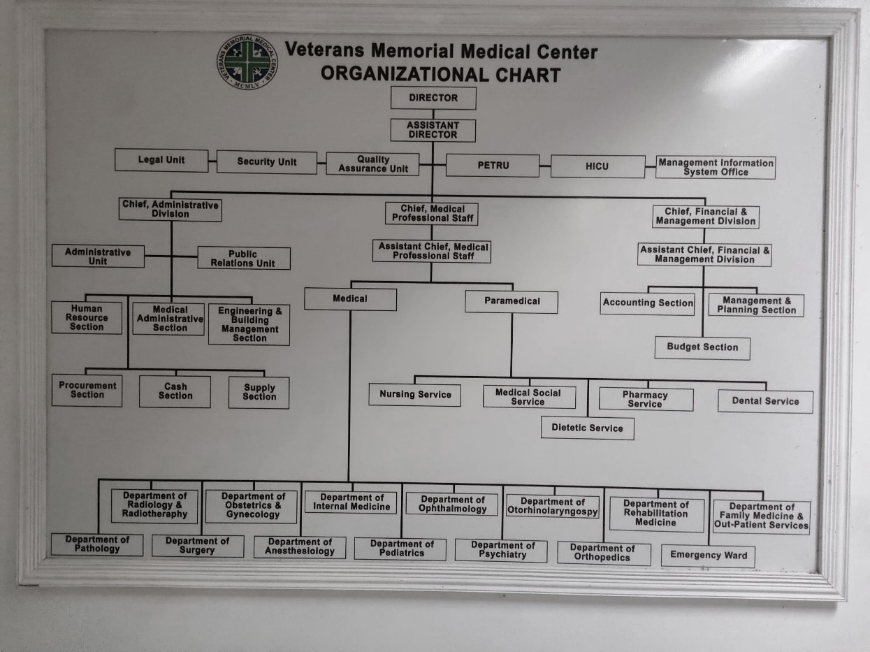

**Figure 2: Company Organizational Chart**

# **Department Profile**

This section of the document will provide Department Profile about the Management Information System Office (MISO) Department of Veterans Memorial Medical Center (VMMC).

# **Department History**

The Management Information System Office (MISO) of Veterans Memorial Medical Center (VMMC) was established in 1977. The MISO is responsible for providing information technology (IT) support to VMMC. The office's mission is to "provide timely, accurate, and secure information to support the delivery of quality healthcare to veterans."

The MISO has a long and distinguished history of providing IT support to VMMC. In the early days, the office was responsible for developing and maintaining VMMC's mainframe computer system. As technology has evolved, the office has adapted to provide new and innovative IT solutions.

Today, the MISO is responsible for a wide range of IT services, including:

* Healthcare data systems
* Clinical decision support systems
* Patient portals
* Telehealth
* Security and compliance

The MISO is committed to providing IT solutions that support VMMC's mission of providing quality healthcare to veterans. The office is constantly working to improve its IT services and to stay ahead of the latest technological trends.

Here are some of the key milestones in the MISO's history:

* 1977: The MISO is established.
* 1980: The office develops VMMC's first mainframe computer system.
* 1990: The office deploys its first clinical decision support system.
* 2000: The office launches its first patient portal.
* 2010: The office begins offering telehealth services.
* 2020: The office implements a new security and compliance framework.

The MISO is a vital part of VMMC. The office's IT solutions help to ensure that VMMC can provide quality healthcare to veterans.

# **Department Mission and Vision**

**VISION**

By 2028, Veterans Memorial Medical Center shall be a world-class medical facility with an excellent and comprehensive health care system that meets global standards.

**MISSION**

As a tertiary hospital, VMMC's mission is to deliver the best quality health care and management to Veterans, their dependents, and the community we serve through safe, effective, efficient, ethical, and environment-friendly patient care, outreach programs, continuous learning and research.

# **Department Core Values**

Integrity: We are honest, ethical, and trustworthy. We uphold the highest standards of professional conduct.

Excellence: We strive to achieve the highest level of performance in all that we do. We are committed to continuous improvement.

Teamwork: We work together collaboratively and cooperatively to achieve our goals. We are respectful of each other's differences and value each other's contributions.

Innovation: We are creative and open to new ideas. We are always looking for ways to improve our processes and services.

# **Department Organizational Chart**

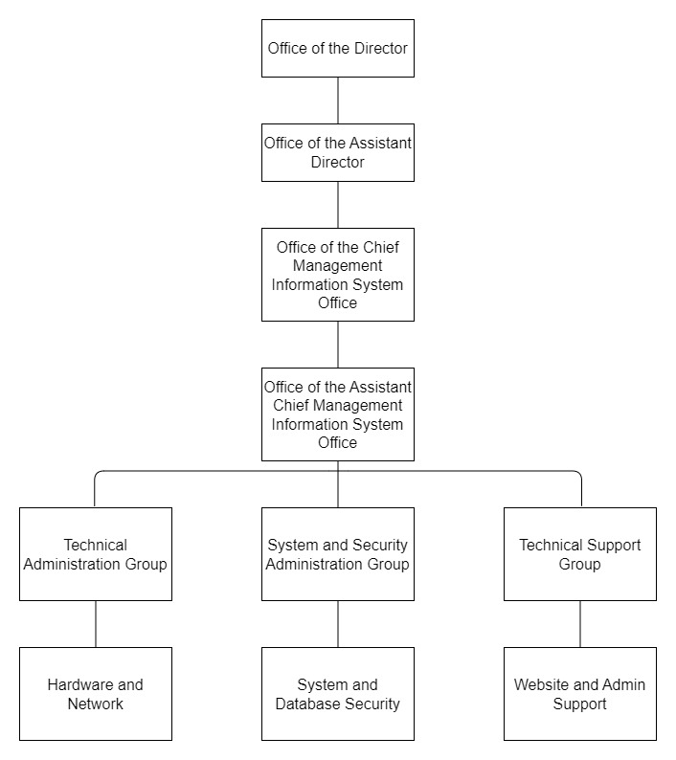This is the Department Organizational cahrt of Management Information System Office (MISO) of Veterans Memorial Medical Center (VMMC).

**Figure 3: Department Organizational Chart**

# **Product/Services Description**

# Veterans Memorial Medical Center - Wikipedia**Company / Department Logo and Its Meaning**

**Figure 4: Company Logo**

The Veterans Memorial Medical Center (VMMC) logo is a simple yet elegant design that represents the hospital's mission to provide quality healthcare to veterans and their families. The logo features a white star on a blue background, with the words "Veterans Memorial Medical Center" in black type beneath it. The cross represents the hope and promise of a better future for veterans, while the blue background symbolizes the strength and resilience of the Filipino people. The black type is used to convey a sense of authority and professionalism.

The VMMC logo is a powerful symbol of the hospital's commitment to its patients. It is a reminder that VMMC is a place where veterans can come for quality healthcare, compassion, and understanding.

Here is a more detailed explanation of the meaning of the VMMC logo:

* The cross: The star is a symbol of hope and promise. It represents the hope that veterans will receive the care they need and deserve, and the promise that VMMC will always be there for them.
* The blue background: The blue background is a symbol of strength and resilience. It represents the strength of the Filipino people, and their resilience in the face of adversity.
* The black type: The black type is a symbol of authority and professionalism. It conveys a sense of trust and confidence, and it reminds patients that VMMC is a place where they can come for quality healthcare.

The VMMC logo is a simple yet effective design that represents the hospital's mission and values. It is a symbol of hope, strength, and professionalism, and it is a reminder that VMMC is a place where veterans can come for quality healthcare.

# **Company / Department Partner / Affiliation**

|  |  |
| --- | --- |
| **Company Partner** | **Company Affiliation** |
| * The Department of Veterans Affairs (VA) * The Department of Defense (DoD) * The Department of Health and Human Services (HHS) | * Philippine Veterans Affairs Office (PVAO) * Department of National Defense |

The Veterans Memorial Medical Center (VMMC) in Quezon City is a tertiary care hospital that is affiliated with the Department of Veterans Affairs (VA) of the United States. It is a Level 1 Trauma Center and a designated regional referral hospital for the National Capital Region (NCR). The VMMC is the only VA hospital in the Philippines and it provides a wide range of medical, surgical, and rehabilitative services to veterans and their families.

The VMMC is also a partner of the Department of Health (DOH) of the Philippines. The VMMC and the DOH have a Memorandum of Agreement (MOA) that outlines the terms of their partnership. The MOA states that the VMMC will provide the DOH with access to its facilities and services, and the DOH will provide the VMMC with financial support.

The VMMC is also a member of the Philippine College of Physicians (PCP) and the Philippine Society of Hospital Epidemiologists (PSHE). The PCP is the national organization of physicians in the Philippines, and the PSHE is the national organization of hospital epidemiologists in the Philippines. The VMMC's membership in these organizations allows it to collaborate with other healthcare professionals and organizations to improve the quality of care it provides.

The VMMC is a leading provider of healthcare services in the Philippines. It is a valuable resource for veterans and their families, and it is a partner of the DOH and other healthcare organizations. The VMMC is committed to providing high-quality care to its patients and to improving the health of the Filipino population.

Here are some of the company/department partners and affiliations of the VMMC hospital in Quezon City:

* Department of Veterans Affairs (VA) of the United States
* Department of Health (DOH) of the Philippines
* Philippine College of Physicians (PCP)
* Philippine Society of Hospital Epidemiologists (PSHE)

The VMMC also has partnerships with other hospitals and healthcare organizations in the Philippines and around the world. These partnerships allow the VMMC to share resources, expertise, and best practices.

# **Company / Department Target Clientele**

Veterans Memorial Medical Center (VMMC) is a non-profit, community-based hospital that provides a wide range of healthcare services to veterans and their families. The hospital's target clientele includes:

* Veterans of all branches of the U.S. military
* Military spouses and dependents
* Active-duty military personnel
* Civilians who are eligible for VA healthcare

VMMC offers a variety of medical, surgical, and specialty services, including:

* Emergency services
* Inpatient and outpatient surgery
* Oncology
* Cardiology
* Geriatrics
* Women's health
* Behavioral health
* And more

VMMC is committed to providing high-quality, compassionate care to all of its patients. The hospital's staff is dedicated to providing veterans and their ore

In addition to its medical services, VMMC also offers a variety of other programs and services, including:

* A veterans' resource center
* A community health center
* A homeless veterans' program
* A veterans' employment program
* And more

VMMC is a valuable resource for veterans and their families. The hospital's comprehensive services and programs help veterans to live healthy, productive lives.

Here are some additional details about VMMC's target clientele:

* Veterans: VMMC's primary target clientele is veterans of all branches of the U.S. military. The hospital offers a variety of services specifically designed for veterans, including specialized care for veterans with PTSD, TBI, and other injuries or illnesses related to their service.
* Military spouses and dependents: VMMC also serve military spouses and dependents. The hospital offers a variety of services for these individuals, including primary care, women's health, and pediatric care.
* Active-duty military personnel: VMMC also provides care to active-duty military personnel. The hospital offers a variety of services for these individuals, including primary care, specialty care, and emergency services.
* Civilians who are eligible for VA healthcare: VMMC also serves civilians who are eligible for VA healthcare. The hospital offers a variety of services for these individuals, including primary care, specialty care, and emergency services.

VMMC is committed to providing high-quality, compassionate care to all of its patients. The hospital's staff is dedicated to providing veterans, military spouses and dependents, active-duty military personnel, and civilians who are eligible for VA healthcare with the care they need and deserve.

# **Location of Company**

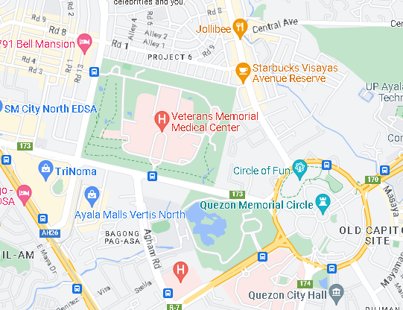The Veterans Memorial Medical Center (VMMC) is located in North Ave, Diliman, Quezon City, Metro Manila.

**Figure 5: VMMC Location**

# **Thrusts and Policy Directions**

The Thrusts and Policy Directions of Veterans Memorial Medical Center (VMMC) are as follows:

* To provide quality, accessible, and affordable healthcare to veterans and their dependents.
* To conduct research and training in the areas of military medicine and veterans' health.
* To promote the health and well-being of veterans and their families.

To achieve these goals, VMMC will focus on the following areas:

* Improving access to care: VMMC will expand its primary care network and increase the number of specialty providers.
* Reducing wait times: VMMC will implement a new electronic health record system and streamline its administrative processes.
* Improving quality: VMMC will participate in national quality improvement initiatives and develop its own internal quality improvement program.
* Increasing efficiency: VMMC will implement new cost-saving measures, such as value-based purchasing and shared savings arrangements.
* Strengthening research: VMMC will invest in research that will improve the health and well-being of veterans.
* Promoting wellness: VMMC will offer a variety of wellness programs and services to veterans and their families.

VMMC is committed to providing quality, accessible, and affordable healthcare to veterans and their dependents. By focusing on the areas listed above, VMMC will be able to achieve its goals and fulfill its mission to serve veterans.

In addition to the Thrusts and Policy Directions, VMMC has a number of other initiatives that are designed to improve the health and well-being of veterans. These initiatives include:

* The VMMC Veterans' Health Promotion Program, which provides health education and wellness services to veterans and their families.
* The VMMC Veterans' Peer Support Program, which provides peer-to-peer support to veterans who are struggling with mental health or substance abuse issues.
* The VMMC Veterans' Employment and Training Program, which helps veterans find and keep jobs.

VMMC is committed to providing comprehensive care to veterans and their families. By offering a variety of services and programs, VMMC is helping veterans to live healthy and productive lives.

# **Company Rules and Regulations**

The Veterans Memorial Medical Center (VMMC) has a comprehensive set of rules and regulations that govern the conduct of its employees, patients, and visitors. These rules and regulations are designed to ensure the safety and well-being of all individuals who come into contact with the hospital.

Some of the key rules and regulations at VMMC include:

* All employees must wear their identification badges at all times.
* Visitors must check in at the main entrance and obtain a visitor's pass.
* Smoking is prohibited in all areas of the hospital.
* Food and drink are not allowed in patient care areas.
* Cell phones must be turned off in patient care areas.
* Visitors are not allowed to bring weapons or other dangerous items into the hospital.

The VMMC also has a number of policies in place to protect the privacy of its patients. These policies include:

* Patients have the right to access their medical records.
* Patients have the right to request that their medical records be kept confidential.
* Patients have the right to refuse treatment.

The VMMC is committed to providing a safe and welcoming environment for all of its patients, employees, and visitors. The rules and regulations that are in place are designed to ensure the safety and well-being of everyone who comes into contact with the hospital.

In addition to the general rules and regulations, VMMC also has specific rules and regulations for specific areas of the hospital. For example, the emergency department has its own set of rules and regulations that are designed to ensure the safety of patients and staff. These rules and regulations are posted in the emergency department and are available to all patients and staff.

If you have any questions about the rules and regulations at VMMC, you can ask a staff member for assistance.

# **III. Activity Report**

# **Daily Accomplishment Report**

**ON-THE-JOB TRAINIG/PRACTICUM DAILY REPORT**

|  |  |  |  |  |  |
| --- | --- | --- | --- | --- | --- |
| **Name of Student Trainee** | | | TACUSALME JHAMIR G. | | |
| **Name of Company** | | | VETERANS MEMORIAL MEDICAL CENTER (VMMC) | | |
| **Name of Department** | | | MANAGEMENT INFORMATION SYSTEM OFFICE (MISO) | | |
| **DAY** | **DATE** | **OFFICIAL TIME** | | **DAILY ACCOMPLISHMENTS** | **NO. OF WORKING HOURS** |
| Tuesday | 04/11/23 | 8:00am-4:30pm | | **Figure 6**  Attended an orientation session to learn about the company's policies and procedures.  Met with the IT department and got acquainted with the team.  Familiarized yourself with the computer maintenance tools and equipment used in the company. | 8 hrs. |
| Wednesday | 04/12/23 | 8:00am-4:30pm | | **Figure 7**  Assisted senior technicians in basic computer maintenance tasks, such as cleaning computer components and ensuring proper ventilation.  Shadowed a networking expert and learned about different network topologies and protocols.  Accompanied an IT staff member to run errands related to purchasing computer parts and peripherals. | 8 hrs. |
| Thursday | 04/13/23 | 8:00am-4:30pm | | **Figure 8**  Observed and participated in encoding data into the company's database systems.  Assisted in organizing and categorizing digital files for easier access and retrieval.  Troubleshot minor computer issues, such as software glitches and driver conflicts. | 8 hrs. |
| Friday | 04/14/23 | 8:00am-4:30pm | | **Figure 9**  Assisted in setting up a new computer system for a company employee.  Shadowed a senior technician in diagnosing and resolving network connectivity problems.  Attended a workshop on computer security measures and learned about best practices. | 8 hrs. |
| Monday | 04/17/23 | 8:00am-4:30pm | | **Figure 10**  Conducted routine computer maintenance tasks, including disk defragmentation and system updates. | 4 hrs. |
| Tuesday | 04/18/23 | 8:00am-4:30pm | | **Figure 11**  Engaged in encoding and verifying data from various sources.  Assisted in troubleshooting computer hardware issues, such as faulty RAM or hard drives.  Learned about preventive maintenance strategies to extend the lifespan of computer systems. | 8 hrs. |
| Wednesday | 04/19/23 | 8:00am-4:30pm | | **Figure 12**  Supported the IT department in setting up a secure wireless network for guest access.  Assisted in inventorying and organizing software licenses and product keys.  Participated in a team meeting to discuss ongoing projects and upcoming tasks. | 8 hrs. |
| Thursday | 04/20/23 | 8:00am-4:30pm | | **Figure 13**  Collaborated with senior technicians in diagnosing and fixing software compatibility issues.  Shadowed an experienced IT staff member during server maintenance and backups.  Assisted in researching and recommending computer hardware upgrades for specific departments. | 8 hrs. |
| Friday | 04/28/23 | 8:00am-4:30pm | | **Figure 14**  Practiced encoding and data entry techniques to improve speed and accuracy.  Participated in network troubleshooting exercises to identify and resolve connectivity issues.  Assisted in documenting standard operating procedures for common computer maintenance tasks. | 8 hrs. |
| Tuesday | 05/02/23 | 8:00am-4:30pm | | **Figure 15**  Accompanied a senior technician in conducting preventive maintenance for a large computer lab.  Assisted in configuring firewall settings to enhance network security.  Participated in a workshop on virtualization technologies and their benefits. | 8 hrs. |
| Thursday | 05/04/23 | 8:00am-4:30pm | | **Figure 16**  Conducted routine data encoding tasks and ensured data integrity.  Assisted in troubleshooting printer connectivity and driver issues.  Learned about network monitoring tools and their importance in maintaining network performance. | 8 hrs. |
| Friday | 05/05/23 | 8:00am-4:30pm | | **Figure 17**  Assisted in building custom computer systems for specialized tasks.  Participated in setting up a virtual private network (VPN) for remote access.  Accompanied an IT staff member on an errand to deliver repaired computers to clients. | 8 hrs. |
| Monday | 05/08/23 | 8:00am-4:30pm | | **Figure 18**  Engaged in encoding and organizing inventory data using spreadsheet software.  Assisted in diagnosing and resolving computer virus infections.  Learned about data recovery techniques and participated in a simulation exercise. | 8 hrs. |
| Wednesday | 05/10/23 | 8:00am-4:30pm | | **Figure 19**  Participated in setting up a local area network (LAN) for a small office.  Assisted in upgrading computer systems to the latest operating systems and software versions.  Collaborated with the IT team in testing and evaluating new computer components. | 8 hrs. |
| Thursday | 05/11/23 | 8:00am-4:30pm | | **Figure 20**  Shadowed an experienced technician in troubleshooting network infrastructure issues.  Assisted in documenting and updating network diagrams and configurations.  Attended a seminar on data privacy and cybersecurity best practices. | 8 hrs. |
| Friday | 05/12/23 | 8:00am-4:30pm | | **Figure 21**  Conducted research on the latest computer maintenance trends and technologies.  Assisted in diagnosing and resolving software conflicts and compatibility issues. | 5 hrs. |
| Monday | 05/15/23 | 8:00am-4:30pm | | **Figure 22**  Accompanied a senior technician on a field visit to troubleshoot network connectivity problems at a client's site. | 4 hrs. |
| Tuesday | 05/16/23 | 8:00am-4:30pm | | **Figure 23**  Participated in setting up a computer lab for a training session.  Assisted in recovering data from a faulty hard drive using specialized tools.  Learned about cloud computing technologies and their impact on modern businesses. | 8 hrs. |
| Wednesday | 05/17/23 | 8:00am-4:30pm | | **Figure 24**  Assisted in configuring routers and switches for a company's branch office.  Shadowed an IT staff member in performing routine backups and data archiving. | 7 hrs. |
| Thursday | 05/18/23 | 8:00am-4:30pm | | **Figure 25**  Collaborated with senior technicians in diagnosing and resolving hardware failures.  Assisted in setting up and configuring virtual machines for testing purposes. | 7 hrs. |
| Friday | 05/19/23 | 8:00am-4:30pm | | **Figure 26**  Conducted final checks and tests on repaired computers before returning them to clients.  Assisted in documenting and updating the company's IT inventory.  Presented a summary of your OJT experience and learnings to the IT team. | 8 hrs. |

*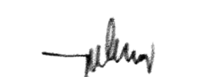***Total No. of HOURS:** **150 hours**

Certified by: ___________**Pia P. Barua** _________

Signature over Printed Name of Trainor

|  |  |
| --- | --- |
| **Figure 6: April 11, 2023** | **Figure 7: April 12, 2023** |
| **Figure 8: April 13, 2023** | **Figure 9: April 14, 2023** |
| **Figure 10: April 17, 2023** | **Figure 11: April 18, 2023** |
| **Figure 12: April 19, 2023** | **Figure 13: April 20, 2023** |
| **Figure 14: April 28, 2023** | **Figure 15: May 2, 2023** |
| **Figure 16: May 4, 2023** | **Figure 17: May 5, 2023** |
| **Figure 18: May 9, 2023** | **Figure 19: May 10, 2023** |
| **Figure 20: May 11, 2023** | **Figure 21: May 12, 2023** |
| **Figure 22: May 15, 2023** | **Figure 23: May 16, 2023** |
| **Figure 24: May 17, 2023** | **Figure 25: May 18, 2023** |
| **Figure 26: May 19, 2023** | |

# **Performance Appraisal Report**

Figure 27: Performance Appraisal Report

%

# **IV. Reflection**

# **Practicum Learning**

As an intern during the practicum, the experience provided valuable insights and hands-on learning in the field of computer maintenance, networking, and related areas.

One of the key learnings during the practicum was in the area of computer maintenance. Assisting senior technicians in tasks such as cleaning computer components, ensuring proper ventilation, and conducting routine maintenance allowed for an understanding of the importance of regular maintenance in optimizing computer performance and extending their lifespan.

In the field of networking, observing and learning from networking experts provided practical experience in different network topologies and protocols. Assisting in the installation of routers and switches for small office networks offered insights into network infrastructure setup and the significance of proper configuration for efficient data transmission.

Another valuable learning experience was troubleshooting various computer issues. Working alongside the IT team, involvement in diagnosing and resolving software glitches, driver conflicts, and minor hardware problems provided an understanding of systematic problem-solving approaches and the importance of staying updated with the latest troubleshooting techniques.

Furthermore, the practicum exposed interns to data encoding and management tasks. Being responsible for encoding data into the company's database systems enhanced data entry skills and familiarity with data management processes. Gaining insights into organizing and categorizing digital files ensured easy access and efficient data retrieval.

In addition to technical skills, the practicum provided ample opportunities to develop essential soft skills. Collaborating with the IT team on projects required effective communication and teamwork. Adapting to the team-oriented environment and communicating effectively with colleagues and supervisors were important aspects of the learning process.

Overall, the practicum experience as an intern offered diverse and valuable learning opportunities. From computer maintenance to networking and troubleshooting, practical knowledge was acquired, technical skills were honed, and essential soft skills were developed. These experiences laid a strong foundation for future careers in computer maintenance, networking, and related fields.

# **Problems Encountered**

During my time at Veterans Memorial Medical Center, one of the problems encountered was related to biometrics systems. The biometric authentication system, which was implemented to enhance security and streamline attendance tracking, faced technical issues that affected its reliability and accuracy.

One of the challenges was inconsistent biometric recognition, leading to difficulties for employees to clock in and out using their fingerprints or other biometric identifiers. This resulted in delays, frustration, and potential errors in attendance records, impacting the efficiency of time tracking and payroll processes.

Furthermore, the integration of the biometrics system with other HR or access control systems posed challenges. Incompatibility issues and difficulties in syncing data between different systems created complexities in managing employee records and ensuring accurate data synchronization across various platforms.

# **Suggestions and Recommendations**

As an intern, I have identified several recommendations to address the biometrics system issues at Veterans Memorial Medical Center. Firstly, resolve integration challenges by developing custom APIs or data synchronization protocols. This will ensure smooth data transfer between the biometrics system and other MISO or access control systems, minimizing complexities and ensuring accurate data synchronization.

Second, provide comprehensive training to employees on proper system usage. This includes educating them on finger placement techniques, hygiene practices, and troubleshooting common issues. Empowering employees with the necessary knowledge and skills will contribute to improved recognition accuracy and minimize errors during clock-in and clock-out processes.

Thirdly, establish a proactive maintenance schedule to ensure the biometrics system is running optimally. Regular checks, device calibration, and software updates will help detect and resolve any potential issues promptly, ensuring system reliability.

Lastly, set up a feedback mechanism for employees to report issues and suggestions. This feedback can be used to identify recurring problems, evaluate potential solutions, and make necessary adjustments for system improvement.

**Appendices**

