CPAN226 Lab 4: Multithreading

Performance Data with Screen Shots
- Sequential Execution Time: 25 s
- Multithreading Execution Time: 5 s
  - Reduction Calculation
    - Reduction% = Sequential – Threaded / Sequential x 100
    - 25 – 5 / 25 x 100 = 80%
  - Fig 1: Sequential server processing 5 request resulting in total time of 25 seconds
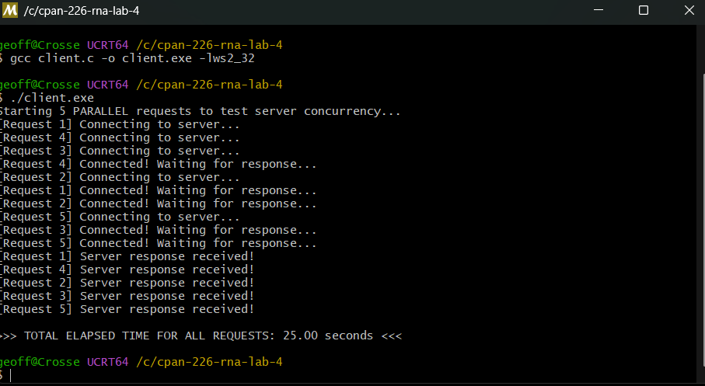
  - Fig 2: Multithreaded Server handling requests concurrently resulting in total time of approximately 5 seconds
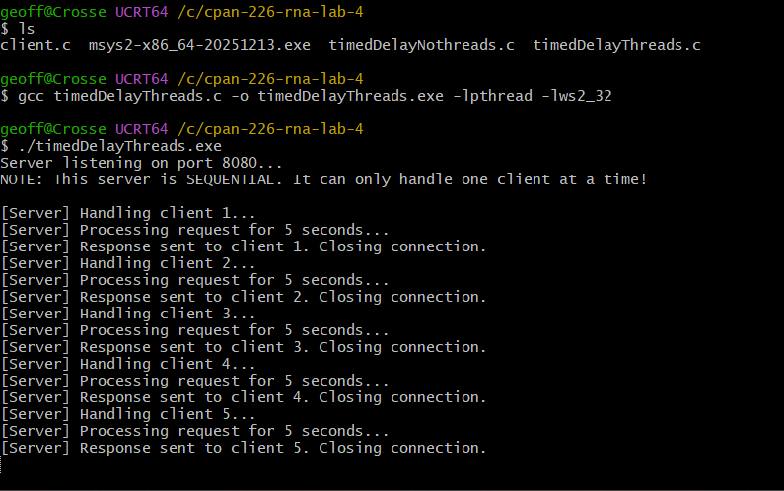

Analysis
  - Code Changes
- The server code was modified to use pthread_create() a new thread for each client connection.
- Instead of handling clients sequentially using a direct function call, each request is processed in a separate thread.
- The thread is detached using pthred_detached() to automatically reclaim resources after execution.
  - Why the time improved
- The total execution time improved because the server now processing request concurrently
- Each request still requires a 5-second delay. But because they run in parallel threads, the server can process multiple clients at the same time instead of waiting for each request to finish before starting the next
Scaling Scenarios
- Sequential server (10 requests) 10 x5 seconds = 50 seconds
- Threaded server (10 requests) – 5 seconds
- If 1000 request were sent
  - Potential limitations include
    - CPU thread limits
    - Memory usage
    - Network bandwidth
    - Thread creation overhead
- A better approach for large system would be a thread pool or asynchronous 1/0 model
  - Conclusion
- Multithreading significantly improves the performance of network servers by allowing multiple client requests to be processed simultaneously
- In the sequential server, request was processing time of 25 seconds for 5 requests
- After implementing multithreading with pthreads, the same workload completed in approximately 5 seconds
- This demonstrates how concurrency improves efficiency in 1/0 bound network applications
