Fertility and Female Labor Supply in Latin America:
New Causal Evidence

Guillermo Cruces
ECLAC and STICERD

Sebastian Galiani*
Universidad de San Andrés

December, 2005
Forthcoming, Labour Economics

Abstract
We study the effect of fertility on maternal labor supply in Argentina and Mexico exploiting a source of exogenous variability in family size first introduced by Angrist and Evans (1998) for the United States. We find that the estimates for the US can be generalized both qualitatively and quantitatively to the populations of two developing countries where, compared to the US, fertility is known to be higher, female education levels are much lower and there are fewer formal facilities for childcare.

JEL: J13 and J22.
Keywords: Causality, Childbearing and Female Labor Supply in Developing Countries.
- Introduction

A significant change in human behavior during the past century was the massive incorporation of women into the labor force. Not surprisingly, there is an extensive theoretical and empirical literature attempting to explain female labor supply and its evolution. In particular, the relationship between fertility and female labor supply is of longstanding interest in the social sciences. Much of the research effort has been devoted to disentangling the causal mechanisms linking childbearing and female labor supply. Recently, Angrist and Evans (1998) (henceforth AE) have made substantial progress in this area. Their identification strategy exploits parental preferences for a mixed sibling sex composition as an instrument for fertility. Since parents of same-sex siblings are significantly more likely to have an additional child, and the sex mix is virtually randomly assigned, an indicator variable for whether the sex of the second child matches the sex of the first child provides a plausible instrument for further childbearing among women with at least two children.
In this paper, we exploit AE’s identification strategy to estimate the causal effect of childbearing on maternal labor supply in two middle-income Latin American countries: Argentina and Mexico. Thus, we investigate the extent to which the causal link identified in AE can be generalized to the context of developing countries where, compared to the US, fertility is known to be higher, female education levels are much lower and there are fewer formal facilities for childcare. This is of interest in of itself but also because, ultimately, the external validity of all causal estimates is established by replication in other datasets (Angrist, 2004).
The rest of the paper is organized as follows. In the next section we describe the data and provide a set of summary statistics. We then present and discuss the estimation strategy. This is followed by the main results of the paper. Conclusions follow.

- Data and summary statistics

Our datasets are gathered from the extended questionnaire samples of both the Mexico 2000 and the Argentina 1991 censuses, conducted respectively by the National Institute of Statistics, Geography and Computing (Instituto Nacional de Estadística, Geografía e Informática, INEGI) and the National Institute of Statistics and Censuses (Instituto Nacional de Estadísticas y Censos, INDEC). The two result in large and nationally representative datasets. For Argentina, we have data on 16,023,180 individuals and 4,287,580 households, covering around 50 percent of the whole population. For Mexico the sample consists of 10,099,182 individuals and 2,312,034 households, covering around 10 percent of the total population. We restrict our sample to women between 21 and 35 years old, with at least two children, and whose oldest child was at most 18 years old at the time of the census. Following AE, we also exclude from the analysis women whose second child is younger than a year old, and carry out our analysis separately on all women and married women. Thus, our final samples sizes are 599,941 (total) and 456,437 (married) observations for Argentina, and 458,849 (total) and 355,730 (married) for Mexico.
Table I presents descriptive statistics and variable definitions. Female employment for our married samples are much higher (30.5 percent) in Argentina than in Mexico (22 percent), but they are both significantly lower than the US figures for equivalent samples (52.8 percent in 1980 and 66.7 in 1990). Both in Argentina and Mexico, female labor supply is lower for married women than for unmarried women. With respect to fertility, the average number of children is higher for married women in Mexico (3.035) than in Argentina (2.985), and higher than the respective US figure (around 2.5 in both the 1980 and 1990 censuses).
In this paper, the fertility variable of interest – i.e., the causing variable in our empirical labor supply regression models – is the indicator More than two children, which is instrumented by the indicators: Same sex, Two boys and Two girls. In both Argentina and Mexico, slightly above 50 percent of the women in any of the samples considered have a third child while in the US the same figure is only about 36 to 40 percent. We also report indicators for whether the first and second children were boys. Finally, Table I also presents the women’s age and age at first birth.

- Estimation strategy
  - Empirical model
Let D_{i} be an indicator for women with more than two children in a sample of women with at least two children. Additionally, let Y_{1i} be the labor supply of mother i if D_{i} equals 1 and Y_{0i} denote her labor supply otherwise; let X be a vector of control variables; and let Z_{i} be an indicator equal to one if a woman’s first two children were of the same sex, and equal to zero otherwise. We estimate the following linear model:

Y_{i} = X_{i}’β + α D_{i} + ε_{i} (1)

In Section 4, we present Two-Stages Least Squares (2SLS) estimates of the parameter of interest from model (1), where we saturate the whole set of control variables. We then also report estimates from the IV estimator developed by Abadie (2003), which allows a flexible nonlinear approximation of the causal response function.

  - First stages
The evidence presented in the top panel of Table II confirms the presence of an effect of sex preferences in further childbearing for women with at least two children in Argentina and Mexico. This panel presents the coefficients of Same Sex (first row) and Two boys and Two girls in two separate regressions (second and third rows) with More than two children as the dependent variable, with a set of demographic controls as described in the Table.
In both countries, women who have had two children of the same sex have a higher probability of having a third child (and, naturally, also a higher number of children) than women who have had two children of different sex (Mixed sex). The difference in these conditional probabilities are around 3.6-4.1 percentage points in Argentina (all-married) and 3.3-3.7 percentage points in Mexico (all-married). These differences, significant at the 1 percent level, are close to those found by AE for the US, and represent evidence of a sex mix preference phenomenon in both Argentina and Mexico.
Table II also shows that women who have two girls have on average a 4.7-5.3 (all-married, Argentina) and 4.3-4.6 (all-married, Mexico) percentage point higher probability of having a third child, while these figures are lower for women who have had two boys (around 2.6-3 and 2.5-2.8 percentage points, respectively). Nevertheless, the significance of both variables indicates the presence of mixed sex sibling preference in both countries, with an additional bias for boys. AE report similar results on a difference in the probability of further childbearing between women who have had two boys, and women who have had two girls, for the 1980 (though not in the 1990) data for the United States.
  - Exclusion restriction
Given the presence of mixed sex sibling preferences combined with a relatively higher preference for boys, we now discuss the potential implications of this phenomenon on the validity of using the Same sex variable (or Two boys and Two girls) as an instrument for More than two children in the context of Argentina and Mexico.
Since exclusion restrictions are non-testable directly, their plausibility must be evaluated on a case-by-case basis. In some developing countries, there might be concerns that the presence of strong son preferences could affect the sex composition of children, either through stopping rules or selective abortion, violating the exclusion restriction. However, the evidence for our sample rules out this concern: both in Argentina and Mexico, the infant sex ratios (the ratio of boys to girls aged zero to four) are approximately equal to the biological ones, which are about 1.04. On the contrary, for instance, in China and Korea, the infant sex ratios show evidence of parental actions affecting biological sex ratios (see, among others, Basu et al., 2003).
Basu and Das Gupta (2001) also argue that beyond cultural and religious factors, some societies exhibit a strong son preference because of the gap between sons’ and daughters’ “ability to contribute to the physical, emotional and financial well-being of their parental household.” Family institutions both in Argentina and Mexico, however, do not exhibit any severe form of son preference. Dowries are virtually unheard of in both countries, and extreme preferences for sons imply forms of discrimination against girls that are not observed in Latin America in general. The infant sex ratios also represent evidence of the lack of a systematic effect of son preference on the mortality of girls. Moreover, additional evidence shows that both in Argentina and Mexico the primary school enrollment rates are virtually the same for boys and girls, and in Argentina girls actually have higher enrollment and completion rates in secondary and tertiary education (Pantelides, 2002).
Finally, another possible threat to the validity of the identification strategy is posed by Rosenzweig and Wolpin (2000). Studying outlays per children in rural India, they find that same sex siblings are related to substantially lower levels of expenditure. They attribute this effect to “hand-me-down” savings, which are more likely to arise when there are children of the same sex in the household for items such as clothing and footwear. Since these items represent a sizeable fraction of the household’s expenditures, they note that the sex composition of children plausibly alters labor supply through mechanisms other than through fertility change alone.
While expenditure data per child is not available for Argentina or Mexico, survey data suggests that sex composition is unlikely to have a noticeable effect on expenditure. Rosenzweig and Wolpin (2000) find in their Indian data that clothing expenditures on children under 18 represents 11 percent of household income. For Mexico, Hernández Franco and Pérez García (2003) report that in the year 2000 households spent around 4.8 percent of their budget on clothing and footwear for all members of the family, with little variation among deciles of household income. Meanwhile, Argentine households in 1987 devoted 6.7 percent of their budget to the same items (for all members), and only 2.8 percent on clothing and foot wear for children aged 10 or less. Rosenzweig and Wolpin’s (2000) estimated “hand-me-down” savings for these goods amounts to 1.3 percent of average earnings: even assuming that these savings exist in Argentina and Mexico (and that they have a direct effect on labor supply), their size would be too small to account for a meaningful reduced form relationship between a same sex indicator and parental labor supply.
Thus, the evidence presented in this section suggests that the bias for boys observed in our samples is likely to be mainly the result of cultural preferences. There is no evidence of strong discrimination against girls in Argentina or in Mexico, and it is unlikely that the sex composition of children affects significantly the consumption pattern of households in any of the two countries. Thus, the combined preferences for a mixed sex sibling composition with a bias for boys may reflect mainly cultural factors. If these are the main reasons behind the bias for boys, there should not be a major concern about the exogeneity of the Same sex indicator as an instrument for fertility.

- Main results

The bottom panel of Table II presents the estimation of model (1) by OLS and a series of IV models. We include a set of standard control variables: age of the woman, her age at first birth, sex of the first child and sex of the second child (see Angrist and Evans, 1998). In order to saturate the model, we map both age and age at first birth into five categories each, and then create a set of forty-nine mutually exclusively indicators by interacting them with the aforementioned control variables., Conditioning on the sex of the first two children allows us to control for any secular additive effect of child gender on female participation. This is useful because Same sex is potentially correlated with the sex of either child, which is of concern if this affects labor supply for reasons other than family size.
The first row presents the simple OLS estimates, which indicate a strongly significant negative correlation between having more than two children and female labor supply. The IV results, presented in the following row, imply for Argentina that having more than two children reduces a mother’s labor supply by about 8.1-9.6 percentage points (all-married – significant at the 5 and 1 percent levels, respectively), with a similar effect observed for Mexico: 6.3-8.6 percentage points (all-married, significant at the 10 and 5% levels). These results are quite close to the 1990 US estimates reported by AE (8.4 percentage points), although they are lower than the US 1980 effects (10.4 percentage points). Finally, it should be noted that there is no systematic pattern of differences between IV and OLS estimates of the same coefficients.
In order to explore whether IV estimates are biased toward OLS, in the second row of the second panel in Table II we report the results obtained by split sample IV (SSIV) estimation, which are biased towards zero and not towards OLS (see Angrist and Krueger, 1995). The estimates obtained by SSIV are all significantly different from zero, and they are even higher (in absolute value) than the IV results for both Argentina and Mexico. Thus, we do not find evidence suggesting that our IV estimates are biased toward OLS. It is worth remembering that, in general, the Same sex IV strategy identifies the average effect of having more than two children on those whose fertility decisions are changed by the instrument (compliers), while OLS is suspected to fail at identifying the same effect averaged over the whole population (see Angrist et al, 1996). Thus, with this interpretation in mind, the finding that IV and OLS estimates are similar is not worrisome.
The following row in Table II presents Abadie’s (2003) IV estimates. The results are almost identical to the 2SLS just described, showing that our almost saturated model captures extremely well the CEF of female labor supply.
In addition, the Same sex indicator is easily decomposed into two variables indicating the sex composition of the first two children, Two boys and Two girls, leading to an overidentified model. AE show that this is useful because the bias from any secular effects of child gender on labor supply should be different from these two instruments, while the labor supply consequences of childbearing seem likely to be independent of whether Same sex equals Two boys or Two girls. Thus, an appropriate specification test is the Sargan test or test of overidentifying restrictions. However, when More than two children is instrumented by both Two boys and Two girls, it is not possible to control for the effects for the sex of each child, and so we report results that control only for the sex of the first child (as in AE).
The Generalized Instrumental Variables Estimates (GIVE) are smaller (in absolute terms) than the IV and OLS ones. However, the differences are never statistically significant at conventional levels of significance. Finally, the statistics of contrast of a standard Sargan test of over-identifying restrictions reject the null hypothesis at or near the 10 percent level for any of the four samples considered. A caveat is in order here: while higher than 5 percent in all cases, the P-Values for these tests are still low and may be highlighting the limits of the validity of the exclusion restrictions in our samples.
All in all, the evidence presented in this paper reveals that the effect of fertility on female labor supply, identified by applying the AE strategy, is qualitatively similar in Argentina, Mexico and the United States. The next question is whether the effects are of the same order of magnitude or whether they differ substantially. A test of the hypotheses that the effect of fertility on female employment for Argentina (1991), Mexico (2000) and the United States (1990, from AE) does not reject the null at standard levels of statistical significance. Thus, we can assert that in the US, and in Argentina and Mexico, the average effect of going from a family size of two children to more than two is statistically similar (for those whose treatment status is changed by the Same sex instrument).

- Conclusion

We study the effect of women’s fertility on labor supply in Argentina and Mexico exploiting an instrumental variable estimator first introduced by Angrist and Evans (1998) for the United States. Our study shows that the “mixed sex sibling preference”, the basis of AE identification strategy, is present in Argentina and Mexico. More importantly, we find that the AE estimates for the US can be generalized both qualitatively and quantitatively to the populations of two developing countries that are different from the original application.

References

Abadie, A. (2003): “Semiparametric Instrumental Variable Estimation of Treatment Response Models”, Journal of Econometrics 113, pp. 231-63.

Angrist, J. (2004): “Treatment Effect Heterogeneity in Theory and Practice”, The Economic Journal, 114 (494), pp. C52-C83.

Angrist, J., G. Imbens and D. Rubin (1996): “Identification of Causal Effects Using Instrumental Variables”, Journal of the American Statistical Association 91, pp. 444-455.

Angrist, J. and W. Evans (1998): “Children and their Parents’ Labor Supply: Evidence from Exogenous Variation in Family Size”, American Economic Review 88(3), pp.450-77.

Angrist, J. and A.B. Krueger (1995): “Split Sample Instrumental Variables Estimates of the
Return to Schooling”, Journal of Business and Economic Statistics 13, pp. 225-235.

Basu, A. and Das Gupta, M. (2001): “Family Systems and the Preferred Sex of Children.” In Hoem, J. editor, (2001), International Encyclopedia of Social and Behavioral Sciences, Elsevier.

Card, D. (2000): “The Causal Effect of Education on Earnings” in Orley Ashenfelter and David Card (eds.), Handbook of Labor Economics, Vol. 3A. Amsterdam: North-Holland.

Leung, S. F. (1991): ‘A Stochastic Dynamic Analysis of Parental Sex Preferences and Fertility”, Quarterly Journal of Economics, Vol. 106(4), pp. pp. 1063-88.

Pantelides, E. (2002): “Completing the Fertility Transition: The Case of Argentina”, in United Nations (2002).

Rosenzweig, M. and K. Wolpin (2000): “Natural ‘Natural Experiments’ in Economics”, Journal of Economic Literature, Volume 38(4), pp. 827-874.

Sobek, M., S. Ruggles and R. McCaa (2002): “Integrated Public Use Microdata Series-International: Preliminary Version 1.1”, Minneapolis: Minnesota Population Center, University of Minnesota.

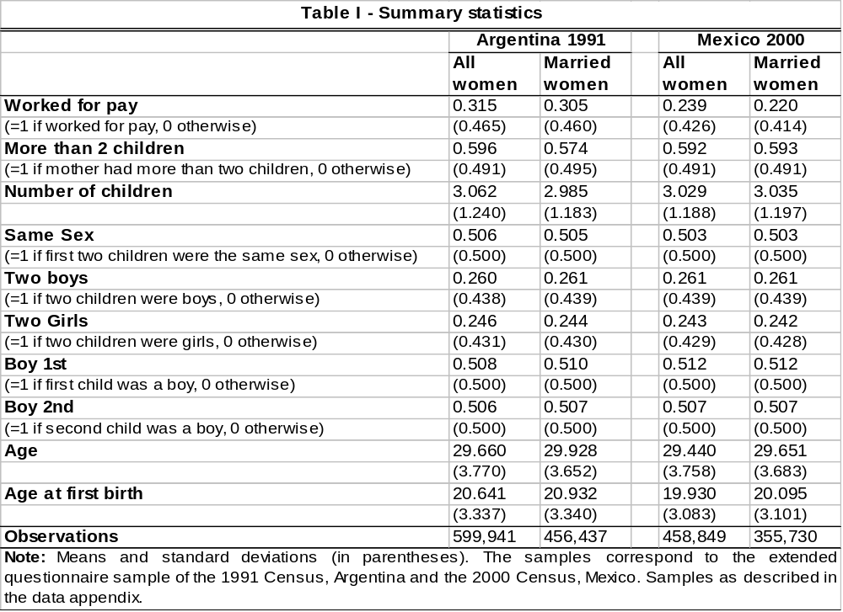
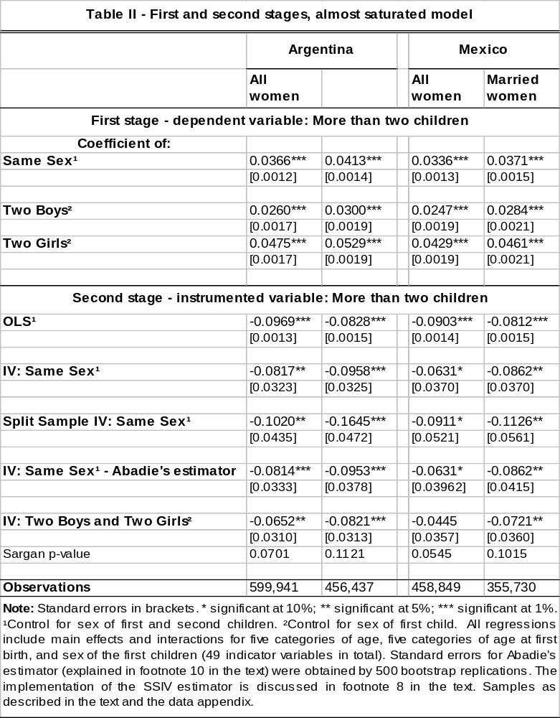

Appendix: Data sources

The Argentine dataset contains information on 16,023,180 individuals and 4,287,580 households, from a total population of 32,245,467 individuals and 8,927,289 households. We constructed this dataset from the original data tapes. The Mexican dataset covers 10.6 percent of the total population of 97,483,412 persons and 22,268,916 households, yielding a sample size of 10,099,182 individual records and 2,312,034 household records. The Mexican data is taken from Sobek et al. (2002).

Matching women and their children
For both Argentina and Mexico, the relationship variable linking members of a household indicates kinship with respect to the head of the household only. In order to match women with their own children, we restrain the sample to females who are heads or spouses of the heads of households. In order to avoid assigning all children of a male head to his current partner, who might not be the mother of all children in the household, we first check that the reported number of children alive (as asked for in a specific census question for both countries) coincides with the number of children in the household matched to the woman, restraining our samples to women for whom both numbers coincide. Finally, we made some extra adjustments based on the age of the woman and/or her husband. We discard a small number of observations for which the age of the mother at first birth was less than 14, taking this as an indicator of data entry errors or misallocated children, since most of the ages were far too low. We also dropped from our final samples a very small fraction of married women for whom the husband’s age at first birth was less than 14.

Worked for pay indicator
In the Argentine census, an individual is classified as working for pay (Worked for pay indicator equal to 1) if he or she works and is not a family worker without remuneration. Thus individuals working for pay include employees (wage earners), the self-employed, owner-managers and civil and domestic servants. In Mexico, we use the same definition and classify an individual as working for pay if he or she does remunerated work.

* Guillermo Cruces, ECLAC (Santiago de Chile) and STICERD-London School of Economics, Houghton St., London WC2A 2AE, United Kingdom, g.a.cruces@lse.ac.uk. Sebastian Galiani, Universidad de San Andrés, Vito Dumas 284, (B1644BID) Victoria, Provincia de Buenos Aires, Argentina, Tel: (54-11) 4725-7053, sgaliani@udesa.edu.ar. We are grateful for the comments of A. Abadie, T. Atkinson, R. Di Tella, W. Evans, P. Gertler, S. Pischke, K. Lang, J. Wadsworth and seminar participants at Universidad de La Plata, Universidad del Pacifico and Universidad de San Andres. We also thank Edgar Poce for outstanding data assistance. G. Cruces acknowledges financial support from STICERD. The views expressed here are those of the authors and do not necessarily reflect those of ECLAC or the UN.
However, since the potential outcome conditional expectation function (CEF) is also a function of the causing variable, we denote this empirical model as an “almost saturated” model.
Abadie’s (2003) “Causal IV” estimates have a robust causal interpretation regardless of the shape of the actual CEF for potential outcomes, since identification is attained non-parametrically.
Strict son preference with no mixed sex sibling preference requires a coefficient of Two boys not significantly different from zero (Leung, 1991).
The figures for Argentina are based on the 1996/7 Expenditure Survey by INDEC. Based on further evidence from this survey (available upon request), we failed to find any effect of the sex composition of children on the budget shares of clothing, education, food and other categories of goods.
The five age category indicators were chosen to contain approximately the same number of observations in each of them, and were defined as 21-25, 26-28, 29-30, 31-32 and 33-35 for age, and 17 or less, 18-19, 20-21, 22-23 and 24 and more for age at first birth.
We also fitted a more parsimonious version of these models including controls for the continuous variables Age and Age at first birth, and indicators for the sex of the first and second child, instead of interactions of categorized versions of these variables. The results were almost identical, and are available upon request.
These results are also robust to: a) using labor force participation as the dependent variable instead the alternative Worked for pay; b) using different age groups to draw our sample of women: all estimates are very similar if we use instead women aged 18-35 or 21-45; c) including in the sample women whose second child is younger than a year old; and d) including in the sample some women that were discarded because of mismatches (see data appendix). We also added municipality dummy variables and, again, the estimates do not change at all. Finally, the results were unaltered when we included the spouse controls instead of the women’s. All of these results are available upon request.
We obtained these results by splitting the samples randomly in two halves, computing the first stage regression with the first half sample and using the coefficients of this regression to predict the values of the instrumented variable in the second half sample. These predicted values were then used in the second stage regression in the second half sample, computed by OLS. The standard errors of the estimate were adjusted to take into account the fact that the instrumented variable was estimated.
See Card (2000) for a similar argument in reconciling IV and OLS estimates of the effect of schooling on earnings.
We implement a simple two-step version of Abadie’s (2003) estimator based on a linear specification of the Local Average Response Function. In the first step, we estimate by OLS the model Z_{i} = X_{i}’γ + e_{i}. The predicted values from this regression are then used to construct the estimated weights K_{i} (Abadie 2003, Theorem 3.1). We finally use these weights to estimate the model given by equation (1), Y_{i} = X_{i}’β + αD_{i} + ε_{i}, by weighted least squares (Abadie 2003, Equation 14). The standard errors of the estimator were obtained by 500 bootstrap replications of this procedure.
This is especially the case since these tests are not very powerful in finite samples. In order to rule out the possibility that we do not reject the null because of lack of statistical power, we ran the same regressions with More than two children instrumented by Same sex, but including also “invalid” instruments: in Mexico, total household income, and in Argentina (since this variable is not available) a proxy in the form of the woman’s education level, or the spouse’s level for married women. In all cases, we reject the null hypothesis of the validity of the overindentifying restriction at the 1 percent level of statistical significance (the P-values are indistinguishable from zero).

