Risk-Adjusted Poverty in Argentina: Measurement and Determinants

Guillermo Cruces* and Quentin Wodon**
August 2005

ABSTRACT: This paper presents a methodology for adjusting measures of income and poverty for the risk faced by a household. The approach draws on the standard economic concept of risk aversion, and it is based on the intuition that households will prefer a steady stream of income to a variable one with the same mean. Relying on a Constant Relative Risk Aversion utility function, we use panel data for Argentina to compute risk-adjusted income and poverty measures. At the aggregate level, we find that taking risk into account substantially increases the poverty headcount. Moreover, a regression analysis suggests that many household characteristics are correlated not only with the average income of the household over time, but also with its variability.
Keywords: Risk, Poverty, Argentina
JEL Codes: D81, I32, D63
Word count: 8200 including endnotes.

*Economic Commission for Latin America and the Caribbean and STICERD-LSE. CEPAL-Naciones Unidas, Casilla 179-D, Santiago, Chile. Email: Guillermo.Cruces@cepal.org
**World Bank, 1818 H Street, NW, Washington, DC 20433, USA, Email: qwodon@worldbank.org

We are grateful to Frank Cowell, Stefan Dercon, Martin Ravallion and two anonymous referees for comments provided on previous drafts of this paper. We are also grateful for comments received at seminar presentations at a 2002 World Bank-IFPRI conference on Vulnerability and Risk, at the 2002 Argentina meeting of the LACEA-IADB-WB network on Inequality and Poverty, at the STICERD work in progress seminar, and finally at the 2003 WIDER Conference on Inequality, Poverty and Human Well-Being. The usual disclaimer applies. This paper was prepared as a background study for the poverty assessment for Argentina prepared by Norman Hicks at the World Bank. The views expressed here are those of the authors and need not reflect those of the World Bank, ECLAC or the United Nations.
Table of contents

1. Introduction 3
2. Methodology 5
2.1. Risk adjusted measures of income and poverty 5
2.2. Determinants of risk-adjusted poverty 10
3. Application to Argentina 11
3.1. Data and descriptive results 11
3.2. Regression analysis 15
4. Conclusion 19
5. References 22
6. Tables and Figures 25

- Introduction
There is ample evidence that poor (and not-so-poor) households are vulnerable to shocks. As suggested by Blundell and Preston (1998) for Britain, if insurance markets were complete, households would be able to offset the impact of shocks on consumption. In developing countries, however, safety nets and credit markets tend not to be well developed. For instance, the World Development Report on poverty produced by the World Bank (2001a) insists on the need to provide security to the poor in addition to opportunities and empowerment. In one of the first studies about this subject, Ravallion (1988) analysed how a risk that is commonly shared among households may affect expected poverty. Jalan and Ravallion (1999) extended this work by examining how well household consumption is insured against income variability in rural China, finding that consumption is never fully insured and that poorer households are less well insured than other households. A series of papers published in a special issue of the Journal of Development Studies by Baulch and Hoddinott (2000), Baulch and McCulloch (2000), Dercon and Krishnan (2000), Jalan and Ravallion (2000), Gunning, Hoddinott, Kinsey and Owens (2000), and Scott (2000) provided additional evidence on the relationships between risk, vulnerability, and poverty.
In much of the above work, and more generally in much of the literature, the relationships between risk, vulnerability, and poverty have been analyzed from the point of view of the impact of shocks (whether covariant or idiosyncratic) on movements in and out of poverty, with the concept of vulnerability defined in terms of the risk of falling into poverty. In this paper, we do not rely on the concept of vulnerability nor on the analysis of movements in and out of poverty. Instead, we directly incorporate risk into the measurement of income, and thereby poverty. Our approach draws on the standard concepts of risk aversion and certainty-equivalent income or consumption. It is based on the intuition that households will prefer a steady stream of income to a variable one with the same mean. We derive a measure of income that reflects the disutility induced by income fluctuations over time. Specifically, using a Constant Relative Risk Aversion utility function, we use panel data to compute a risk-adjusted income measure at the household level. This is then used to estimate risk-adjusted poverty measures and to assess the determinants of risk-adjusted income and poverty. This methodology was first applied to risk-adjusted measures of inequality by Makdissi and Wodon (2003), and extended to comparisons of long term relative deprivation between groups by Cruces, Makdissi and Wodon (2004).
We illustrate the framework with panel data for urban households living in the Greater Buenos Aires Area in Argentina for the period 1995-2002. The use of Argentine data is especially appropriate given the repeated shocks that have affected the country. After a lost decade in the eighties that ended up in a process of hyperinflation, Argentina adopted a hard peg of the local currency to the US dollar in 1991 (the so called Convertibility Plan). The period 1991-1994 was relatively stable, but the currency board implied that the economy remained vulnerable to external shocks. In 1994-1995, the country was hit by contagion of the Tequila effect following Mexico's devaluation. After a period of recovery from 1996 to 1998, the economy suffered again when Brazil, Argentina's main trading partner, devalued its currency in January 1999. This episode marked the beginning of a three year recession that ended in a major crisis. At the end of 2001, the country's economy collapsed in a financial meltdown accompanied by a banking and currency crisis. Argentina's peso lost nearly 70 per cent of its value against the US dollar from January to August 2002, while real wages fell and poverty levels reached the highest recorded values for the country. According to estimates published by Argentina's national statistical institute, the Instituto Nacional de Estadisticas y Censos (INDEC hereafter), from October 2001 to May 2002, the share of the population in poverty increased from 35.4 per cent to 49.7 per cent in the Greater Buenos Aires area, and from 38.3 to 53.0 per cent for the total urban population (INDEC, 2002).
The impact of these repeated shocks is well captured in our empirical work. The results suggest that risk-adjusted poverty measures are higher than standard cross-sectional measures for reasonable values of the risk aversion parameter. Furthermore, the impact of a number of household characteristics on risk-adjusted incomes differs from their impact on a household's average income over time. This implies that these characteristics affect the impact of risk over and above their effect on the average of income over time. Among these characteristics, we find that households with elderly members are less subject to risk, while households with inactive or unemployed workers suffer more from risk. Moreover, being a recent migrant increases risk even though it does not affect average income, while a better education reduces risk and income.
The rest of the paper is organised as follows. Section 2 presents the conceptual framework for the estimation of risk-adjusted measures of income and poverty, and for the analysis of their determinants. Section 3 presents our empirical results using data from Argentina. A brief conclusion follows.
- Methodology
  - Risk adjusted measures of income and poverty
This Section presents risk-adjusted measures of poverty, which are based in the concept of risk-adjusted income, derived from the notion of certainty-equivalent income from the risk literature. We can illustrate the methodology with a very simple example. Suppose that an individual is facing an uncertain income in the future, which can take one of four values 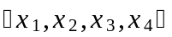 with equal probability. A risk-averse individual will prefer to receive a given fixed sum with certainty rather than face the uncertainty implied by the realisation of one of these sums. The concept of risk aversion implies that the sum , the certainty equivalent, will be lower than the average or expected value of . Intuitively, the individual would be willing to pay to get rid of the uncertainty, trading off income for security. The value of the certainty equivalent is determined by the degree of risk aversion of the individual and by the variability of her income, and thus provides the basis for our welfare-based definition of risk-adjusted income. However, since future realisations are not observable, we rely in our study on panel data on incomes to infer the possible future values of income for a household from its past occurrences – since we observe households for four periods, we construct the future distribution by using 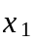 in 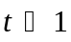 , 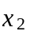 in 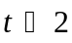 , 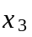 in 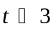 and 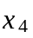 in 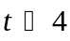 .
In formal terms, the methodology presented below follows Makdissi and Wodon (2003) and Ligon and Schechter (2003) in making the identifying assumption that incomes observed in the past for a household represent equally probable draws from the distribution of possible incomes for that household. This implies that a panel dataset with observations per household can be interpreted as providing information on the distribution of future states of nature for each household, and thus represents equiprobable states of nature, each described by its associated outcome 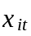 .
A household's income risk is characterised by these states of nature. The certainty-equivalent income of the household, , is the amount of income that, if received with certainty in each possible state, would provide the same level of utility as the incomes over different states ( ). Thus can be defined within a social welfare context with respect to some function  which represents the social judgement on the welfare value of the random variable (Makdissi and Wodon, 2003):
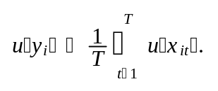(1)
In this formulation of uncertainty in an expected utility model, the function is assumed to be continuous with a positive first derivative (implying non satiation) and a negative second derivative (implying risk aversion).
Many utility functions satisfy these conditions and have been used in the risk literature, for instance the constant absolute risk aversion (CARA) and the quadratic utility functions. We chose to parametrise as a Constant Relative Risk Aversion (CRRA) function, because it has been argued (Newbery and Stiglitz, 1981, Chapter 6) that the CRRA exhibits some desirable properties regarding the relationship between the risk premium and the level of income. We thus define as:
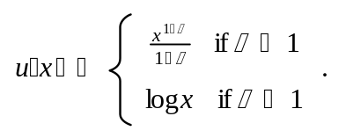(2)
We denote by the constant Arrow-Pratt relative risk aversion coefficient. A common practice in the risk literature (for example, Leland, 1968; Newbery and Stiglitz, 1981) is the use of a Taylor approximation of the certainty equivalent, defined as
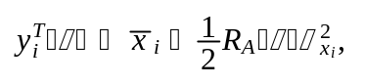(3)
where 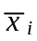 is the mean household income over the whole period under consideration, 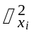 is the variance of the income of household and 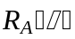 is the Arrow-Pratt measure of absolute risk aversion equal to 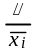 for the CRRA utility function. The problem with this Taylor approximation is that it is only valid for small levels of risk, and thus likely to produce biased results for high values of . In this paper, we use instead the exact measure of risk-adjusted income implied by Equations (1) and (2), which is equal to
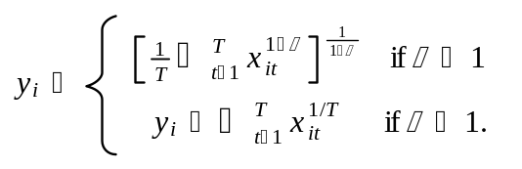(4)
Using Equation (4), it is relatively straightforward to estimate risk-adjusted poverty measures based on household's income fluctuations. Since in practice we do not know the possible states of the world, we assume that income observations in different periods of time are drawn from the distribution given in the panel.
At any given time, the poverty status of a household is defined with respect to a poverty line (which may be absolute or relative), such that households with incomes lower than are considered poor. Here, instead of focusing on the static condition 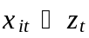 , we use the household's risk-adjusted measure of income given by Equation (4) for the periods. Note that because we have different poverty lines over time, we need to normalise (that is, divide) the income of each household at time t by , so that a household is considered poor if 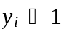 . Note also that we need to take into account the composition of the household in defining what are its basic needs and whether it is poor or not.
Taking all of the above into consideration, we define as follows:
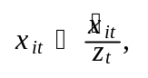(5)
where 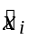 is some form of equivalised monetary income for the household. Following standard practice in Argentina (INDEC, 2002), our measure of household 's equivalised income is the sum of the monetary income of each of the 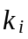 members ( 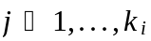 ) of the household, divided by the sum of each member's equivalent adult weights 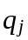 :
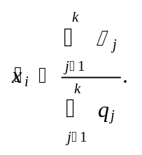(6)
The vector of certainty-equivalent incomes 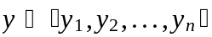 , where is the number of households, is obtained from using the defined by Equation (5) into (4); it is then used to compute a set of risk-adjusted measures of poverty. We will focus here on the usual additive poverty indices of the 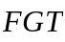 (Foster, Greer and Thorbecke, 1984) class. Since we have normalised all incomes by the poverty lines (so that a value of one for the normalised income corresponds exactly to the poverty line), the FGT measures are defined as
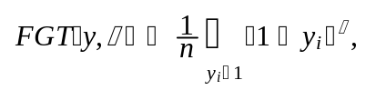(7)
where may be interpreted as a parameter of aversion to inequality among the poor. With 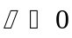 , we obtain the poverty headcount. With 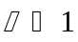 and 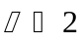 , we obtain the poverty gap and the squared poverty gap respectively. These risk-adjusted poverty measures can then be compared to those obtained with the mean income over time for each household (which corresponds to the certainty equivalent defined in Equation (4) with the risk aversion parameter set to zero), namely
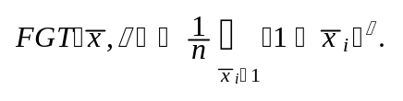(8)
Note that under standard poverty measurement procedures, a household with equivalised income just above the poverty line during the periods would not be considered poor. However, the impact of risk aversion could well make such a household poor according to our methodology if there is some variation in income over time. Note also that a potential problem arising from the use of panel data is that a steady growth in incomes over time may be interpreted as risk because it will lead to income variability. In our application however, this is not much of an issue since the period of time for which we have panel data on each household is relatively short (1.5 years), so that growth effects should be small (for an analysis based on data for longer periods of time using relative poverty measures to correct for the impact of growth, see Cruces et al., 2004).
Finally, our methodology can be discussed in the light of Jalan and Ravallion's (2000) decomposition of poverty measures into chronic and transient components, which has been widely used in the poverty literature (for example, Dercon and Krishnan, 2000; McCulloch and Baulch, 2000, and Cruces and Wodon, 2003b, with the same dataset employed in this paper).
Jalan and Ravallion's (2000) approach defines chronic poverty as a poverty measure (usually the squared poverty gap) evaluated at the mean of household income over time, as in our Equation (8). Overall poverty is computed as the mean of the household's one-period poverty measures , and the transient element is derived as as the difference between the overall and the chronic measures. A virtue of the chronic - transient poverty approach is that it reveals the contribution of income variability to an overall measure of poverty, while our risk-adjusted measure of poverty (Equation 7), based on the certainty equivalent of income, seems to merge the level and variability of income into one measure. However, as explained in the next Section and in the empirical analysis, the added value of our approach resides in comparing poverty based on current and average income over time (Equation 7), on the one hand, with poverty figures based on the certainty equivalent income (Equation 8) for different values of the risk aversion parameter, on the other hand. With this in mind, the relationship between the two methodologies becomes clearer. The main difference is that, for a given poverty evaluation function, Jalan and Ravallion (2000) account for income variability implicitly through the poverty measure, while our methodology explicitly adjusts income for risk through a utility-based parameter. While Jalan and Ravallion's (2000) approach is arguably more compact, our methodology explicitly disentangles the issues of variability and poverty, and allows for a penalty for uncertainty that does not depend on the shape of the poverty evaluation function but on welfare based criteria. The two approaches are thus complementary, and the empirical analysis below compares the results obtained with both.
  - Determinants of risk-adjusted poverty
In addition to the estimation of the risk-adjusted measures of poverty presented above, the empirical work inthe next Section studies the determinants of risk-adjusted poverty at the household level. Typically, an analyst would estimate the probability of a household of being poor using a regression of the determinants of the logarithm of adult equivalent income, which avoids specification problems occurring with probits and logits. In this case, we do the same, but using also the logarithm of the risk-adjusted adult equivalent income as a dependent variable. More precisely, we estimate the determinants or correlates of standard income and risk-adjusted income jointly by using seemingly unrelated regression techniques (SUR), for reasons given below. Denoting by 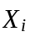 the vector of independent variables for household , and again by 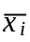 the mean income of the household (without adjustment for risk, that is with ), we estimate the following system
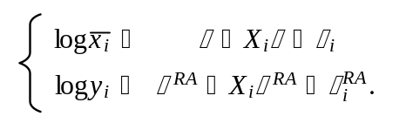(9)
From these regressions, it is straightforward to compute the probability of being poor using either the standard or the risk-adjusted measures of adult equivalent income (for example, Ravallion and Wodon, 1999). Denoting by and 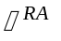 the standard deviations of the errors in the mean and risk-adjusted income regressions, and by the cumulative density of the standard normal distribution, the probability of being poor is given by
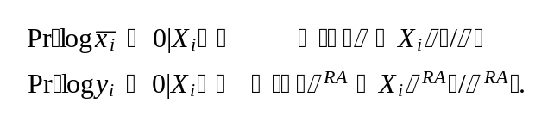(10)
Since we have the same set of independent variables, using SUR to estimate the system (9) does not change any of the coefficient estimated by separate regressions, but it enables us to test for statistically significant differences in the determinants of both measures of income. The difference in parameter estimates between the two regressions, 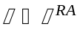 , is analogous to the estimation of a third regression for the determinants of what we might call our measure of risk:
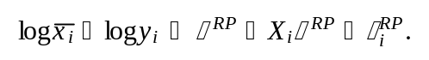(11)
The difference between (mean income) and (the certainty equivalent) is the risk premium and thus Equation (11) represents some form of a logarithmic risk premium (hence the RP superscript): a higher risk premium implies a lower level of utility, since the household would be willing to give up a higher amount of income to stabilise it. In this third regression, we have 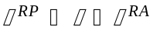 and 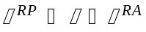 . Testing for differences in the coefficient estimates in the SUR would be equivalent to testing for the statistical significance of the parameter estimates in this third risk premium regression, with the caveat that it would not be likely to have a normally distributed error term. In this case, it is better to estimate the first two regressions and test for differences in coefficients.
A positive and statistically significant value of implies that the related independent variable contributes to an increase in the risk premium, and thereby a decrease in risk-adjusted income. Thus variables that have a positive value of are associated with higher risk, and therefore with a lower level of utility.
This provides a straightforward interpretation of the impact of various variables on risk-adjusted income and poverty. The individual regressions in Equation (9) provide an assessment of the effect of each characteristic on average income over time and risk-adjusted income, while the SUR test of differences in coefficients reveals the impact of these characteristics on the risk faced by the household.
- Application to Argentina
  - Data and descriptive results
We apply this framework to an analysis of poverty in Argentina using the Argentine Permanent Household Survey (Encuesta Permanente de Hogares-EPH). The survey is collected in urban areas every year by the Instituto Nacional de Estadísticas y Censos (INDEC) in May and October. We exploit the structure of the survey, which is a rotating panel where 25 per cent of the sample is replaced in each wave. It is possible to observe households for four waves (that is, 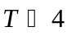 ), which corresponds to a total period of 1.5 year. We restrict our sample to households belonging to the Greater Buenos Aires area (GBA), which represents around 60 per cent of the total population of the country and 70 per cent of the urban population (and thereby of our survey sample). We use the fifteen waves corresponding to the period May 1995-May 2002.
[INSERT TABLE 1 ABOUT HERE]
In order to minimise the loss of potentially important observations, the cases with reported zero incomes that were considered valid by INDEC were assigned a symbolic value of 1 per cent of the poverty line in our analysis. This correction is necessary for computational reasons, since is not defined for 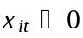 for (Equation 4) and we want to count on the same data for all values of the risk-aversion parameter. The poverty measures presented below are virtually unaffected by this procedure since we focus on the headcount index. Of almost 5500 households in the final sample, only two reported zero incomes in all four waves.
[INSERT TABLE 2 ABOUT HERE]
The fifteen EPH waves between May 1995 and May 2002 form a series of repeated cross-sections. However, the survey is collected as a rotating panel, which allows us to analyse the data in terms of cohorts, which are defined as the group of households that stay in the survey in four consecutive waves. The May 1995-May 2002 surveys result in twelve cohorts with an average of 453 households and 1812 individuals each. Table 1 presents the number of observations by wave and by cohort, and Table 2 illustrates the distinction between waves and cohorts in a rotating panel. When compared to the cross-sectional use of the data, this approach implies a loss of observations when using the panel structure. This loss is due not only to attrition (non-response in subsequent waves), but also to the criteria imposed by INDEC to consider a household's income observation as valid only if the income of every member of the household is reported. While the loss of observations is substantial (48 per cent of the households are lost), it does not seem to affect the results in an important qualitative way. This is shown in Figure 1 which illustrates the effects of the attrition in the panel. While nominal incomes are lower in the panel (by 4.5 per cent on average) versus the cross-sectional mean, the trends in income are very similar between the cross section and panel data sets. Regarding the headcounts of poverty, the average difference between the cross-sectional and panel measures is only 0.14 percentage points. Thus, although our final sample has lower incomes than the full sample, we do not expect the potential increase in poverty to invalidate our main results.
[INSERT FIGURE 1 ABOUT HERE]
Figure 2 presents the estimates of the adult equivalent income based on a cross-sectional use of the panel sample (thick broken line), as well as the risk-adjusted poverty estimates for , , , and (Cf. Equation 4). The latter is calculated for each of the twelve cohorts for which we have four observations.
[INSERT FIGURE 2 ABOUT HERE]
In terms of broad trends in income and poverty, the country was hit by contagion from the financial crisis in Mexico in 1995 (the Tequila crisis), but the economy then recovered from 1996 to 1998. Since then, however, the fall in household income was large and strongly correlated to the evolution of macroeconomic aggregates. Argentina entered a prolonged recession in the period 1999-2001, prompted by contagion from the financial crisis in Russia and South-East Asia, and by the subsequent devaluation of Brazil, its main trading partner, in 1999. This prolonged recession unfolded an unprecedented economic crisis at the end of 2001, when Argentina was forced to abandon the currency board and devaluate its currency in early 2002. All this macroeconomic fluctuations are reflected in the evolution of household income in Figure 2. Cruces and Wodon (2003a, 2003b) present a more detailed description of poverty trends and dynamics, and an analysis of transient and chronic poverty over this period, respectively.
As expected, the cross-sectional mean and the panel mean (which corresponds to with ) are very similar, but we can still observe the smoothing effect introduced by the averaging across the cohort, notably in the last observation corresponding to the 2001/2002 crisis, where there was a very large fall in cross sectional income which affected the cohort mean only partially.
Regarding the risk-adjusted measures, higher values of lead to reductions in the mean risk-adjusted income, which can be substantial as observed in the graph: going from values of to 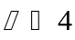 reduces log-income by more than 15 per cent.
Figures 3 and 4 provide similar information for the headcount of poverty, that is the share of the population with adult equivalent income below the poverty line, corresponding to the FGT measure with (Equation 7). The distinction between the two Figures is that one is obtained by considering waves, while the other is obtained by considering cohorts. When the analysis is done by wave, we use all households which appear in one round of the survey, say May 1998. When the analysis is done by cohort, we use all households with observations starting at a given point in time, and we follow them through time. Table 2 makes this distinction clearer. The results are fairly similar in the two Figures, one exception being the last observation (May 2002) by wave, where the cross-sectional poverty is very high due to the crisis, while the panel-based estimates are lower since the impact of the crisis is averaged out.
[INSERT FIGURE 3 ABOUT HERE]
In both Figures, we compare the cross-sectional measures (bold dashed lines) with the risk-adjusted panel-based estimates. With , the use of the mean normalised adult equivalent income over the four waves, , reduces poverty compared to the cross-sectional estimates. This is because with zero risk aversion, the smoothing effect of averaging income over time leads to lower poverty (transitory income shocks are removed by the averaging), as already pointed out for Figure 2. This smoothing effect has been known in the literature of income distribution for a long time. What we point out is that the introduction of risk aversion by increasing the value of (and thus considering the disutility from income variation) increases poverty substantially when compared to the estimates obtained using .
The net impact, that is whether the cross-sectional measure is higher or lower than the risk-adjusted and panel-based measure depends on the level of risk aversion assumed. For , the headcount of risk-adjusted poverty is similar to the cross-sectional headcount. For higher values of , however, the impact of risk aversion seems to be larger than the smoothing effect.
[INSERT FIGURE 4 ABOUT HERE]
What might be a realistic value for ? As noted in Makdissi and Wodon (2003), while Arrow (1971) has argued on theoretical grounds that should be around , Friend and Blume (1975) have presented empirical evidence based on portfolio holdings that the coefficient may be around , Hildreth and Knowles (1982) have obtained estimates between and , and Mehra and Prescott (1985) have used 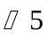 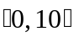 . Cowell and Gardiner (1999) describe different sources and methodologies, as well as a detailed description of the role of risk-aversion in social valuation and its connection with welfare economics. They mention the value of 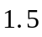 which is used by the UK's Treasury for the government's appraisal and evaluation of projects. For poverty measurement, given the difficulty of surviving with very limited income, a value of would not sound unrealistic, in which case cross-sectional estimates would lead to an underestimation of poverty.
  - Regression analysis
From a policy perspective, the more interesting results are those obtained from the regression analysis of the determinants of (log) income and risk-adjusted income. The independent variables included in the regressions include (a) household level variables, including the number of babies, children, adults, and elderly household members, and the square of their values, whether the household head has a spouse, whether the household head is a woman, the age of the head and its aged squared, and his/her migration status in the last five years; (b) characteristics of the household head, including his/her level of education (where the omitted category is incomplete primary or no formal education); whether he/she is unemployed or inactive (with employed as the omitted category); whether he/she is an employer, a self-employed worker, an informal worker, or a wage earner (omitted); the type of his/her qualification (omitting the no qualification category), and whether he/she works in the public sector; and (c) the same set of characteristics for the spouse of the household head, when there is one. All these variables correspond to the initial conditions, that is, the values of the first observation for each household. In addition, we include controls for each of the cohorts, excluding the first one: given the degree of macroeconomic volatility over the 1995-2002 period, described in the previous Section, each cohort has been subject to different aggregate shocks, and these controls aim to capture their effects.
[INSERT TABLE 3 ABOUT HERE]
Table 3 provides summary statistics of the variables used in the estimation. The sample mean of the logarithm for the average normalised income over time without risk aversion is 0.754 (corresponding to a mean income of 2.13 times the poverty line), while the average logarithm of income with is 0.549 (corresponding to a mean income of 1.73 times the poverty line). This suggests that assuming as the coefficient for risk aversion results in a drop of income of almost 20 per cent. The interpretation of the other variables presented in Table 3 is straightforward: most of the variables are indicators, so that the mean represents the share of the sample population with those characteristics.
Table 4 presents the results of the regression analysis of the system (9) by SUR in the first two columns, using the risk-adjusted income with a value of , as well as tests for statistically significant differences in the parameter estimates of the two models in the third column (corresponding as explained above to Equation 11). Consider the first column of the table which corresponds to the logarithm of mean income over time without risk aversion ( ). The results are fairly intuitive. A higher household size (whether through more infants, children, or adults) tends to reduce the expected adult equivalent income, but the impact is decreasing at the margin. In the case of elderly members, the impact on income without risk aversion is not statistically significant. However, part of the impact of being elderly may be captured through the inactivity indicators for the household head or spouse, which have a negative impact on mean income. Households with older and/or female heads tend to be richer, though the coefficient on female heads is only significant at the 10 per cent level. There seems to be no statistically significant impact from the head being a recent migrant.
[INSERT TABLE 4 ABOUT HERE]
In addition to being inactive, being unemployed reduces the expected income for both the head and the spouse, but being an employer or self-employed worker does not have a statistically significant impact, again for both the head and the spouse (the signs of the coefficients are as expected, given that the excluded category is a wage earner). However, much of the impact of being self-employed may be picked up by the negative and statistically significant coefficient for the informal worker indicator for both the head and the spouse (we use the definition of informality proposed by the International Labour Organization for Argentina).
A higher job qualification of the head (at the professional level) or the spouse (at each of the three levels considered) has a positive impact on the expected income of the household, as do the education levels of the head and the spouse, with higher levels of education correlated with progressively higher household income. Being in the public sector reduces expected income in the case of the head of household (for the spouse, the impact is also negative but not statistically significant). Only the three cohorts indicators, corresponding to the period October 1999-May 2002, are associated with negative and statistically significant coefficients, reflecting the progressive deepening of the recession. In a nutshell, the data confirm the rather obvious hypothesis that richer households are smaller, better educated, with employed heads or spouses in better quality jobs.
The most interesting results are related to the impact (or lack thereof) of the same independent variables on risk, and thereby on risk-adjusted income. Rather than discussing the parameters obtained in the second column of Table 4, which are very similar to shose of the first column, it is easier to directly proceed to the results for the tests of statistically significant differences in the coefficients of the two models, which are presented in column 3. If the difference is found to be not significant, it implies that the independent variable has the same effect (or lack of effect) in both mean income and risk-adjusted income. However, a significant difference implies that the independent variable has a differential effect on the two dependent variables, or, in other words, it has an effect on risk. As explained in the methodological Section, the test of differences in coefficients can also be interpreted as a regression with the logarithmic risk premium as the dependent variable (Equation 11). In that context, a negative value of the difference represents a negative effect of the variable on the risk premium, while a positive value implies a higher risk premium (and thus a lower utility for the household).
Regarding the structure of the household, only the presence of adults aged 65 and over seems to affect significantly the household's level of risk. The negative difference in column 3 implies that the risk-adjusted adult equivalent income is higher than the mean income when the household has elderly members. This can probably be explained by the fact that the elderly often receive a steady stream of income (from pensions or capital assets), and consequently experience less income variability than other age groups, even though their income level may be lower, as discussed earlier.
There seems to be no statistically significant impact of the age or gender of the head on risk. However, other characteristics of the household head do appear to have an impact. First, if the head has migrated to the GBA region (from other provinces in Argentina or from other countries) in the last five years, the household appears to suffer more from risk than otherwise. Thus, even if there are no statistically significant differences in mean income between migrants and non-migrants after controlling for human capital, recent migrants may be more exposed to income risk, perhaps because they do not have good support networks.
For both the head and the spouse, being unemployed increases risk over and above its negative impact on income. For the head, informality (in the current job, or in the last job if unemployed) also increases risk, and thereby reduces the risk-adjusted income of the household. A higher level of education reduces risk, so that those with little education suffer not only from a lower mean income, but also from higher income variability. Said differently, investments in human capital seem to pay off not only in terms of returns, but also in terms of income stability.
Finally, two cohorts indicators have a positive and significant effect on risk. This is the case for the last cohort indicator, which is due to the large fall in real incomes induced by the devaluation of January 2002 (see Figure 2). The other cohort indicator with a positive effect on risk is the one for the period 1996-1997. This is probably due to the aftermath of the Tequila crisis and of the recovery, which led households in this cohort to experience large levels of income variability.
[INSERT TABLE 5 ABOUT HERE]
The regressions in Table 4 are based on risk-adjusted income with since, as discussed above, this value was found to be reasonable and within the boundaries in the literature. The analysis of income and poverty aggregates, however, was done with different values of the risk aversion parameter, and Table 5 presents the correspondent robustness check of the regression analysis for 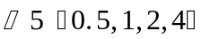 . It is not necessary to emulate the structure of Table 4, since the first column (the regression of log average income) is the same in all cases: Table 5 only presents the equivalent of the third column of Table 4, the difference in the parameters for average and risk-adjusted income, for each value of . The results in Table 5 are reassuring in terms of the robustness of those in Table 4. With the exception of the education variables of the spouse, all the variables that were found to have a significant effect on risk with in Table 4 are also relevant for the other values of considered. While there are differences in the magnitude of these effects, their statistical significance is markedly similar.
Finally, these results can be complemented by those comparing them with those obtained with Jalan and Ravallion's (2000) determinants of chronic - transient poverty, which are fully discussed in Cruces and Wodon (2003b). As noted in Section 2.1, while our methodology concentrates on the variability of income and the effects of risk, Jalan and Ravallion's (2000) contribution deals with the chronic and transient components of poverty and their determinants. Using the same dataset as in this paper, the main findings of Cruces and Wodon (2003b) are that households with young heads have lower levels of chronic poverty but higher levels of transient poverty, which complements our finding of reduced risk for households with elderly members. Being an employer was found to increase transient poverty and not affect its chronic component, and the same was found for households with a self-employed spouse, which is not reflected in an effect on risk in our Tables 4 and 5. The effects of the employers and the self employed indicators on transient and chronic poverty can be complemented with the high and strongly significant impact on risk of the informal workers (Table 4). Finally, Cruces and Wodon (2003b) find that the cohort indicators captured an increase in chronic poverty throughout most of the period and an increase in transient poverty for the last three cohorts. In the results presented in Table 4, besides the reduction in income in the 1999-2001 recession, the cohort indicators clearly captured the increase in risk caused by the 2002 crisis.
- Conclusion
In this paper, we have presented a simple and intuitively appealing methodology to incorporate the disutility arising from income variability in the measurement of poverty. It is based on the intuition that households will prefer a steady stream of income to a variable one with the same mean. The methodology was applied to household panel data from Argentina for the period 1995-2002. Averaging income data over time at the household level may reduce poverty measures by mitigating the impact of negative shocks, but this effect tends to be more than offset when the disutility from income fluctuations is taken into account by introducing risk aversion into the measurement of income. A regression analysis of the determinants of risk-adjusted income reveals that risk is not uniform across households. Households with better educated members are not only richer, but also experience lower levels of income variability. Households with recent migrants, as well as households with informal workers and/or unemployed or inactive members tend to suffer more from risk than other types of households. Households with elderly members tend to suffer less from income variability. At the broader macro-economic level, as expected, a crisis tends not only to reduce income levels, but also to increase risk, which magnifies the overall negative impact on poverty. One next step for this analysis could be to relax some of the assumptions made for taking into account the risk aversion of households, for example by testing for the sensitivity of the results to different parameters of risk aversion or to different underlying utility functions.

Endnotes

- References
Arrow, K.J. (1971) Essays in the Theory of Risk-Bearing, Horth-Holland, Amsterdam.
Baulch, B. and J. Hoddinott (2000) Economic Mobility and Poverty Dynamics in Developing Countries. Journal of Development Studies, 36(6):1-24.
Baulch, B. and N. McCulloch (2000) Simulating the Impact of Policy upon Chronic and Transitory Poverty in Rural Pakistan. Journal of Development Studies, 36(6):100-130.
Blundell, R. and I. Preston (1998) Consumption Inequality and Income Uncertainty. Quarterly Journal of Economics, 113(2): 603-640.
Chaudhuri, S., J. Jalan and A. Suryahadi (2002) Assessing Household Vulnerability to Poverty from Cross-sectional Data: A Methodology and Estimates from Indonesia, Discussion Paper # 0102-52, Columbia University, Department of Economics, New York.
Cowell, Frank A. and K. A. Gardiner (2000) Welfare Weights. OFT Economic Research Paper, 202, Office of Fair Trading, London.
Cruces, G. and Q. Wodon (2003a) Argentina's Crises and the Poor, 1995-2002. Económica, 49 (1-2) La Plata, Argentina. Also available as STICERD-DARP Working Paper 71.
Cruces, G. and Q. Wodon, (2003b) Transient and Chronic Poverty in Turbulent Times: Argentina 1995-2002. Economics Bulletin, Vol. 9, No. 3, pp. 1-12.
Cruces, G., P. Makdissi and Q. Wodon (2004) Poverty Measurement under Risk Aversion using Panel Data. Contributions to Economic Analisys & Policy 3(1) Article 13.
Dabalen, A. and N. Poupart (2002) Vulnerability to Rainfall Shock in Ethiopia, Paper presented at the IFPRI-World Bank Conference on Risk and Vulnerability: Estimation and Policy Implications, Washington, D.C., September 23-24, 2002.
Dercon, S. and P. Krishnan (2000) Vulnerability, Seasonality and Poverty in Ethiopia, Journal of Development Studies, 36(6):25-53.
Epstein, L. G. and Zin, S. E.(1989) Substitution, Risk Aversion and the Temporal Behavior of Consumption and Asset Returns: a Theoretical Framework. Econometrica, 57(4) 937-969.
Fiszbein, A., P. Giovagnoli, and I. Aduriz (2003) Argentina's Crisis and its Impact on Household Welfare. CEPAL Review, 79, 151--168.
Foster, J., J. Greer, and E. Thorbecke (1984) A Class of Decomposable Poverty Measures. Econometrica, 52:761-65
Friend, I. and M.E. Blume (1975) The Demand for Risky Assets. American Economic Review, 65:900-922.
Gunning, J.W., J. Hoddinott, B. Kinsey and T. Owens (2000) Revisiting Forever Gained: Income Dynamics in the Resettlement Areas of Zimbabwe, 1983-96. Journal of Development Studies, 36(6):132-154.
Hildreth, C. and G.J. Knowles (1982) Some Estimates of Farmers Utility Functions, Technical Bulletin 335, Agricultural Experimental Station, University of Minnesota.
Hulme, D. and A. Shepherd (2003) Conceptualizing Chronic Poverty. World Development 31(3) 403--423.
INDEC (2002) Incidencia de la Pobreza y de la Indigencia en los Aglomerados Urbanos -- Mayo 2002, Informacion de Prensa, ISSN 0327-7968, Buenos Aires.
Jalan, J. and M. Ravallion (1999) Are the Poor Less Well Insured? Evidence on Vulnerability to Income Risk in Rural China. Journal of Development Economics, 58:61-81.
Jalan, J. and M. Ravallion (2000) Is Transient Poverty Different? Evidence for Rural China. Journal of Development Studies, 36(6): 82-99.
Kurosaki, T. (2003) Measurement of Chronic and Transient Poverty: Theory and Application to Pakistan, Institute of Economic Research, Hitotsubashi University.
Leland, H. (1968) Saving and Uncertainty: the Precautionary Demand for Savings. Quaterly Journal of Economics 82(3).
Ligon, E. and L. Schechter (2003) Measuring Vulnerability. Economic Journal, 113(486) c95-110.
Makdissi, P. and Q. Wodon (2003) Risk-Adjusted Measures of Wage Inequality and Safety Nets. Economics Bulletin, Vol. 9, No. 1 pp. 1-10.
Mansuri, G. and A. Healy (2002) Vulnerability Prediction in Rural Pakistan, Paper presented at the IFPRI-World Bank Conference on Risk and Vulnerability: Estimation and Policy Implications, Washington, D.C., September 23-24, 2002.
McCulloch, N., and B. Baulch (2000) Simulating the Impact of Policy Upon Chronic and Transitory Poverty in Pakistan. Journal of Development Studies 36, 100-130.
Mehra, R. and E.C. Prescott (1985) The Equity Premium. Journal of Monetary Economics, 15:145-161.
Morales, E. (1988) Canasta Básica de Alimentos - Gran Buenos Aires, Documento de trabajo nº 3. INDEC / IPA, Buenos Aires.
Newbery, D. M. and J. E. Stiglitz, (1981) The Theory of Commodity Price Stabilization. Clarendon Press, Oxford.
Ravallion, M. (1988) Expected Poverty under Risk-induced Welfare Variability. Economic Journal, 98:1171-1182.
Ravallion, M. and Wodon, Q. (1999) Poor Areas or Only Poor People? Journal of Regional Science, 39:689-711.
Scott, C. (2000) Mixed Fortunes: a Study of Poverty Mobility among Small Farm Households in Chile, 1968-1986. Journal of Development Studies, 36(6):155-180.
Skoufias, E. and A. Quisumbing (2002) Consumption Insurance and Vulnerability to Poverty: A Synthesis of the Evidence from Bangladesh, Ethiopia, Mali, Mexico and Russia, Paper presented at the IFPRI-World Bank Conference on Risk and Vulnerability: Estimation and Policy Implications, Washington, D.C., September 23-24, 2002.
World Bank (2000) Argentina: Poor People in a Rich Country. Report No. 19992-AR, Washington, DC.
World Bank (2001a) World Development Report 2000-2001: Attacking Poverty. Oxford University Press, Oxford.
World Bank (2001b) Household Risk, Self-Insurance and Coping Strategies in Urban Argentina, Report No. 22426-AR, Washington DC.

- Tables and Figures

Table 1: Sample size in cross-section and panel data sets
Wave | Original Sample | Final Sample | Cohort | Number of Observations | Number of Households
May-95 | 3463 | 418 | 95-1/96-2 | 1672 | 418
Oct. 95 | 3436 | 879 | 95-2/97-1 | 1844 | 461
May-96 | 3459 | 1322 | 96-1/97-2 | 1772 | 443
Oct. 96 | 3369 | 1774 | 96-2/98-1 | 1808 | 452
May-97 | 3424 | 1815 | 97-1/98-2 | 1832 | 458
Oct. 97 | 3423 | 1843 | 97-2/99-1 | 1960 | 490
May-98 | 3549 | 1899 | 98-1/99-2 | 1992 | 498
Oct. 98 | 3567 | 1923 | 98-2/01-1 | 1904 | 476
May-99 | 3551 | 1938 | 99-1/00-2 | 1892 | 473
Oct. 99 | 3494 | 1870 | 99-2/01-1 | 1692 | 423
May-00 | 3528 | 1822 | 00-1/01-2 | 1800 | 450
Oct. 00 | 3521 | 1750 | 00-2/02-1 | 1616 | 404
May-01 | 3473 | 1277
Oct. 01 | 3453 | 854
May-02 | 3505 | 404
Source: Authors' estimation based on EPH, 1995-2002 (INDEC, 2002).

Table 2: Two ways of looking at the panel data: Cohorts and waves
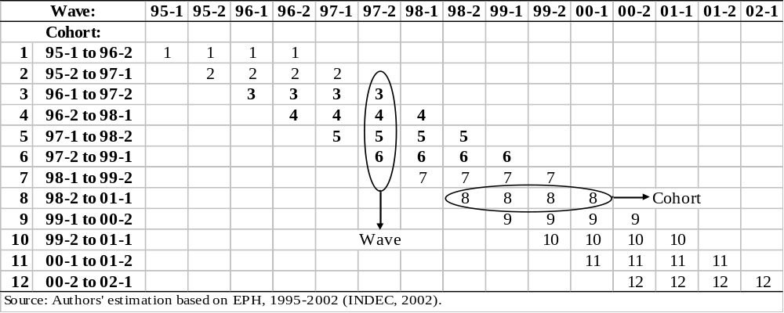
Table 3: Summary statistics for the dependent and independent variables
Variable | Mean | Std. Dev. | Min | Max
Log of Average Income | 0.754 | 0.844 | -4.610 | 3.951
Log of Risk Adjusted Income, ρ=0.5 | 0.720 | 0.866 | -4.605 | 3.946
Log of Risk Adjusted Income, ρ=1 | 0.669 | 0.921 | -4.605 | 3.942
Log of Risk Adjusted Income, ρ=2 | 0.549 | 1.129 | -4.605 | 3.933
Log of Risk Adjusted Income, ρ=4 | 0.441 | 1.251 | -4.605 | 3.915
Number of infants 0-5 | 0.349 | 0.693 | 0 | 6
Number of children 6-14 | 0.543 | 0.922 | 0 | 8
Number of youth 15-24 | 0.586 | 0.907 | 0 | 6
Number of adults 25-64 | 1.552 | 0.940 | 0 | 6
Number of elderly 65+ | 0.395 | 0.677 | 0 | 4
Age of the head | 51.002 | 16.061 | 15 | 96
Share of female headed households | 0.242 | 0.428 | 0 | 1
Head is recent migrant | 0.026 | 0.159 | 0 | 1
Head inactive | 0.279 | 0.449 | 0 | 1
Head unemployed | 0.069 | 0.254 | 0 | 1
Head as employer | 0.032 | 0.177 | 0 | 1
Head as self-employed | 0.143 | 0.351 | 0 | 1
Head as informal worker | 0.232 | 0.422 | 0 | 1
Head in public sector | 0.082 | 0.274 | 0 | 1
Head as operative (qualification) | 0.350 | 0.477 | 0 | 1
Head as technical worker (qualification) | 0.112 | 0.315 | 0 | 1
Head as professional worker (qualification) | 0.068 | 0.252 | 0 | 1
Head with primary education - Complete | 0.345 | 0.475 | 0 | 1
Head with secondary education - Incomplete | 0.177 | 0.382 | 0 | 1
Head with secondary education - Complete | 0.143 | 0.350 | 0 | 1
Head with superior education - Incomplete | 0.008 | 0.090 | 0 | 1
Head with superior education - Complete | 0.026 | 0.158 | 0 | 1
Head with university education | 0.146 | 0.353 | 0 | 1
No spouse in the household | 0.306 | 0.461 | 0 | 1
Spouse inactive | 0.418 | 0.493 | 0 | 1
Spouse unemployed | 0.048 | 0.215 | 0 | 1
Spouse as employer | 0.007 | 0.081 | 0 | 1
Spouse as self-employed | 0.056 | 0.229 | 0 | 1
Spouse as informal worker | 0.103 | 0.303 | 0 | 1
Spouse as operative (qualification) | 0.066 | 0.249 | 0 | 1
Spouse as technical worker (qualification) | 0.050 | 0.218 | 0 | 1
Spouse as professional worker (qualification) | 0.026 | 0.159 | 0 | 1
Spouse in public sector | 0.044 | 0.206 | 0 | 1
Spouse with primary education - Complete | 0.252 | 0.434 | 0 | 1
Spouse with secondary education - Incomplete | 0.115 | 0.319 | 0 | 1
Spouse with secondary education - Complete | 0.119 | 0.324 | 0 | 1
Spouse with superior education - Incomplete | 0.010 | 0.097 | 0 | 1
Spouse with superior education - Complete | 0.034 | 0.182 | 0 | 1
Spouse with university education | 0.071 | 0.257 | 0 | 1
Source: Authors' estimation based on EPH, 1995-2002 (INDEC, 2002).

Table 4: Determinants of log adult equivalent income and log risk-adjusted income
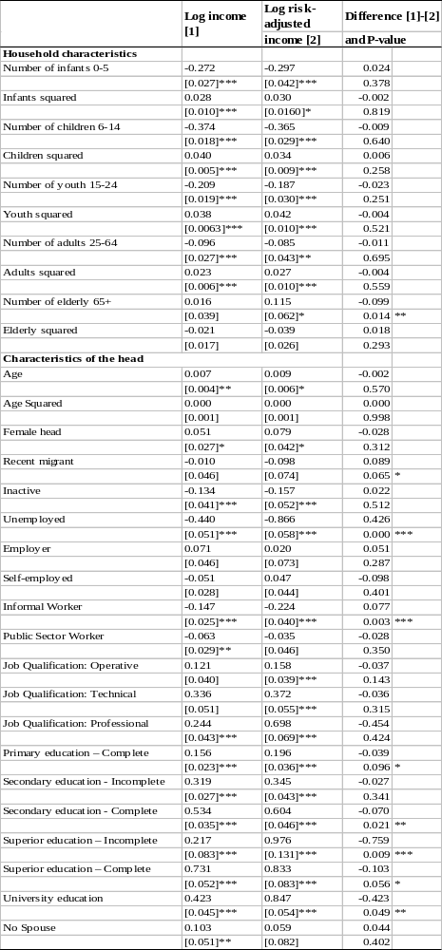
Table 4 (continued)
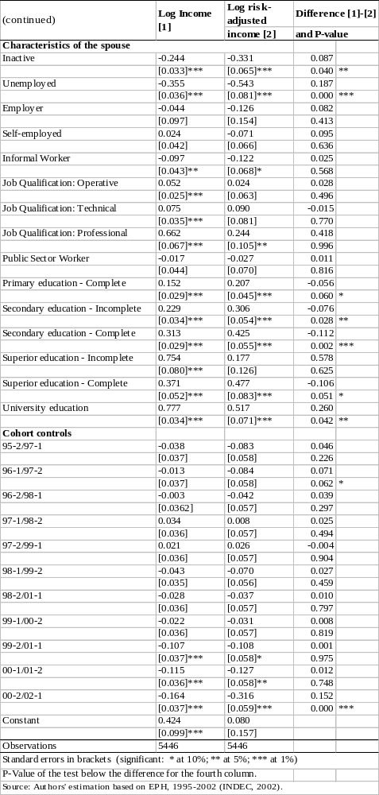
Table 5: Difference in coefficients of determinants of log adult equivalent income and log risk-adjusted income, ρ={0.5,1,2,4}
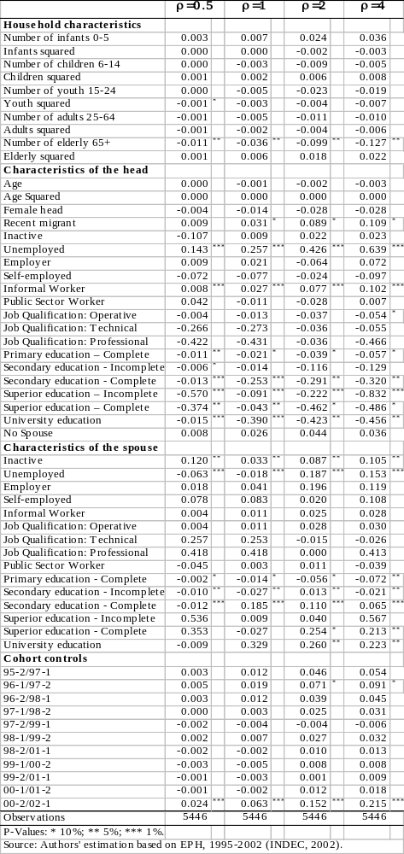
Figure 1: Complete Sample and Panel Sub-Sample, GBA 1995-2002
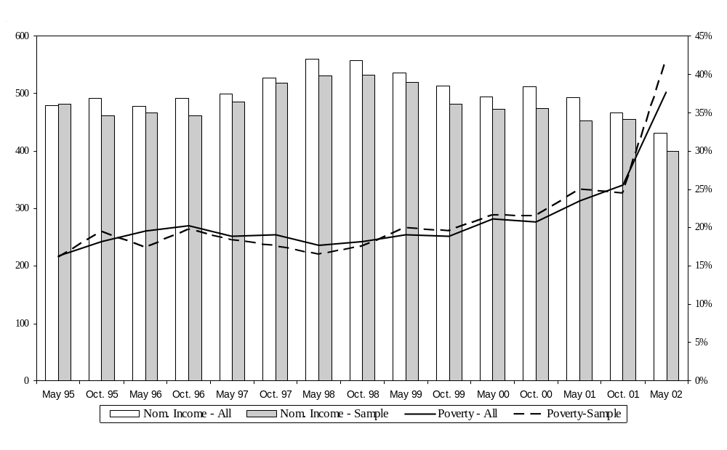

Figure 2: Risk Adjusted Normalised Income, GBA, 1995-2002
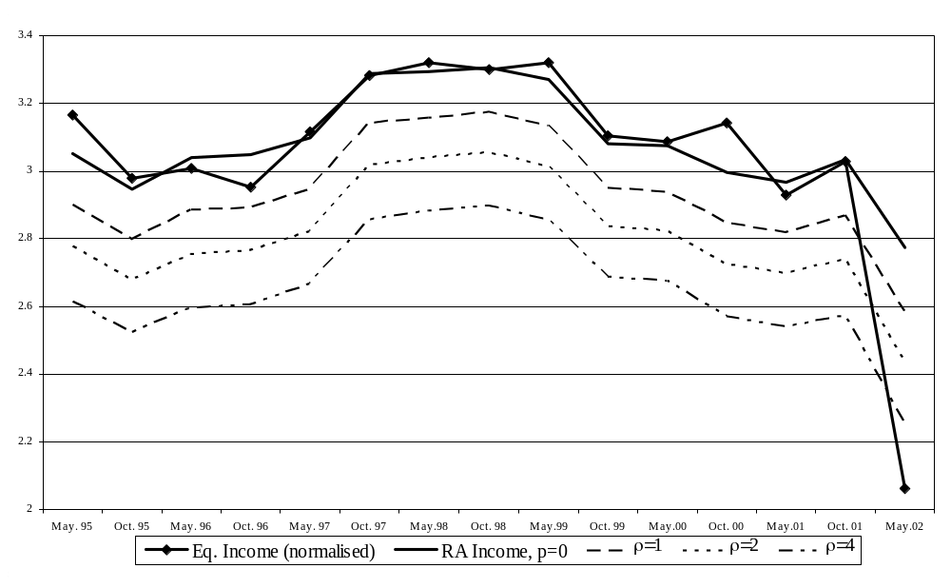
Figure 3: Risk Adjusted Measures of Poverty by Wave, GBA, 1995-2002
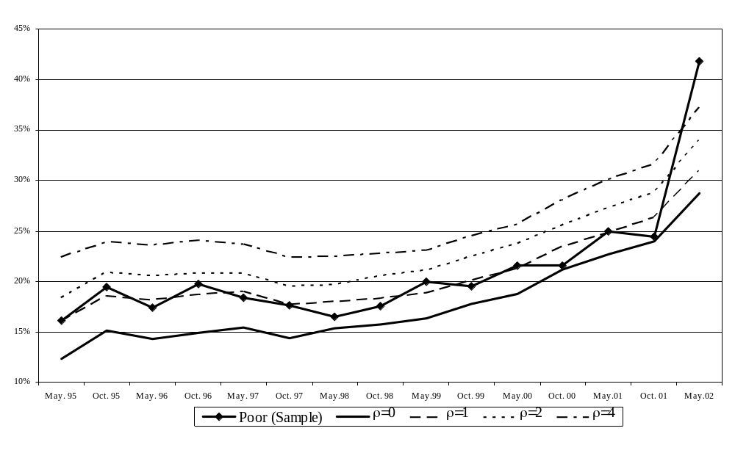

Figure 4: Risk Adjusted Measures of Poverty by Cohorts, GBA, 1995-2002
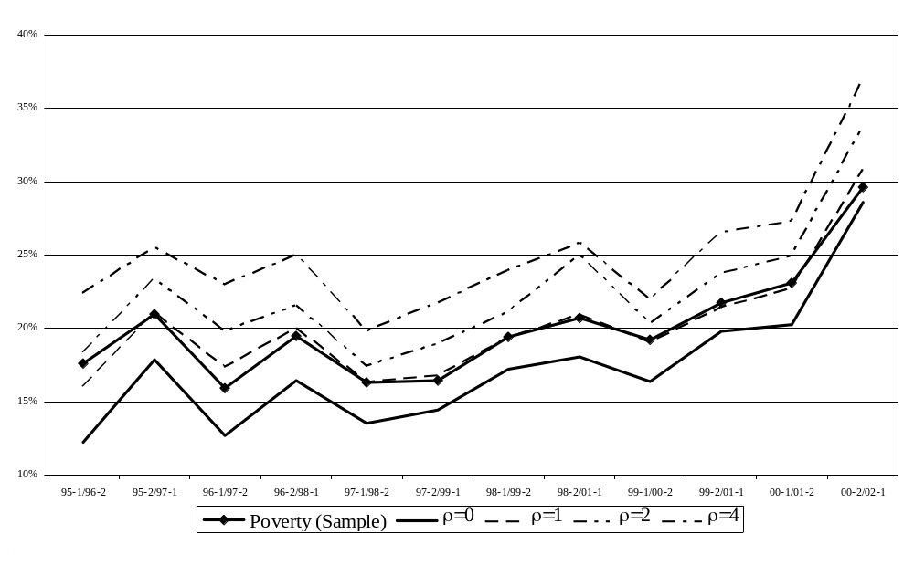

Additional works were presented at a workshop on this topic at the International Food Policy Research Institute, among others by Chaudhuri, Jalan and Suryahadi (2002), Christiaensen and Subbarao (2001), Dabalen and Popuart (2002), Ligon and Schechter (2003), Mansuri and Healy (2002), Skoufias and Quisumbing (2002), as well as the present paper. See also a special edition of World Development (Hulme and Shepherd, 2003).
There are exceptions to this. For example, Ligon and Schechter (2003) present a model of vulnerability based on an explicit welfare criteria.
It would be better to use consumption data for the empirical work, because this would enable us to better factor-in ex post some of the smoothing strategies used by households to offset risk. Unfortunately, there are no consumption panel datasets for Argentina, and we therefore use the available income data. This probably implies that our estimates for the impact of risk on poverty represent an upper bound, since consumption is typically less volatile than income. On the other hand, our data already factors in some of the behavioral responses of households to deal with risk. For instance, some households may increase their labour force participation to offset income losses, and this will be captured by the variable used to measure income over time.
For previous work on poverty and risk in Argentina at the World Bank, see World Bank (2000, 2001b).
There are, of course, more complicated models of utility under uncertainty. For instance, given the focus in this paper on uncertainty over time, the class of functions defined by Epstein and Zin (1989) disentangle the coefficient of risk aversion from the elasticity of intertemporal substitution. However, the simple setup of this Section is motivated by the need of empirical tractability.
An anonymous referee pointed out that our measure, being based solely on monetary income, ignores non-monetary income sources which might be important among the urban poor, especially during times of high inflation. While this is a limitation of our data (and of household surveys in general), the evidence presented in Fiszbein et al. (2003) shows that non-monetary income sources played a relatively marginal role during the 2001-2002 crisis in Argentina. Specifically, barter deals, while significant, did not play an important part in household consumption. Moreover, since rural property is highly concentrated, there is no evidence of systematic inkind transfers from relatives in rural areas. Fiszbein et al.'s (2003) detailed results on coping strategies are complementary to our approach.
We adopt the same equivalent adult scale as INDEC, the Argentine statistical agency, to ensure comparability with other studies. The weights are obtained from a normative calory intake basket of goods. Male adults are represented by a weight of 1, with different values according to gender and age groups. Morales (1998) and Cruces and Wodon (2003a) provide a detailed account of these parameters.
Kurosaki (2003) presents an in-depth study of the sensitivity of the transient - chronic approach to the underlying poverty measure. He makes an interesting parallelism between the FGT measures traditionally used in this approach and quadratic utility functions, claiming that the Clark-Watts family of measures is more appropriate since it is akin to a CRRA utility function.
We owe this point to an anonymous referee.
As shown below, when using poverty based on average income over time, the measure is reduced with respect to cross-sectional figures, because income shocks are averaged over time. The parameter of risk aversion introduces a penalty for variability, and so comparing poverty rates with (corresponding to average income) and captures the degree of poverty that is due to variability.
Note that the large difference for the last wave is a consequence of the lower number of observations for the first and last waves (see Table 2).
All risk adjusted and average measures of poverty in Figures 3 and 4 are significantly different from zero at the 5 per cent level (but note that the differences in risk-adjusted incomes for consecutive values of are only significant at the 10 per cent level in Figures 1 and 2). The confidence intervals of the headcount measures with different values of and the poverty measures (using the 5446 observations from all waves, available upon request) can be used to support the results pointed out in the text: all risk adjusted and average measures of poverty are statistically different between them at the 5 per cent level. Poverty rates computed with the average income ( ) is smaller than poverty based on current income, but it raised when considering values of . However, only after the risk adjusted poverty measures are clearly above those based on the current income measure.
A referee pointed out that education and qualification measures might be higly collinear. The correlation matrix, however, indicates a relatively low level of 0.46 between professional qualifications and higher education, all other coefficients being lower. The empirical results were not substantially affected by removing either group of variables from the regression.
Note that we do not include in the regressors changes in the right-hand side variables over time, such as changes in unemployment status, because we do not attempt to model the behavioral response of households to shocks at this stage. Such a detailed analysis is beyond the scope of this paper. Here, we limit our analysis to the impact of the initial conditions on risk-adjusted measures of income poverty.

