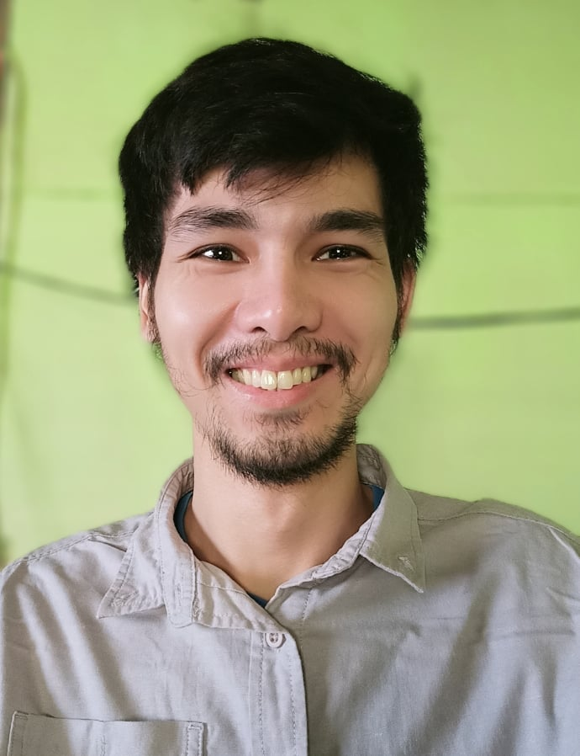

**Gene Christian Somoza**

Full Stack Web Developer

Sitio Santolan, Pallocan West, Batangas City

+63 998 290 0769

somozagenechristian@gmail.com

**Skills**

HTML, CSS, Javascript,

SASS, Jquery, Vue.js,

Node.js, PHP, Laravel,

MySql, SqLite, Git

**Social**

Github

github.com/gcsomoza

Website

gcsomoza.github.io

**Career Profile**

Senior Web Developer with 7 years experience developing and implementing web technology solutions. Writes clean, reusable, and maintainable code that is suitable for collaboration with other programmers in the team.

**Professional Experience**

* **Jan 2018 – Present**

**Vanriix International — Web Application Developer**

Responsible in developing web applications needed by our clients.

* **Nov 2013 – Dec 2017**

**Integrity Net — Software Developer**

Responsible in developing in-house applications and providing technical support for its users.

* **May 2011 – Sep 2013**

**Maxbank — Jr. Database Administrator**

Responsible in performing regular database backup, maintaining network devices and core banking applications, and providing technical support for its users.

**Education**

* **Batch 2007 – 2011**

**University of Batangas — BSCS**

Bachelor of Science in Computer Science