**Concept Proposal Submitted to the Northwest Potato Research Consortium**

**Title: Automated identification of plant-parasitic nematodes of potato at genus and species level**

**Year Initiated: 2022-23. Current Year: 2022-23. Terminating Year: 2024.**

**Personnel & Cooperators:**

PIs involved include David Linnard Wheeler and Cynthia Gleason from Washington State University, Inga Zasada from the USDA-ARS, and Sam Chavoshi from Agnema. Sudha GC Upadhaya is a graduate student working with Dr. Wheeler. Both PIs from WSU will request funding.

**Funding Request for 2022-23: $75,000**

**Introduction: Problem Statement, Research Question(s) & Justification:**

Effective management of plant parasitic nematodes requires early and accurate identification and quantification in each field. Current nematode diagnosis relies heavily on morphology-based identification methods which demand highly skilled personnel and are time consuming. Similarly, molecular marker-based methods tend to be cost and resource intensive and are not available for all plant parasitic nematodes.

To help resolve this problem, we need a fast, accurate and efficient nematode identification tool. Such tools are reliably developed in various domains, from biomedicine to entomology, with machine learning algorithms (Martineau et al. 2017; McKinney et al. 2020). Most recently, a research group in Florida was funded to develop an identification tool for plant parasitic nematodes that affect citrus (Buck 2021). We propose to develop a similar tool for nematodes that affect potato, like *Pratylenchus, Meloidogyne, Paratrichodorus, Trichodorus,* and *Globodera* spp. (Hills et al. 2020).

For this project, machine learning algorithms will be developed to identify common plant parasitic nematodes genera and species associated with potato production. Models will be built and trained on a large number of raw images of different nematode genera and species. The algorithms will learn to associate diagnostic features, like morphology, texture etc., with species of plant parasitic nematodes from each image. Once trained, model performance will be validated on previously unseen images. In the long term, these models will be developed into an online tool for the automated detection and quantification of plant parasitic nematodes that threaten the potato industry. Such a tool will enable stakeholders to make faster and more informed plant disease management decisions.

**Goal(s), Hypothesis, & Objectives**:

The objectives of this study are to (i) acquire microscopic images of common plant parasitic nematodes of potato and identify (ii) six nematode genera and (iii) three *Meloidogyne* species with machine learning algorithms.

For objective 1, pure cultures of each nematode genus and species will be produced in the lab. Next, soil will be collected from potato fields in WA, ID and OR. Nematode extraction will be completed with standard procedures (**Fig 1a**). Nematodes from pure culture and those extracted from soils will then be imaged. In total, images from six nematode genera including *Pratylenchus* spp. (n = 1000), *Meloidogyne* spp. (n = 1000), *Globodera* spp. (n = 1000), *Paratrichodorus* spp., (n = 1000), *Trichodorus* spp. (n = 1000), and *Helicotylenchus* spp. (n =1000) will be captured with a microscope at 200/100X magnification (**Fig 1b**). Non-parasitic nematodes (n = 2000) will also be imaged and serve as a control group. In addition, images of three root-knot nematode species, *Meloidogyne hapla* (n = 1000), *M. chitwoodi* (n = 1000) and *M. incognita* (n = 1000) will also be acquired (**Fig 1b**). Captured images will include both full and partial (head and tail) body parts of juvenile/adult nematode. Both PIs will complete objective 1.

For objective 2 and 3, images will then be labelled with the correct genus names and, species names for *Meloidogyne* sp. and used as an input for machine learning algorithms (**Fig 1c**). Two separate machine learning algorithms will be developed and validated for genus and species level classification problems (**Fig 1d**). The best models will be selected using accuracy, true positive, and true negative scores for each nematode genus and *Meloidogyne* species (**Fig 1e**). Finally, the image analysis pipeline will be developed in open-source programming language and will be published online.

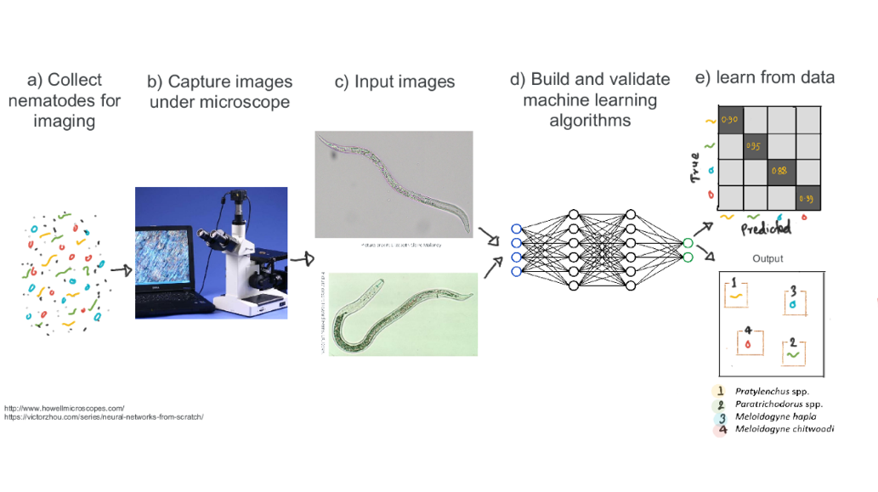

**Figure 1.** Flow chart of experiment

Anticipated outcomes of this research include development and validation of machine learning algorithms for automated identification of (i) six important plant-parasitic nematode genera and (ii) three root-knot nematode species.

**Collaboration:** DL Wheeler and S GC Upadhaya will perform image preprocessing, develop, and optimize machine learning algorithms, and run analysis. C. Gleason, I Zasada, and S. Chavoshi will capture the microscopic images of plant parasitic nematodes.

**Additional grant funding:** This project will serve to generate preliminary data for larger grants, like Washington State Department of Agriculture’s Specialty Crop Block Grant and USDA-NIFA Agriculture and Food Research Initiative (AFRI). The proposal will be scaled up to develop open-source platform for automated identification as well as quantification of plant parasitic nematodes.