**Title**

**Authors**

David Linnard Wheeler*1, Sudha GC Upadhaya1, Jeness Scott2,

Jeremiah Kam Sung Dung2, and Dennis Allen Johnson1

1. Department of Plant Pathology, Washington State University,

Pullman, WA, USA

2.Department of Botany and Plant Pathology, Oregon State University, Madras, OR, USA

**Correspondence:**

David L. Wheeler

Tel: 1+ (215) 880-3024

david.wheeler@wsu.edu

|  |  |
| --- | --- |
| **Section** | **Word count** |
| Main body (without abstract, references & legends) |  |
| Abstract |  |
| Introduction |  |
| Materials and Methods |  |
| Results |  |
| Discussion |  |
| Acknowledgements |  |
| **Figures & Tables** | **Number** |
| Number of Figures | 6 |
| Figures to be published in color | 6 |
| Tables | 4 |
| Supplementary figures | 1 |
| Supplementary tables | 6 |
| Supplementary document | 1 |

**Abstract**

The fungus *Verticillium dahliae* is an endophyte and pathogen of hundreds of plant species.The goal of this research was to characterize *V. dahliae* and host genes during symptomatic and asymptomatic infections. To accomplish this goal, we tested the null hypotheses that differences in gene expression do not exist (i) within hosts during infection with different *V. dahliae* isolates that vary in aggressiveness*,* (ii) between *V. dahliae* isolates within a host, and (iii) between *V. dahliae* isolates across symptomatic and asymptomatic hosts. Potato, peppermint, and brown mustard plants were inoculated with two isolates of *V*. *dahliae* that vary in aggressiveness. Whole plants were harvested 10 days post inoculation. Dual RNA-sequencing (RNA-seq) was completed. In total 2,214, 1588, 2,079 and 41 differentially expressed genes (DEGs) were detected from potato, peppermint, brown mustard, and *V. dahliae*, respectively*.* Of these, 12, 4, 10, and 4 genes were validated for potato, peppermint, brown mustard, and *V. dahliae* with real-time quantitative reverse transcription PCR (RT-qPCR). For both symptomatic hosts, potato and mint, at least twice as many DEGs were detected from plants inoculated with the most aggressive isolate of *V. dahliae* compared to plants inoculated with the less aggressive isolate. Of the characterized DEGs, some were associated with transcription factor activity, protein and RNA binding, and carbon fixation. For *V. dahliae*, only 2 DEGs were detected between isolates within a host. Of these genes, one was uncharacterized and one was associated with oxioreductase activity. Lastly, a total of 15 DEGs were detected between asymptomatic mustards plants and either symptomatic potato or peppermint plants. While some of these DEGs were uncharacterized, others were involved in catalytic, peptidase, oxioreductase, and hydrolase activity. This research has documented the similarities and differences in host and fungal gene expression during infection with isolates of *V. dahliae* that vary in aggressiveness.

**Introduction**

Members of the fungal genus *Verticillium* infect hundreds of plant species (Berlanger and Powelson, 2000). Isolates of the most economically destructive species of *Verticillium*, *V. dahliae* Kleb., (Pegg and Brady, 2002) can behave as both pathogens and endophytes on different hosts (Malcolm et al 2015; Wheeler et al. 2018). For example, some hosts, like brown mustard (*Brassica juncea* L.), are colonized but do not express detectable symptoms (Wheeler and Johnson, 2016). Other hosts, like potato (*Solanum tuberosum* L.) and peppermint (*Mentha* x *piperita* L.) are susceptible, express acute symptoms, and respond to infection with reductions in biomass (Dung et al. 2010; Johnson and Dung, 2010).

Successful management of these symptomatic reactions to *V. dahliae* could potentially be improved with more information about the genetic dynamics that influence symptomology. As of now, management of Verticillium wilts is difficult because *V. dahliae* produces survival structures called microsclerotia that can survive for 14 years (Wilhelm 1955), has a wide host range (Berlanger and Powelson, 2000), is sometimes (Tsror et al. 2005) but not always sensitive to soil-fumigants (Woodward et al. 2011), and resistance to the fungus is not always present in cultivars that possess other desirable traits (Johnson and Dung, 2010). Solutions to some of these management obstacles could conceivably be revealed by information about the genes that dictate biological processes in both *V. dahliae* and its hosts.

The authors are not the first to make this observation. Reports of transcriptional differences among isolates of *V. dahliae* and its hosts are abound. For example, differentially expressed genes (DEG) of *V. dahliae* isolates were detected by Duressa *et al*. 2013, Jin *et al*. 2019, and Jiménez-Ruiz *et al*. 2019 under different conditions. Similarly, DEGs from various hosts infected with *V. dahliae* have been reported by Guo *et al.* 2017, Sun *et al.* 2017, Tan *et al.* 2015. Finally, at least one study documented the transcriptomes of both *V. dahliae* and one of its hosts, *Arabidopsis*, during infection (Scholz *et al.* 2018). Thus, gene expression profiles *V. dahliae* and its symptomatic hosts have received considerable attention.

In contrast, the authors are not aware of any studies that have documented the transcriptomes of multiple *V. dahliae* isolates and asymptomatic or symptomatic hosts during infection. The goal of this research is to fill this gap. To accomplish this goal, the asymptomatic host, brown mustard, and symptomatic hosts, including potato and peppermint, were separately inoculated with one of two isolates of *V. dahliae* that varied in aggressiveness. Dual RNA-seq was subsequently completed. DEGs were detected and validated. The results documented here demonstrate that transcriptomes of hosts and isolates are mostly similar despite overt differences in symptomology and aggressiveness.

**Materials and Methods**

To test the hypotheses stated above, a dual RNA-seq trial was completed and validated with real-time quantitative reverse transcription PCR (RT-qPCR). Each trial is described below.

**RNA seq trial**

The experimental design of the dual RNA-seq trial is described in **Figure 1**. The treatment structure was a 3 x 3 completely crossed factorial design. The first factor, host, consisted of three levels: Russet Burbank potato, Black Mitchum peppermint, and brown mustard ISCI 99. Similarly, the second factor, fungus, consisted of three levels: *Verticillium dahliae* isolate 653 (highly aggressive towards potato and weakly aggressive towards peppermint), *V. dahliae* isolate 111 (highly aggressive towards peppermint and mildly aggressive towards potato), and a water control. Neither isolate elicits visible symptoms on brown mustard. Each treatment was replicated 10 times and arranged in a randomized complete block design in a greenhouse.

Seeds of brown mustard, potato plantlets, and cuttings of peppermint with 2-4 nodes were planted in Turface® (Profile Products LLC, Buffalo Grove, IL) to enable easy harvesting. Plants were fertigated with 100 ppm of 20-10-20 NPK (Peters Professional, Summerville, SC) daily until all plants emerged from the Turface. Upon emergence of all plants, the Turface was either drenched with 100ml of 1 x 106 *V. dahliae* conidia/ml or sterile distilled water. After inoculation, plants were grown under a 15 hour/day photoperiod for 10 days.

Whole plants were harvested 10 days post inoculation (dpi). Harvested plants were subsequently flash frozen in liquid nitrogen, stored at -80°C for 1 week, and lyophilized. Once dried, whole plants were ground with a mortar and pestle. RNA was extracted with a modified version of Kumar *et al.* 2007 (**Supplementary document 1**). Estimates of RNA quality and quantity were determined by fragment analysis (Advanced Analytical Technologies Inc., Ankeny, IA) at Washington State University’s Center for Reproductive Biology, Molecular Biology and Genomics Core.

Samples of 3 biological replicates from each treatment were sent to Novogene corporations (Beijing, China) for library preparation and sequencing. In short, after RNA qualification, mRNA was enriched with oligo (dT) beads, cDNA was synthesized and purified with end-repairs and the addition of poly (A) tails and ligation of adapters. Fragments were amplified and sequenced on an Illumina NovaSeq 6000 platform (Illumina, San Diego, CA).

For potato and *V. dahliae,* RNA fragments were mapped to each respective reference genome (potato: PRJNA63145; Xu *et al.* 2011; *V. dahliae*:PRJNA225532; Klosterman et al. 2011). For peppermint and brown mustard, RNA fragments were first filtered to remove reads with adapter contamination, reads comprised of 10% or more uncertain nucleotides, or reads comprised of 50% or more of low-quality nucleotides. After filtering, clean reads were assembled with Trinity (Grabherr *et al.* 2011). Redundant contigs were identified and removed with hierarchical clustering in Corset (Davidson and Oshlack, 2014). Unigenes were then selected as the longest transcript for each cluster.

Gene expression levels were determined and DEGs identified with the DESeq2 package version 1.26.0 (Love *et al.* 2014) in R version 3.6.2 (R Core Team (2019)). Reads with fewer than 1 count across samples were removed to expedite analysis. Contrasts between hosts within an isolate of V. *dahliae* and between isolates within a host were calculated after log fold change shrinkage (LFC) with the lfcShrink() function in R. *P-*values were adjusted to *q*-values = 0.001 to control for the False-Discovery Rate (FDR).

Gene expression levels for potato and *V. dahliae* were determined with the expected fragments per kilobase of transcript per million fragments mapped (FPKM) (Trapnell *et al.* 2010). For peppermint and brown mustard, the abundance of reads were estimated with RNA-seq by Expectation-Maximization (RSEM) with Bowtie 2 (Langmead *et al.* 2012). FPKM was then used to calculate expression gene expression levels. DEGs were identified with the DESeq2 package version 1.26.0 (Love *et al.* 2014) in R version 3.6.2 (R Core Team (2019)).

Functional annotation of unigenes was completed with seven databases: NR, NT, Pfam, KOG/COG, Swiss-Prot, KEGG, and GO. Alignment of unigenes to protein databases was accomplished with several software packages. Alignment of unigenes in NR, Swiss-Prot, and KOG was completed with Diamond 0.8.22 (Buchfink *et al.* 2015) with evalue thresholds of 1 × 10−5 for NR and Swiss-Prot and 1 × 10−3 for KOG. Alignment of unigenes in NT was completed with NCBI’s Blast 2.2.28+ (Altschul *et al.* 1990) with an e-value threshold of 1 × 10−5. Alignment of unigenes in Pfam was completed in HMMER (Eddy 2011) with an e-value threshold of 1 × 10−2. Alignment of unigenes in GO was completed with results from Pfam and NR in Blast2GO v2.5 (Götz et al., 2008) with an e-value of 1 × 10−6. Finally, alignment of unigenes in KEGG was completed with the KAAS-KEGG Automatic Annotation Server with an e-value of 1 × 10−10 (Moriya *et al.* 2007).

GO enrichment analysis of significant DEGs was performed using Blast2GO v4.0 for each host. Statistically significant GO terms were identified based on Fisher’s exact test, and Benjamini-Hochberg FDR corrected *P*-values less than 0.05.

**Validation trial**

 A subset of the DEGs identified in the RNA-seq experiment described above were validated with an independent experiment. Plants were grown, inoculated, and RNA was isolated, quantified and qualified as described above. cDNA was synthesized from 1 µg of total RNA in 20µl reaction volume using qScriptTM cDNA SuperMIX (QuantaBio) following the manufacturer’s instructions. The cDNA was diluted to 1:5 in DNAase and RNAase free sterile water for brown mustard, potato, and peppermint gene validation. For V. dahliae gene validation, cDNA was diluted to 1:3. All cDNA was stored at -20°C prior to validation.

A total of 28 DEGs were selected for validation from RNA-seq results. DEGs were selected for each host if they exhibited the highest fold change values or represented putative pathogenicity or virulence-related genes. Primers were designed for each gene using NCBI Primer-BLAST. Primers with 19-23 bp size, 40-60% GC content, amplicon size of 70-180 bp with no self-annealing and primer dimer formation were used. Primer sequences and amplicon lengths are presented in **Table 1**.

RT-qPCR was performed in a QuantStudioTM Real-Time PCR System (Applied Biosystems) using SYBRTM Select Master Mix (2X) (Applied Biosystems) in 10µl reaction volumes. The reaction mixture consisted of 5µl SYBR Select Master Mix(2X), 0.5µl of each forward and reverse primers (10µM), 1µl diluted cDNA and 3µl sterile water. The cycling conditions for RT-qPCR were 95°C for 10 minutes, followed by 40 cycles of 95°C for 15s and 60°C for 1 min. Melting curve analysis was performed from 60°C to 95°C with fluorescence reading acquired at 0.5°C increments per cycle to confirm the presence of a single amplified product. Three biological and technical replications were used for all DEGs. Negative controls consisted of samples without cDNA. Primer efficiency and Cycle threshold (Ct) values were calculated using LinRegPCR program (Ruijter *et al*. 2009). Primer efficiencies of DEGs ranged between 72 to 97%. The log2 fold change value was derived using the delta-delta Ct method for each comparison (Livak and Schmittgen 2001). Normalization of the DEGs for potato was completed with the house-keeping gene elongation factor 1-α (EF1α), and with the actin gene (ACT*)* for brown mustard, peppermint, and V. *dahliae* (**Table 1**). To confirm the direction of fold change values RT-qPCR data were compared with fold changes obtained from RNA-sequencing. Correlations between fold change estimates from these methods were calculated for each host.

**Results**

**RNA seq trial**

Summary statistics for reference-based transcriptome assemblies for potato and *V. dahliae* are presented in **Table 2**. For potato, an average of 68% of total reads mapped back to the reference genome across all samples. For *V. dahliae,* an average of 0.1% of total reads mapped back to the reference genome across all samples.

Summary statistics for *de novo-based* transcriptome assemblies for peppermint and brown mustard are presented in **Table 3**. For both peppermint and brown mustard, an average of 98% of raw reads were retained after read cleaning. Further, for both peppermint and brown mustard, 99% of total transcripts were identified as unique unigenes.

The number of DEGs varied across hosts and *V. dahliae* isolates. Tables of DEGs are provided as supplementary files (**Supplementary Tables 2-5**).

The total number of detected DEGs varied among treatments (**Figure 2**). For brown mustard, a total of 2,079 DEGs were detected (**Figure 2Aa,** Supplementary Table 2). Of these, approximately 60% were upregulated (Supplementary Table 2). Approximately 40% of all DEGs were identified from the contrast between plants infected with *V. dahliae* isolate 653 (aggressive towards potato) and the non-inoculated control. Conversely, only about 23% of total DEGs were identified from the contrast between plants infected with *V. dahliae* isolate 111 and the non-inoculated control. In comparasion, about 1% DEGs were identified from the contrast between plants infected with different isolates of *V. dahliae.* Shared DEGs were not detected in any of the contrasts for brown mustard (**Figure 2Aa**).

For potato, a total of 2,214 DEGs were detected (**Figure 2Ab,** Supplementary Table 3). Of these, approximately 47% were upregulated (Supplementary Table 3). As above, approximately, 47% of all DEGs were identified from the contrast between plants infected with *V. dahliae* isolate 653 and the non-inoculated control. Further, about 19% of the DEGs were identified from the contrast between plants infected with *V. dahliae* isolate 111 and the non-inoculated control. Like mustard, about 1% of DEGs were identified from the contrast between plants infected with different isolates of *V. dahliae.* Finally, 0.1% of DEGs were shared among all of the contrasts for potato (**Figure 2Ab**).

For mint, a total of 1,588 DEGs were detected (**Figure 2A,** Supplementary Table 4). Of these, approximately 30% were upregulated (Supplementary Table 4). Approximately 83% of all DEGs were identified from the contrast between plants infected with *V. dahliae* isolate 111 and the non-inoculated control. Conversely, only about 1% of these DEGs were identified from the contrast between plants infected with *V. dahliae* isolate 653 and the non-inoculated control. Still fewer DEGs, about 0.5%, were identified from the contrast between plants infected with different isolates of *V. dahliae.* Finally, 0.25% of DEGs were shared among all of the contrasts for brown mint (**Figure 2Ac**).

Finally, for *V. dahliae,* a total of 62 DEGs were detected (**Figure 2B,** Supplementary Table 5). Of these DEGs, 40% were upregulated (Supplementary Table 5). Of the 62 total DEGs, only two DEGs were detected from comparisons between isolates within a host (Supplementary Table 5). For the *V. dahliae* DEGs detected between hosts, 27 or 44% were detected between the asymptomatic host, brown mustard, and a symptomatic host. The remaining *V. dahliae* DEGs were detected between symptomatic hosts.

Like the differences in DEGs detected among hosts, gene expression patterns of *V. dahliae* varied across hosts and *V. dahliae* isolates (**Figure 3**). In general, patterns in gene expression were patchy within each host and between *V. dahliae* isolates*.* For example, brown mustard genes expressed in response to infection with *V. dahliae* isolates varied from each other as much as each did from plants that were not inoculated (**Figure 3a**). Similarly, for potato, overt differences in gene expression between non-inoculated plants and those inoculated with either isolate of *V. dahliae* represented only a subset of the total genes (e.g. *LOX12*) (**Figure 3b**). However, exceptions to this observation were noted. For example, potato plants inoculated with either isolate of *V. dahliae* expressed lower levels of several genes (top rows of **Figure 3b**) compared to non-inoculated plants. Likewise for peppermint, some plants inoculated with either of the *V. dahliae* isolates exhibited gene expression patterns more similar to non-inoculated plants than inoculated plants. Finally, for *V. dahliae*, the differences in gene expression between isolates are largely eclipsed in magnitude by the differences observed between hosts. In other words, the strong vertical patterns in **Figure 3d** demarcate differences between hosts, not isolates.

Patterns in DEGs were further investigated with volcano plots (**Figure 4A**). For the DEGs from host plants, the largest consistent differences in the magnitude of gene expression were observed in asymptomatic brown mustard plants. However, the single largest change in relative expression was detected in peppermint plants infected with *V. dahliae* isolate 111 compared to inoculated plants. Further, the most statistically significant changes associated with the smallest *q*-values occurred in potato and peppermint plants inoculated with *V. dahliae* isolate 111 compared to inoculated plants (**Figure 4A**).

For DEGs from *V. dahliae* isolates, the largest differences in the magnitude of gene expression were observed in *V. dahliae* isolate 111 recovered from peppermint and compared to mustard or potato (**Figure 4B**). Small but statistically significant differences in gene expression were detected within potato and peppermint. Moreover, the most statistically significant changes associated with the smallest *q*-values occurred in all comparisons between hosts and within a *V. dahliae* isolate (**Figure 4B**).

Significant gene ontology (GO) terms from three main GO categories: biological process, molecular function, and cellular component were identified for DEGs using the GO database in Blast2GO. A total of 322, 235, and 156 significantly enriched GO terms were identified for potato, brown mustard, and peppermint, respectively. The largest number of GO terms belonged to the biological process (GO:0008150) followed by molecular function (GO:0003674) and cellular component (GO: 0005575) **(Supplementary Table 6). However,**no significantly enriched GO terms were identified for Verticillium dahliae. The top 15 GO terms for each host are presented in **Figure 5**. Five GO terms within the metabolic process sub-group and three within the catalytic activity sub-group were common in all three hosts. In potato, a higher number of significantly (adjusted *P* < 0.05) enriched GO terms were related to stimulus response (GO:0050896) compared to brown mustard and peppermint **(Supplementary Table 6).** The GO terms related to stimulus response in potato included response to stress (GO:0006950), response to biotic stimulus (GO:0009607), response to fungus (GO:0009620), immune response (GO:0006955), defense response (GO:0006952), response to reactive oxygen species (GO:0000302), chitin catabolic process (GO:0006032), and chitin metabolic process (GO:0006030). However, in brown mustard, two GO terms belonging to the same category were detected namely, response to stress (GO:0006950) and response to oxygen-containing compounds (GO:1901700). In peppermint, only one GO term, response to stimulus (GO:0050896), was significantly enriched.

A separate GO enrichment analysis was performed to elucidate biological differences in each host during infection with the *V.* *dahliae* isolates that varied in aggressiveness. Different types of significantly enriched GO terms were observed with different frequencies for each host and comparison (**Supplementary Table 7**). The brown mustard, endophyte of both isolates, had nearly equal number of significantly enriched GO terms in both comparisons (111 vs. control and 653 vs. control) **(Table 4)**. Interestingly, more GO terms were detected from potato DEGs within the isolate 653 (aggressive towards potato) vs. control contrast compared to the isolate 111 (less aggressive towards potato) vs. control contrast **(Table 4)**. A similar pattern was observed in peppermint as well. DEGs observed in 111 (aggressive towards peppermint) vs. control had 98 significantly enriched GO terms, whereas DEGs from 653 (less aggressive towards peppermint) vs. control had no significantly enriched GO terms **(Table 4)**. In addition, GO analysis for DEGs from 653 vs. 111 in potato identified two GO terms; defense response and response to biotic stimulus, whereas no significant GO terms were detected in brown mustard and peppermint for the same comparison **(Table 4)**.

**Validation trial**

A subset of the DEGs identified with RNA-seq data above were validated with RT-qPCR. A total of 30 of 43 DEG comparisons, including 10 from brown mustard, 12 from potato, 4 from peppermint, and 4 from *V. dahliae*, were validated. These comparisons include expression changes of 5, 9, 3 and 4 genes for brown mustard, potato, peppermint, and *V. dahliae*, respectively. The DEGs with similar direction (up or down-regulation) of fold changes in both RT-qPCR and RNA-seq data are presented in **Figure 6**. The correlation coefficient (*r*) of gene expression changes (log2fold change) between RT-qPCR and RNA seq were 0.97, 0.91, and 0.86, and 0.85 forbrown mustard, potato, peppermint, and *V. dahliae,* respectively **(Supplementary Figure 1).**

Generally, the magnitude of gene expression change was lower in RT-qPCR compared to RNA-seq (**Figure 6**). Differences if the magnitude of fold changes likely arose from the different normalization methods used for RNA-seq and RT-qPCR (Love *et al.* 2014). A total of 13 comparisons of DEGs did not exhibit the same expression patterns as those from the RNA seq data. More specifically, a total of 8, 2, 2, and 1 DEGs with different expression patterns were from brown mustard, potato, peppermint and *V. dahliae*, respectively.

For the hosts, the biological function of the DEGs varied depending on the isolate of *V. dahliae* with which they were inoculated. For example, Pathogenicity-related (PR) genes like *PR04* and *PRR1* (Vleeshouwers et al. 2000) were significantly upregulated (adjusted *P* value < 0.05) in potato plants when challenged with the aggressive 653 isolate compared to the control and less aggressive 111 isolate. The transcription factor *WRK40*, which plays an important role in plant signal transduction upon pathogen recognition (Eulgem and Somssich 2007), was also differentially expressed in potato infected with isolate 111 compared to the non-inoculated control.

Additionally, a jasmonic acid (JA) regulation gene, *TIF5A*, that regulates defense responses against hemibiotrophic pathogens like *V. dahliae* (Scholz *et al*. 2018) was upregulated in potato plants inoculated with the less aggressive isolate 111 compared to the more aggressive isolate 653. Similarly, oxidoreductase and *lipoxygenase* (*LOX12*) genes were upregulated in response to infection by isolate 111 compared to isolate 653. However, two defense response genes of potato, *PRS2* and *IER1* showed the opposite expression in the RT-qPCR data compared to the data from RNAseq.

For brown mustard, DEGs involved in nuclear mRNA export, ATP binding, kinase activity, DNA binding transcription factor, and RNA binding were validated with RT-qPCR. For example, *NUP1* involved in mRNA transport was differentially upregulated in brown mustard plants inoculated with isolates 653 and 111 compared to non-inoculated control. Similarly, *PDRP2* involved in ATP binding, and transferase activity was downregulated in brown mustard plants infected with 653 and 111 compared to non-inoculated control. *SCL1*, a transcription regulator, was also differentially downregulated in 111 inoculated plants compared to plants inoculated with 653 and non-inoculated plants.

For peppermint…

For *V. dahliae*, genes with putative roles in virulence such as peptidase, hydrolase, oxidoreductase, and catalytic activity were differentially expressed. AOX is involved in oxidoreductase activity was differentially upregulated in isolate 111 compared to isolate 653 upon infection in potato. The heptaketide hydrolase, *AYG1*, which plays a role in melanin biosynthesis (Fujii *et al*. 2004) was differentially expressed in isolate 111 during infection of brown mustard compared to potato. In addition, differential expression of *AYG1* was also observed in both isolates during infection of both potato and peppermint. Similarly, another melanogenesis associated gene, scytalone dehydratase (*SCYD*) (Kubo *et al*. 1996), was also downregulated in isolate 111 during infection of potato compared to peppermint. In addition, putative virulence factor, pectate lyase, *PLYF* was downregulated in isolate111 during infection of brown mustard compared to peppermint.

**Discussion**

Verticillium wilts are problematic diseases for many plant species in temperature regions around the world (Pegg and Brady, 2002). Management of Verticillium wilts is difficult, in part, because of the variation in symptom expression and aggressiveness across hosts and isolates of *Verticillium dahliae*, respectively*.* The short-term goal of this research was to document the transcriptomes of hosts and isolates along the spectrums of symptom expression and aggressiveness, respectively. Long-term, this research should provide resources for other scientists to study and develop management strategies for Verticillium wilts.

To accomplish these goals, transcriptomes were characterized (i) within potato, brown mustard, and peppermint plants in response to infection by different *V. dahliae* isolates, (ii) between *V. dahliae* isolates within each host, and (iii) between *V. dahliae* isolates across symptomatic and asymptomatic hosts.

When brown mustard, potato, and peppermint were challenged with *V. dahliae,* transcriptional responses to the fungus were similar for some hosts and different for others. For example, despite differences in symptom expression between the symptomatic hosts, potato and peppermint, and the asymptomatic hosts, brown mustard, all were enriched for metabolic processes and catalytic activity. These transcriptional similarities, despite overt differences in symptomology, are consistent with a recent report from the Arabidopsisand *Fusarium oxysporum* system (Guo et al. 2021) where pathogenic and endophytic isolates of *F. oxysporum* elicited similar responses from Arabidopsis. Moreover, this observation supports the hypothesis that differences in symptomology are not always categorically reflected in host transcriptomes.

Potato and brown mustard also produced transcripts associated with pattern- triggered immunity (PTI) defense responses when challenged with at least one isolate. For example, plasma membrane (PM)-localized pattern recognition receptors (PRRs) were detected from potato and brown mustard plants inoculated with both isolates (supplementary tables 2 and 3). These PRRs detect microbe-associated molecular patterns (MAMPs) or damage-associated molecular patterns (DAMPs) from microbes and induce subsequent defense responses (Bigeard et al. 2015; Jones and Dangl, 2006). Thus, both isolates elicit MAMPs responses in potato and brown mustard. Although expected for the symptomatic hosts, it was not obvious, *a priori*, that PRR related genes would be differentially expressed in asymptomatic brown mustard plants. Fortunately, these results too were corroborated in the Arabidopsis and *F. oxysporum* system by (Guo et al. 2021). The absence of PRR transcripts in peppermint plants can be explained in several ways. First, although it is possible that peppermint plants were not infected, it is unlikely given the appearance of wilt symptoms in inoculated plants. Another possibility is that we failed to capture transcripts associated with PTI by sampling too early or late in the infection process. This seems possible given that we sampled after the appearance of symptoms. Finally, it is also possible that we did capture PTI-related transcripts but that they remain uncharacterized.

Similarly, evidence of effector-triggered immunity (ETI) was also detected in potato and brown mustard plants challenged with select isolates. The failure to detect R genes in peppermint could be explained, as above, by an actual absence of a ETI response or by the availability of fewer genomic resources for peppermint compared to the other hosts. Regardless, transcripts of a pathogenesis-related R gene (*PRR1*) were recovered from both potato and brown mustard plants when challenged with both isolates or isolate 111, respectively. Detection of these defense-related genes in asymptomatic hosts, like brown mustard, was corroborated in the maize and *Fusarium virguliforme* by Baetsen-Young *et al* 2021. In this system, the researchers attributed phenotypic differences between hosts to differential temporal activation of defense responses between asymptomatic maize plants and symptomatic soybean plants (Baetsen-Young *et al* 2021). To determine if temporal differences in defense responses predict phenotypes in the *V. dahliae* system, additional time course experiments are needed.

Relatively few differences in gene expression were detected within *V. dahliae.* Most *V. dahliae* DEGs (n=25), for example, were detected between brown mustard and peppermint plants inoculated with isolate 111 while only two DEGs were detected between brown mustard and potato plants inoculated with isolate 653. Thus *V. dahliae* appears to produce more similar gene expression profiles between brown mustard and potato than between brown mustard and peppermint. This is consistent with the inference that populations of *V. dahliae* from brown mustard co-occur with those from potato (Wheeler et al. 2018) and, if we assume genetic similarity translates to transcriptome similarity, may therefore produce transcriptomes in each host.

Only two DEGs were detected between the two isolates of *V. dahliae* within the hosts. The DEG detected between isolates during infection of potato was characterized while the DEG detected between isolates during infection of peppermint was not characterized. Within potato, transcripts of alternative oxidase (*AOX*) were upregulated when inoculated with isolate 111 compared to isolate 653. Since fungal AOX proteins are involved in pathogenesis, fungicide resistance, stress signaling, cellular development, and mycotoxin production (Tian *et al.* 2020), *AOX* genes may warrant further investigation to development better management strategies for Verticillium wilt of potato. Within peppermint, transcripts of an uncharacterized gene were downregulated when inoculated with isolated 653 compared to isolate 111. Within mustard, no DEGs were detected between isolates of *V. dahliae.* Although a null result, the absence of DEGs between isolates during infection of asymptomatic brown mustard raises interesting questions about the biology of endophytic vs pathogenic relationships. For example, do all isolates produce the same transcriptomes during infection of asymptomatic hosts, or is there yet-to-be-sampled variation? Given that only one DEG was detected between isolates during infection of either symptomatic host, perhaps some isolates produce similar transcriptomes in response to most hosts unless provided sufficient time to develop transcriptomes specific for certain hosts, like potato and peppermint. More research is needed to address these questions since transcriptomics of endophytic and pathogenic fungi during infection of different asymptomatic and symptomatic hosts appears to be a neglected topic.

In summary, the transcriptomes of all hosts were relatively similar despite differences in symptom expression. DEGs were detected across all hosts but not across all isolates of *V. dahliae.* Evidence of PTI and ETI were detected among symptomatic potato and asymptomatic brown mustard plants inoculated with *V. dahliae* isolates. Finally, only a few DEGs were detected across isolates of *V. dahliae* within each host. Collectively, these results support the hypothesis that transcriptomes of hosts and *V. dahliae* isolates are more similar than different. Additional research is needed to identify sources of differences between hosts with and without symptoms and between pathogenic and endophytic isolates.

**Acknowledgements**

**Tables**

**Table 1.** List of primer sequence and putative functions of differentially expressed genes (DEGs) used for the RT-qPCR validation

|  |  |  |  |  |  |
| --- | --- | --- | --- | --- | --- |
| Host | Gene name | Putative biological/ molecular function | Forward sequence (5’ to 3’) | Reverse sequence (5’ to 3’) | Amplicon size (bp) |
| brown mustard | Cluster-15354.86688 | Unknown | ATTCACACTGCTCCACGCTA | GGCTGAAGGGTGAGAATGGG | 78 |
| brown mustard | *NUP1* | Nucleus or nuclear membrane organization | CCATCCTTGCTTGGATTGCC | ATGCAGGAGGCTAAGGTTGG | 110 |
| brown mustard | *PDRP2* | ATP binding/ Phospho- transferase activity | TATAAAGCAGGCAGCGAAGC | GAGAGCACTCCCCAACGAT | 105 |
| brown mustard | *SCL1* | Transcription regulation | AACTGCTGAAAAGGATGACAAGT | TGCTCTTGCTGCTTTCCGTT | 84 |
| brown mustard | Cluster-15354.44072 | RNA binding | TGCGTTCCTCAGAACCAGAG | AGCTTCTTCTCCACTGCTGAC | 106 |
| brown mustard | *ACT-2* | Housekeeping gene | TGGGTTTGCTGGTGACGAT | TGCCTAGGACGACCAACAATACT | 290 |
| potato | *PR04* | Plant defense | GCCGTGCAATTGTGGGTGTC | CGCACACTTTTCCACTAGCAC | 76 |
| potato | *ABAH1* | Stress response | CCACTTCCTCCTGGTACTTTAGG | AACTTGTTTAGCTGCCTCTGG | 177 |
| potato | PGSC0003DMG400024310 | Heterocyclic compound binding/ cation binding | GAGAAGGAAGATTGGTGGGACA | CTACCCATCCCTCCTCCACA | 105 |
| potato | *LOX12* | Oxidoreductase/ dioxygenase activity | ATTAGCTCTGTTCAAGGTGATCC | TCTCCAAGTAGGCTGGATTGC | 70 |
| potato | *PRR1* | Plant defense | TGTCTTTTGCCCTTGAAGGCT | GACAACGTCTCACCAGCTCT | 115 |
| potato | *CHSB* | Transferase activity | GAGCTCAAGGAGAAATTTAAGCG | ACAACAACTATGTCTTGCCTTGC | 149 |
| potato | *EDL3* | Stress response | AATGGTCGGATCGGAGGAGA | TCGGATTACACCCGCAACAG | 70 |
| potato | *WRK40* | Transcription regulation | AGACAACCCATCTCCAAGAGC | TCGATTGGTCTTCCACGCTT | 95 |
| potato | *TIF5A* | Defense response | ATGTCCGAGCCTTCATCACC | GGAGCAACTAGTGATGGTATGGT | 130 |
| potato | *EF1α* | Housekeeping | ATTGGAAACGGATATGCTCCA | TCCTTACCTGAACGCCTGTCA | 101 |
| peppermint | *CNGC5* |  |  |  |  |
| peppermint | *EGL1* |  |  |  |  |
| peppermint | *PMTK* |  |  |  |  |
| *V. dahliae* | *AOX* | Oxidoreductase activity | GCTGCGTGGAAGTTTGTGC | TTCTTGTCAACCTGCTGCTCA | 83 |
| *V. dahliae* | *YDDQ* | Hydrolase activity | AAGATTGTGCTCGTCGGGTA | TCTCAGCCAGAGCAACCTTC | 163 |
| *V. dahliae* | mRNA_1341 | Unknown | GCTGTCCGCATCTGACTTGT | GGTGACGTTGAACTTTGCCA | 97 |
| *V. dahliae* | *AYG1* | Melanin biosynthesis | GATTCGGCTGACCCAGACAG | ACCTTGCCCATATCGAACCG | 89 |
| *V. dahliae* | *ACT* | Housekeeping | GGCTTCCTCAAGGTCGGCTATG | GCTGCATGTCATCCCACTTCTTC | NA |

**Table 2.** Summary statistics for reference-based transcriptome assembly of *Solanum tuberosum* and *Verticillium dahliae*. Included are the total number of reads generated, reads that map to the reference genomes, reads that map to multiple locations, reads that map to only one location, and reads that did not map to the respective reference genome.

|  |  |  |
| --- | --- | --- |
| **Source** | ***Solanum tuberosum*** | ***Verticillium dahliae*** |
| Total reads | 65,720,887 ± 16,583,820 | 77,301,461 ± 6,069,398 |
| Mapped reads | 44,601,321 ± 11,149,227 | 103,065 ± 66,259 |
| Multiple mapped reads | 1,764,566 ± 428,612 | 439 ± 327 |
| Uniquely mapped reads | 42,836,754 ± 10,728,311 | 102,625 ± 65,971 |
| Unmapped reads | 21,119,565 ± 5,447,805 | 77,198,396 ± 6,074,812 |

**Table 3.** Summary statistics for *de novo* transcriptome assembly of *Mentha x piperita* and *Brassica juncea*. Included are the sequencing read counts, the number of reads recovered after filtering, the total number of clean nucleotides, the percentage of bases with correct nucleotide recognition greater than 99.9%, the total number of transcripts and unigenes, and the mean lengths of transcripts and unigenes.

|  |  |  |
| --- | --- | --- |
| **Source** | ***Mentha x piperita*** | ***Brassica juncea*** |
| Raw reads | 69,008,844 ± 17,431,082 | 65,190,911 ± 21,342,502 |
| Clean reads | 67,599,600 ± 17,071,506 | 63,754,238 ± 20,863,378 |
| Clean nucleotides (G) | 10 ± 2 | 10 ± 3 |
| Q30 (%) | 96 ± 0.1 | 95 ± 2 |
| Number of transcripts | 266,580 | 223,003 |
| Mean length of transcripts (nt) | 937 | 790 |
| Number of unigenes | 266,009 | 222,364 |
| Mean length of unigenes (nt) | 684 | 792 |

**Table 4:** Number of significantly enriched GO terms in brown mustard, potato, and peppermint for differentially expressed genes (DEGs) in different comparisons. DEGs observed in each host for comparisons: control vs. *Verticillium dahliae* isolate 111, control vs. *Verticillium dahliae* isolate 653, and *Verticillium dahliae* isolates 653 vs. 111 were used to identify numbers of significant GO terms.

|  |  |  |  |
| --- | --- | --- | --- |
| Comparison | Number of GO terms | | |
| brown mustard | potato | peppermint |
| 111 vs control | 89 | 25 | 152 |
| 653 vs control | 103 | 98 | 0 |
| 653 vs 111 | 0 | 2 | 0 |
| Total | 192 | 125 | 152 |

**Figures**

**Figure 1.** The treatment structure for this experiment was a 3 x 3 completely crossed factorial design. The first factor, host, consisted of three levels: brown mustard (a), potato (b), and peppermint (c). Likewise, the second factor, fungus, consisted of three levels: *Verticillium dahliae* isolate 653 (black), *V. dahliae* isolate 111 (red), and a water control (blue). Each treatment was replicated 10 times and arranged in a completely randomized block design.

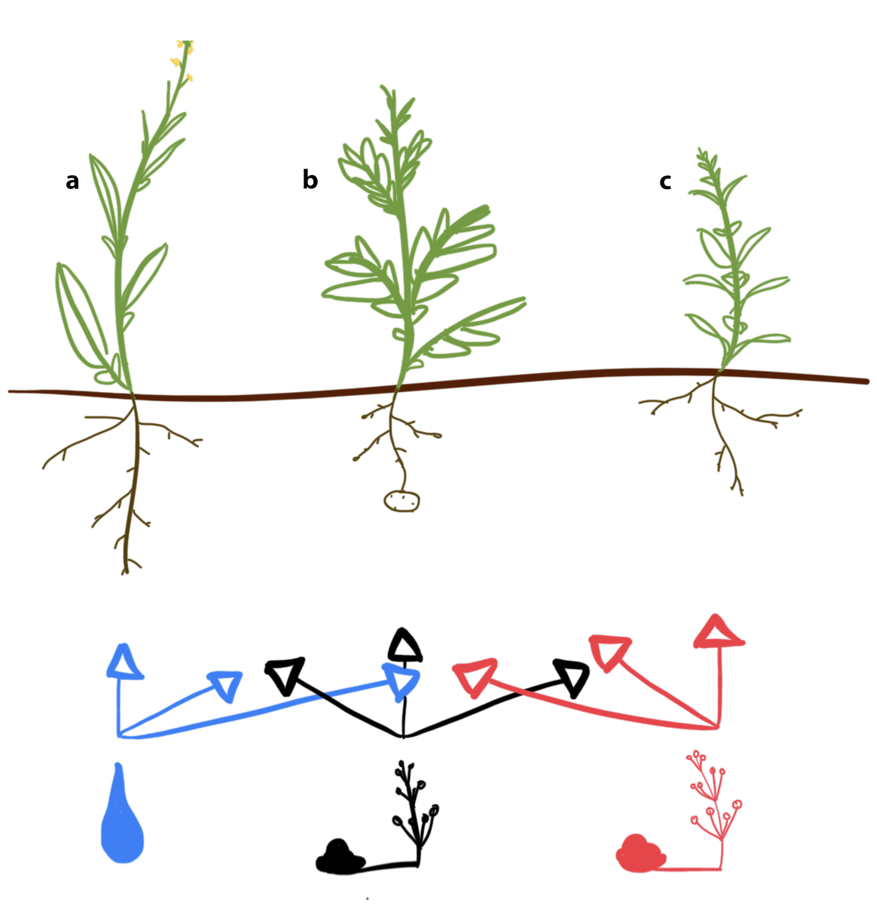

**Figure 2.** Comparisons of differentially expressed genes (DEGs) between (**A**): brown mustard (a), potato (b), and peppermint (c) infected with *Verticillium dahliae* isolate 653 and non-inoculated control (pink), *V. dahliae* isolate 111 and non-inoculated control (blue), and between *V. dahliae* isolates 653 and 111 (orange) and (**B**): *V. dahliae* isolates recovered from each host. Numbers within each venn diagram represent the shared number of DEGs between comparisons.

**Figure 3.** Heatmaps for the top 20 differentially expressed genes (DEG) for (a) brown mustard, (b) potato, (c) peppermint, and (d) *Verticillium dahliae*.DEGs are clustered with *k-*means by rows. Columns represent treatments. DEGs without recognizable gene names were not homologous to genes from online repositories. Each cell represents a biological replicate. The color of each cell reflects the relative changes in gene expression illustrated in the legends.



**Figure 4.** Volcano plots for (**A**) brown mustard (a), potato (b), and peppermint (c) and (**B**) *Verticillium dahliae.*  Log-transformed *P*-values are expressed as a function of the fold-change between comparisons of interest. Panel **A** illustrates comparisons between *V. dahliae* isolate 653 vs. non-inoculated control, *V. dahliae* isolate 111 vs. non-inoculated control, and between both *V. dahliae* isolates. Panel **B** illustrates comparisons between *V. dahliae* isolates within a host and between hosts within an isolate. Black dots represent genes with relatively small fold-changes and large, non-significant, *P*-values. Yellow dots represent genes with relatively large fold-changes but large, non-significant, *P*-values. Grey dots represent genes with relatively small fold-changes but small *P*-values. Red dots represent genes with relatively large fold-changes and small *P*-values.

**Figure 5**. Top 15 GO terms of DEGs detected in brown mustard (a), potato (b), peppermint (c). The number of DEGs is expressed as a function of GO terms. GO categories are represented by colors; biological process (brick red), cellular component (orange), and molecular function (blue).

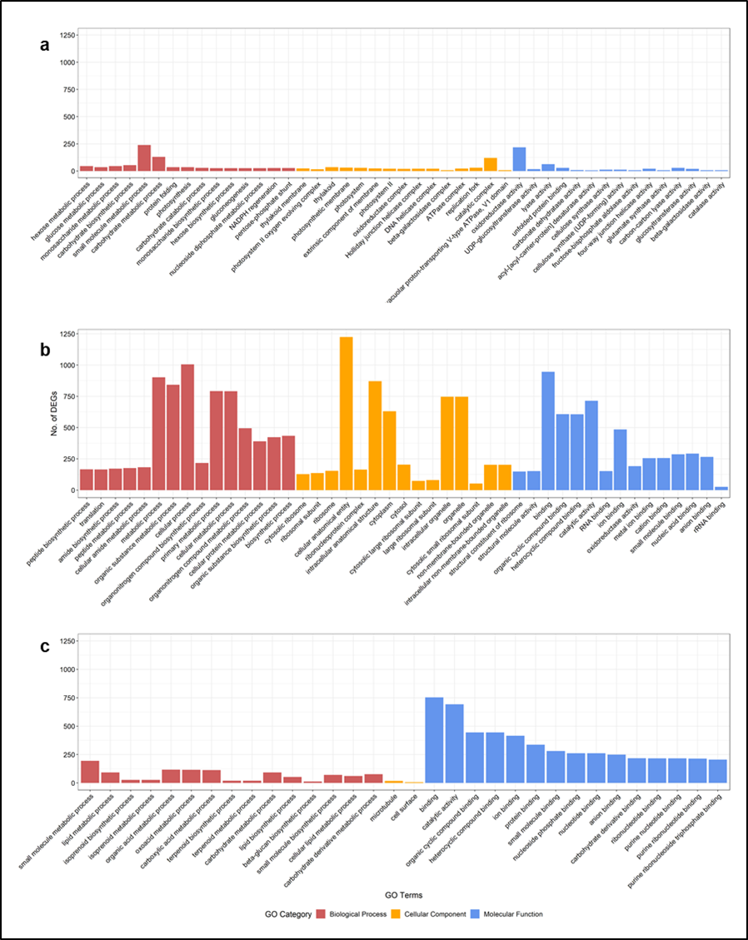

**Figure 6.** Validation of relative expression changes for selected DEGs of brown mustard, potato, peppermint, and *V. dahliae* with RT-qPCR data. The fold change for three biological replicates was calculated using the method for RT-qPCR and average fold change was derived using DESeq2 for RNA-seq. The Log2 fold change value (y-axis) for each comparison (shown in legend) is expressed a function of each gene (x-axis).



**References**

1. Altschul SF, Gish W, Miller W, Myers EW, Lipman DJ. 1990. Basic local alignment search tool. J Mol Biol. 215(3):403–10.
2. Baetsen-Young A, Chen H, Shiu S-H, and Day B. 2021. Contrasting transcriptional responses to *Fusarium virguliforme* colonization in symptomatic and symptomatic hosts. The Plant Cell. 33: 224-247. doi:10.1093/plcell/koaa021
3. Berlanger I, Powelson ML. 2000. Verticillium wilt. The plant health instructor. [WWW document] URL <https://www.apsnet.org/edcenter/intropp/lessons/fungi/ascomycetes/Pages/VerticilliumWilt.aspx> [accessed on 18 March 2020].
4. Bigeard J, Colcombet J, and Hirt H. 2015. Signaling mechanisms in patterned-triggered immunity (PTI).
5. Buchfink B, Xie C. and Huson D. 2015. Fast and sensitive protein alignment using DIAMOND. *Nat Methods* 12, 59–60. https://doi.org/10.1038/nmeth.3176.
6. Davidson, N.M., Oshlack, A. Corset: enabling differential gene expression analysis for *de novo* assembled transcriptomes. *Genome Biol* 15, 410 (2014). https://doi.org/10.1186/s13059-014-0410-6.
7. Dodds PN and Rathjen JP. 2010. Plant immunity: towards an integrated view of plant -pathogen interactions. Nat Rev Genet 11: 539-548
8. Dung JKS, Schroeder BK, and Johnson DA. 2010. Evaluation of Verticillium wilt resistance in Mentha arvensis and M. longifolia genotypes. Plant Dis. 94:1255-1260.
9. Eddy SR. Accelerated Profile HMM Searches. 2011. PLoS Comput Biol. 10;7(10):e1002195.
10. Eulgem T. and Somssich IE. 2007. Networks of WRKY transcription factors in defense signaling. Current Opinion in Plant Biology. 10:366-371.
11. Fujii I, Yasuoka Y, Tsai HF, Chang YC, Kwon-Chung KJ. and Ebizuka Y. 2004. Hydrolytic polyketide shortening by ayg1p, a novel enzyme involved in fungal melanin biosynthesis. Journal of Biological Chemistry. *279*:.44613-44620.
12. Götz S, García-Gómez J M, Terol J, et al. 2008. High-throughput functional annotation and data mining with the Blast2GO suite. Nucleic Acids Research 36, 3420-3435.
13. Grabherr M G, Haas B J, Yassour M, et al. 2011. Full-length transcriptome assembly from RNA-Seq data without a reference genome. Nature Biotechnology 29, 644-652.
14. Guo S, Zuo Y, Zhang Y, Wu C, Su W, Jin W, Yu H, An Y, and Li Q. 2017 Large-scale transcriptome comparison of sunflower genes responsive to Verticillium dahliae.BMC Genomics.18:42. doi:10.1186/s12864-016-3386-7.
15. Guo L, Yu H, Wang B, Vescio K, DeIulio GA, Yang H, Berg A, Zhang L, Edel-Hermann V, Steinberg C, Kistler HC, Ma LJ. 2021. Metatranscriptomic comparison of endophytic and pathogenic Fusarium–Arabidopsis interactions reveals plant transcriptional plasticity. Molecular Plant-Microbe Interactions. <https://doi.org/10.1094/MPMI-03-21-0063-R>
16. Jiménez-Ruiz J, Leyva-Pérez MO, Gómez-Lama Cabanás C, Barroso JB, Luque F, Mercado-Blanco J. 2019. The Transcriptome of *Verticillium dahliae* Responds Differentially Depending on the Disease Susceptibility Level of the Olive (*Olea europaea* L.) Cultivar. Genes*. 10*, 251.
17. Jin L, Chen D, Liao S. *et al.* 2019. Transcriptome analysis reveals downregulation of virulence-associated genes expression in a low virulence *Verticillium dahliae* strain. Arch Microbiol. 201, 927–941. https://doi.org/10.1007/s00203-019-01663-7
18. Johnson DA and Dung JKS. 2010. Verticillium wilt of potato - The pathogen, disease and management. Can. J. Plant Pathol. 32:58-67.
19. Jones JDG and Dangl JL 2006. The Plant Immune System. Nature, 444, 323-329.  
    http://dx.doi.org/10.1038/nature05286
20. Klosterman SJ, Subbarao KV, Kang S, Veronese P, Gold SE, Thomma BPHJ, et al. 2011. Comparative Genomics Yields Insights into Niche Adaptation of Plant Vascular Wilt Pathogens. PLoS Pathog 7(7): e1002137. <https://doi.org/10.1371/journal.ppat.1002137>
21. Kubo, Y., Takano, Y., Endo, N., Yasuda, N., Tajima, S. and Furusawa, I., 1996. Cloning and structural analysis of the melanin biosynthesis gene *SCD1* encoding scytalone dehydratase in *Colletotrichum lagenarium*. Applied and Environmental Microbiology. 62:4340-4344.
22. Kumar, GNM, Iyer S, Knowles NR. 2007. Extraction of RNA from Fresh, Frozen, and Lyophilized Tuber and Root Tissues. Journal of Agricultural and Food Chemistry. 55: 1674-1678. Doi: 10.1021/jf062941m
23. Langmead B, and Salzberg SL. 2012. Fast gapped-read alignment with Bowtie 2. Nat Methods. 9(4):357–U354.
24. Livak, K.J. and Schmittgen, T.D. 2001. Analysis of relative gene expression data using real-time quantitative PCR and the 2− ΔΔCT method. Methods. 25:402-408.
25. Love MI, Huber W, and Anders S. 2014. Moderated estimation of fold change and dispersion for RNA-seq data with DESeq2. Genome Biol. 15:550. doi: 10.1186/s13059-014-0550-8.
26. Malcolm GM, Kuldau GA, Gugino BK, and Jiménez-Gasco MM. 2013. Hidden host plant associations of soilborne fungal pathogens: An ecological perspective. Phytopathology 103:538-544.
27. Moriya, Y, Itoh M, Okuda S, Yoshizawa A, and Kanehisa M. 2007. KAAS: an automatic genome annotation and pathway reconstruction server. Nucleic Acids Res. 35, W182-W185.
28. Pegg, G. F., and Brady, B. L. 2002. Verticillium Wilts. CABI Publishing, Wallingford, Oxon, UK.
29. R Core Team. 2019. R: A language and environment for statistical computing. R Foundation for Statistical Computing, Vienna, Austria. URL https://www.R-project.org/.
30. Ruijter, J.M., Ramakers, C., Hoogaars, W.M.H., Karlen, Y., Bakker, O., Van den Hoff, M.J.B. and Moorman, A.F.M. 2009. Amplification efficiency: linking baseline and bias in the analysis of quantitative PCR data. Nucleic acids research. 37: 45.
31. Scholz SS, Schmidt-Heck W, Guthke R, Furch ACU, Reichelt M, Gershenzon J and Oelmüller R. 2018. *Verticillium dahliae-Arabidopsis* Interaction Causes Changes in Gene Expression Profiles and Jasmonate Levels on Different Time Scales. Front. Microbiol. 9:217. doi: 10.3389/fmicb.2018.00217.
32. Sun Q, Jiang H, Zhu X, Wang W, He X, Shi Y, Yuan Y, Du X and Cai Y. 2013. Analysis of sea-island cotton and upland cotton in response to *Verticillium dahliae* infection by RNA sequencing. BMC Genomics 14, 852. <https://doi.org/10.1186/1471-2164-14-852>.
33. Tan G, Liu K, Kang J, Xu K, Zhang Y, Lizong H, Zhang J, Li C. 2015. Transcriptome analysis of the compatible interaction of tomato with *Verticillium dahliae*. Frontiers in Plant Science. 6:428. <https://doi.org/10.3389/fpls.2015.00428>
34. Tian F, Lee SY, Woo SY, and Chun HS. 2020. Alternative oxidase: a potential target for controlling aflatoxin contamination and propagation of *Aspergilluis flavus.* Frontiers in Microbiology  <https://doi.org/10.3389/fmicb.2020.00419>
35. Trapnell C, Williams B, Pertea G. *et al.* 2010. Transcript assembly and quantification by RNA-Seq reveals unannotated transcripts and isoform switching during cell differentiation. *Nat Biotechnol* 28, 511–515. https://doi.org/10.1038/nbt.1621
36. Tsror L, Shlevin E, and Peretz-Alon I. 2005. Efficacy of metam sodium for controlling*Verticillium dahliae* prior to potato production in sandy soils. Am. J. Pot Res*.* 82, 419–423.
37. Vleeshouwers VG, Van Dooijeweert W, Govers F, Kamoun S. and Colon LT. 2000. Does basal PR gene expression in Solanum species contribute to non-specific resistance to *Phytophthora infestans*? Physiological and Molecular Plant Pathology. 57:35-42.
38. Wheeler DL and Johnson DA. 2016. *Verticillium dahliae* infects, alters biomass, and produces inoculum on rotation crops. Phytopathology. 106:602-613.
39. Wheeler DL, Dung JKS, and Johnson DA. 2018. From pathogen to endophyte: emergence of an endophytic population of *Verticillium dahliae* in rotation crops from a sympatric population associated with wilted potatoes. New Phytologist. 222: 497-510.<https://doi.org/10.1111/nph.15567>
40. Wilhelm S. 1955. Longevity of Verticillium wilt fungus in the laboratory and field. Phytopathology 45:180-181.
41. [Woodward JE, Wheeler](https://apsjournals.apsnet.org/doi/10.1094/PHP-2011-0323-02-RS) TA, [Cattaneo](https://apsjournals.apsnet.org/doi/10.1094/PHP-2011-0323-02-RS) MG, [Russell](https://apsjournals.apsnet.org/doi/10.1094/PHP-2011-0323-02-RS) SA, and [Baughman](https://apsjournals.apsnet.org/doi/10.1094/PHP-2011-0323-02-RS) TA. 2011. Evaluation of Soil Fumigants for Management of Verticillium Wilt of Peanut in Texas. Plant Health Progress.12. <https://doi.org/10.1094/PHP-2011-0323-02-RS>
42. Xu X, Pan S, Cheng S. *et al.* 2011. Genome sequence and analysis of the tuber crop potato. *Nature* 475, 189–195. <https://doi.org/10.1038/nature10158>

**Supplementary Figures**

**Supplementary Figure 1.** Scatter plots showing the linear relationship between RT-qPCR and RNA-seq gene expression changes in brown mustard, potato, peppermint, and *V. dahliae*. *r*-value represents the correlation coefficient for the respective host.

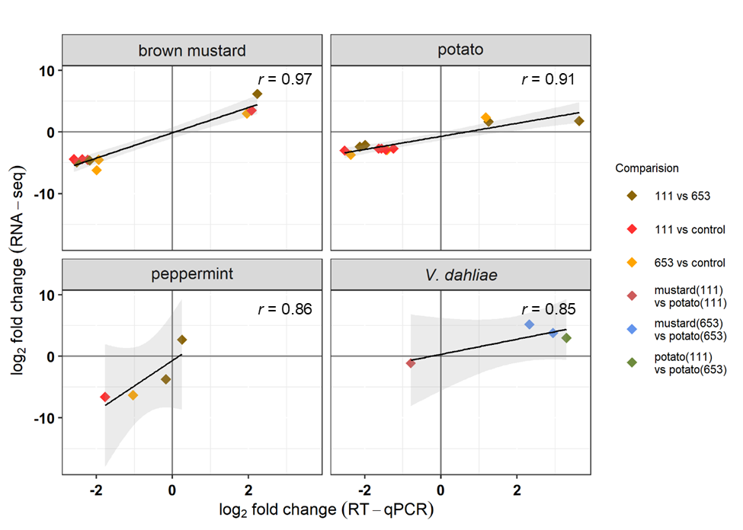

**Figures not cited in the text:**

**Additional Figure 1.** Log fold change of DEGs from plants (**A**) and *Verticillium dahliae* isolates (**B**) as a function of the mean number of normalized counts. Panel (**A**) presents MA plots for brown mustard (a), potato (b), and peppermint (c) plant genes expressed in plants infected with *Verticillium dahliae* isolate 653 vs. the non-inoculated control, *V. dahliae* isolate 111 vs. the non-inoculated control, and *V. dahliae* isolate 111 vs. *V. dahliae* isolate 653. Baseline controls for the last column depend on the host and are labeled accordingly. Panel (**B**) presents MA plots for *V. dahliae* genes expressed in different hosts.

**Additional Figure 2.** Scatter plot showing the correlation between RNA-seq and RT-qPCR gene expression changes for all hosts. *r* represents the correlation coefficient between RT-qPCR and RNA-seq expression change data.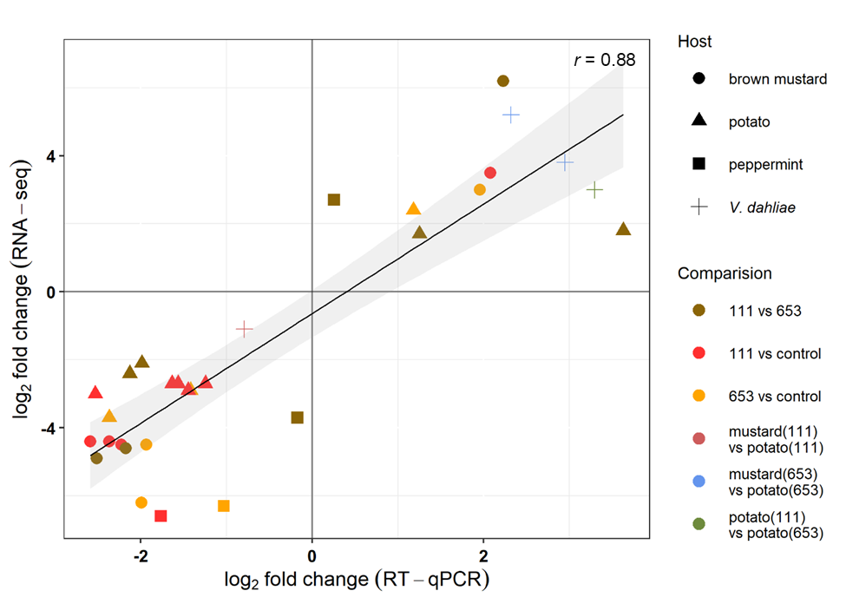

**Additional Figure 3.** Expression changes of *Verticillium dahliae* genes in peppermint inoculated with isolate 111 relative to peppermint inoculated with isolate 653. RT-qPCR method was utilized to derive expression changes. The delta-delta Ct method was used to calculate log2 fold change for each gene and *V. dahliae* housed keeping gene, Rho was used for normalization.

