NetProg Lab 6

Saptarshi Ganguly, Gordon Tsangg, Dani Reil, and Joseph Gonzales

1. LIST, STOR, and RETR
2. All FTP codes received in order without omissions:

220, 331, 230, 215, 211,

257, 200, 227, 125, 226,

220, 331, 230, 250, 257,

200, 227, 125, 226, 227,

125, 226, 250, 257, 227,

125, 226, 250, 257, 200,

227, 125, 226

1. Username: Administrator Password: napier
2. The name of the file uploaded is “111.ping”
3. The name of the file downloaded is “manual.txt”
4. Packet 21 is the first to perform a “LIST”
5. Port 21 is used on the server for the transfer
6. Files on the server are 1.docx and manual.txt
7. Ports 49430 and 49440 are used by the clients for the transfer
8. Operating System: Ubuntu 18.04.5

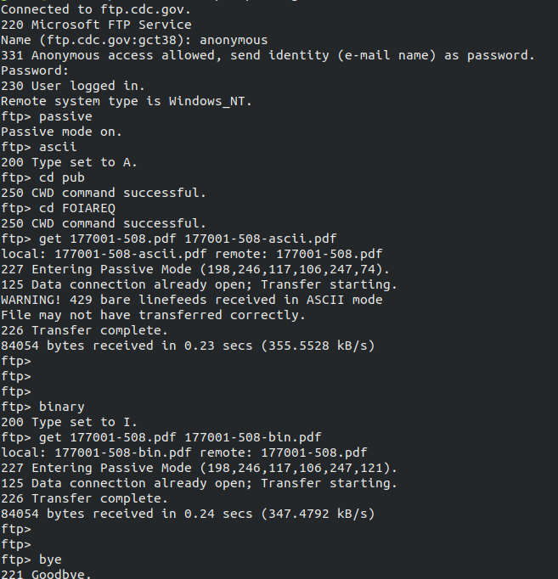  
Terminal Output FTP in BINARY and ASCII

1. When I performed the ftp of both binary and ascii version of the same file, I was operating under Ubuntu 18.04.5. There are some noticeable differences between the binary and ascii files. The logo on the upper left of the first page in the ascii file seems to get distorted a little whereas in the binary file it is perfect. The ascii file also seems to lack Observation 3 and Section 3 Summary and Conclusions on page 7 as opposed to the binary file where this both of these sections exist. Besides these two major differences, both the ascii and binary files are the same. The reason why these two files were different is because binary FTP transfers files exactly as they are without any conversion and ascii FTP transfers converts all the various characters in the file based upon the operating system used by the client. Binary FTP transfers preserve the integrity of the document, especially if it’s an image such as the logo on the upper left portion on page 1 which is why the binary version kept the logo intact as opposed to the ascii version where the image became distorted. Ascii FTP transfers are usually used to transfer text files that can be easily read using a text editor and handle the end of lines better than binary ftp transfers would. As to why there is a missing section in the ascii version, I would suggest it might have something to do with the warning message given in the terminal output of “WARNING! 429 bare linefeeds received in ASCII mode. File may not have transferred properly.” It could potentially be due to when trying to convert everything in the pdf over to ascii format, some portions ended up getting corrupt or lost.