Student Team Composition
The PSC Revs is composed of dynamic students, all of whom have unique backgrounds that offer a wide set of skills that range from development expertise to communications and commerce. Below is a list of our multi-disciplinary team:
- Computer Engineer: Ian Rodriguez
- Software Engineer: Luan Phung
- Electrical Engineer(s): Yasmine El-Garawani & Xu Yan
- MIS & Project Management: Mahdia Khan, Ali Etubashi & Tarick Al-Nomay
- Computer Science: Remy Bernard, Fahim Akhand & Abdias Jean-Pierre
Furthermore, our team comes from 4 academic institutions (UQO, UOttawa, Carleton U, and Concordia) as well as varied cultures and ethnicities. All of which offers not only a unique perspectives, but also unique solutions and recommendations.

Activity on GitHub
During the Hackathon, we generated a lot of interest (i.e. hype) for the hackathon event as well as our application ideas through Twitter, Snapchat, Gitter, the Wire, in person as well as on GitHub. During the first day of the Hackathon we generated a poll of 4 GCConnex enhancement ideas to guide us in our development efforts. The results are listed below based on 65 responses on the Wire (as of 11AM on April 7, 2017):
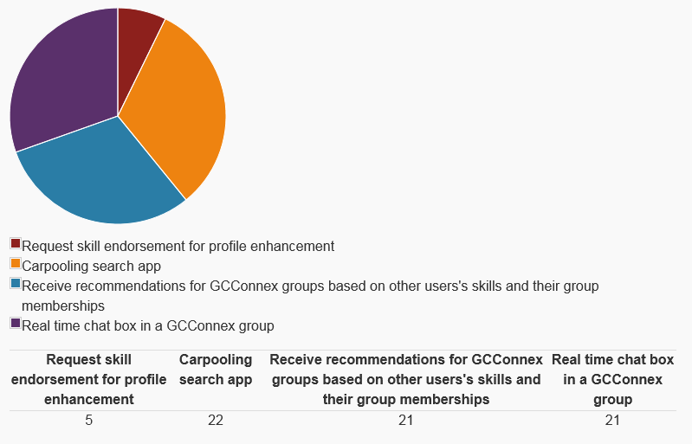
https://gcconnex.gc.ca/polls/view/25244032/hello-all-we-are-participating-in-the-gc-tools-hackathon-and-are-curious-as-to-what-gcconnex-enhancement-appeals-to-you-the-most-as-a-public-servant-please-select-the-option-that-appeals-to-you-the-most
We also took our efforts to Twitter to not only build awareness for the event but to also foster support in our endeavours. The results below are calculated by the total sum of users that have seen each tweet associated to and over the course of the hackathon. In total thus far we have had 1.2K impressions during these 2 days as well as a total engagement growth rate of 3.8%.
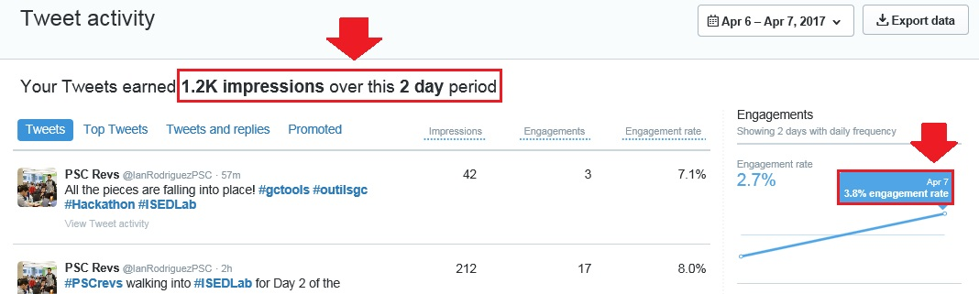
We also actively endorsed our participation in this event (in person and on GC Connex) to facilitate interest. An example of the engagement we have experienced can be seen in the following Wire post.
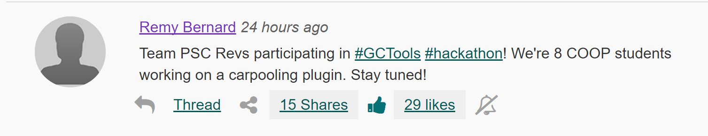
There was 15 shares and 29 likes by the end of yesterday (April 6, 2017). The poll we conducted also reflects the activity and participation we have generated during this event. Although we have selected to develop one of the 4 enhancements (i.e. GC Carpool), we created issues on GitHub with a reference to the un-tackled enhancements since there exists a level of interest across GC Connex users. Below is a list of issues that have been uploaded to GitHub;
#938 (Enhancement) Carpooling search app
#936 (Enhancement) Real time chat box in a GCConnex group
#935 (Enhancement) Recommendations for GCConnex groups based on other users's skills and their group memberships
#934 (Enhancement) Request skill endorsement for profile enhancement Hackathon
https://github.com/gctools-outilsgc/gcconnex/issues

Our Application
The GC Carpool application is the enhancement we chose to develop based on preliminary poll results. This application will be comprised of 2 user types, Drivers and Passengers. Drivers will post their routes with information relevant to carpooling then upload it. Passengers will then enter their origin and desired location to generate a list of possible drivers they can request carpooling with. The Driver can accept or decline passenger requests. Upon accepting a passenger, the Driver’s route will be updated to include Waypoints to reflect Passenger pick-up locations. Below are 2 screenshots of the UI. Below are images of the UI for both the home page and the Driver’s Route page.
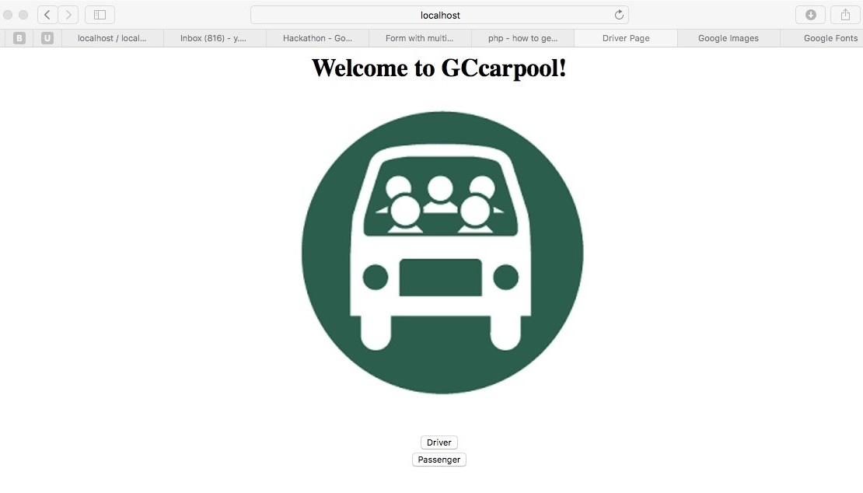
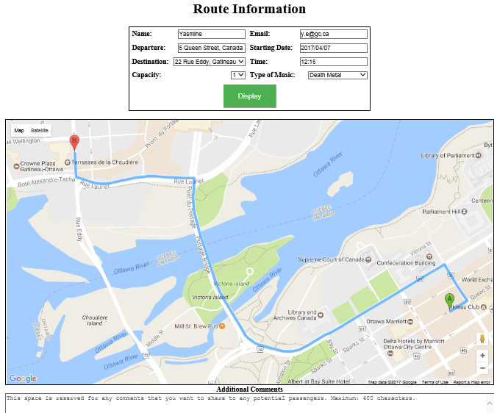
Furthermore, the database will play an imperative role in the effectiveness of this application. For this reason we decided to also include our preliminary ERD of the desired state of the database structure.
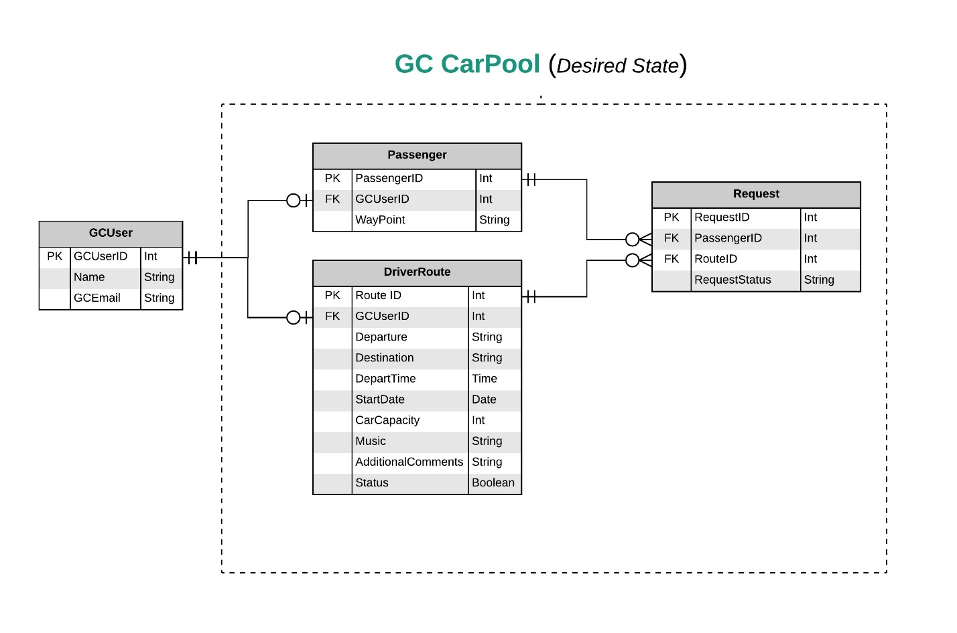

Accessibility
Although our application is in the prototype stage, we unanimously decided to give it an accessibility rating of 7 out of 10. Through the use of Google Map API, we believe that our application is intuitive and requires minimal learning efforts to utilize effectively. Perception and navigation should be very easy to a user who has used Google Maps in the past.

Usability and User Experience
Refer to the Screenshots above. We believe that our user experience will be a pleasant one given that our interface is simple, straightforward and intuitive given that route points will be illustrated on the map. If the user has made a mistake then they will see it upon entering submit and correct when appropriate.

Stability:
- Is the Code Stable? Yes, what we have so far is.
- Run Smoothly without Crashing? Yes, so far…
- Errors? None in code
- Proper functionality? Created elements yes, but some buttons not initialized yet

Ease of implementation
Integrating our submission into GCTools will require familiarization with GitHub environments, PHP scripting, Google MAPS API integration and the GC Connex environment itself.

Effectiveness
We believe that our application will not only augment the ability of users, but will also promote activity within GC Connex given the conditions we all face as public servants with public transportation and public parking. This app, we believe, will harness the network effect and stimulate inter-organisational communication through the GC Connex social platform. There is definitely intrinsic value here in that users that utilize this self-regulating service will be reducing the overall carbon footprint of public servants, establish meaningful relationships with colleagues, as well as foster a sense of community with fellow public servants.

Our Presentation
Below is a link to the Google Drive presentation that was used to present our hackathon endeavours;
https://drive.google.com/file/d/0ByvGai4UYVQLaExlRVBTWjY4Q0U/view?invite=CPv0jpkE&ts=58ebb79e

Test Site
(Accessible by anyone): http://tbshackathon4.canadaeast.cloudapp.azure.com/gcconnex

