ISCache

Introduction
In a distributed environment, one of the most prominent performance enhancing solutions is the extensive adoption of web caching mechanisms. Web Caching has been employed since the beginning of the Internet with its role being strengthened year after year.
Its purpose is to reduce the amount of information that needs to be transmitted across the network, as information previously stored in the cache can often be re-used. This reduces bandwidth and processing requirements of the web server, and helps to improve responsiveness for users of the web. In the gCube context, caching is applied in many subsystems, such as search, resulting in 2-degree performance enhancements.
A major gCube component which is employed by virtually all other components is the Information Service (IS). IS implements the features supporting the publishing, discovery and ‘real-time’ monitoring of the set of resources forming a gCube-based infrastructure. It acts as the registry of the infrastructure, i.e. all the resources are registered there and every service partaking to the infrastructure must refer to it to dynamically discover the rest of Infrastructure constituents.
Since IS is perhaps the most heavily used component in D4Science, its workload is huge, thus having a negative impact in its efficiency. Therefore, it is imperative that this component must be alleviated from all the burden of serving all other components. The easiest and quickest way to employ a caching mechanism which will operate between IS and its clients.

ISCache Goals
The general purpose of ISCache is to provide a caching layer between IS and its clients. More analytically, the goals of ISCache are the following:
- Operate as middleware between IS and its client and wrap around (a subset of) IS functionality
- Easy-to-use
- Extendibility
- Monitoring and Management facility
- Minimum bootstrapping

Operate as middleware between IS and its client and wrap around (a subset of) IS functionality
Currently, the purpose of ISCache is to act as a proxy of a subset of IS, providing information about running instances and resources. More analytically, it can be used only as a querying facility for the EPRs of running instances and resources. It does not cover, collections, generic resources and querying of data other that EPRs. Thus, it's not a fully-fledged substitute of IS, but it acts as a service location querying mechanism. For a complete analysis of its API, look at [User Guide].

Easy-to-use
The most important aspect of any computer software in terms of public acceptance is ease of use. To this direction, ISCache is really easy to use. It needs no special knowledge, no configuration, it exposes a very simple API and can be administered by virtually anyone with minimum know-how (for further details see [Developer Guide]).

Extendibility
ISCache is designed to be highly configurable. The cache consistency mechanism (CCM) is completely decoupled from the cache querying mechanism. In this way, one could simply load his own consistency module without restarting the JVM that ISCache runs on. Moreover, the requirements and restrictions over the CCM modules are the minimum possible, thus giving many degrees of freedom regarding the design and implementation (for further details see [Developer Guide]).

Monitoring and Management facility (M&M)
ISCache architecture is fully JMX-enabled, so administrators or users can configure it at runtime, without any implications on the correct and non-stop execution of the component that employs ISCache. Moreover, one can simply use Jconsole as a simple, easy-to-use and off-the-shelf JMX client to configure his ISCache instance, without any need for special clients (for further details see [Developer Guide]).

Minimum bootstrapping
ISCache needs no bootstrapping.

User Guide
On the user perspective, ISCache can be regarded as a service querying mechanism, fully respectful to the gCube environment.
There are two levels of use: the basic level, where users rely on the pre-configured system settings and needs no parameterization; and the advanced level, where users want custom-made functionality and therefore need to configure the system. It's needless to say that these levels are logical and simply used for ease-of-documentation.

Basic Level
For the basic use, the only artifacts users need to pay attention to are the ISCache and ISCacheManager classes.
ISCacheManager class is the entry point to the ISCache functionality and is simply used for initializing the ISCache workflow. In the beginning, use the static ISCacheManager#initialize() method, which initializes the ISCache environment. Since information is categorized based on scopes, ISCacheManagers are created on scope basis. In order to create a new ISCacheManager, simply use the static ISCacheManager#addManager(<GCUBEScope instance>) method. This method invocation will create a new ISCacheManager instance and add it to the internal registry. The static method for removing ISCacheManager instances, is ISCacheManager#delManager(<GCUBEScope instance>). A specific ISCacheManager instance can be retrieved by invoking the static method ISCacheManager#getManager(<GCUBEScope instance>).
Once the ISCacheManager has been created and retrieved it can be used to provide an internally created and configured ISCache instance which provides the cache querying mechanism. The ISCache object can be retrieved using ISCacheManager#getCache() method. Then, they can invoke the methods defined in the ISCache class and manage the cache information.
ISCache class provides the actual service location querying methods. In essence, one can query the EPR of a given running instance or resource of a gCube service. According to the gCube naming conventions, each gCube service is characterized by a service class and a service name. A basic distinction is stateless and stateful services. Among the stateful services we can discern two coarse grained categories: Factory port types and resource port types. Obviously, for stateless services, we cannot further categorize the available port types.
So, users can query about the EPRs of all three (or any future) port type categories. For example, querying about the EPRs of the Factory port types of the XMLIndexer service can be done like this:
iSCache.getEPRsFor("MetadataManagement", "XMLIndexer", "FACTORY") :: EndpointReference[]
The first argument is the service class, the second is the service name and the third is the port type category. The result is an array of EndpointReference instances.

Querying about the EPRs of the all but the Factory port types of the same service can be done like this:
isCache.etEPRsFor("MetadataManagement", "XMLIndexer", "STATEFULL") :: EndpointReference[]
We should not the the “STATEFULL” keyword name may not be appropriate. We are open to new proposals.

Finally, querying about the EPRs of the GoogleService (stateless) can be done like this:
isCache.getEPRsFor("Search", "GoogleService", "SIMPLE") :: EndpointReference[]

Users can omit the third argument and simply get back all EPRs.

The queries mentioned above simply retrieve all EPRs without specifying and filtering criteria. These criteria, in gCube terms, are atomic conditions, so users can add them for every port type category. So, one can add filtering criteria for specific categories, such as “STATEFULL”. For example, if I want to retrieve the EPRs of the XMLIndexer resources but only the ones that have “GCUBEDaix” as the “AccessType” property value, then I first add that criterion, like this:
isCache.addFilterCriterion("MetadataManagement", "XMLIndexer", "STATEFULL", "/child::*[local-name()='AccessType']", "GCUBEDaix");
This criterion, is translated to a new AtomicCondition instance which is only applied when asking about resource EPRs. Filtering criteria can be deleted (delFilterCriterion) and retrieved (getFilterCriterion).
The API stops for the basic use ends here. Users need not any extra methods for querying for resource/RI EPRs and they are certainly not interested of internals of ISCache (if and how the information is cached, whether it's retrieved from the cache or directly from the origin server, etc.)

Advanced Level
The vast majority of users may not need the advanced features of ISCache and users that may need them can be safely included in the development group :-).
ISCache provides the means to extend its functionality by providing custom-made cache consistency managers (CCMs). As previously stated, one can add/delete consistency managers at runtime without affecting the ISCache state. For the management of CCMs there is the ISCacheConsistencyManager class which is retrieved by the non-static ISCacheManager#getCCM() method.
The methods exposed by the ISCacheConsistencyManager class are
- public boolean addCCManager(String CCManagerFQName) throws Exception
- public boolean addCCManagerDynamic(String CCManagerFQName, String codebase) throws Exception
- public boolean delCCManager(String CCManagerFQName) throws Exception
- public void setActiveCCManager(String CCManagerFQName) throws Exception
- public String[] getCCManagers()
The assumption is that the CCM is packaged into a jar. The addCCManager methods take the main CCM class fully qualified name (FQN) as parameter and try to load the class. The term 'main CCM class' refers to the class name that implements the CCM interface (more on that, in the [Developer Guide]). The second method loads the CCM class from a remote repository. These methods load the CCM but do not set it as the active CCM. The idea is that you can have multiple CCMs loaded but only one can by the active one. You can set the active CCM with the setActiveCCManager method. The del|getCCManager methods simply do what their names suggest.

Management and Monitoring
As previously stated, ISCache is fully JMX-enabled, which means that is can be monitored and managed by JMX clients. One such client is JConsole which is packaged with the JDK (>= 1.5). In order for you component to be managed by JMX, you must include the following java flags:
-Dcom.sun.management.jmxremote.port=<port> -Dcom.sun.management.jmxremote.authenticate=false -Dcom.sun.management.jmxremote.ssl=false -Djava.rmi.server.hostname=<hostname>
If you want special authentication/authorization, please refer to JMX tutorial.
Then simply, run jconsole in your console, choose the ISCache process and you'll see the following window:
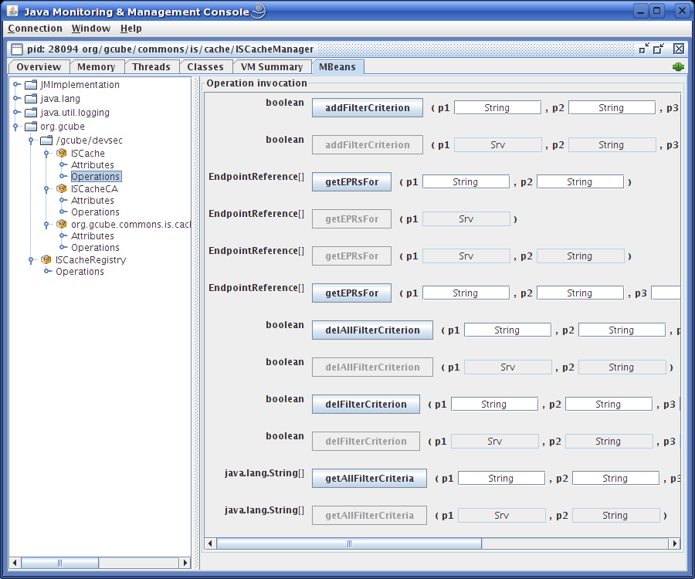
Figure 1 ISCache JConsole window

All ISCache-specific information can be found under the org.gcube folder. For each ISCacheManager you create, there is a different subfolder with the corresponding GCUBEScope name (in this example: /gcube/devsec). ISCache node contains all the operations of the ISCache class (as mentioned before). The ISCache CA node contains all the operations mentioned in the Advanced Level. Finally there is another node under each ISCacheManager subfolder which is named after the main CCM class FQN (in this example: org.gcube.commons.is.cache.consistency.PollManager. This node contains all the mechanics to manage and monitor each CCM that is loaded into the system.
Finally, there is another node which is out of the ISCacheManager subfolders. Its name is ISCacheRegistry and is simply used for creating and deleting ISCacheManagers.
Note that users can use JConsole (or another JMX client) and their own java code to control ISCache. These work in synergy without any collision. Since this is not a JMX tutorial, we will not analyze further. You are free to experiment with JConsole so as to get familiar with its functionality.

Examples of Usage
// initialize ISCache environment
ISCacheManager.initialize();

// add manager which correspond to "/gcube/devsec"
ISCacheManager.addManager(GCUBEScope.getScope("/gcube/devsec"));
// add manager which correspond to "/gcube/testing"
ISCacheManager.addManager(GCUBEScope.getScope("/gcube/testing"));
// delete manager which correspond to "/gcube/devsec"
ISCacheManager.delManager(GCUBEScope.getScope("/gcube/testing"));

// get the devsec manager
ISCacheManager icm = ISCacheManager.getManager(GCUBEScope.getScope("/gcube/devsec"));

// add a new STATEFULL filtering criterion to the XMLIndexer service
icm.getCache().addFilterCriterion("MetadataManagement", "XMLIndexer", "STATEFULL", "/child::*[local-name()='AccessType']", "GCUBEDaix");

// get the XMLIndexer Factory EPRs
String[] eprs = icm.getCache().getEPRsFor("MetadataManagement", "XMLIndexer", "FACTORY"));
// get the XMLIndexer resources EPRs
eprs = icm.getCache().getEPRsFor("MetadataManagement", "XMLIndexer", "STATEFULL"));
// get the GoogleService EPRs
eprs = icm.getCache().getEPRsFor("Search", "GooglService", "SIMPLE"));

Developer Guide

Architecture
Perhaps the most simple way of understanding the ISCache architecture is to take a look at the class diagram, shown below:
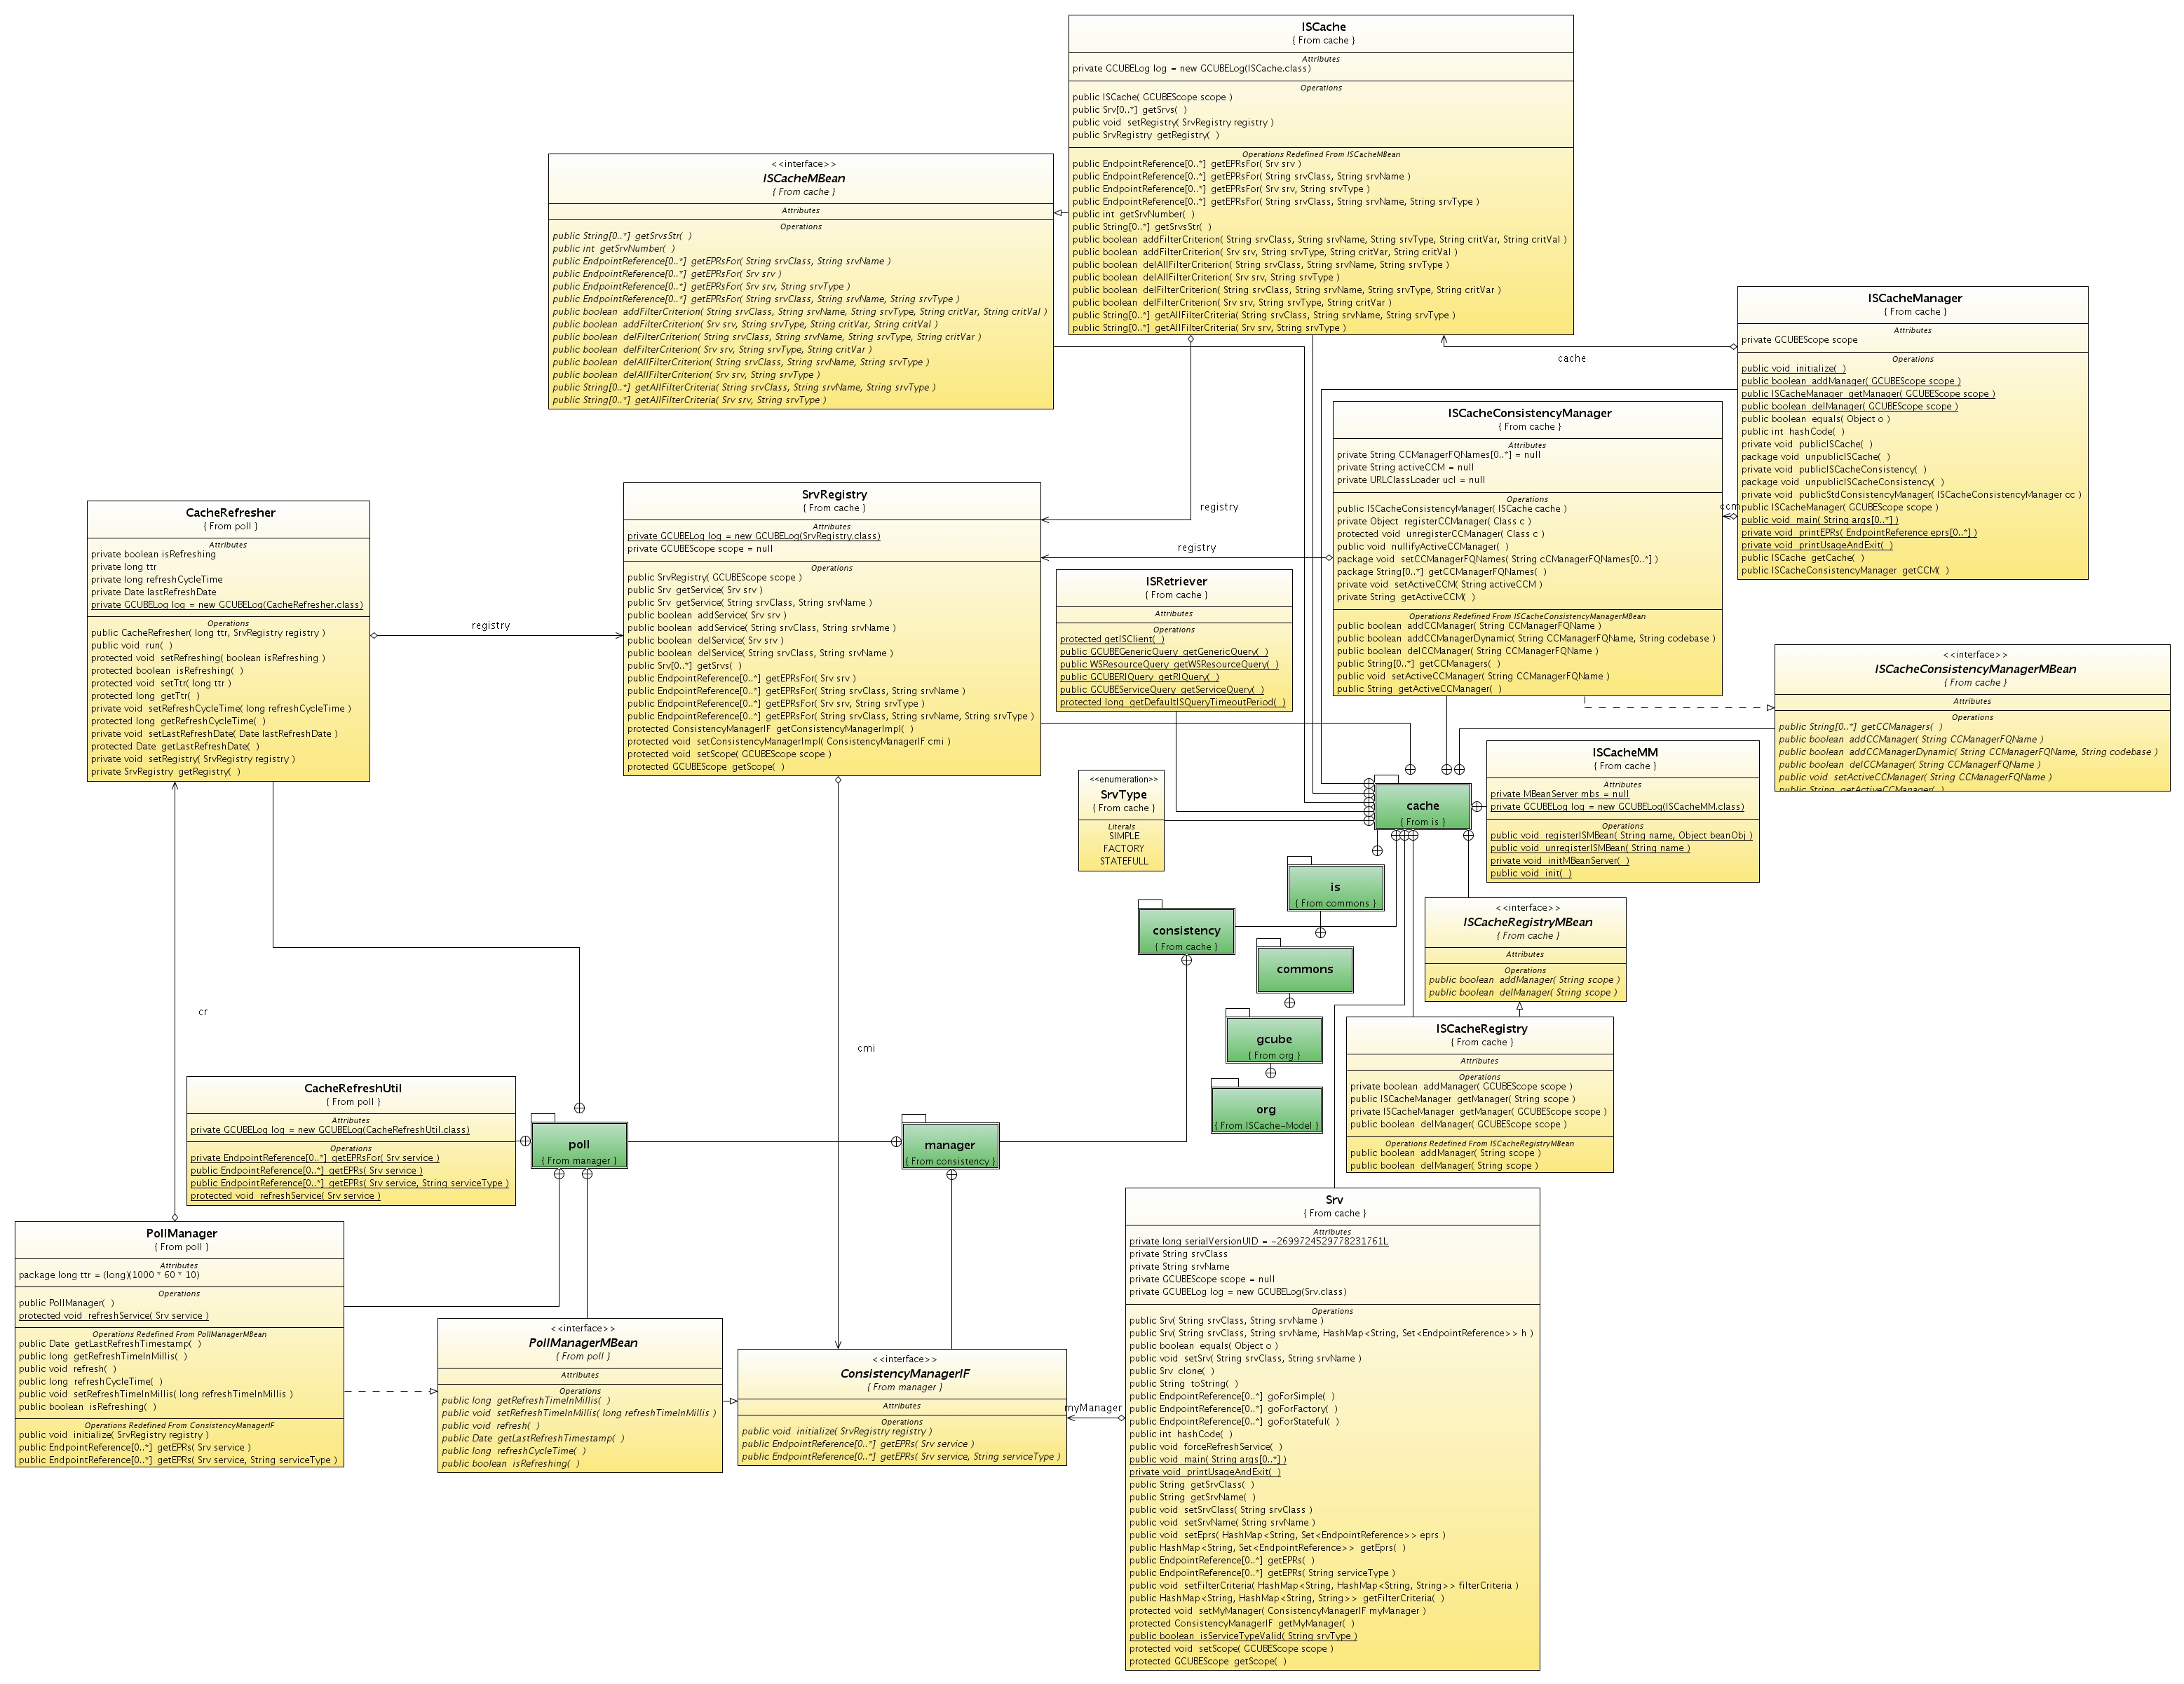
Figure 2 ISCache class diagram

As previously written, the entry point to ISCache functionality is the ISCacheManager class. Using this class, one can access the ISCache and ISCacheConsistencyManager classes, the API of which was explained above.
For every ISCacheManager instance, there is a single instance from the ISCache, SrvRegistry and ISCacheConsistencyManager classes. SrvRegistry is an in-memory registry of services and provides operations for adding/removing services and retrieving their EPRs. Note that users need not manually add or remove services. This is taken care by the system. Basically, the EPR retrieval methods invoke the corresponding methods of the service (Srv class) instance registered in the SrvRegistry. The Srv class is the abstract representation of a service. It has a serviceName, a serviceClass and two other attributes. The first (eprs) is a hash table of {portTypeCategory, List<EndpointReference>}. The portTypeCategory is currently FACTORY, SIMPLE, STATEFULL. The other attribute (filterCriteria) is another hash table of {portTypeCategory, List<FilteringCriteria>}.
Each Srv instance, apart from the getters/setters of the serviceClass, serviceName and filtering criteria, it exposes the getEPR method which is invoked by the SrvRegistry class, as mentioned above. This getEPR method does not retrieve the EPRs found in the eprs attribute, but rather invoke another getEPRs method of an instance of any class that implements the CacheConsistencyIF interface. This interface dictates the public API that a CCM needs to implement. So, the idea is when a user invokes the getEPRs method of the ISCache instance, this invocation is finally answered by the getEPRs method of the CCM. In this way, CCMs are free to enforce their own policy regarding cache consistency. Obviously, Srv instances do provide a method of direct EndpointReference generation; however this method is not available to the public but only to the CCM, which can freely retrieve and cache the EndpointReferences.

Standard CCM
ISCache comes with a default, quite simple CCM, which operates as follows:
At regular, configurable time intervals, it gets from the origin server the service EPRs and caches them. Whenever users ask for a service EPR, CCM simply returns the cached information. The caching is done in memory with a pretty simple way of employing hash tables.

Adding a new CCM
The only thing that a CCM must do is to implement the CacheConsistencyIF, which declares 3 methods:
- public void initialize(SrvRegistry registry) throws Exception;
- public Set<EndpointReference> getEPRs(Srv service) throws Exception;
- public Set<EndpointReference> getEPRs(Srv service, String serviceType) throws Exception;
The first one initializes CCM, passing a reference to the SrvRegistry instance. In this way, CCM can access and control the service registered in SrvRegistry.
The other two methods are invoked each time a user want to get back a RI/resource EPR, as explained above. In the implementation of these methods, CCM is free to enforce its policy. For example, it may just invoke the on-demand EPR generation methods of the Srv class and return them, without doing any caching. Or it may get the EPRs at regular basis at the background, cache them and return them when they're needed by users.

