Title:

Authors: Gordon F. Custer1,2*, Joshua G. Harrison3, Andrew Kniss4, and Linda TA van Diepen1,2

Affiliations: 1Department of Ecosystem Science and Management, University of Wyoming; 2Program in Ecology, University of Wyoming; 3Department of Botany, University of Wyoming; 4Department of Plant Sciences, University of Wyoming

*denotes corresponding author

Author Contact: GC – Gordon.custer91@gmail.com

Keywords:

Target: Scientific Reports or Applied and Environmental Microbiology

**Abstract – 200-word guideline**

Since the adoption of glyphosate resistant crops, patterns of pesticide use have changed dramatically. While the aboveground effects of herbicide application are often a primary focus, our understanding of its influence belowground lags. With microbes largely responsible for nutrient cycling and other pivotal ecosystem processes, understanding the direction and magnitude of their responses to vegetation removal is of the utmost concern. Previous research has revealed mixed responses of microbial diversity and function following herbicide application in agro-ecosystems, spurring calls for additional research to clarify direct and indirect effects. In this study, we examine non-target effects of herbicide application by comparing three commonly used chemical herbicides -glyphosate, dicamba, and a tank mix of atrazine and mesotrione- to handweeded and non-treated controls. We examine shifts in soil microbial function, soil nutrient pools, and microbiome composition in *Zea mays* fields over twenty-days post-treatment. We show the examined herbicides to have limited and short-lasting effects on soil edaphic properties and microbial function. Shifts in enzymatic activities, nutrient concentrations, and fungal community structure were instead predicted by weedy vegetation cover, but not weed removal treatment, suggesting that these responses are indirectly mediated by herbicide application. Conversley, we show that weed removal treatment was as significant predictor of bacterial community composition. Additionally, we report homogenization of bacterial community composition following chemical herbicide application, a trend not observed in the non-treated and handweeded controls. Our results suggest that chemical herbicide application may have limited effects on microbial diversity and functions in agro-ecoystems.

**Main Text – 4500-word guideline not including methods**

**Introduction**

Genetically modified herbicide-resistant crops were introduced to the United States in 1996, prompting a shift in herbicide use patterns. Primarily driven by the application of glyphosate (N-(phosphonomythel)glycine), herbicide application in the US increased by nearly 240 million kg from 1996 to 2011 (1). Classically, producers were concerned a single parameter: crop yield. However, the birth of the soil health movement has prompted a new way of thinking about production agriculture with a new appreciation for long-term yield and a holo-ecosystem approach to farming. With this new school of thought, researchers and producers alike are realizing the importance of understanding the non-target effects that herbicide and other agricultural amendments might have on soil and the ecosystem services that it provides (2, 3).

While commonly applied to control unwanted weedy plant populations, herbicides may also affect the structure and function of the soil microbiome (2, 4–7). This unseen component of agroecosystems provides countless benefits including plant growth promotion (8), pathogen suppression (9), enhanced nutrient cycling (10–13), as well as aggregate formation and maintenance of soil structure. Thus, contributing an estimated $330 to $500 per ha/yr in ecosystem services (14). Given their critical importance in agroecosystems, understanding how microbial communities respond to herbicide application is necessary to optimize agricultural systems for maximum yield and sustainability.

Reviews and syntheses of the effects that herbicide application has on microbiome structure and function reveal a lack of generalizable trends (5, 15–18) and instead show that the effects are dependent upon the characteristics of the soil, plant, application rate, and herbicide mode of action (2, 5, 19). Further complicating efforts to accurately model the influence of chemical intervention is the fact that herbicides have the potential to indirectly affect the soil microbiome through changes to vegetation and subsequent shifts in the patterns of root exudation (20). To better understand the short-term effects chemical herbicide application has on the soil microbiome, we compared three herbicides, each with a unique mode of action, alongside handweeded and non-treated control plots, allowing for the direct and indirect effects of herbicide application to be assessed. With each chemical herbicide possessing a unique mode of action (Table 1), we hypothesized that we would observe a unique response in microbial function and microbiome structure (2) for each treatment. Specifically, we hypothesized that the atrazine-mesotrione treated plots would affect nitrogen (N) cycling microbes (21) and result in significant shifts in N-pools and N-acquiring enzymes. Additionally, we expected the glyphosate and dicamba herbicides to affect the soil microbiome through disruption of amino acid synthesis pathways present in both microbes and plants.

**Results**

*Vegetation responses*

Herbicide weed removal treatments resulted in a reduction of weedy vegetation cover at both post-treatment sampling points (p < 0.01, F4,15 > 8.75 18.75). Like total weedy cover, herbicide application reduced lamb’s quarter and redroot pigweed cover at 10- and 20-days post-application when compared to the nontreated plots (p < 0.05). Handweeded plots showed an initial decrease in weed cover relative to the non-treated plots (p < 0.05), but at 20-days post treatment, weed cover in the two control plots was similar.

*Edaphic responses*

Prior to treatment, no differences in edaphic conditions were detected across our plots (Supplementary Table A1). Weed removal treatment was found to be a significant predictor of nitrate and total inorganic N content at both post treatment sampling points (p < 0.05), with total weedy vegetation being significant only at the 20-day sampling time (Supplementary Table A2). Glyphosate treated plots were found to have higher levels of nitrate and total inorganic N than the handweeded plots at both post-treatment sampling points (p < 0.05) (Supplementary Table A3).

When examining how our soil variables changed over time within a single weed removal treatment, multiple differences were observed. Significant models include nitrate, nitrite, ammonium, total inorganic N, phosphate, calcium, magnesium, pH, EC, and gravimetric moisture content (p < 0.05) (Supplementary Table B1). Pairwise comparisons showed the pre-treatment sampling point to have the highest levels of nitrate, total inorganic N, calcium, and magnesium, though only nitrate and inorganic N were statistically significant (p < 0.05) (Supplementary Tables B2 and B3). In all plots, gravimetric moisture content increased over the twenty-day sampling period (p<0.05). Across all treatment types and sampling times, the concentration of nitrate was found to be negatively correlated with total vegetation cover, redroot pigweed cover, and lamb’s quarter cover (p < 0.05, r < -0.14). Ammonium, calcium, and magnesium showed the opposite trend and were positively correlated with total vegetation and redroot pigweed cover (p < 0.01, r > 0.19). Only redroot pigweed produced a significant correlation between vegetation cover and phosphate concentration (p < 0.001, r = -0.25).

*Extracellular enzyme response*

We show no significant differences in total enzymatic profiles among treatments at any of the sampling times (p > 0.25, F4,14 < 1.261, R2 < 0.195). However, total weedy vegetation cover was a significant predictor of differences in enzymatic profiles at the 10- and 20-days post-treatment sample times (p < 0.05, F1,14 > 4.411, R2 > 0.195). With respect to individual enzymes, only alkaline phosphatase (PHOS), ß-glucosidase (BG), and the ratio of N:P cycling enzymes produced significant differences among herbicide treatments (p < 0.05) (Supplementary Table C1). Significant pairwise comparisons at the pre-treatment sampling were limited to PHOS activity and the ratio of N:P cycling enzymes, with the nontreated plots having higher initial PHOS activity as compared to the handweeded plots, and lower N:P ratio as compared to the handweeded and atrazine-mesotrione treated plots (Supplementary Tables C2 and C3). While not statistically significant, this trend flipped at sampling time two and three with handweeded plots exhibiting the highest mean PHOS activity across all treatment types. Likewise, the activity of BG spiked at time two in the handweeded plots compared to the other treatments, with a similar, though non-significant trend being observed for the glyphosate treated plots (Figure 1). Total weedy vegetation was a significant predictor for BX, AG, and PHOS at time one, and for BG, LAP, and the ratio of C:P cycling enzymes at sampling time two. In all cases, β- coefficients of the regressions were positive indicating that total weedy vegetation had a positive effect on enzyme activity.

When the examining the effect of time within in a single weed removal treatment, only the handweeded plots showed a significant difference in total enzymatic profile over the 20-day sampling period (p < 0.01, F2,11 = 6.88, R2 = 0.607). The atrazine-mesotrione, dicamba, and nontreated plots revealed no significant differences in individual enzyme activities or overall enzymatic profiles over the sampling period (p > 0.05). Phosphatase activity was the most variable of the measured enzymes over the twenty-day period, showing a statistically significant increase in activity at 10-days after treatment followed by a reduction 20-days after treatment in both the handweeded and glyphosate treated plots (p < 0.05) (Figure 1, Supplementary Table D1). No correlation was found between phosphate ion concentration and PHOS activity when considering all plots (p > 0.9, r = 0.011). Additionally, both the handweeded and glyphosate treated plots displayed similar trends in the activity of BG, AG, BX, and the ratio of C:N cycling enzymes, with the lowest activity pre-treatment and the highest at time two followed by a return to pretreatment levels at sampling time three. However, this was only statistically significant for the handweeded plots (p < 0.05) (Supplementary Tables D2 and D3). Finally, mantel testing of edaphic conditions and enzymatic activities showed that distance matrices of nutrient availability and total enzymatic profile were not correlated (p > 0.75, r = -0.037).

Our conservative linear mixed models of the entire dataset revealed enzyme specific responses to weed removal treatment, initial enzyme activity, total weedy vegetation, and the interaction of time and weed removal treatment. BG, LAP and the ratio of C:P cycling enzymes were predicted by total weedy vegetation (p < 0.05). Positive β-coefficients for weedy vegetation cover indicate that higher weed cover led to increased enzyme activity. Both BG and LAP were also predicted by the interaction of treatment and time (p < 0.05), though this was only marginally significant for BG (p = 0.055). PHOS activity prior to treatment was deemed a significant predictor of PHOS activity at time two and three (p < 0.05). Both herbicide treatment (p = 0.057) and the treatment by time interaction (p = 0.052) were marginally significant for predicting PHOS activity as well. All other mixed models for enzyme activity produced no significant predictors (Supplementary Table E1).

*Bacterial diversity*

Bacterial count tables were rarefied to 3,000 reads per sample. After outlier removal, 164 independent samples were included in downstream analysis. Rarefied results are reported unless otherwise noted. No differences in bacterial α-diversity (Shannon, richness, or Chao1) were found between the treatment types at any of the sampling times (p > 0.26). Adonis testing of the rarefied and DMN taxon tables showed a significant effect of weed removal treatment (p < 0.05, F4,147 = 1.101, R2 = 0.0268), and a significant effect of the interaction of weed removal treatment*time (p < 0.001, F8,147 = 1.189, R2 = 0. 0579) (Figure 2, column 1). The effect of sampling time on community dissimilarity was not significant for the rarefied taxon count tables (p = 0.11, F2,147 = 1.094, R2 = 0.0133) but was significant for the DMN table (p < 0.01, F2,152 = 2.1183, R2 = 0.02247), indicating lesser abundant taxa may account for temporal differences. Total weedy vegetation was not a significant predictor of bacterial dissimilarity for either of the taxon tables.

Comparison of multivariate dispersion revealed treatment type specific trends. Glyphosate and atrazine-mesotrione treated plots showed homogenization in their bacterial community over the twenty-day sampling period (p < 0.057) (Figure 2, column 2). The handweeded and nontreated plots showed a trend of increased heterogeneity, though this was not statistically significant. When all chemical treatments were combined into the single chemically treated herbicide group, we found higher levels of multivariate spread as compared to the non-treated and handweeded plots at sampling time one (p < 0.01). However, the dispersion of the chemically treated group decreased over the next twenty-days, and at the final sampling, all groups showed similar levels of multivariate spread (Figure 2, column 3).

Changes in the abundance of dominant families over time were detected in all treatment types. Of particular interest, the family Shpingomonadacae showing a statistically significant increase in abundance in all chemical herbicide treated plots (p < 0.001, F2,30 = 9.469). No other consistent taxon enrichments or depletions were detected across herbicide or treatment types. Linear modeling of bacterial taxa identified by simper and the Baruta classification algorithm showed that weed removal treatment, sampling time, and total weedy vegetation explained at most a total of 15% of the variation in taxon abundances (Supplementary Table F1).

*Fungal Diversity*

Fungal count tables were rarefied to 1,000 reads per sample and resulted in 157 independent samples being included in downstream analysis, after outlier removal; rarefied results reported unless otherwise noted. No differences in α-diversity (Shannon, richness, or Chao1) were found between the treatment types at either of the first two sampling times (p > 0.3). At 20-days post application, Shannon diversity (H`) was marginally significant (p = 0.051, F4,48 = 2.551), with no significant pairwise differences between treatments. PERMANOVA testing of the rarefied and DMN taxon tables revealed a significant effects of sampling time (p < 0.05, F2,140 < 1.521, R2 = 0.0139), total weedy vegetation (p < 0.01, F1,140 = 1.845, R2 = 0.0116), and the interaction of sampling time*weed removal treatment (p < 0.05, F8,140 = 1.185, R2 = 0.0259) (Figure 3, column 1). No clear trends in dispersion within treatments through time were found for the fungal community (Figure 3 – columns 2 & 3). Shifts in dominant fungal families revealed increased abundance of Ceratobasidiaceae in the glyphosate treated plots over the three sampling times (p < 0.001, F2,30 = 9.469). Additionally, the family Spizellomycetaceae showed in increase in abundance in the two controls as well as the glyphosate treated plots over the sampling period (p < 0.05, F2,28  > 3.351). Linear modeling of fungal taxa identified by simper and the Baruta classification algorithm showed that weed removal treatment, sampling time, and total weedy vegetation explained at most a total of 33% of variation in taxon abundances (Supplementary Table G1). However, these taxa were rare and not detected in select treatments.

**Discussion**

Our examination of the soil microbiome following weed removal treatment revealed few statistically significant differences over 20-days post-treatment. Our results suggest soil function in traditionally managed agroecosystems is largely resistant and resilient to herbicide application. Factors affecting bacterial and fungal diversity differed, with bacteria showing a significant effect of weed removal treatment and fungi showing a response to total weedy vegetation. We report that the examined edaphic parameters and most enzyme activities, other than PHOS, were not different among treatments at sampling time one (pre-treatment), suggesting our initial conditions were similar across plots and that any observed differences at sampling times two and three are a result of herbicide application and/or changes in weedy vegetation. Additionally, convergence of dissimilarity in bacterial assemblages following chemical herbicide applications suggests that, regardless of herbicide type, chemical intervention homogenizes the bacterial compartment in soil and results in a single “chemically disturbed” assemblage type, contrary to our initial hypothesis.

By splitting our dataset by weed removal treatment, we examined the effect of time since treatment on edaphic parameters and found changes in the concentrations of nutrients like ammonium, phosphate, nitrate, magnesium and calcium. However, these shifts were correlated with total weedy vegetation cover. With this, we hypothesize that immobilization of nutrients by plants and microbes is driving the observed decreases as opposed to a direct effect of herbicide. Additionally, as the trend of increased extractable phosphate was observed in all treated plots (i.e., nontreated controls excluded), we suggest that the effects of herbicide treatment are indirectly mediated through increased litter inputs, instead of a sign of organophosphate degradation, as could be the case in the glyphosate treated plots (22).

Previous work has examined the effects of glyphosate on soil N and showed no difference in inorganic N between vegetation removal plots over twenty weeks (e.g., handweeded and glyphosate) (24). The authors did however report significant differences between the handweeded plots and the nontreated plots, showing nitrate levels, as measured by resin ion exchange strips, to be higher in their handweeded plots as compared to their nontreated controls. Conversely, we report nitrate levels to be lowest in our handweeded and nontreated plots, with concentrations being highest in our glyphosate plots. While our results differ from Hagner et al. (24), we show that nitrate concentrations were significantly correlated with vegetation cover, and at 20-days post-treatment, the handweeded plots experienced an increase in weedy vegetation and crop cover. Given the lack of difference between their handweeded and glyphosate treated plots and the observed correlations between nitrate concentration and vegetation cover in our experiment, we suggest that differences in inorganic nitrogen between glyphosate, handweeded, and nontreated plots are indirectly mediated through changes in vegetation instead of a direct effect of herbicide application (19, 20, 25). Experimental designs like ours and the one implemented by Hagner et al. (24) allow for direct and indirect effects of herbicide application and vegetation removal to be accounted for when considering the implications of chemical herbicide application and provide a more complete picture regarding the ecosystem effects of chemical herbicide intervention.

Differences in N-cycling following atrazine application have also been reported, with a general trend of short term reduction in the rate of N mineralization following application (21, 26). Accordingly, we show a decrease in the inorganic N pool in the atrazine treated plots over the twenty-day post-application period, providing support for our hypothesis and further evidence that this herbicide affects nitrogen cycling. Importantly, the trend of decreased inorganic N was also observed in other treatments as well, and together with the observed correlations with total weedy vegetation, we are unable to determine whether this effect is direct or indirect as the crop, *Zea mays*, and other weedy vegetation may be partially responsible for a reduction in inorganic N through uptake and immobilization in plant biomass.

Previous research has reported the response of PHOS to glyphosate based herbicides in clay-loam soils to be related to time since application, with alkaline phosphatase being more sensitive (29) than other members of the phosphatase enzyme family. Cherni et al. (30) used a controlled mesocosm experiment to examine the effect of glyphosate on phosphatase activity and showed no differences between the recommended field rate group (1 L/HA) and controls and only a mild increase in activity in the 10X field rate application (10 L/HA), suggesting that the application of glyphosate based herbicide at rates of up to 10X field rate has limited effects on PHOS activity. As our application rate was only slightly above the 1X and well below the 10X rates used by Cherni et al. (30) it is not surprising that shifts in PHOS activity were minimal and short lived. Others have also shown a high glyphosate dose requirement in order to observe significant effects on microbial activity (31–33), and hypothesize that at these high rates, increased microbial activity following herbicide application is a result of detrimental effects on lithotrophic microbes (25). If true, this would shift the competitive balance among soil microbes, favoring heterotrophs. Our observed shifts in the abundance of Shpingomondacae provide support and show an increased abundance of this putative herbicide degraders following chemical herbicide application (34, 35).

However, as we observed increased activity in several extracellular enzymes, both in the handweeded and Roundup (glyphosate) treated plots, it is possible that an increase in available above- and belowground plant detritus could explain the shifts in enzymatic activity. With the observed hump shape in enzyme activities and a return to pre-treatment levels, we hypothesize that labile litter inputs would stimulate decomposition, but once the detritus became more recalcitrant or its C:N ratio increased, it may no longer be favorable for decomposition, resulting in the observed decrease in extracellular enzyme activity from 10 to 20-days post-application, with similar results shown by Damin and Triveli (25). It is worth noting, that even though we observed differences in PHOS activity in our experiment, our mixed modeling found the activity of PHOS at time one to be a significant predictor of activities at time two and three, suggesting the existence of a legacy effect in phosphatase activity. Thus, our ability to say whether PHOS activity was affected by weed removal treatment is limited.

The lack of differences in total enzymatic profiles between treatments at sampling time one indicates that our plots were relatively homogeneous prior to treatment. At ten days post-treatment, weed removal did not affect enzymatic profiles, but total weedy vegetation did. This provides additional support that the effects of herbicide application on soil function are indirectly mediated through changes in vegetation (19, 20). This was also the case for fungi, with total weedy vegetation significantly affecting the composition of the fungal microbiome. As plant diversity has been shown to influence fungal diversity (27), it is not surprising that total weedy vegetation influences microbial enzymatic profile (28).

Taken together, the limited functional and fungal responses, along with bacterial community homogenization following chemical treatment directly refutes our hypothesis that each mode of action would result in a unique functional and community response, and instead resulted in either no effect or a homogenous effect following application. Additionally, the importance of total weedy vegetation suggests that instead of direct effects, herbicide application affects the soil microbiome via indirect mechanisms. With this, our findings are not all that surprising due to the high degree of functional redundancy in the soil microbiome (40, 41) and the fact that we used a relatively low rate of herbicide in our applications. With respect to herbicide application in agricultural systems, it appears that direct effects on microbial function are few and short lasting, and that in heavily managed, traditional agricultural systems, the choice of herbicide has no lasting effect on soil function and that the observed effects are instead mediated though indirect pathways, like shifts in vegetation cover.

**Methods**

*Site description and experimental design*

In the summer of 2018, 20 experimental plots were established at the Sustainable Agriculture Research and Extension Center (SAREC) in Lingle, WY (MAT 8.4° C). Plots were fertilized using a dry fertilizer prior to corn planting in accordance with best farming practices (40 rock fertilizer- 125Nitrogen-35Phosphorus-0Potassium-35Elemental Sulfur-13Sulfate-2Zinc blend -J.R. Simplot Company, Boise, ID). Plots were then planted with *Zea mays* variety ‘P9188AMX’ at 34,000 seeds per acre and irrigated using a lateral pivot system every three – five days. The soil at this site has an alkaline pH (~ 8) with CaCO3 content between 1 and 3 %. The soil can be characterized as silty clay loam (27 % - 40 % clay) (42) and is mapped as a well-drained Haverson and McCook loam (i.e. HnA), 0-3% slope (Web Soil Survey, USDA-NRCS). Each plot, 3 m x 10 m, consisted of five evenly spaced rows of *Zea mays*. The experimental design included five different treatments with four replicate plots each: a non-treated control (herein referred to as non-treated), a handweeded control (herein referred to as handweeded), and three different chemical herbicide applications applied at recommended field rates: glyphosate (group 9), dicamba (group 4), and a tank mix consisting of atrazine and mesotrione (group 5 and group 27, respectively) (Table 1). In the handweeded plots, above ground vegetation was cut using a hoe and left on the soil surface. Belowground biomass was not disturbed and remained in the soil. A pre-treatment sampling was conducted on the morning of weed removal treatment in early June. Following herbicide application and hand weeding, two post-treatment samplings were conducted: 10-days post-treatment and 20-days post-treatment.

*Sampling and analysis*

To facilitate sampling, a grid was laid out over each plot and coordinates of sample locations were determined using a random number generator. The corn stalk closest to the randomly generated coordinate was selected, and a 0.25 m2 Daubenmire plot was placed so that stalk was in the center. Cover classes of the main weeds including, redroot pigweed (*Amaranthus retroflexus*), Nightshades (Solanaceae), lamb’s quarter (*Chenopodium album*), and any graminoid, were recorded for each Daubenmire plot. Total weedy vegetation cover was estimated by converting weedy cover classes to a continuous predictor and summing.

Three plot replicate soil samples were collected at each of the time points for a total of 180 samples (5 treatments x 4 replicate plots x 3 plot replicates x 3 time points). Each plot replicate soil sample was a composite of three soil cores from a single Daubenmire to ensure sufficient soil for laboratory analyses.Soil samples were collected using flame sterilized soil corer to a depth of 5 cm and stored on ice in sterile Whirl-Pak bags. *In situ* soiltemperature was measured at a depth of 2.5 cm using a temperature probe. Soil samples were transported back to the University of Wyoming on ice for further processing.

In the lab, field-fresh soil samples processed within 24 hours. Soil samples were first thoroughly mixed in the Whirl-Pak bag used for collection and then sieved though an ethanol-cleaned 2 mm sieve. Gravimetric moisture content was determined by weight difference of a five-gram subsample of sieved field-fresh soil after oven drying at 105° C for 48 hours. Next, ~11 g of sieved soil was weighed out for extraction in 50 mL of 0.5 M K2SO4 for assessment of extractable levels of cations (ammonium, calcium, sodium, and magnesium) and anions (nitrate, nitrite, phosphate, and chloride) on a Thermo scientific Dionex Integrion HPIC system (Thermo Fisher Scientific, Waltham, MA). Briefly, samples were shaken in extractant for 30 minutes, stored at 4 °C overnight and filtered through Fisherbrand Q5 filter paper the next day. Filtered extracts were diluted with nanopore water (1:10) prior to analysis and filtered through a 0.45 μm hydrophilic filter as per (43). Anions were ran on a Dionex IonPac AS18 4 um 4x150 mm column for 20 minutes with a flow rate of 1.0 mL/min at 35 °C. Cations were ran on a Dionex IonPac CS16-Fast 4um 4x150mm column for 20 minutes with a flow rate of 0.64 mL/min at 40°C. Raw values of anions and cations were reported as ppm and converted to mg/kg dry soil. The remaining soil was then split into two portions, of which one was frozen at -20 °C for microbial analysis (e.g., DNA extraction for determination of microbial community structure and extracellular enzyme analysis for microbial function), and the other portion was air-dried. Air dried soil was used to measure pH and electrical conductivity using an Oakton PC700 benchtop meter (OAKTON instruments, Vernon Hills, IL) with a soil to DI water ratio of 1:2 (w:v).

*Extracellular enzyme analysis*

Extracellular enzyme activities (EEA) were measured for seven enzymes involved in the cycling of carbon (C), nitrogen (N), and phosphorus (P) as outlined in (44–48). The enzymes measured include ß-glucosidase (BG), β-xylosidase (BX), α-glucosidase (AG), cellobiohydrolase (CBH), alkaline phosphatase (PHOS), N-acetyl-ß-glucosaminidase (NAG), and leucine aminopeptidase (LAP). A preliminary assay was performed using four different substrate concentrations (ranging from 200 μM to 4000 μM) at five different measurement times (1, 2, 4, 6, 8 and 10 hours). This was done to ensure non-limiting substrate availability and maximum potential enzyme activity (Vmax) (49). Three soil samples encompassing the expected variability in enzyme activity were used for these preliminary assays. Briefly, a soil slurry was created by homogenizing 1 g of soil with 100 ml of sodium acetate buffer (50 mM, pH 7.95) for 30 seconds using a Magic Bullet blender (Homeland Housewares LLC). To minimize difference between buffer and soil pH, we used a buffer pH 7.95 which represents the mean pH of all soil samples within 1 standard deviation. In a 96-well microplate, 200 μL of soil slurry homogenate was combined with 50 μL substrate and incubated at 20 °C for 1-10 hours. Four technical replicates per soil sample were used to measure fluorescence after addition of substrates. Hydrolytic enzyme activity was measured via fluorescence on a SYNERGY HTX multi-mode reader (BioTek® Instruments Inc., Winooski, VT) at an excitation wavelength of 360 nm and an emission wavelength of 450 nm. Background fluorescence was corrected using a negative control (sample homogenate with buffer), as well as a quench control (sample homogenate with standards). This was done to correct for interference of soil particles with fluorescence intensity. Fluorescence conversions were based on measurements of standards (10 μM): 7-amido-4-methylcoumarin hydrochloride (AMC) for LAP and 4-methylumbelliferone (MUB) for BG, BX, AG, CBH, NAG, and PHOS. Final enzyme activities were calculated using formulas outlined in DeForest (47) and were reported as nmol of substrate converted per hour per g soil dry mass (nmol h-1 g-1). The incubation time and substrate concentration, from the preliminary assay, producing the highest average enzyme activity were selected for each enzyme. This resulted in a single substrate concentration and incubation time to be used for each enzyme across all samples for final enzyme assays. Final enzyme assays for all samples were done in a similar manner as the preliminary assays but using the substrate concentration and incubation time that resulted in the maximum potential enzyme activity (Vmax). One sample from each plot was used for enzyme analysis for a total of 20 sample at each time point and 60 samples across the three time points.

*Microbiome library preparation*

Subsamples of the same soils used for edaphic measurements were extracted using PowerSoil extraction kits (MO BIO, Carlsbad, CA) according to manufacturer’s instructions. Soil DNA extracts were stored at -20 °C until PCR and library preparation.

Both bacterial (16S) and fungal (internal transcribed spacer; ITS) amplicon libraries were prepared in the same fashion, though different primers were used to amplify each region. In order to amplify the V4 region of the bacterial 16S rRNA gene the modified 515F (5’-GTGYCAGCMGCCGC GGTAA-3’) (50) and 806R (5’-GGACTACNVGGGTWTCTAAT-3’) (51) were used. For the ITS1 region of the fungal genome, the primers ITS1F (5'-CTTGGTCATTTAGAGGAAGTAA-3') (52) and ITS2 (3'-CGTAGCTACTTCTTGCGTCG-5') (53) were used. Environmental DNA (eDNA) was normalized to 10 ng/μL prior to amplification. The 15 μL reactions contained 3 μL 5x Kapa HiFi HotStart PCR buffer (Roche, Basel, Switzerland), 0.45 μL 10M dNTPs, 0.3 μL Kapa HiFi HotStart DNA polymerase (Roche, Basel, Switzerland), 3.25 μL HPLC H2O, 6 μL of appropriately paired barcoded primers (3 μL forward and 3 μL reverse), and 2 μL of the diluted 10 μL eDNA sample. In a two-step process, eDNA was amplified and barcoded, then Illumnia adaptors were added. In the amplification and barcoding step, the following PCR conditions were used: 95 °C for 3 min (1 cycle), 15 cycles of 98 °C for 30 sec, 62 °C for 30 sec, 72 °C for 30 sec, and 72 °C for 5 min (1 cycle). PCR was performed in duplicate for each sample and combined to limit PCR biases. PCR products were cleaned using Axygen’s AxyPrep Mag PCR Clean-up Kit according to manufacturer instructions without addition of TE buffer (Axygen Biosciences, Union City, CA). In the second step of the PCR, Illumina barcodes were added to our DNA samples. Each reaction in this step consist of 10 μL of cleaned PCR product from the first step and 5 μL of FlowCell mastermix consisting of 3 μL of 5x Phusion HF buffer (Thermo Fisher Scientific, Waltham, MA, USA), 0.45 μL 10M dNTPs, 0.3 μL Kapa HiFi HotStart DNA polymerase (Roche, Basel, Switzerland), 0.5 μL 10 μM forward (AATGATACGGCGACCACCGAGATCTACACTCGTCGGCAGCGTC) and reverse (CAAGCAGAAGACGGCATACGAGATGTCTCGTGGGCTCGG) FlowCell primers, and 0.75 μL HPLC H2O. In the Illumina adaptor addition step, the following PCR conditions were used: 95 °C for 3 min (1 cycle), 19 cycles of 98 °C for 30 sec, 55 °C for 30 sec, 72 °C for 30 sec, and 72 °C for 5 min (1 cycle). PCR products from the second step were cleaned using GSAF’s modified MagBead protocol and the Axygen’s AxyPrep Mag PCR Clean-up Kit. Following cleaning, sample concentration was checked using a Synergy HTX Take 3 trio plate reader. Samples DNA concentrations were then normalized and combined, and the final library concentration was checked using qPCR. The final library was sent for sequencing at Psomagen genomic sequencing and analysis facility (Rockville, MD) on their NovaSeq6000 using paired end 2 x 250 bp chemistry with a 10% PhiX spike in. Both the fungal and bacterial libraries we sequenced together on a single lane and were separated bioinformatically.

*Bioinformatic processing of sequence data*

*Statistical analysis*

While soil samples collected from within the same treatment plot could be considered pseudoreplication and would thus violate the assumption of independent observations, we argue that pseudoreplication is scale dependent, and the scale that microbes operate on would allow us to assume independence among samples collected from the same treatment plot. With aboveground vegetation acting as a driver of belowground function and vegetation being heterogeneous meter to meter within a single treatment plot, we decided to treat each composite soil sample as an independent sample instead of averaging samples within a plot and losing the ability to assess variation within a treatment plot. All statistical analyses were carried out in R V4.1.1 - “Kick Things” (54). For all statistical comparisons, we report statistical significance at α = 0.05 and marginal significance at α = 0.1.

*Edaphic, enzymatic and vegetation statistical analyses*

Edaphic and enzymatic measurements were analyzed using ANCOVA. Our dataset was subset into either: 1) individual time points containing all five weed removal treatment types or 2) individual weed removal treatments that contained all sampling three time points. In both cases, total weedy vegetation was included as a covariate. The first set of statistical models was used to compare the effects of weed removal treatment within a single time point (Y ~ weed removal treatment + total weedy vegetation, data = time point containing all five treatment types). The second set of models was used to examine changes over time within a single weed removal treatment (Y ~ time + total weedy vegetation, data = individual treatment type with all three time points). Pairwise differences in edaphic parameters among time points and treatment types were assessed using Tukey’s HSD. In addition, we utilized a conservative mixed modeling approach to examine the effect of time, weed removal treatment, and total weedy vegetation on enzyme activity simultaneously using linear mixed models, with fixed effects of weed removal treatment, pre-treatment enzyme activity (to account for initial differences), total weedy vegetation, and a time*weed removal treatment interaction. The random effect in our model was limited to sampling time to account for temporal non-independence (Y ~ pre-treatment enzyme activity + treatment + time + total weedy vegetation + treatment*time + (1|time), data = all data points from time two and three).

Multivariate response to weed removal treatments and time since treatment was assessed using PerMANOVA testing implemented using the Adonis function in the vegan package (55, 56). Non-metric multidimensional scaling (NMDS) was utilized to visualize differences in total enzymatic profiles (i.e., Bray-Curtis dissimilarities of all enzymes). Mantel testing was implemented to examine correlations in the distance matrices of edaphic conditions and enzymatic activities.

Differences in the cover of total weedy vegetation, lamb’s quarter, and redroot pigweed across herbicide treatments within a single time point were assessed individually using ANCOVA. These measurements were collected as cover classes and converted to a continuous covariate. Thus, we do not report percent change or means following treatment, only directionality of change.

*Microbiome statistical analyses*

Differences in microbial alpha-diversity (α) across herbicide types were assessed using the rarefied taxon within each sampling time point. A significant effect was noted when the herbicide treated plots diverged from either of the controls. The effect of herbicide on community dissimilarity was assessed using both rarefied taxon count tables and the Dirichlet multinomial (DMN) modeled point estimates generated by the CNVRG package (57). Significant effects of herbicide treatment were determined by PERMANOVA testing using beta_dispr() and adonis() functions in the vegan package (55). Total weedy vegetation was included in these models (Y ~ Herbicide * Time + total weedy vegetation, permutations = 1,000). Heterogeneity in microbiome composition at each sampling was assessed using Bray-Curtis dissimilarities and visualized with boxplots of pairwise dissimilarities to all other members of that treatment group. Significant differences in multivariate dispersion were assessed using beta_dispr(). All chemical treatments were analyzed separately and then again when combined as single treatment group, herein referred to as “chemical herbicide”. Shifts in community composition were visualized using NMDS implemented in the vegan and ggordiplots packages. Those taxa accounting for variation among treatments were identified via the Baruta classification algorithm (58) and simper (55). The response of these taxa were then modeled using Hellingner-transformed relative abundances and zero-inflated beta regression with time, weed removal treatment, and total weedy vegetation as fixed effects. The top 25 most abundant families were identified and shifts in their abundance over time were identified using ANVOA with sampling time as the fixed effect.

**References** (limited to 60 references, though not strictly enforced)

1. Benbrook CM. 2012. Impacts of genetically engineered crops on pesticide use in the U.S.-the first sixteen years. Environ Sci Eur 24:1–13.

2. Rose MT, Cavagnaro TR, Scanlan CA, Rose TJ, Vancov T, Kimber S, Kennedy IR, Kookana RS, Van Zwieten L. 2016. Impact of Herbicides on Soil Biology and FunctionAdvances in Agronomy. Elsevier Inc.

3. Palm C, Blanco-Canqui H, DeClerck F, Gatere L, Grace P. 2014. Conservation agriculture and ecosystem services: An overview. Agric Ecosyst Environ 187:87–105.

4. Tu CM, Bollen WB. 1968. Interaction between Paraquat and microbes in soils. Weed Res 8:38–45.

5. Nguyen DB, Rose MT, Rose TJ, Morris SG, van Zwieten L. 2016. Impact of glyphosate on soil microbial biomass and respiration: A meta-analysis. Soil Biol Biochem 92:50–57.

6. Álvarez-Martín A, Hilton SL, Bending GD, Rodríguez-Cruz MS, Sánchez-Martín MJ. 2016. Changes in activity and structure of the soil microbial community after application of azoxystrobin or pirimicarb and an organic amendment to an agricultural soil. Appl Soil Ecol 106:47–57.

7. Liao H, Li X, Yang Q, Bai Y, Cui P, Wen C, Liu C, Chen Z. 2021. Herbicide selection promotes antibiotic resistance in soil microbiomes.

8. de Souza R, Ambrosini A, Passaglia LMP. 2015. Plant growth-promoting bacteria as inoculants in agricultural soils. Genet Mol Biol 38:401–419.

9. Durán P, Thiergart T, Garrido-Oter R, Agler M, Kemen E, Schulze-Lefert P, Hacquard S. 2018. Microbial Interkingdom Interactions in Roots Promote Arabidopsis Survival. Cell 175:973–983.

10. Chen C., Condron L., Davis M., Sherlock R. 2002. Phosphorus dynamics in the rhizosphere of perennial ryegrass (Lolium perenne L.) and radiata pine (Pinus radiata D. Don.). Soil Biol Biochem 34:487–499.

11. Richardson AE, Barea J-M, McNeill AM, Prigent-Combaret C. 2009. Acquisition of phosphorus and nitrogen in the rhizosphere and plant growth promotion by microorganisms. Plant Soil 321:305–339.

12. Richardson AE, Simpson RJ. 2011. Soil Microorganisms Mediating Phosphorus Availability Update on Microbial Phosphorus. Plant Physiol 156:989–996.

13. Garcia J, Kao-Kniffin J. 2018. Microbial Group Dynamics in Plant Rhizospheres and Their Implications on Nutrient Cycling. Front Microbiol 9:1–7.

14. Sandhu HS, Wratten SD, Cullen R, Case B. 2008. The future of farming: The value of ecosystem services in conventional and organic arable land. An experimental approach. Ecol Econ 64:835–848.

15. Imfeld G, Vuilleumier S. 2012. Measuring the effects of pesticides on bacterial communities in soil: A critical review. Eur J Soil Biol 49:22–30.

16. Bünemann EK, Schwenke GD, Van Zwieten L. 2006. Impact of agricultural inputs on soil organisms - A review. Aust J Soil Res 44:379–406.

17. Puglisi E. 2017. Response of microbial organisms (aquatic and terrestrial) to pesticides. EFSA Support Publ 9.

18. Thiour-Mauprivez C, Martin-Laurent F, Calvayrac C, Barthelmebs L. 2019. Effects of herbicide on non-target microorganisms: Towards a new class of biomarkers? Sci Total Environ 684:314–325.

19. Weidenhamer JD, Callaway RM. 2010. Direct and Indirect Effects of Invasive Plants on Soil Chemistry and Ecosystem Function. J Chem Ecol 36:59–69.

20. Lekberg Y, Wagner V, Rummel A, McLeod M, Ramsey PW. 2017. Strong indirect herbicide effects on mycorrhizal associations through plant community shifts and secondary invasions. Ecol Appl.

21. Hernández M, Jia Z, Conrad R, Seeger M. 2011. Simazine application inhibits nitrification and changes the ammonia-oxidizing bacterial communities in a fertilized agricultural soil. FEMS Microbiol Ecol 78:511–519.

22. Yu Y, Zhang H, Zhou Q. 2011. Using soil available P and activities of soil dehydrogenase and phosphatase as indicators for biodegradation of organophosphorus pesticide methamidophos and glyphosate. Soil Sediment Contam 20:688–701.

23. Berg B, McClaugherty C. 2014. Plant LitterCarbon. Springer Berlin Heidelberg, Berlin, Heidelberg.

24. Hagner M, Mikola J, Saloniemi I, Saikkonen K, Helander M. 2019. Effects of a glyphosate-based herbicide on soil animal trophic groups and associated ecosystem functioning in a northern agricultural field. Sci Rep 9:8540.

25. Damin V, Triveli P. 2011. Herbicides Effect on Nitrogen Cycling in AgroecossystemsHerbicides and Environment. InTech.

26. Mahía J, González-Prieto SJ, Martín A, Bååth E, Díaz-Raviña M. 2011. Biochemical properties and microbial community structure of five different soils after atrazine addition. Biol Fertil Soils 47:577–589.

27. Millard P, Singh BK. 2010. Does grassland vegetation drive soil microbial diversity? Nutr Cycl Agroecosystems 88:147–158.

28. Prober SM, Leff JW, Bates ST, Borer ET, Firn J, Harpole WS, Lind EM, Seabloom EW, Adler PB, Bakker JD, Cleland EE, DeCrappeo NM, DeLorenze E, Hagenah N, Hautier Y, Hofmockel KS, Kirkman KP, Knops JMH, La Pierre KJ, MacDougall AS, McCulley RL, Mitchell CE, Risch AC, Schuetz M, Stevens CJ, Williams RJ, Fierer N. 2015. Plant diversity predicts beta but not alpha diversity of soil microbes across grasslands worldwide. Ecol Lett 18:85–95.

29. Płatkowski M, Telesiński A. 2016. Response of soil phosphatases to glyphosate and its formulations – Roundup (laboratory conditions). Plant, Soil Environ 62:286–292.

30. Cherni AE, Trabelsi D, Chebil S, Barhoumi F, Rodríguez-Llorente ID, Zribi K. 2015. Effect of Glyphosate on Enzymatic Activities, Rhizobiaceae and Total Bacterial Communities in an Agricultural Tunisian Soil. Water, Air, Soil Pollut 226:145.

31. Ratcliff AW, Busse MD, Shestak CJ. 2006. Changes in microbial community structure following herbicide (glyphosate) additions to forest soils. Appl Soil Ecol 34:114–124.

32. Zabaloy MC, Gómez MA. 2008. Microbial respiration in soils of the Argentine Pampas after metsulfuron methyl, 2,4-D, and glyphosate treatments. Commun Soil Sci Plant Anal 39:370–385.

33. Accinelli C, Screpanti C, Dinelli G, Vicari A. 2002. Short-time effects of pure and formulated herbicides on soil microbial activity and biomass. Int J Environ Anal Chem 82:519–527.

34. Feld L, Nielsen TK, Hansen LH, Aamand J, Albers CN. 2016. Establishment of Bacterial Herbicide Degraders in a Rapid Sand Filter for Bioremediation of Phenoxypropionate-Polluted Groundwater. Appl Environ Microbiol 82:878–887.

35. Liu B, Wang H, Zhang K, Zhu J, He Q, He J. 2020. Improved Herbicide Resistance of 4-Hydroxyphenylpyruvate Dioxygenase from Sphingobium sp. TPM-19 through Directed Evolution. J Agric Food Chem 68:12365–12374.

36. Morant AV, Jørgensen K, Jørgensen C, Paquette SM, Sánchez-Pérez R, Møller BL, Bak S. 2008. β-Glucosidases as detonators of plant chemical defense. Phytochemistry 69:1795–1813.

37. Scranton MA, Yee A, Park S, Walling LL. 2012. Plant Leucine Aminopeptidases Moonlight as Molecular Chaperones to Alleviate Stress-induced Damage. J Biol Chem 287:18408–18417.

38. Gómez-Anduro G, Ceniceros-Ojeda EA, Casados-Vázquez LE, Bencivenni C, Sierra-Beltrán A, Murillo-Amador B, Tiessen A. 2011. Genome-wide analysis of the beta-glucosidase gene family in maize (Zea mays L. var B73). Plant Mol Biol 77:159–183.

39. T. Sherene. 2017. Role of Soil Enzymes in Nutrient Transformation: A Review. Bio Bull 3 (1):109–131.

40. Talbot JM, Bruns TD, Taylor JW, Smith DP, Branco S, Glassman SI, Erlandson S, Vilgalys R, Liao H-L, Smith ME, Peay KG. 2014. Endemism and functional convergence across the North American soil mycobiome. Proc Natl Acad Sci 111:6341–6346.

41. Nielsen UN, Ayres E, Wall DH, Bardgett RD. 2011. Soil biodiversity and carbon cycling: a review and synthesis of studies examining diversity-function relationships. Eur J Soil Sci 62:105–116.

42. Brempong MB, Norton U, Norton JB. 2019. Compost and soil moisture effects on seasonal carbon and nitrogen dynamics, greenhouse gas fluxes and global warming potential of semi-arid soils. Int J Recycl Org Waste Agric 8:367–376.

43. 2020. Standard Methods Online -- Standard Methods for the Examination of Water and Wastewater.

44. Bell CW, Fricks BE, Rocca JD, Steinweg JM, McMahon SK, Wallenstein MD. 2013. High-throughput Fluorometric Measurement of Potential Soil Extracellular Enzyme Activities. J Vis Exp 1–16.

45. Saiya-Cork K., Sinsabaugh R., Zak D. 2002. The effects of long term nitrogen deposition on extracellular enzyme activity in an <i>Acer saccharum<i> forest soil. Soil Biol Biochem 34:1309–1315.

46. Van Diepen LTA, Frey SD, Sthultz CM, Morrison EW, Minocha R, Pringle A. 2015. Changes in litter quality caused by simulated nitrogen deposition reinforce the N-induced suppression of litter decay. Ecosphere 6:1–16.

47. DeForest JL. 2009. The influence of time, storage temperature, and substrate age on potential soil enzyme activity in acidic forest soils using MUB-linked substrates and l-DOPA. Soil Biol Biochem 41:1180–1186.

48. Custer GF, VanDiepen LTA, Stump WL. 2020. Structural and functional dynamics of soil microbes following spruce beetle infestation. Appl Environ Microbiol 86:1–19.

49. German DP, Weintraub MN, Grandy AS, Lauber CL, Rinkes ZL, Allison SD. 2011. Optimization of hydrolytic and oxidative enzyme methods for ecosystem studies. Soil Biol Biochem 43:1387–1397.

50. Parada AE, Needham DM, Fuhrman JA. 2016. Every base matters: Assessing small subunit rRNA primers for marine microbiomes with mock communities, time series and global field samples. Environ Microbiol 18:1403–1414.

51. Apprill A, Mcnally S, Parsons R, Weber L. 2015. Minor revision to V4 region SSU rRNA 806R gene primer greatly increases detection of SAR11 bacterioplankton. Aquat Microb Ecol 75:129–137.

52. Gardes M, Bruns TD. 1993. ITS primers with enhanced specificity for basidiomycetes ‐ application to the identification of mycorrhizae and rusts. Mol Ecol 2:113–118.

53. White TJ, Bruns T, Lee S, Taylor J. 1990. Amplification and direct sequencing of fungal ribosomal RNA genes for phylogenetics, p. 315–322. *In* PCR Protocols. Elsevier.

54. R Development Core Team. 2020. A Language and Environment for Statistical Computing. R Found Stat Comput. Vienna, Austria.

55. Oksanen J, Blanchet FG, Friendly M, Kindt R, Legendre P, McGlinn D, Minchin PR, O’Hara RB, L. G, Simpson P, Solymos M, Stevens HH, Szoecs E, Wagner H. 2018. vegan: Community Ecology Package. R package version 2.5-2.

56. McMurdie PJ, Holmes S. 2013. phyloseq: An R Package for Reproducible Interactive Analysis and Graphics of Microbiome Census Data. PLoS One 8:1–11.

57. Harrison JG, Calder WJ, Shastry V, Buerkle CA. 2020. Dirichlet‐multinomial modelling outperforms alternatives for analysis of microbiome and other ecological count data. Mol Ecol Resour 20:481–497.

58. Kursa MB, Rudnicki WR. 2020. Boruta: Wrapper Algorithm for All Relevant Feature Selection.

**Acknowledgements** (optional)

**Author contributions** (names must be given as initials)

**Data availability statement** (mandatory)

**Additional Information** (including a Competing Interests Statement)

**Figure legends** (these are limited to 350 words per figure)

**Tables**

Table 1. Weed removal treatment name, chemical agent, modes action, and application rates used in experimental design.

|  |  |  |  |
| --- | --- | --- | --- |
| **Weed removal treatment – Commercial formulation** | **Chemical agent** | **Mode of action** | **Application rate** |
| Clarity ® | dicamba | Auxin mimic | 584.6 mL/Ha |
| Aatrex ® and Calisto ® | atrazine and mesotrione tank mix | Photosystem II and carotenoid pigment synthesis inhibitor | 1169.25 mL/Ha and 219.25 mL/Ha |
| RoundUp Powermax ® | glyphosate | EPSPS synthase inhibitor | 2338.49 mL/Ha |
| Handweeded | NA | Mechanical removal | NA |
| Non-treated | NA | NA | NA |

**Figures**

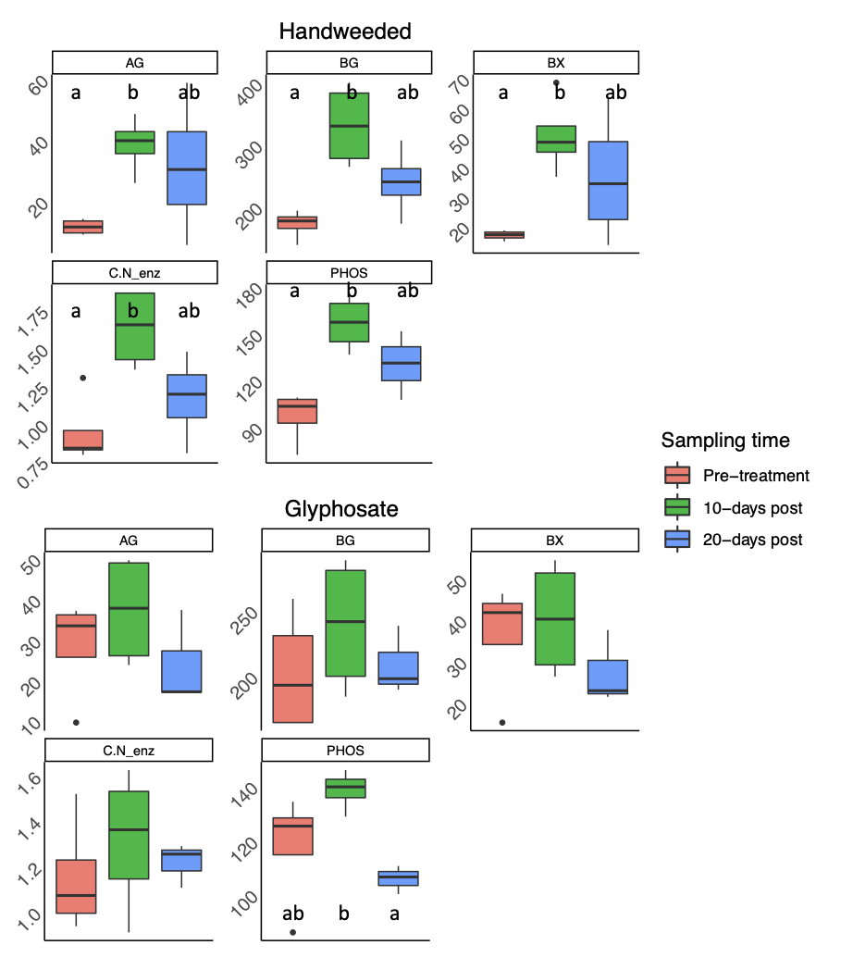

Figure 1. Enzyme activities of the a) handweeded and b) glyphosate treatment plots over three sampling times. Enzyme activities were significant as per global models for AG, BG, BX, the ratio of C:N cycling enzymes, and PHOS for the handweeded plots. Only PHOS activity was significant in the glyphosate plots, but the same trend was observed for many enzymes in both treatment types. Thick middle lines in boxes of box and whisker represent the median, with top and bottom of each box representing the 75th and 25th quartiles, respectively. Whiskers represent 1.5 x IQR. Within each panel, letters indicate significant pairwise differences between sampling time points at α = 0.05. No letters indicate lack of significant pairwise differences.

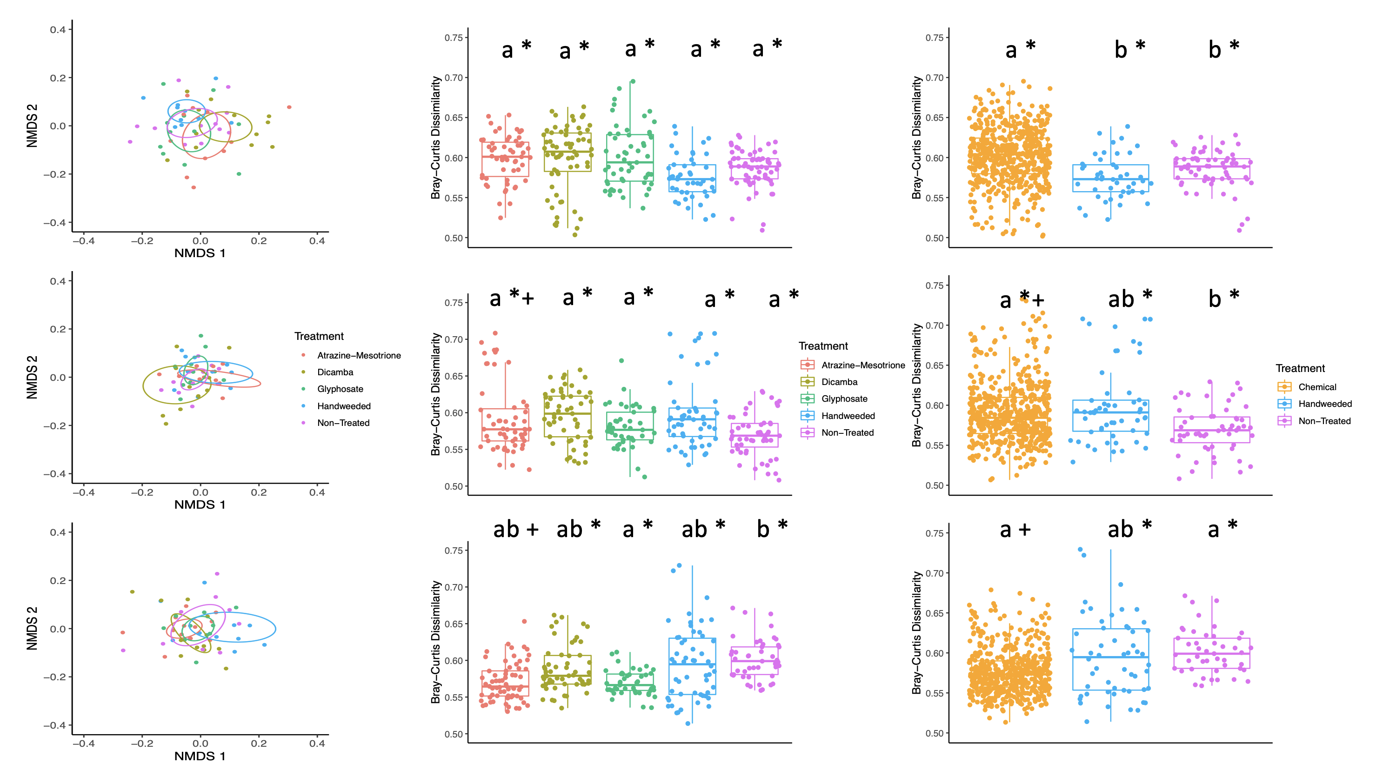

Figure 2. Column 1: 16S ordination of rarefied count tables with 95% SE ellipses. Points indicate independent samples and are colored by treatment type. Column 2: Sample pairwise dissimilarity within treatment types. Letters indicate significance within a single panel (i.e., differences among treatment types). Symbols indicate differences among time points for a single treatment type. For example, in column 2, Atrazine-Mesotrione treated plots differed at sampling time one and three, as indicated by * vs. +. Column 3: Sample pairwise dissimilarity when all chemical treatments were grouped together as a single chemical herbicide treatment. Letters indicate significance within a single panel (i.e., differences among treatment types). Symbols indicate differences among time points for a single treatment type. For example, in column 3, the chemical treated plots differed at sampling time one and three, as indicated by * vs. +.

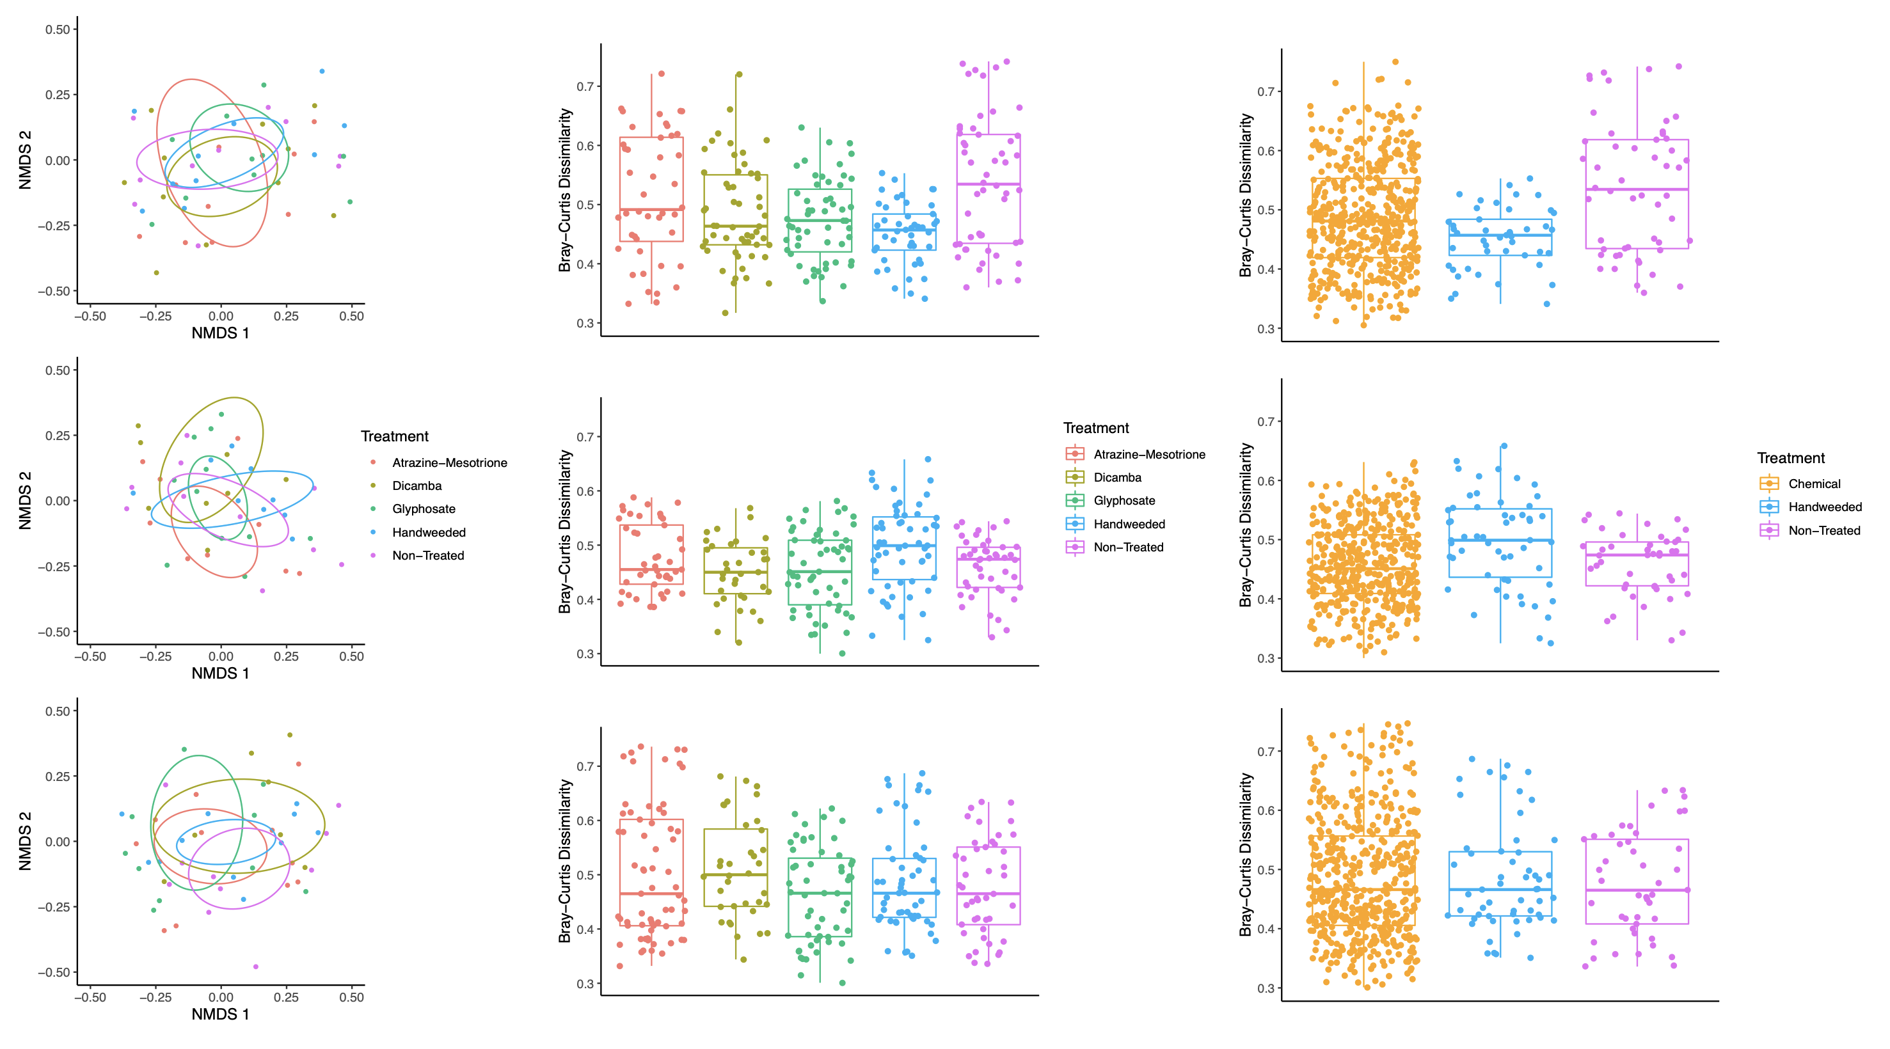

Figure 3. Column 1: ITS ordination of rarefied count tables with 95% SE ellipses. Points indicate independent samples and are colored by treatment type. Column 2: Sample pairwise dissimilarity within treatment types. No significant pairwise differences were detected across treatments within a time point or across time within in single treatment. Column 3: Sample pairwise dissimilarity when all chemical treatments were grouped together as a single chemical herbicide treatment. No significant pairwise differences were detected across treatments within a time point or across time within in single treatment.