Title: Direct and indirect effects of herbicide application on an agricultural soil microbiome

Authors: Gordon F. Custer1,2,3,4*, Joshua G. Harrison5, Andrew R. Kniss6, and Linda TA van Diepen1,2*

ORCIDs: GC: 0000-0002-4328-0714; JH: 0000-0003-2524-0273 ; AK: 0000-0003-2551-4959; LvD: 0000-0002-5902-9364

Affiliations: 1Department of Ecosystem Science and Management, University of Wyoming, Laramie, WY.; 2Program in Ecology, University of Wyoming, Laramie, WY.; 3Department of Plant Science, The Pennsylvania State University, University Park, PA; 4Huck One Health Microbiome Center, The Pennsylvania State University, University Park, PA; 5Department of Botany, University of Wyoming, Laramie, WY.; 6Department of Plant Sciences, University of Wyoming, Laramie, WY.

*denotes corresponding authors

Author Contact: GC – [gfc7@psu.edu](mailto:gfc7@psu.edu), LvD – [lindavandiepen@uwyo.edu](mailto:lindavandiepen@uwyo.edu)

Keywords: Agricultural intensification, homogenization, glyphosate, pesticide, enzymes, bacteria, fungi

**Abstract**

Chemical herbicides, including glyphosate, atrazine, and many others, are commonly used to control unwanted vegetation in agroecosystems and protect crop yield potential. Effects of herbicides on aboveground weedy vegetation are well documented; by comparison, the influence of herbicides on below-ground microbial communities is poorly understood. Given the importance of the soil microbiome for providing ecosystem services, understanding microbial responses to herbicide treatment is of pressing interest. In this study, we examined the non-target effects of herbicide application by comparing three commonly used chemical herbicide treatments — glyphosate, dicamba, and a tank mixture of atrazine plus mesotrione — to handweeded and non-treated controls. We assessed changes in soil microbial function, nutrient pools, and microbiome composition in *Zea mays* over 20 days post-treatment. The examined herbicides were shown to have limited and transient effects on soil edaphic properties and microbial function. Changes in enzymatic activities, nutrient concentrations, and fungal community structure were predicted primarily by weedy vegetation cover, suggesting that the observed responses are indirectly mediated by herbicide application. Conversely, we show that weed removal treatment was a significant predictor of bacterial community composition and that chemical herbicide application resulted in homogenization of the bacterial community, a trend not observed in the non-treated and handweeded controls. Together, our results suggest that chemical herbicide application has a limited effect on microbial diversity and function in agroecosystems. However, the trend of biotic homogenization in agroecosystems warrants further examination.

**Introduction**

Genetically modified herbicide-resistant crops were introduced to the United States in 1996, prompting a shift in herbicide use patterns. Over this time, herbicide use intensity has increased significantly in the United States (1, 2) making these chemical compounds a staple in conventional agriculture. In this way, producers remove unwanted vegetation to reduce crop-weed competition and optimize their systems for annual yield. However, the birth of the soil health movement has encouraged a new way of thinking about agriculture with a greater appreciation for long-term agroecosystem productivity and sustainability. With this school of thought, researchers and producers alike are realizing the importance of considering the non-target effects that herbicide and other agricultural amendments and practices might have on soil and the ecosystem services that it provides (1, 2).

While commonly applied to control unwanted weeds, herbicides have the potential to affect the structure and function of the soil microbiome (1, 3–6). The microbial components of agroecosystems provide countless benefits including plant growth promotion (7), pathogen suppression (8), enhanced nutrient cycling (9–12), as well as aggregate formation and maintenance of soil structure, thus contributing an estimated $330 to $500 per ha annually in ecosystem services (13). Given their critical importance in agroecosystems, understanding how microbial communities respond to herbicide application is necessary to optimize agricultural systems for yield and sustainability.

Reviews aimed at understanding the effects of herbicide application on the soil microbiome reveal a lack of generalizable trends (4, 14–17) and instead show that the consequences are dependent upon the characteristics of the soil, vegetation, herbicide application rate, and the herbicide’s mode of action (1, 4, 18). Further complicating efforts to accurately model the influence of chemical intervention is the fact that herbicides indirectly affect the soil microbiome by changing vegetation cover, thus altering patterns of root exudation (19). To better understand the short-term direct and indirect effects of chemical herbicide application on the soil microbiome, we compared three herbicide treatments, each with a unique mode of action (Table 1), along with handweeded and non-treated controls. We hypothesized that each treatment would produce a unique response in microbiome structure and function due to differences in mode of action (1). Specifically, previous research has shown that the application of a triazine class of herbicides (simazine) disrupts nitrogen cycling in agricultural soils by affecting ammonia oxidizers (20). With this, we hypothesized that the application of atrazine and mesotrione (a triazine herbicide and a triketone herbicide) would affect nitrogen (N) cycling microbes (20), resulting in significant shifts in N-pools and N-acquiring enzyme activities. Additionally, we hypothesized that the glyphosate and dicamba herbicide treatments would negatively affect the soil microbiome by disrupting amino acid synthesis and signaling pathways present in both microbes and plants. In particular, we expected to observe decreased enzymatic activities following herbicide application (21, 22).

**Results**

*Vegetation cover*

At sampling time one (i.e., before treatment), weedy vegetation cover was not significantly different across the treatment plots (p > 0.9, F4,12 = 0.2036) (Figure 1). At sampling times two and three (i.e., ten and twenty days post-treatment, respectively), weed removal treatment was a significant predictor of total weedy cover (p < 0.001, F4,12 > 19.903). Additionally, we show significant pairwise differences among treatments for both total weedy cover and the cover of individual weedy species. By the end of our sampling period, the non-treated plots had a higher % cover of total weedy vegetation, redroot pigweed, and common lambsquarters (Figure 1), as compared to all other weed removal treatments.

*Soil physicochemical responses*

Before treatment, no differences in edaphic conditions were detected across our plots (Supplementary Table A1). Weed removal treatment was a significant predictor of nitrate and total inorganic N content at both post-treatment sampling points (p < 0.05), with total weedy vegetation significant only at the 20-day sampling time (Supplementary Table A2). Glyphosate-treated plots were found to have higher levels of nitrate and total inorganic N than the handweeded plots at both post-treatment sampling points (p < 0.05) (Supplementary Table A3).

When examining how our edaphic variables changed over time within a single weed removal treatment, multiple differences were observed, including nitrate, ammonium, total inorganic N, phosphate, calcium, magnesium, pH, EC, and gravimetric water content (p < 0.05) (Supplementary Table B1, B2 and B3). In all plots, gravimetric water content increased over the 20-day sampling period (p<0.05). Across all treatment and sampling times, the concentration of nitrate was found to be negatively correlated with total vegetation cover, redroot pigweed cover, and lamb’s quarter cover (p < 0.05, r < -0.14), and in general, decreased over the 20-day sampling period (Supplementary Table B1).

*Extracellular enzyme responses*

We report no significant differences in total enzymatic profiles among weed removal treatments at any of the individual sampling times (p > 0.25, F4,14 < 1.261, R2 < 0.195). However, total weedy vegetation cover was a significant predictor of differences in enzymatic profiles at the 10- and 20-day post-treatment sample times (p < 0.05, F1,14 > 4.411, R2 > 0.195). For individual enzymes, only alkaline phosphatase (PHOS), ß-glucosidase (BG), and the ratio of N:P cycling enzymes showed significant differences among herbicide treatments (p < 0.05) (Supplementary Table C1). At the pre-treatment sampling, the nontreated plots showed significantly higher initial PHOS activity and a lower N:P ratio as compared to the handweeded plots (p < 0.05) (Supplementary Table C1). The activity of BG spiked in the handweeded plots compared to the other treatments at sampling time two, although pairwise differences were not detected (Supplementary Table C1, C2, and C3) (Figure 2). Total weedy vegetation was a significant predictor for BX, AG, and PHOS at time one, and for BG, LAP, and the ratio of C:P cycling enzymes at sampling time two (Supplementary Table C2). In all cases, β-coefficients of the regressions were positive, indicating that total weedy vegetation positively affected enzyme activity.

When examining the effect of time within a single weed removal treatment, only the handweeded plots showed a significant difference in total enzymatic profile over the 20-day sampling period (p < 0.01, F2,11 = 6.88, R2 = 0.607). The atrazine + mesotrione, dicamba, and nontreated plots showed no differences in overall enzymatic profiles or individual enzyme activities throughout the sampling period (p > 0.05). Phosphatase activity was the most variable of the measured enzymes over the 20 days, showing a statistically significant increase in activity at 10-days after treatment followed by a reduction 20-days after treatment in both the handweeded and glyphosate-treated plots (p < 0.05) (Figure 2) (Supplementary Table D1).Additionally, the handweeded and glyphosate-treated plots also displayed similar trends in the activity of AG, BG, BX, and the ratio of C:N cycling enzymes, with the lowest activity pre-treatment and the highest at sampling time two (i.e., 10 days post-treatment) followed by a return to pretreatment levels at sampling time three (i.e., 20 days post-treatment) (Figure 2). However, this was only statistically significant for the handweeded plots (p < 0.05) (Figure 2, Supplementary Table D1). Finally, mantel testing of edaphic conditions and enzymatic activities showed that distance matrices of nutrient availability and enzymatic activities were not correlated (p > 0.75, r = -0.037).

Linear mixed effects modeling revealed enzyme-specific responses to weed removal treatment, initial enzyme activity, total weedy vegetation, and the interaction of sampling time and weed removal treatment. BG, LAP, and the ratio of C:P cycling enzymes were predicted by total weedy vegetation (p < 0.05) (Supplementary Table E1). Positive β-coefficients for weedy vegetation cover indicate that higher weed cover led to increased enzyme activity. Both BG (p = 0.055) and LAP (p < 0.05) were predicted by the interaction of treatment and time, though this was only marginally significant for BG. The level of PHOS activity before treatment was deemed a significant predictor of PHOS activity at times two and three (p < 0.05). Both herbicide treatment (p = 0.057) and the treatment by time interaction (p = 0.052) were marginally significant for predicting PHOS activity as well. All other mixed models for enzyme activity produced no significant predictors (Supplementary Table E1).

*Bacterial diversity*

After outlier removal, 164 independent samples were included in the downstream analysis. Rarefied results are reported unless otherwise noted. No differences in bacterial α-diversity (Shannon, richness, or Chao1) were found between the treatment types at any of the sampling times (p > 0.26). Adonis testing of the rarefied and Dirichlet Multinomial (DMN) transformed taxon tables across all sampling timepoints showed a significant, but minor effect of weed removal treatment (p < 0.05, F4,147 = 1.101, R2 = 0.0268), and an effect of the interaction of weed removal treatment by time (p < 0.001, F8,147 = 1.189, R2 = 0. 0579) (Figure 3, column 1). When split by time point, the effect of herbicide treatment was significant across all three sampling events for the DMN transformed count table (p < 0.01) and only at timepoints one and three for the rarefied table (p < 0.05). Total weedy vegetation was a significant predictor of bacterial β-diversity at sampling time two for both the rarefied and DMN transformed count tables (p < 0.05). The effect of sampling time on community dissimilarity was not significant for the rarefied taxon count tables (p = 0.11, F2,147 = 1.094, R2 = 0.0133) but was significant for the DMN table (p < 0.01, F2,152 = 2.1183, R2 = 0.02247).

We then assessed the difference in multivariate dispersion to understand how herbicide application may affect biotic homogenization in the soil microbiome. Glyphosate and atrazine + mesotrione treated plots showed homogenization in their bacterial community over the 20-day sampling period (p < 0.057) (Figure 3, column 2). The handweeded and nontreated plots showed a trend of increased heterogeneity, though this was not statistically significant. When all chemical treatments were combined into a single chemically treated herbicide group, we found higher levels of dispersion as compared to the non-treated and handweeded plots at sampling time one (p < 0.01) (Figure 3, column 3). However, the dispersion of the chemically treated group decreased over the next 20 days, while the non-treated and handweeded plots had the same level of dispersion throughout the 20 days. At the final sampling, the chemically treated herbicide group showed similar levels of dispersion as the handweeded plots, but still higher dispersion compared to the non-treated plots.

Changes in the abundance of dominant families over time were detected in all treatment groups. Of particular interest, the family Sphingomonadaceae showed a statistically significant increase in abundance in all chemical herbicide-treated plots (p < 0.001, F2,30 = 9.469). No other consistent taxon enrichments or depletions were detected across herbicide or treatment types. Linear modeling of bacterial taxa identified by simper and the Boruta machine learning classification algorithm showed that weed removal treatment, sampling time, and total weedy vegetation explained at most 15% of the variation in taxon abundance (Supplementary Table F1).

*Fungal Diversity*

After outlier removal, we report 157 independent samples for downstream analysis. Rarefied results are reported unless otherwise noted. No differences in α-diversity (Shannon, richness, or Chao1) were found between the treatment types at either of the first two sampling times (p > 0.3). At 20 days post-application, Shannon diversity (H`) was marginally significant (p = 0.051, F4,48 = 2.551), with no significant pairwise differences between treatments. PERMANOVA testing of the rarefied and DMN taxon tables revealed significant effects of sampling time (p < 0.05, F2,140 < 1.521, R2 = 0.019), total weedy vegetation (p < 0.01, F1,140 = 1.845, R2 = 0.0116), and the interaction of sampling time*herbicide (p < 0.05, F8,140 = 1.185, R2 = 0.059) (Figure 4, column 1). When split by sampling timepoint, we report total weedy vegetation to be a significant predictor of β-diversity at sampling times one and two for both the DMN and rarefied tables (p < 0.05). Weed removal treatment was not significant at any of the individual timepoints (p > 0.2). No clear trends in dispersion within treatments through time were found for the fungal community (Figure 4 – columns 2 & 3).

Shifts in dominant fungal families revealed an increased abundance of Ceratobasidiaceae in the glyphosate-treated plots over the three sampling times (p < 0.001, F2,30 = 9.469). Additionally, the family Spizellomycetaceae showed an increase in abundance in the two controls as well as the glyphosate-treated plots over the sampling period (p < 0.05, F2,28  > 3.351). Linear modeling of fungal taxa identified by simper and the Boruta classification algorithm showed that weed removal treatment, sampling time, and total weedy vegetation explained -at most- a total of 33% of the variation in taxon abundances (Supplementary Table G1). However, these taxa were rare and often not detected across samples.

**Discussion**

The application of chemical herbicides in conventionally managed agricultural systems is widespread. However, a comprehensive understanding of how these agrochemicals affect below-ground microbial processes remains lacking. Our experimental results aid in this appreciation and suggest that soil microbial function in conventionally managed agroecosystems is largely resistant and resilient to herbicide application over a period of 20 days post-treatment. Furthermore, we show that the factors affecting bacterial and fungal diversity over our 20-day sampling period differed, with bacterial community composition responding significantly to weed removal treatments and fungi responding to changes in total weedy vegetation. Additionally, the convergence of bacterial communities following chemical herbicide applications suggests that, regardless of the herbicide type, chemical intervention homogenizes the bacterial compartment in soil and leads to a “chemically disturbed” microbiome, contrary to our initial hypothesis. Finally, and perhaps most importantly, experimental designs that incorporate handweeded and untreated plots (23) are extremely valuable as they allow for direct and indirect effects of herbicide application to be teased apart. This improved understanding offers valuable insight into the dynamics of the soil microbiome following vegetation removal and permits an accurate assessment of the effects of chemical herbicide application.

The lack of differences in total enzymatic profiles between treatments at sampling time one indicates that our plots were functionally homogeneous before treatment, and as such, any differences at the subsequent time points can be attributed to our weed-removal treatments. At ten days post-treatment, weed removal treatments did not affect enzymatic profiles, but total weedy vegetation did. This supports the idea that the effects of herbicide application on soil function are indirectly mediated through changes in vegetation (18, 19). This trend was also observed for the fungal community, with total weedy vegetation significantly affecting the composition of the fungal microbiome. As plant diversity is known to influence fungal diversity (24) and fungi are thought to be largely responsible for the degradation of plant litter (25), it is not surprising that total weedy vegetation cover affects microbial enzymatic profile (26) though its influence on soil fungi.

Although we report transient increases in the enzymatic activities in glyphosate-treated plots, we also observed this trend in our handweeded controls. This finding suggests that an increase in available above- and below-ground plant detritus may be responsible, as opposed to a direct effect of glyphosate application. With the observed spike in enzyme activities and a return to pre-treatment levels, we believe that labile litter inputs would stimulate decomposition. However, once the detritus became more recalcitrant or its C:N ratio increased, it may no longer be favorable for decomposition, resulting in the observed decrease in extracellular enzyme activity from 10 to 20-days post-application. A soil microcosm experiment also observed this hump-shaped response in microbial activity over 20 days post-application. However, the duration of the increase in respiration was affected by the application rate, something we did not change in our experiment (27).

The response of microbial enzymatic activity to glyphosate-based herbicides in clay-loam soils has been shown to display temporal variability, with alkaline phosphatase being more sensitive (29) than other members of the phosphatase enzyme family. Using a controlled mesocosm experiment to examine the effect of glyphosate on phosphatase activity, Cherni et al. (30) showed no differences between the recommended field rate group (1 L/ha) and untreated controls and only a mild increase in activity at 10X field application rates (10 L/ha). As our application rate was only slightly above the 1X and well below the 10X rates used by Cherni et al. (30), it is not surprising that shifts in PHOS activity were minimal and only short-lived. To this end, others have also shown a high glyphosate dose requirement to observe significant effects on microbial activity (27, 31, 32) and hypothesize that at these high rates, increased microbial activity may be a result of detrimental effects to lithotrophic microbes (28). If true, this would shift the competitive balance among soil microbes, favoring heterotrophs. The observed increase in the abundance of Sphingomondaceae provides support for this hypothesis and suggests a competitive advantage for these putative herbicide degraders following chemical herbicide application (33).

Given the importance of nitrogen availability for agricultural productivity (34), understanding the influence of chemical herbicides on nitrogen-cycling microbes should remain a primary concern. Although our sequencing approach did not specifically target these microbes, measures of inorganic nitrogen availability and nitrogen cycling enzymes provide clues to their response. Previous work examining the effects of glyphosate on soil N showed no differences in inorganic N pools between vegetation removal plots over twenty weeks (e.g., handweeded and glyphosate) (23). However, Hagner et al. reported significant differences between their handweeded and nontreated plots, showing nitrate levels, as measured by resin ion exchange strips, to be higher in their handweeded plots as compared to their nontreated controls (23). Their result indicates that the removal of vegetation may lead to increased soil nitrate levels. In contrast, our study found nitrate levels to be lowest in our handweeded and nontreated plots, with concentrations being highest in our glyphosate plots. While our results may appear superficially different from Hagner et al. (23), we show that nitrate concentrations were significantly correlated with vegetation cover, and at 20 days post-treatment, the handweeded plots experienced increased weedy vegetation and crop cover, potentially contributing to decreased inorganic N availability. Given the lack of difference between their handweeded and glyphosate-treated plots and the observed correlations between nitrate concentration and vegetation cover in our experiment, we suggest that differences in inorganic nitrogen between glyphosate, handweeded, and nontreated plots are mediated through changes in vegetation instead of a direct effect of herbicide application (18, 28).

Beyond glyphosate, differences in N-cycling have also been reported following triazine application, with a general trend of short-term reduction in the rate of N mineralization following application (20, 35). Accordingly, we show a decrease in the inorganic N pool in the atrazine+mesotrione treated plots over the 20-day post-application period, providing support for our hypothesis and further evidence that this herbicide affects nitrogen-cycling microbes. Importantly, however, the trend of decreased inorganic N was observed in other treatments as well. Together with the observed correlations with total weedy vegetation, we are unable to determine if this effect is direct or indirect as the crop, *Zea mays*, and other weedy vegetation may be partially responsible for a reduction in inorganic N through uptake and immobilization in plant biomass.

Although the effects of chemical herbicides on soil microbial function and physicochemical parameters appear to be limited in scope, the observed homogenization of the bacterial community following chemical treatment is potentially cause for concern. Biotic homogenization may severely limit the ability of ecosystems to respond to global change scenarios, thus negatively affecting long-term stability (36–38). In particular, in conventional agricultural systems, there is evidence that the intensive use of agrochemicals and disturbance (e.g., tillage) to boost productivity may result in a reduction in β-diversity of microbiomes as compared to organic practices (39). As we face increasingly common climatic extremes (40), maintaining the resiliency of agroecosystems is imperative for the continued provisioning of a stable global food supply (41).

Taken together, the limited functional and fungal responses, along with bacterial community homogenization following chemical treatment, directly refute our hypothesis that each mode of action would result in a unique response in community structure and function. Additionally, the importance of total weedy vegetation suggests that instead of direct effects, herbicide application may primarily affect the soil microbiome via indirect mechanisms. With this, our findings are not all that surprising due to the high degree of functional redundancy in the soil microbiome (42, 43) and the fact that we applied our herbicide treatments at the recommended field rates. With respect to agricultural systems, it appears that the direct effects of chemical herbicides on microbial function are few and short-lasting. In heavily managed, conventional agricultural systems, the choice of herbicide has no lasting effect on soil function, and the observed effects are mediated through indirect pathways.

**Methods**

*Site description and experimental design*

In the summer of 2018, 20 experimental plots were established at the at the University of Wyoming James C. Hageman Sustainable Agriculture Research and Extension Center (SAREC) (42°07’45.92”N, 104°23’24.88”W, 1,276m elevation) in Lingle, WY (MAT 8.4° C). Plots were fertilized using a dry fertilizer before corn planting following best farming practices (40 rock fertilizer- 125Nitrogen-35Phosphorus-0Potassium-35Elemental Sulfur-13Sulfate-2Zinc blend -J.R. Simplot Company, Boise, ID). Plots were then planted with *Zea mays* variety ‘P9188AMX’ at 84,000 seeds/ha on May 16, 2018 and irrigated weekly using a lateral sprinkler system. The soil at this site has an alkaline pH (7.8), CaCO3 content between 1 and 3%, organic matter content of 1.4%, and CEC of 19.6. The soil is characterized as loam (42% sand, 37% silt, and 21% clay) (44) and is mapped as a well-drained Haverson and McCook loam (i.e. HnA), 0-3% slope (Web Soil Survey, USDA-NRCS). Each plot, 3 m x 10 m, consisted of four rows of *Zea mays* spaced 76 cm apart. The experimental design was a randomized complete blockwith four replicates of each treatment. Treatments included a non-treated control (herein referred to as non-treated), a handweeded control (herein referred to as handweeded), and three different chemical herbicide applications applied at recommended field rates (Table 1): glyphosate (WSSA site of action group 9), dicamba (WSSA site of action group 4), and a tank mix consisting of atrazine (WSSA site of action group 5) plus mesotrione (WSSA site of action group 27). In the handweeded plots, above-ground vegetation was cut using a hoe and left on the soil surface on June 11, 2018. Belowground biomass was not disturbed and remained in the soil. A pre-treatment sampling was conducted on the morning of herbicide application on June 5, 2018. Following herbicide application and hand weeding, two post-treatment samplings were conducted: 10 days post-treatment and 20 days post-treatment.

*Sampling and analysis*

To facilitate sampling, a grid was laid out over each plot, and the coordinates of sample locations were determined using a random number generator. The corn stalk closest to the randomly generated coordinate was selected, and a 0.25 m2 Daubenmire plot was placed so that the stalk was in the center. Cover classes of the main weeds, including redroot pigweed (Amaranthus retroflexus), nightshades (Solanaceae), common lambsquarters (*Chenopodium album*), and any graminoid, were recorded for each Daubenmire plot. Total weedy vegetation cover was estimated by summing the midpoint of cover classes.

Three replicate soil samples per plot were collected at each of the time points for a total of 180 samples (5 treatments x 4 replicate plots x 3 sample replicates x 3 time points). Each plot replicate soil sample was a composite of three soil cores from a single Daubenmire to ensure sufficient soil for laboratory analyses.Soil samples were collected using a flame-sterilized soil corer to a depth of 5 cm and stored on ice in sterile Whirl-Pak bags. *In situ* soiltemperature was measured at a depth of 2.5 cm using a temperature probe. Soil samples were transported back to the University of Wyoming on ice for further processing.

In the lab, field-fresh soil samples were processed within 24 hours. Soil samples were first thoroughly mixed in the Whirl-Pak bag used for collection and then sieved through an ethanol-cleaned 2 mm sieve. Gravimetric water content was determined by weight difference of a five-gram subsample of sieved field-fresh soil after oven drying at 105° C for 24 hours. Next, ~11 g of sieved soil was weighed out for extraction in 50 mL of 0.5 M K2SO4 for assessment of extractable levels of cations (ammonium, calcium, sodium, and magnesium) and anions (nitrate, nitrite, phosphate, and chloride) on a Thermo Scientific Dionex Integrion HPIC system (Thermo Fisher Scientific, Waltham, MA). Briefly, samples were shaken in extractant for 30 minutes, stored at 4 °C overnight, and filtered through Fisherbrand Q5 filter paper the next day. Filtered extracts were diluted with nanopore water (1:10) before analysis and filtered through a 0.45 μm hydrophilic filter as per (45). Anions were run on a Dionex IonPac AS18 4 um 4x150 mm column for 20 minutes with a flow rate of 1.0 mL/min at 35 °C. Cations were run on a Dionex IonPac CS16-Fast 4um 4x150mm column for 20 minutes with a flow rate of 0.64 mL/min at 40°C. Raw values of anions and cations were reported as ppm and converted to mg/kg dry soil. The remaining soil was then split into two portions, of which one was frozen at -20 °C for microbial analysis (e.g., DNA extraction for determination of microbial community structure and extracellular enzyme analysis for microbial function), and the other portion was air-dried. Air-dried soil was used to measure pH and electrical conductivity using an Oakton PC700 benchtop meter (OAKTON instruments, Vernon Hills, IL) with a soil to DI water ratio of 1:2 (w:v).

*Extracellular enzyme analysis*

Extracellular enzyme activities (EEA) were measured for seven enzymes involved in the cycling of carbon (C), nitrogen (N), and phosphorus (P) as outlined in (46–50). The enzymes measured include ß-glucosidase (BG), β-xylosidase (BX), α-glucosidase (AG), cellobiohydrolase (CBH), alkaline phosphatase (PHOS), N-acetyl-ß-glucosaminidase (NAG), and leucine aminopeptidase (LAP). A preliminary assay was performed using four different substrate concentrations (ranging from 200 μM to 4000 μM) at five different measurement times (1, 2, 4, 6, 8, and 10 hours). This was done to ensure non-limiting substrate availability and maximum potential enzyme activity (Vmax) (51). Three soil samples encompassing the expected variability in enzyme activity were used for these preliminary assays. Briefly, a soil slurry was created by homogenizing 1 g of soil with 100 ml of sodium acetate buffer (50 mM, pH 7.95) for 30 seconds using a Magic Bullet blender (Homeland Housewares LLC). To minimize the difference between buffer and soil pH, we used a buffer pH of 7.95 which represents the mean pH of all soil samples within 1 standard deviation. In a 96-well microplate, 200 μL of soil slurry homogenate was combined with 50 μL substrate and incubated at 20 °C for 1-10 hours. Four technical replicates per soil sample were used to measure fluorescence after the addition of substrates. Hydrolytic enzyme activity was measured via fluorescence on a SYNERGY HTX multi-mode reader (BioTek® Instruments Inc., Winooski, VT) at an excitation wavelength of 360 nm and an emission wavelength of 450 nm. Background fluorescence was corrected using a negative control (sample homogenate with buffer), as well as a quench control (sample homogenate with standards). This was done to correct for interference of soil particles with fluorescence intensity. Fluorescence conversions were based on measurements of standards (10 μM): 7-amino-4-methylcoumarin hydrochloride (AMC) for LAP and 4-methylumbelliferone (MUB) for BG, BX, AG, CBH, NAG, and PHOS. Final enzyme activities were calculated using formulas outlined in DeForest (49) and were reported as nmol of substrate converted per hour per g soil dry mass (nmol h-1 g-1). The incubation time and substrate concentration, from the preliminary assay, producing the highest average enzyme activity were selected for each enzyme. This resulted in a single substrate concentration and incubation time to be used for each enzyme across all samples for final enzyme assays. Final enzyme assays for all samples were done similarly to the preliminary assays but using the substrate concentration and incubation time that resulted in the maximum potential enzyme activity (Vmax). One sample from each plot was used for enzyme analysis for a total of 20 samples at each time point and 60 samples across the three time points. The ratios of carbon, nitrogen, and phosphorous cycling enzymes were calculated to determine the relative activities. These ratios were determined by summing the activities of each enzyme group. For example, total C-cycling enzyme activity is the sum of the activities of BG + AG + CBH + and +BX. Total N-cycling enzyme activity was calculated as the activities of LAP + NAG. Total phosphorus cycling enzyme activity was simply the value of PHOS as this was the only phosphorus cycling enzyme assayed. Finally, the ratios of these groups were determined by dividing total C/total N (C:N), total C/total P C:P, and total N/total P (N:P) (52).

*Microbiome library preparation*

Subsamples of the same soils used for edaphic measurements were extracted using PowerSoil extraction kits (MO BIO, Carlsbad, CA) according to the manufacturer’s instructions. Soil DNA extracts were stored at -20 °C until PCR and library preparation.

Both bacterial (16S) and fungal (internal transcribed spacer; ITS) amplicon libraries were prepared in the same fashion, though different primers were used to amplify each region. To amplify the V4 region of the bacterial 16S rRNA gene the modified 515F (5’-GTGYCAGCMGCCGC GGTAA-3’) (53) and 806R (5’-GGACTACNVGGGTWTCTAAT-3’) (54) primers were used. For the ITS1 region of the fungal genome, the primers ITS1F (5'-CTTGGTCATTTAGAGGAAGTAA-3') (55) and ITS2 (3'-CGTAGCTACTTCTTGCGTCG-5') (56) were used. Environmental DNA (eDNA) was normalized to 10 ng/μL before amplification. The 15 μL reactions contained 3 μL 5x Kapa HiFi HotStart PCR buffer (Roche, Basel, Switzerland), 0.45 μL 10M dNTPs, 0.3 μL Kapa HiFi HotStart DNA polymerase (Roche, Basel, Switzerland), 3.25 μL HPLC H2O, 6 μL of appropriately paired barcoded primers (3 μL forward and 3 μL reverse), and 2 μL of the diluted 10 μL eDNA sample. In a two-step process, eDNA was amplified and barcoded, then Illumina adaptors were added. In the amplification and barcoding step, the following PCR conditions were used: 95 °C for 3 min (1 cycle), 15 cycles of 98 °C for 30 sec, 62 °C for 30 sec, 72 °C for 30 sec, and 72 °C for 5 min (1 cycle). PCR was performed in duplicate for each sample and combined to limit PCR biases. PCR products were cleaned using Axygen’s AxyPrep Mag PCR Clean-up Kit according to manufacturer instructions without the addition of TE buffer (Axygen Biosciences, Union City, CA). In the second step of the PCR, Illumina barcodes were added to our DNA samples. Each reaction in this step consists of 10 μL of cleaned PCR product from the first step and 5 μL of FlowCell master mix consisting of 3 μL of 5x Phusion HF buffer (Thermo Fisher Scientific, Waltham, MA, USA), 0.45 μL 10M dNTPs, 0.3 μL Kapa HiFi HotStart DNA polymerase (Roche, Basel, Switzerland), 0.5 μL 10 μM forward (AATGATACGGCGACCACCGAGATCTACACTCGTCGGCAGCGTC) and reverse (CAAGCAGAAGACGGCATACGAGATGTCTCGTGGGCTCGG) FlowCell primers, and 0.75 μL HPLC H2O. In the Illumina adaptor addition step, the following PCR conditions were used: 95 °C for 3 min (1 cycle), 19 cycles of 98 °C for 30 sec, 55 °C for 30 sec, 72 °C for 30 sec, and 72 °C for 5 min (1 cycle). PCR products from the second step were cleaned using GSAF’s modified MagBead protocol and Axygen’s AxyPrep Mag PCR Clean-up Kit. Following cleaning, sample concentration was checked using a Synergy HTX Take 3 trio plate reader. Sample DNA concentrations were then normalized and combined, and the final library concentration was checked using qPCR. The final library was sent for sequencing at Psomagen genomic sequencing and analysis facility (Rockville, MD) on their NovaSeq6000 using paired-end 2 x 250 bp chemistry with a 10% PhiX spike in. Both the fungal and bacterial libraries we sequenced together on a single lane and were separated bioinformatically.

*Bioinformatic processing of sequence data*

Sequence data were processed using vsearch 2.9.0 (57). Paired-end reads were merged and reads with more than a single estimated error were removed. Reads were clustered into operational taxonomic units using a 99% similarity threshold. Taxonomy was assigned using the sintax algorithm (58) and the Greengenes (59) database for bacteria (v13.5) and the Unite (60) database for fungi (downloaded: April 4, 2020). To control for uneven sampling depths, bacterial and fungal count tables were rarefied to 3,000 and 1,000 reads per sample, respectively.

In addition to rarefaction, the relative abundances of microbial taxa (OTUs) within a treatment group were modeled using the CNVRG algorithm (61). This was done on unnormalized count tables. This model uses a Bayesian approach to estimate proportional relative abundances using the Dirichlet and multinomial distributions. Multinomial parameters are estimated for each sample and correspond to the proportional abundance of a taxon in a sample. The model is hierarchical and uses the Dirichlet distribution as a prior for this multinomial. The parameters of the Dirichlet distribution describe the proportional abundance of a taxon within a sampling group. This approach allows for a very sensitive comparison of taxon relative abundances across groups through accurate proportional abundance determination. Multinomial parameters can be used as a taxon by sample table of proportions for downstream analyses.

*Statistical analysis*

While soil samples collected from within the same treatment plot could be considered pseudoreplication and would thus violate the assumption of independent observations, we argue that pseudoreplication is scale dependent, and the scale that microbes operate on would allow us to assume independence among samples collected from the same treatment plot. With aboveground vegetation acting as a driver of belowground function and vegetation being heterogeneous meter to meter within a single treatment plot, we decided to treat each composite soil sample as an independent sample instead of averaging samples within a plot and losing the ability to assess variation within a treatment plot. All statistical analyses were carried out in R V4.1.1 - “Kick Things” (62). For all statistical comparisons, we report statistical significance at α = 0.05 and marginal significance at α = 0.1.

*Edaphic, enzymatic, and vegetation statistical analyses*

Edaphic and enzymatic measurements were analyzed using ANCOVA. Our dataset was subset into either: 1) individual time points containing all five weed removal treatment types or 2) individual weed removal treatments that contained all sampling three time points. In both cases, total weedy vegetation cover was included as a covariate. The first set of statistical models was used to compare the effects of weed removal treatment within a single time point (Y ~ weed removal treatment + total weedy vegetation, data = time point containing all five treatment types). The second set of models was used to examine changes over time within a single weed removal treatment (Y ~ time + total weedy vegetation, data = individual treatment type with all three time points). Pairwise differences in edaphic parameters among time points and treatment types were assessed using Tukey’s HSD. In addition, we utilized a conservative mixed modeling approach to examine the effect of time, weed removal treatment, and total weedy vegetation on enzyme activity simultaneously using linear mixed models, with fixed effects of weed removal treatment, pre-treatment enzyme activity (to account for initial differences), total weedy vegetation, and a time*weed removal treatment interaction. The random effect in our model was limited to sampling time to account for temporal non-independence (Y ~ pre-treatment enzyme activity + treatment + time + total weedy vegetation + treatment*time + (1|time), data = all data points from time two and three).

Multivariate response to weed removal treatments and time since treatment was assessed using PerMANOVA testing implemented using the Adonis function in the vegan package (63, 64). Non-metric multidimensional scaling (NMDS) was utilized to visualize differences in total enzymatic profiles (i.e., Bray-Curtis dissimilarities of all enzymes). Mantel testing was implemented to examine correlations in the distance matrices of edaphic conditions and enzymatic activities.

Differences in the cover of total weedy vegetation, lamb’s quarter, and redroot pigweed across herbicide treatments within a single time point were assessed individually using ANCOVA. These measurements were collected as cover classes and converted to a continuous covariate (e.g., 0% = 0, 1-5% = 1, 6-15% = 2). Thus, we do not report percent change or means following treatment, only the directionality of change.

*Microbiome statistical analyses*

Differences in microbial alpha-diversity (α) across herbicide types were assessed using the rarefied taxon count table within each sampling time point. A significant effect was noted when the herbicide-treated plots diverged from either of the controls. The effect of herbicide on community dissimilarity was assessed using both rarefied taxon count tables and the Dirichlet multinomial (DMN) modeled point estimates generated by the CNVRG package (61). Significant effects of herbicide treatment were determined by PERMANOVA testing using beta_dispr() and adonis() functions in the vegan package (63). Total weedy vegetation was included in these models (Y ~ Herbicide * Time + total weedy vegetation, permutations = 1,000). Heterogeneity in microbiome composition at each sampling was assessed using Bray-Curtis dissimilarities and visualized with boxplots of pairwise dissimilarities to all other members of that treatment group. Significant differences in multivariate dispersion were assessed using beta_dispr(). All chemical treatments were analyzed separately and then again when combined as a single treatment group, herein referred to as “chemical herbicide”. Shifts in community composition were visualized using NMDS implemented in the vegan and ggordiplots packages. Those taxa accounting for variation among treatments were identified via the Boruta classification algorithm (65) and simper (63). The response of these taxa was then modeled using Hellinger-transformed relative abundances and zero-inflated beta regression with time, weed removal treatment, and total weedy vegetation as fixed effects. The top 25 most abundant families were identified and shifts in their abundance over time were identified using ANOVA with sampling time as the fixed effect.

**References**

1. Rose MT, Cavagnaro TR, Scanlan CA, Rose TJ, Vancov T, Kimber S, Kennedy IR, Kookana RS, Van Zwieten L. 2016. Impact of Herbicides on Soil Biology and FunctionAdvances in Agronomy. Elsevier Inc.

2. Palm C, Blanco-Canqui H, DeClerck F, Gatere L, Grace P. 2014. Conservation agriculture and ecosystem services: An overview. Agric Ecosyst Environ 187:87–105.

3. Tu CM, Bollen WB. 1968. Interaction between Paraquat and microbes in soils. Weed Res 8:38–45.

4. Nguyen DB, Rose MT, Rose TJ, Morris SG, van Zwieten L. 2016. Impact of glyphosate on soil microbial biomass and respiration: A meta-analysis. Soil Biol Biochem 92:50–57.

5. Álvarez-Martín A, Hilton SL, Bending GD, Rodríguez-Cruz MS, Sánchez-Martín MJ. 2016. Changes in activity and structure of the soil microbial community after application of azoxystrobin or pirimicarb and an organic amendment to an agricultural soil. Applied Soil Ecology 106:47–57.

6. Liao H, Li X, Yang Q, Bai Y, Cui P, Wen C, Liu C, Chen Z. 2021. Herbicide selection promotes antibiotic resistance in soil microbiomes.

7. de Souza R, Ambrosini A, Passaglia LMP. 2015. Plant growth-promoting bacteria as inoculants in agricultural soils. Genet Mol Biol 38:401–419.

8. Durán P, Thiergart T, Garrido-Oter R, Agler M, Kemen E, Schulze-Lefert P, Hacquard S. 2018. Microbial Interkingdom Interactions in Roots Promote Arabidopsis Survival. Cell 175:973–983.

9. Chen CR, Condron LM, Davis MR, Sherlock RR. 2002. Phosphorus dynamics in the rhizosphere of perennial ryegrass (Lolium perenne L.) and radiata pine (Pinus radiata D. Don.). Soil Biol Biochem 34:487–499.

10. Richardson AE, Barea J-M, McNeill AM, Prigent-Combaret C. 2009. Acquisition of phosphorus and nitrogen in the rhizosphere and plant growth promotion by microorganisms. Plant Soil 321:305–339.

11. Richardson AE, Simpson RJ. 2011. Soil Microorganisms Mediating Phosphorus Availability Update on Microbial Phosphorus. Plant Physiol 156:989–996.

12. Garcia J, Kao-Kniffin J. 2018. Microbial Group Dynamics in Plant Rhizospheres and Their Implications on Nutrient Cycling. Front Microbiol 9:1–7.

13. Sandhu HS, Wratten SD, Cullen R, Case B. 2008. The future of farming: The value of ecosystem services in conventional and organic arable land. An experimental approach. Ecological Economics 64:835–848.

14. Imfeld G, Vuilleumier S. 2012. Measuring the effects of pesticides on bacterial communities in soil: A critical review. Eur J Soil Biol 49:22–30.

15. Bünemann EK, Schwenke GD, Van Zwieten L. 2006. Impact of agricultural inputs on soil organisms - A review. Australian Journal of Soil Research 44:379–406.

16. Puglisi E. 2017. Response of microbial organisms (aquatic and terrestrial) to pesticides. EFSA Supporting Publications 9.

17. Thiour-Mauprivez C, Martin-Laurent F, Calvayrac C, Barthelmebs L. 2019. Effects of herbicide on non-target microorganisms: Towards a new class of biomarkers? Science of the Total Environment 684:314–325.

18. Weidenhamer JD, Callaway RM. 2010. Direct and Indirect Effects of Invasive Plants on Soil Chemistry and Ecosystem Function. J Chem Ecol 36:59–69.

19. Lekberg Y, Wagner V, Rummel A, McLeod M, Ramsey PW. 2017. Strong indirect herbicide effects on mycorrhizal associations through plant community shifts and secondary invasions. Ecological Applications https://doi.org/10.1002/eap.1613.

20. Hernández M, Jia Z, Conrad R, Seeger M. 2011. Simazine application inhibits nitrification and changes the ammonia-oxidizing bacterial communities in a fertilized agricultural soil. FEMS Microbiol Ecol 78:511–519.

21. Riah W, Laval K, Laroche-Ajzenberg E, Mougin C, Latour X, Trinsoutrot-Gattin I. 2014. Effects of pesticides on soil enzymes: A review. Environ Chem Lett 12:257–273.

22. Tejada M. 2009. Evolution of soil biological properties after addition of glyphosate, diflufenican and glyphosate+diflufenican herbicides. Chemosphere 76:365–373.

23. Hagner M, Mikola J, Saloniemi I, Saikkonen K, Helander M. 2019. Effects of a glyphosate-based herbicide on soil animal trophic groups and associated ecosystem functioning in a northern agricultural field. Sci Rep 9:8540.

24. Millard P, Singh BK. 2010. Does grassland vegetation drive soil microbial diversity? Nutr Cycl Agroecosyst 88:147–158.

25. Bani A, Pioli S, Ventura M, Panzacchi P, Borruso L, Tognetti R, Tonon G, Brusetti L. 2018. The role of microbial community in the decomposition of leaf litter and deadwood. Applied Soil Ecology 126:75–84.

26. Prober SM, Leff JW, Bates ST, Borer ET, Firn J, Harpole WS, Lind EM, Seabloom EW, Adler PB, Bakker JD, Cleland EE, DeCrappeo NM, DeLorenze E, Hagenah N, Hautier Y, Hofmockel KS, Kirkman KP, Knops JMH, La Pierre KJ, MacDougall AS, McCulley RL, Mitchell CE, Risch AC, Schuetz M, Stevens CJ, Williams RJ, Fierer N. 2015. Plant diversity predicts beta but not alpha diversity of soil microbes across grasslands worldwide. Ecol Lett 18:85–95.

27. Accinelli C, Screpanti C, Dinelli G, Vicari A. 2002. Short-time effects of pure and formulated herbicides on soil microbial activity and biomass. Int J Environ Anal Chem 82:519–527.

28. Damin V, Triveli P. 2011. Herbicides Effect on Nitrogen Cycling in AgroecossystemsHerbicides and Environment. InTech.

29. Płatkowski M, Telesiński A. 2016. Response of soil phosphatases to glyphosate and its formulations – Roundup (laboratory conditions). Plant Soil Environ 62:286–292.

30. Cherni AE, Trabelsi D, Chebil S, Barhoumi F, Rodríguez-Llorente ID, Zribi K. 2015. Effect of Glyphosate on Enzymatic Activities, Rhizobiaceae and Total Bacterial Communities in an Agricultural Tunisian Soil. Water Air Soil Pollut 226:145.

31. Ratcliff AW, Busse MD, Shestak CJ. 2006. Changes in microbial community structure following herbicide (glyphosate) additions to forest soils. Applied Soil Ecology 34:114–124.

32. Zabaloy MC, Gómez MA. 2008. Microbial respiration in soils of the Argentine Pampas after metsulfuron methyl, 2,4-D, and glyphosate treatments. Commun Soil Sci Plant Anal 39:370–385.

33. Feld L, Nielsen TK, Hansen LH, Aamand J, Albers CN. 2016. Establishment of Bacterial Herbicide Degraders in a Rapid Sand Filter for Bioremediation of Phenoxypropionate-Polluted Groundwater. Appl Environ Microbiol 82:878–887.

34. Blumenthal JM, Baltensperger DD, Cassman KG, Mason SC, Pavlista AD. 2008. Importance and Effect of Nitrogen on Crop Quality and Health, p. 51–70. *In* Nitrogen in the Environment. Elsevier.

35. Mahía J, González-Prieto SJ, Martín A, Bååth E, Díaz-Raviña M. 2011. Biochemical properties and microbial community structure of five different soils after atrazine addition. Biol Fertil Soils 47:577–589.

36. Wang S, Loreau M, Mazancourt C, Isbell F, Beierkuhnlein C, Connolly J, Deutschman DH, Doležal J, Eisenhauer N, Hector A, Jentsch A, Kreyling J, Lanta V, Lepš J, Polley HW, Reich PB, Ruijven J, Schmid B, Tilman D, Wilsey B, Craven D. 2021. Biotic homogenization destabilizes ecosystem functioning by decreasing spatial asynchrony. Ecology 102.

37. Banerjee S, Zhao C, Garland G, Edlinger A, García-Palacios P, Romdhane S, Degrune F, Pescador DS, Herzog C, Camuy-Velez LA, Bascompte J, Hallin S, Philippot L, Maestre FT, Rillig MC, van der Heijden MGA. 2024. Biotic homogenization, lower soil fungal diversity and fewer rare taxa in arable soils across Europe. Nat Commun 15:327.

38. Wang H, Liu S, Li H, Tao X, Wang H, Qi J, Zhang Z. 2022. Large-scale homogenization of soil bacterial communities in response to agricultural practices in paddy fields, China. Soil Biol Biochem 164:108490.

39. Lupatini M, Korthals GW, de Hollander M, Janssens TKS, Kuramae EE. 2017. Soil Microbiome Is More Heterogeneous in Organic Than in Conventional Farming System. Front Microbiol 7.

40. Ummenhofer CC, Meehl GA. 2017. Extreme weather and climate events with ecological relevance: A review. Philosophical Transactions of the Royal Society B: Biological Sciences. Royal Society Publishing https://doi.org/10.1098/rstb.2016.0135.

41. Altieri MA, Nicholls CI, Henao A, Lana MA. 2015. Agroecology and the design of climate change-resilient farming systems. Agron Sustain Dev. Springer-Verlag France https://doi.org/10.1007/s13593-015-0285-2.

42. Talbot JM, Bruns TD, Taylor JW, Smith DP, Branco S, Glassman SI, Erlandson S, Vilgalys R, Liao H-L, Smith ME, Peay KG. 2014. Endemism and functional convergence across the North American soil mycobiome. Proceedings of the National Academy of Sciences 111:6341–6346.

43. Nielsen UN, Ayres E, Wall DH, Bardgett RD. 2011. Soil biodiversity and carbon cycling: a review and synthesis of studies examining diversity-function relationships. Eur J Soil Sci 62:105–116.

44. Brempong MB, Norton U, Norton JB. 2019. Compost and soil moisture effects on seasonal carbon and nitrogen dynamics, greenhouse gas fluxes and global warming potential of semi-arid soils. International Journal of Recycling of Organic Waste in Agriculture 8:367–376.

45. 2020. Standard Methods Online -- Standard Methods for the Examination of Water and Wastewater. http://standardmethods.org/. Retrieved 6 June 2018.

46. Bell CW, Fricks BE, Rocca JD, Steinweg JM, McMahon SK, Wallenstein MD. 2013. High-throughput Fluorometric Measurement of Potential Soil Extracellular Enzyme Activities. Journal of Visualized Experiments 1–16.

47. Saiya-Cork KR, Sinsabaugh RL, Zak DR. 2002. The effects of long term nitrogen deposition on extracellular enzyme activity in an <i>Acer saccharum<i> forest soil. Soil Biol Biochem 34:1309–1315.

48. Van Diepen LTA, Frey SD, Sthultz CM, Morrison EW, Minocha R, Pringle A. 2015. Changes in litter quality caused by simulated nitrogen deposition reinforce the N-induced suppression of litter decay. Ecosphere 6:1–16.

49. DeForest JL. 2009. The influence of time, storage temperature, and substrate age on potential soil enzyme activity in acidic forest soils using MUB-linked substrates and l-DOPA. Soil Biol Biochem 41:1180–1186.

50. Custer GF, van Diepen LTA, Stump WL. 2020. Structural and Functional Dynamics of Soil Microbes following Spruce Beetle Infestation. Appl Environ Microbiol 86:1–19.

51. German DP, Weintraub MN, Grandy AS, Lauber CL, Rinkes ZL, Allison SD. 2011. Optimization of hydrolytic and oxidative enzyme methods for ecosystem studies. Soil Biol Biochem 43:1387–1397.

52. Sinsabaugh RL, Hill BH, Follstad Shah JJ. 2009. Ecoenzymatic stoichiometry of microbial organic nutrient acquisition in soil and sediment. Nature 462:795–798.

53. Parada AE, Needham DM, Fuhrman JA. 2016. Every base matters: Assessing small subunit rRNA primers for marine microbiomes with mock communities, time series and global field samples. Environ Microbiol 18:1403–1414.

54. Apprill A, Mcnally S, Parsons R, Weber L. 2015. Minor revision to V4 region SSU rRNA 806R gene primer greatly increases detection of SAR11 bacterioplankton. Aquatic Microbial Ecology 75:129–137.

55. Gardes M, Bruns TD. 1993. ITS primers with enhanced specificity for basidiomycetes ‐ application to the identification of mycorrhizae and rusts. Mol Ecol 2:113–118.

56. White TJ, Bruns T, Lee S, Taylor J. 1990. Amplification and direct sequencing of fungal ribosomal RNA genes for phylogenetics, p. 315–322. *In* PCR Protocols. Elsevier.

57. Rognes T, Flouri T, Nichols B, Quince C, Mahé F. 2016. VSEARCH: a versatile open source tool for metagenomics. PeerJ 4:e2584.

58. Edgar RC. 2016. SINTAX: a simple non-Bayesian taxonomy classifier for 16S and ITS sequences. bioRxiv https://doi.org/10.1101/074161.

59. DeSantis TZ, Hugenholtz P, Larsen N, Rojas M, Brodie EL, Keller K, Huber T, Dalevi D, Hu P, Andersen GL. 2006. Greengenes, a chimera-checked 16S rRNA gene database and workbench compatible with ARB. Appl Environ Microbiol 72:5069–5072.

60. Nilsson RH, Larsson K-H, Taylor AFS, Bengtsson-Palme J, Jeppesen TS, Schigel D, Kennedy P, Picard K, Glöckner FO, Tedersoo L, Saar I, Kõljalg U, Abarenkov K. 2019. The UNITE database for molecular identification of fungi: handling dark taxa and parallel taxonomic classifications. Nucleic Acids Res 47:D259–D264.

61. Harrison JG, Calder WJ, Shastry V, Buerkle CA. 2020. Dirichlet‐multinomial modelling outperforms alternatives for analysis of microbiome and other ecological count data. Mol Ecol Resour 20:481–497.

62. R Development Core Team. 2020. A Language and Environment for Statistical Computing. R Foundation for Statistical Computing. Vienna, Austria.

63. Oksanen J, Blanchet FG, Friendly M, Kindt R, Legendre P, McGlinn D, Minchin PR, O’Hara RB, L. G, Simpson P, Solymos M, Stevens HH, Szoecs E, Wagner H. 2018. vegan: Community Ecology Package. R package version 2.5-2.

64. McMurdie PJ, Holmes S. 2013. phyloseq: An R Package for Reproducible Interactive Analysis and Graphics of Microbiome Census Data. PLoS One 8:1–11.

65. Kursa MB, Rudnicki WR. 2020. Boruta: Wrapper Algorithm for All Relevant Feature Selection.

**Tables**

Table 1. Weed removal treatment name, chemical agent, modes of action, and application rates used in experimental design.

|  |  |  |  |
| --- | --- | --- | --- |
| **Weed removal treatment – Commercial formulation** | **Chemical agent** | **Mode of action** | **Application rate** |
| Clarity ® | dicamba | Auxin mimic | 280 g dicamba acid equivalent/ha |
| Aatrex ® and Calisto ® | atrazine  mesotrione | Photosystem II inhibitor  carotenoid pigment synthesis inhibitor | 560 g atrazine/ha  105 g mesotrione/ha |
| RoundUp Powermax ® | glyphosate | EPSPS synthase inhibitor | 1.26 kg glyphosate acid equivalent/ha |
| Handweeded | NA | Mechanical removal | NA |
| Non-treated | NA | NA | NA |

**Figures**

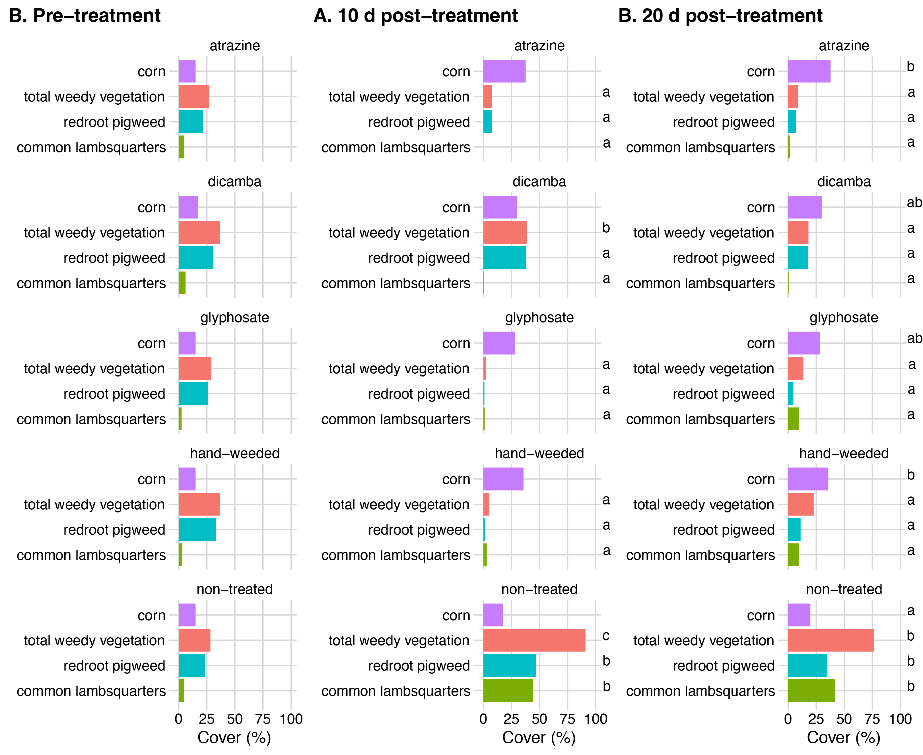

**Figure 1.**  Percent cover for the three dominant plant species and total weedy vegetation. No statistically significant differences in vegetation cover were found at the pre-treatment sampling. At 10 days post-treatment and 20 days post-treatment, total weedy vegetation cover was found to be the highest in the non-treated plots. Letters indicate significant pairwise difference (α = 0.05) within that timepoint and vegetation type. For example, all treated plots had the same cover for common lambs quarter at 10 days post-treatment with the exception of the non-treated plots. Conversely, the lack of letters indicates no pairwise differences. For example, corn cover at 10 days post-treatment was the same across all treatment groups.

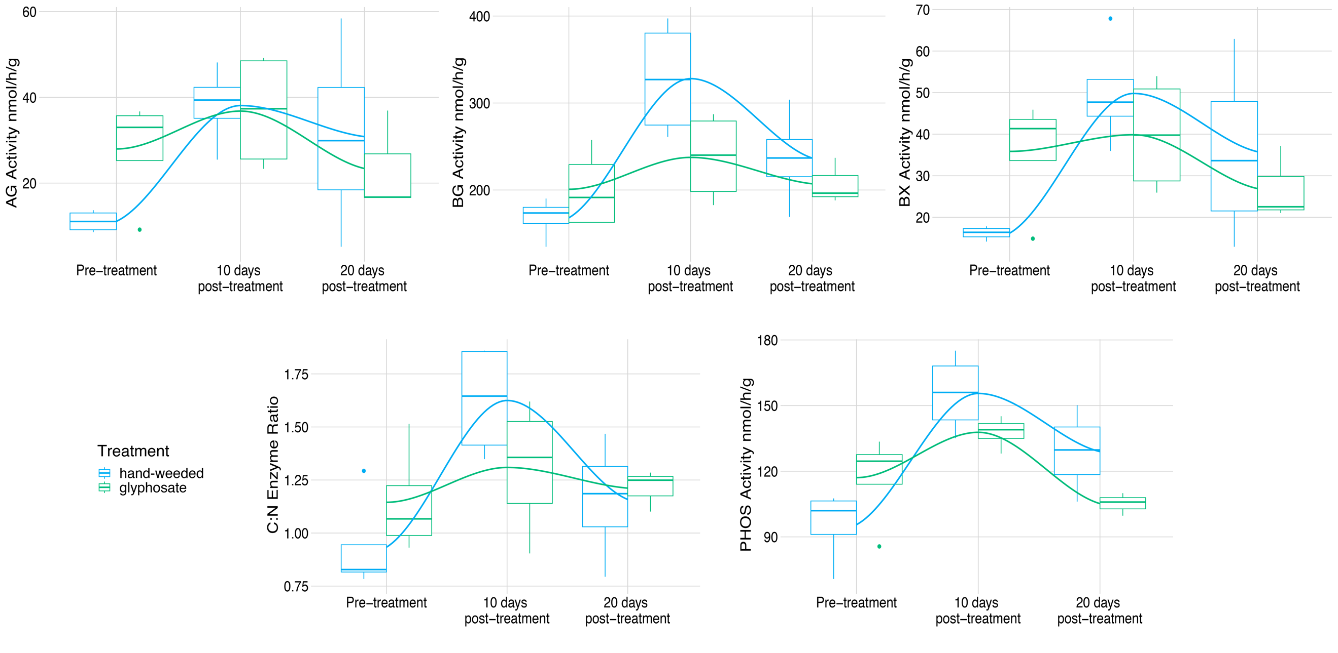

Figure 2. Enzyme activities in the hand-weeded (blue) and glyphosate (green) treated plots over three sampling times. Enzyme activities were significantly different over the sampling period as per the global models for AG, BG, BX, the ratio of C:N cycling enzymes, and PHOS in the handweeded plots. Only PHOS activity was significant in the glyphosate treated plots. However, the same trend was observed in the plotted enzymes across both treatments. Thick middle lines in boxes of box and whisker plots represent the median, with the top and bottom of each box representing the 75th and 25th quartiles, respectively. Whiskers represent 1.5 x IQR. Loess regression lines are plotted on top of the boxplots to clarify the trend in enzyme activity over the 20 day sampling period. Pairwise comparisons with summary statistics for enzyme activities can be found in Supplementary Table D1.

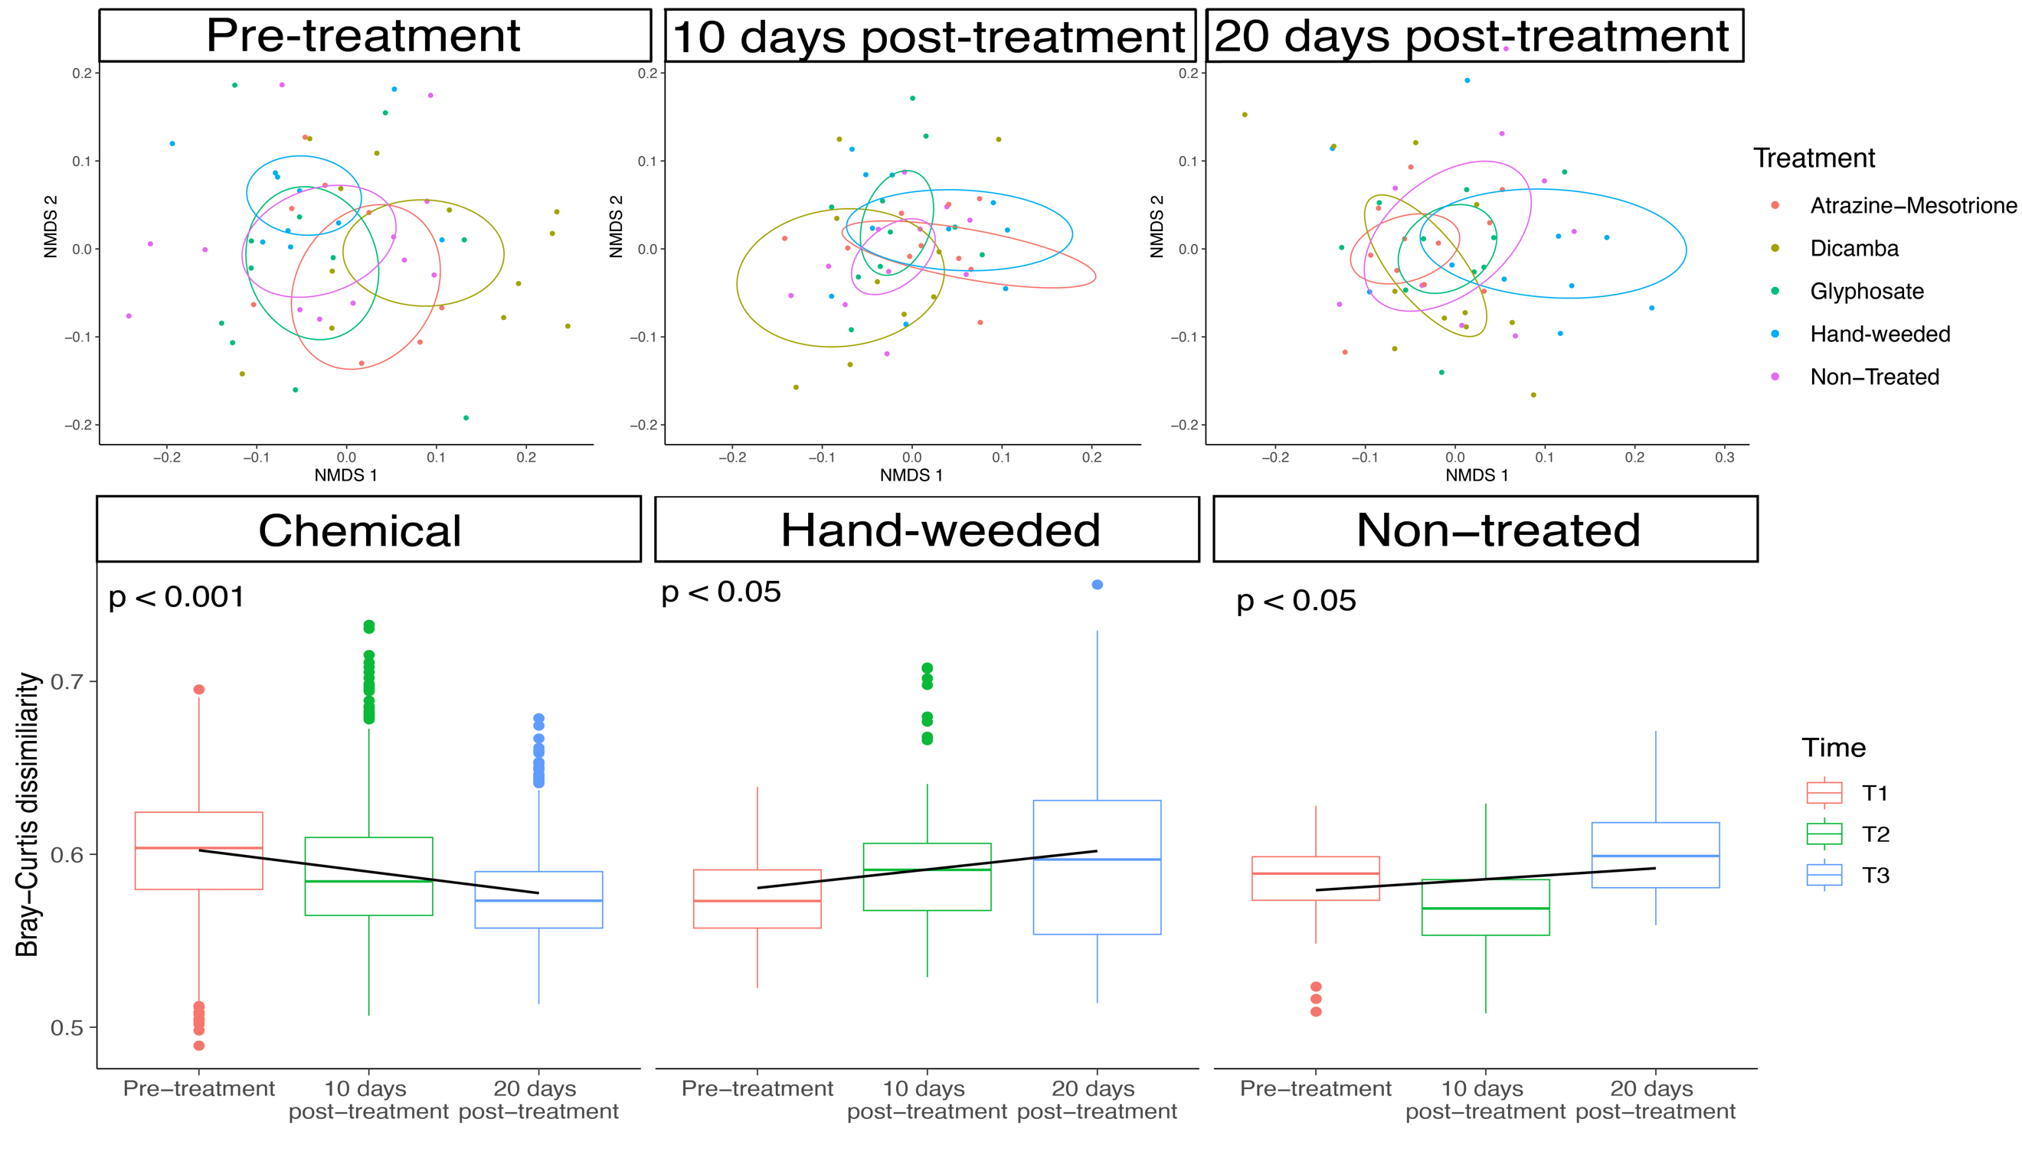

Figure 3. Row 1: 16S ordination (NMDS) of rarefied count tables with 95% SE ellipses. Points indicate independent samples and are colored by treatment type. No differences in community composition were found across the treatments within each timepoint. Columns are ordered by sampling time: Column 1 – pre-treatment, Column 2 – 10 days post-treatment, and Column 3 – 20 days post-treatment. Row 2: Sample pairwise dissimilarity (Bray-Curtis dissimilarity) when all chemical treatments were grouped as a single chemical herbicide treatment and compared across time. P-values indicate a significant change in heterogeneity across the three sampling points. The chemical herbicide group experienced a negative trend in heterogeneity (β = -0.001), while the hand-weeded and non-treated groups experienced a statistically significant increase in heterogeneity over the 20 day sampling period ((β = 0.001, and (β = -0.0006, respectively)

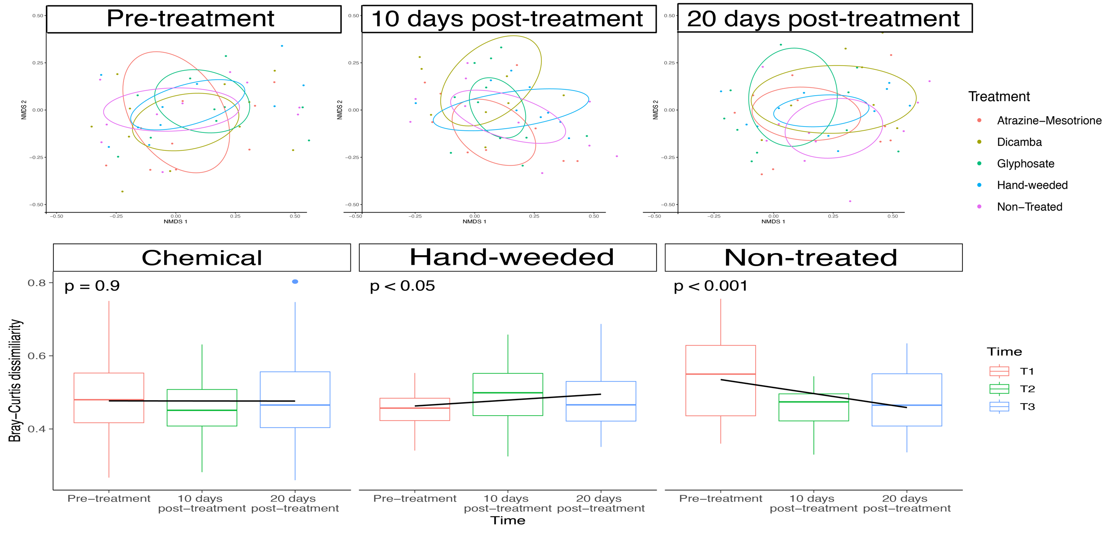

Figure 4. Row 1: ITS ordination (NMDS) of rarefied count tables with 95% SE ellipses. Points indicate independent samples and are colored by treatment type. No differences in community composition were found across the treatments within each timepoint. Columns are ordered by sampling time: Column 1 – pre-treatment, Column 2 – 10 days post-treatment, and Column 3 – 20 days post-treatment. Row 2: Sample pairwise dissimilarity (Bray-Curtis dissimilarity) when all chemical treatments were grouped as a single chemical herbicide treatment and compared across time. P-values indicate the statsitical significance of a change in heterogeneity across the three sampling points. The chemical herbicide group shows no trend in heterogeneity (β < -0.00001), while the hand-weeded and non-treated groups experienced either a statistically significant increase and decrease in heterogeneity over the 20 day sampling period, respectively ((β = 0.001, and (β = -0.003, respectively)