**USBPhy-RW Tool User Manual**

===========

This web is describing how to use USBPhy-RW tool read/write RTK Single PHY chip(RTL82x1) registers.

Tool folder contains three files including config/ReadMe/USBPhyRW.(As the following jpeg)   
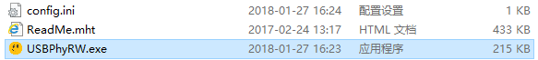

Please attach USBPhy-RW dongle into your PC then run USBPhyRW.exe.

This tool is created by .NET4 Please be aware of necessary installation for .NET4 support package.

This tool create asynchronous hid method to get all HID interface handle and lock the dev by VID/PID. It get data buff via standard windows API method.

USBPhy-RW dongle FW is developed by C with STM32 MCU library. And the dongle will be enumrated as a HID dev so you don’t need install any other driver pkg.

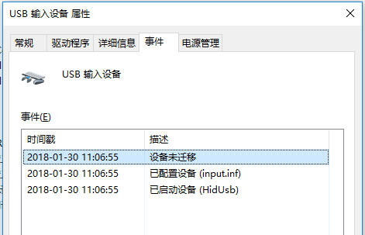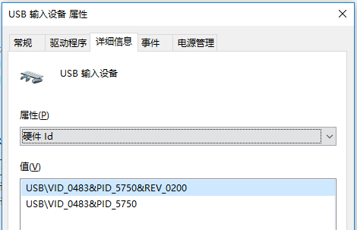

The whole project doc including hardware pcb/.NET source/MCU FW source are open source.

If you need these please send me mail.

===========

USBPhy-RW dongle owns some interfaces. MicroUSB/2.0mm-4Pin MDC&MDIO connector/SWDIO/UART

1,SWDIO is used for original FW upgrade. This is not used for general applying.

2,UART is for external event signal trig in. This is not used for general applying.

3, MicroUSB is used for connecting with your PC.

4, 2.0mm-4Pin MDC&MDIO connector is used for PHY chip signal connection which is marked in the bottom silk screen.

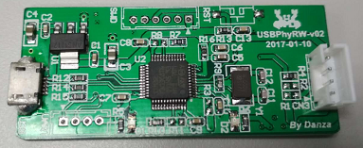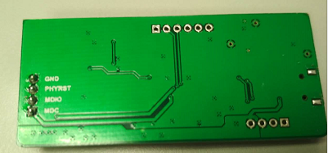

===========

Run USBPhyRW.exe and the program shows the following screen.

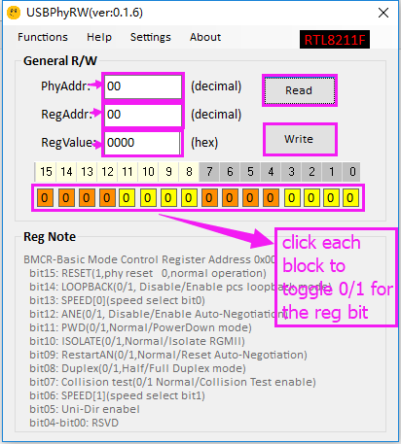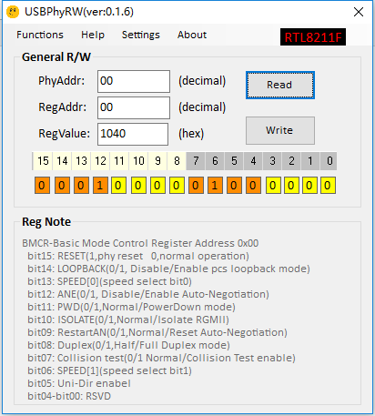

You can read phy reg by filling phyaddr/regaddr box and press Read button. The vaule will show in the RegValue box and following color blocks.

And write phy reg by filling phyaddr/regaddr box/RegVaule box/ and press Write button. The vaule will write into the phy reg.

===========

This tool can help you set IOL test regs by the Entry of ‘Functions->IOL Test’

Please select your chip type before use by the Entry of ‘Functions->Select Chip’

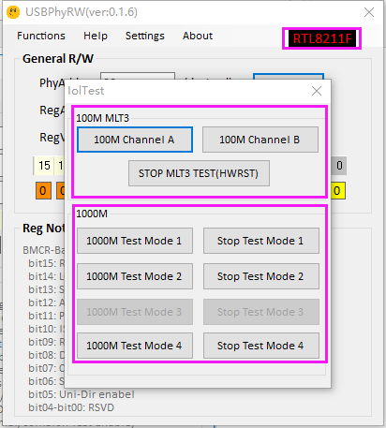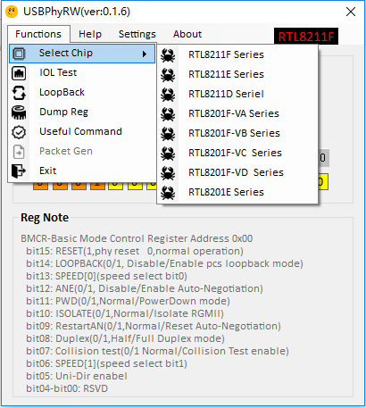

Note. This function is only tested by RTL8211F/RTL8211E demoboard. RTL8211D series has not been tested yet.

You can also set reg according to IOL APPNote by manual.

===========

You can check the communication between USBPhy-RW dongle and you PC by the entry ‘Settings->USBSettings ‘

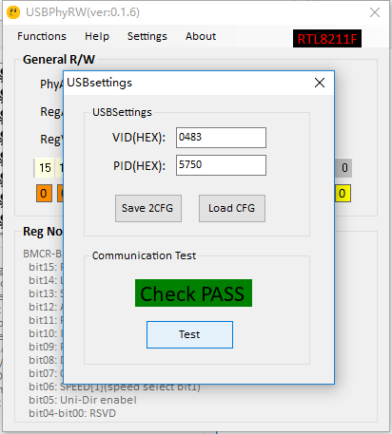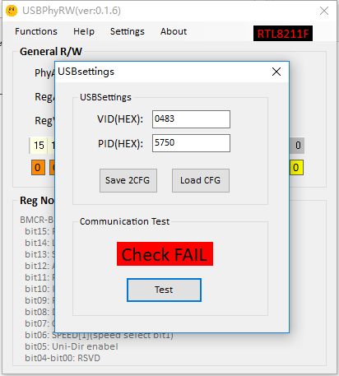

===========

You can upgrade the dongle FW by IAP and this program online. But the server is in RS internal(My work PC) so the connection may be fail if the network is unreachable.

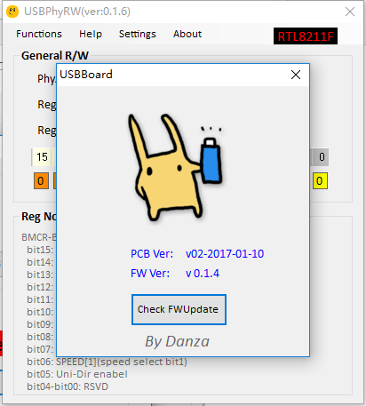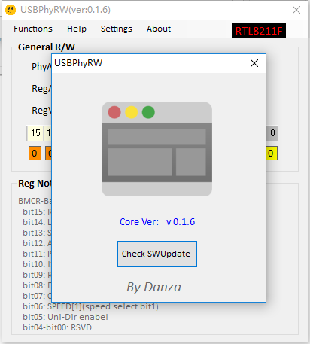

===========

You can contact with me if any bug. (EXT 57489)

Thank you.