The using file is “eigt_wide_viz” (in gcwealth/output/databases/website), where all variables are numeric but: GEO, applies_to, tax, currency and sources that are **strings**. It is a long-format on type of tax and applies to, while the plotting variables are in columns.

Important: the underlying principle is that the filtering process select ONE row per each country-year (in the case of multiple rows due to different brackets, the required values are repeated equally for each bracket). Furthermore, in the case of “estate or inheritance” filter, if a given country-year has both estate and inheritance taxes, we give priority to inheritance. In other words, the category “EI Tax” refers to a situation where both estate and inheritance tax are existing, but we consider (and plot) the information associated with inheritance tax.

**Case 1. Top marginal-rates**

Command: *(value of toprat) if tax == “ EI Tax” & status==1 & (applies_to == “children” | applies_to == “everybody”)*

(In **the old setting** this corresponds to: *Value of x_hs_rat_toprat if x_hs_cat_eigsta == “Y“)*

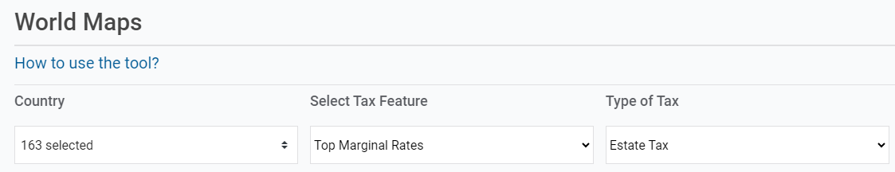

Command: *(value of toprat) if tax == “Estate Tax” & status == 1 & (applies_to == “children” | applies_to == “everybody” )*

(In **the old setting** this corresponds to: *Value of x_hs_rat_etopra if x_hs_cat_eigsta == “Y“)*

Command: *(value of toprat) if tax == “Inheritance Tax” & status == 1 & (applies_to == “children” | applies_to == “everybody” )*

(In **the old setting** this corresponds to: *Value of x_hs_rat_itopra if x_hs_cat_eigsta == “Y“)*

+ ADD A NEW TYPE OF TAX FILTER CALLED “Gift Tax”

Command: *(value of toprat) if tax == “Gift Tax” & status == 1 & (applies_to == “children” | applies_to == “everybody” )*

**Case 2. Exemption Thresholds**



Command: *(value of exempt) if tax == “EI Tax” & status == 1 & (applies_to == “children” | applies_to == “everybody” )*

(In **the old setting** this corresponds to: value of *x_hs_thr_chiexe if x_hs_cat_eigsta == “Y“)*



Command: *(value of exempt) if tax == “Estate Tax” & status == 1 & (applies_to == “children” | applies_to == “everybody” )*

(In **the old setting** this corresponds to: *x_hs_thr_chiexe IF x_hs_cat_esttax == “Y“)*



Command: *(value of exempt) if tax == “Inheritance Tax” & status == 1 & (applies_to == “children” | applies_to == “everybody” )*

(In **the old setting** this corresponds to: *x_hs_thr_chiexe IF x_hs_cat_inhtax == “Y“)*

+ ADD A NEW TYPE OF TAX FILTER CALLED “Gift Tax”

Command: *(value of exempt) if tax == “Gift Tax” & status == 1 & (applies_to == “children” | applies_to == “everybody” )*

**Case 3 – Tax Revenues**

Tax Revenues do not vary by the type of tax: they are the total EIG revenues collected.

(REVENUE INFORMATION DOES NOT DEPEND ON THE TYPE OF TAX)

Command: *(value of prorev) if prorev != .* (i.e., we plot all non-missing values of prorev)

(In **the old setting** this corresponds to: value of *x_hs_rto_tprrev if x_hs_cat_eigsta=="Y")*

(REVENUE INFORMATION DOES NOT DEPEND ON THE TYPE OF TAX)

Command: *(value of revenu) if revenu != .* (i.e., we plot all non-missing values of revenu)

(In **the old setting** this corresponds to: value of *x_hs_agg_totrev if x_hs_cat_eigsta=="Y")*

(REVENUE INFORMATION DOES NOT DEPEND ON THE TYPE OF TAX)

Command: *(value of revgdp) if revgdp != .* (i.e., we plot all non-missing values of revgdp)

(In **the old setting** this corresponds to: value of *x_hs_rto_trvgdp**if x_hs_cat_eigsta=="Y")*

