Steps to run the project-

Method 1-Using Command prompt

Step 1: Install and download node.js and npm -
In a web browser, navigate to https://nodejs.org/en/download/. Click the Windows Installer or Linux installer according to OS to download the latest default version. The Node.js installer includes the NPM package manager.
Step 2: Download server to host the program
Simplest Node.js server is http-server.It can be downloaded by command prompt.
- Click the Start icon and click in the Search box.
- Type cmd into the search box. You will see the cmd (Command Prompt) in the search window.
- Hover the mouse over the cmd program and right-click.
- Select "Run as administrator".

In command prompt type the following command to install http server
$ npm install http-server -g

Step 3: Place the project folder in desktop.
Step 4:Run the project-

In the previously opened command prompt change the directory to desktop by following commands
$ cd desktop
Or
$ cd directory-name

Now you can run a server via the following commands:
$ cd Algorithm-Visualizer

$ http-server

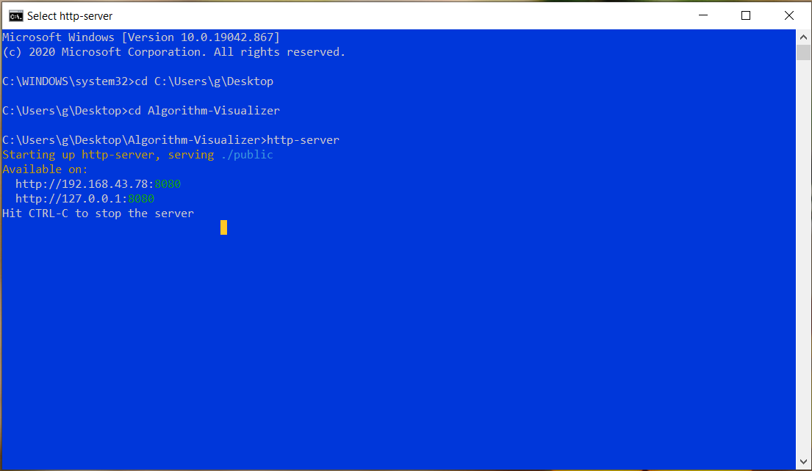

The above command will start the server .Now open the chrome browser and paste the address presented on the screen on the chrome address bar .

Method 2-Using Visual Studio code live server

Step 1:Download VS code :
https://code.visualstudio.com/download
Step 2:Download live server :

After you've downloaded and installed VS Code, you are going to see the welcome screen:
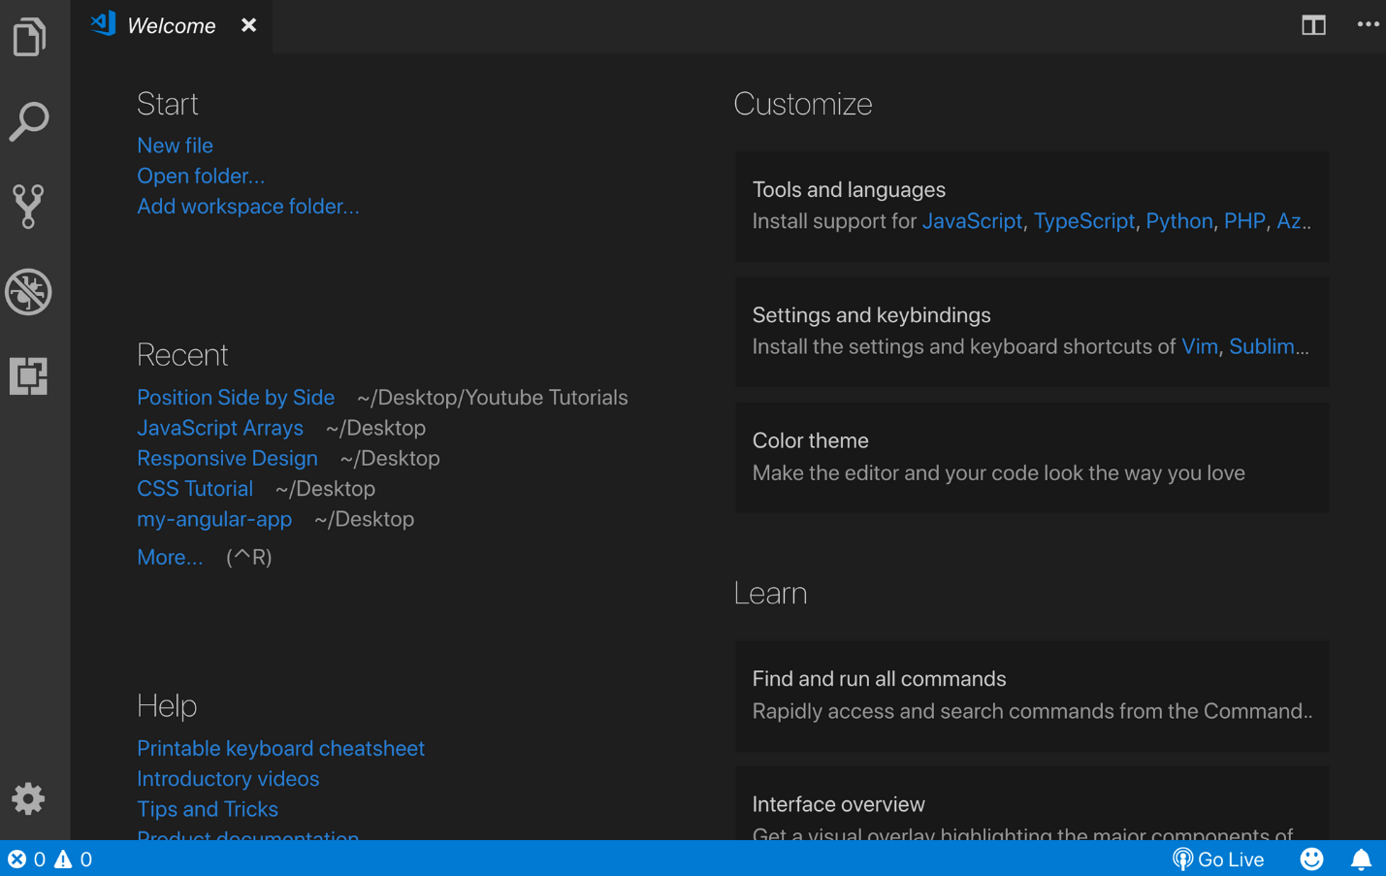
On the left side, you should see a couple of icons. One of them (under the no bugs icon) is the extensions button:
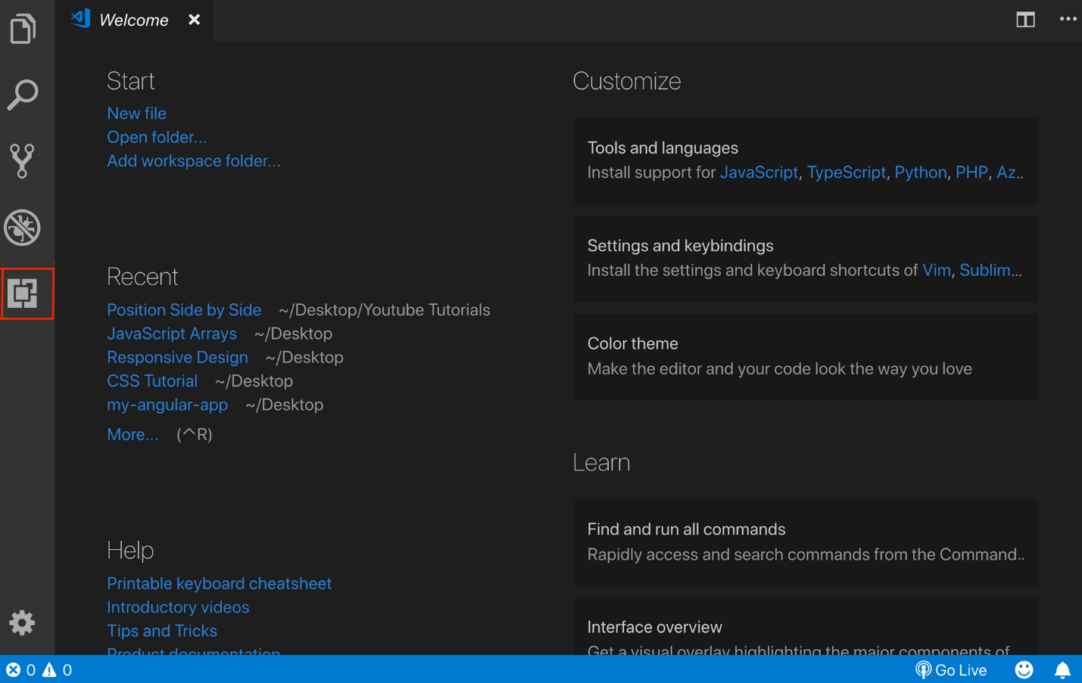
Once you click on it a search bar will appear. Just type in “live server”.
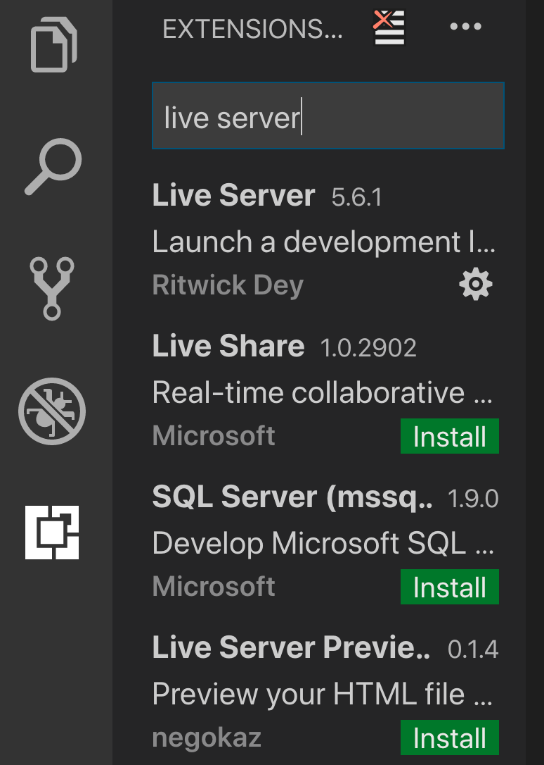

You will see many options, so you can choose whichever one works for your system. I use Live Server by Ritwick Dey, so let's continue with that one in this example:
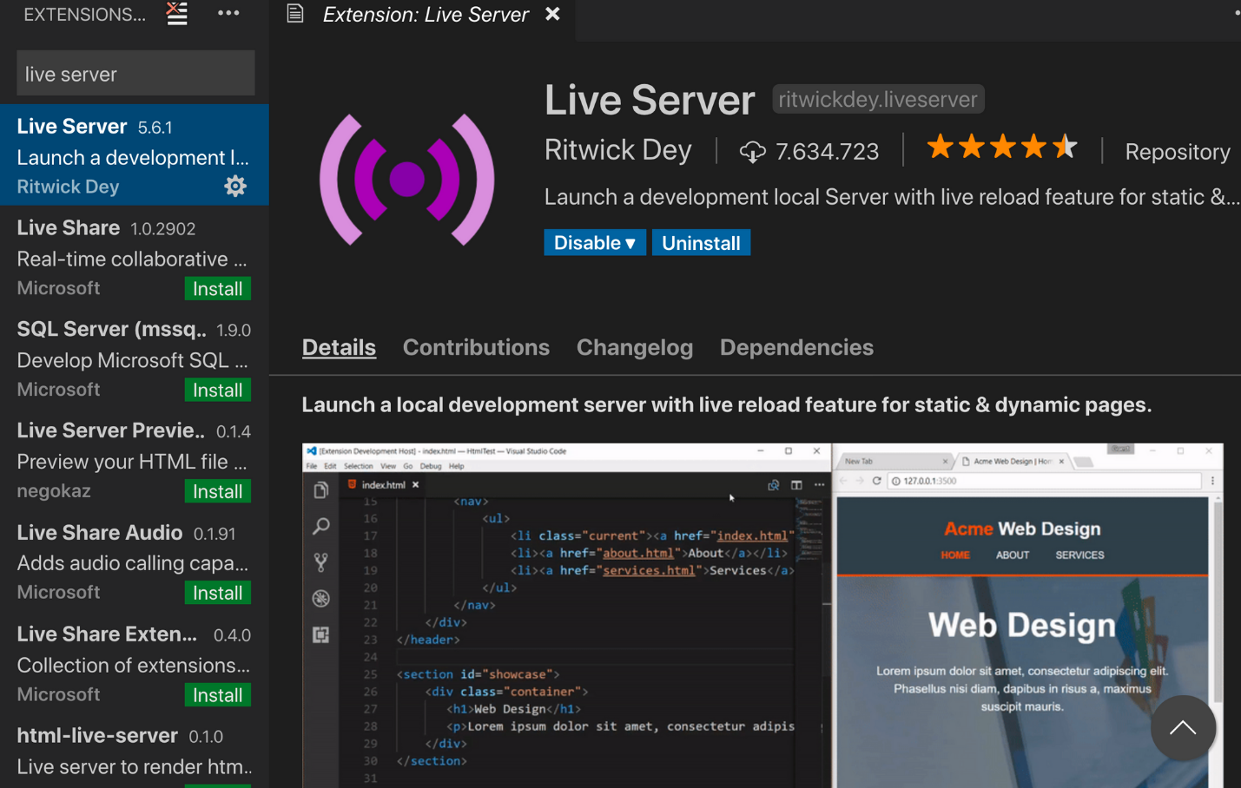

Click on the install button and it will install the extension.
Step 3:Run the project :

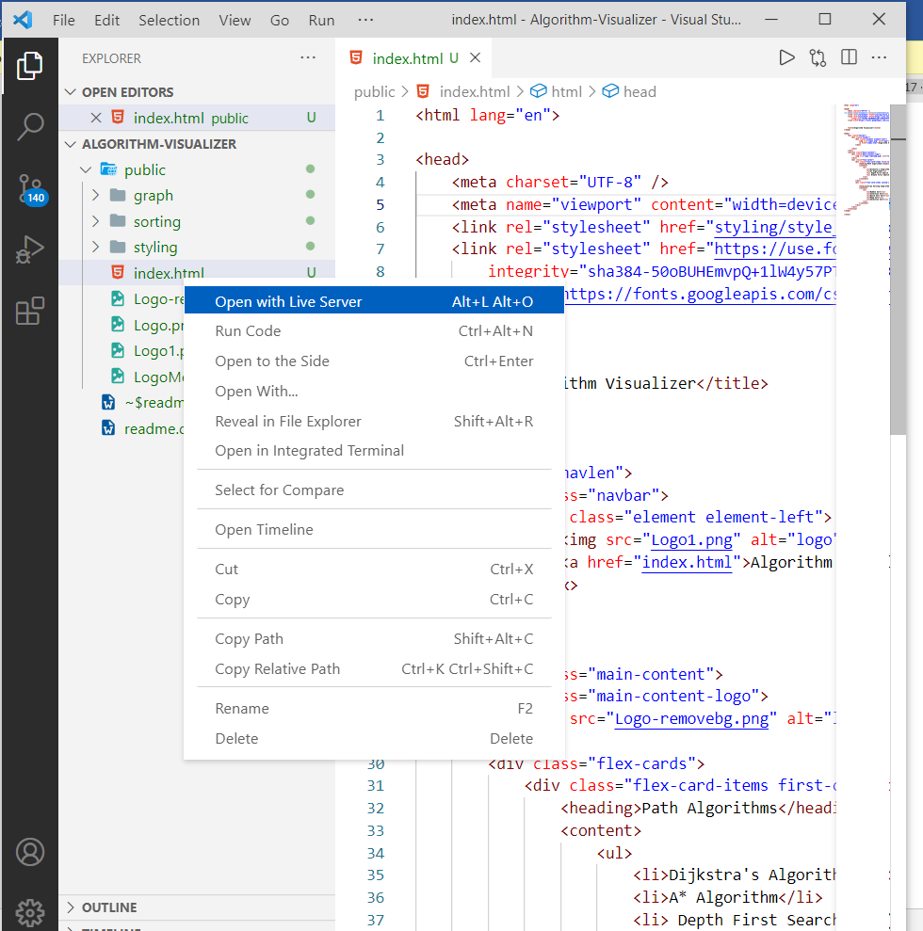

Click on file tab at top left .select folder algorithmVisualizer .
From the left pane of VS code open public folder and then double click on the index .html file
Now right click on file name and select open with live server

