***Sub Engineer***
1. A pitot tube is used to measure
a. pressure
b. difference in pressure
c. velocity of flow
d. none of these.
2. The thickness of a sharp crested weir is kept less than
a. one-half of the height of water on the sill
b. one-fourth of the height of water on the sill
c. two-third of the height of water on the sill
d. none of these.
3. The property of steam function ψ is :
a. the flow around any path in the fluid is zero for continuous flow
b. the rate of change of ψ with distance in an arbitrary direction, is proportional to the component of velocity normal to that direction
c. the velocity vector may be found by differentiating the stream function
d. all the above.
4. The maximum vacuum created at the summit of a syphon is
a. 2.7 m of water
b. 7.4 m of water
c. 5.5 m of water
d. none.
5. If the atmospheric pressure on the surface of an oil tank (sp. gr. 0.8) is 0.1 kg/cm2, the pressure at a depth of 2.5 m, is
a. 2 metres of water
b. 3 metres of water
c. 3.5 metres of water
d. 4.0 metres of water.
6. The total pressure force on a plane area is equal to the area multiplied by the intensity of pressure at its centroid, if
a. area is horizontal
b. area is vertical
c. area is inclined
d. all the above.
7. If the volume of a liquid weighing 3000 kg is 4 cubic metres, 0.75 is its
a. specific weight
b. specific mass
c. specific gravity
d. none of these.
8. Bernoulli's equation assumes that
a. fluid is homogeneous
b. flow is steady
c. flow is along the stream line
d. all the above.
9. The time required to close a valve gradually is (where L is the length of pipe and C = velocity of pressure wave)
a.
b. ≤
c. >
d. <
10. A syphon is used
a. to connect water reservoirs at different levels intervened by a hill
b. to supply water to a town from higher level to lower level
c. to fill up a tank with water at higher level from a lower level
d. none of these.
11. Most economical section of a circular channel for maximum discharge
a. hydraulic mean depth = 0.286 diameter of circular section
b. wetted perimeter = 2.6 diameter of circular section
c. wetted perimeter = 2.83 depth of water
d. all the above.
12. Unit of kinematic viscosity is
a. m2/sec
b. Newton sec/m2
c. Newton sec/m3
d. Kg sec/m2.
13. The moment of inertia of a floating body along its longitudinal axis and the volume of water displaced by it are I and V respectively. The height of the metacentre above centre of buoyancy of the body, is
a.
b.
c.
d. 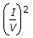
14. Time of emptying liquid from a hemispherical vessel through an orifice at its bottom, is
a. 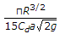
b. 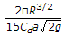
c. 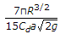
d. 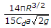
15. Critical depth (h) of a channel, is
a. 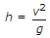
b. 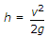
c. 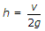
d. 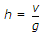
16. The ratio of maximum velocity to average velocity of viscous fluid through a circular pipe is
a. 0.5
b. 0.75
c. 1.25
d. 2.00
17. The shear stress distribution in viscous fluid through a circular pipe is :
a. maximum at the centre
b. maximum at the inside of surface
c. same throughout the section
d. none of these.
18. Product of Renold number, Froud's number and Mach number is :
a. 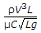
b. 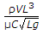
c. 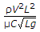
d. 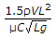
19. Pick up the correct statement from the following :
a. For tranquil flow h > √2g or v <
b. For critical flow 
c. For torrential flow h > or v < √gh
d. None of these.
20. The side slope of Cipolletti weir is generally kept
a. 1 to 4
b. 1 to 3
c. 1 to 2
d. 1 : 5
21. A cylinder 3 m in diameter and 4 m long retains water one side as shown in the below figure. If the weight of the cylinder is 2000 kgf, the horizontal reaction at B is
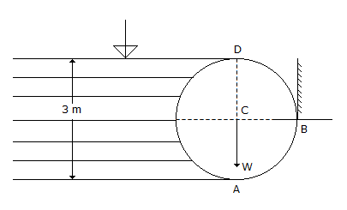
a. 10,000 kgf
b. 15,000 kgf
c. 20,000 kgf
d. 18,000 kgf.
22. Inside pressure in a hollow soap bubble in the air is : (where d is the diameter of the bubble)
a.
b.
c.
d.
23. The momentum correction factor (β) for the viscous flow through a circular pipe is
a. 1.33
b. 1.50
c. 1.66
d. 2.00
24. A piezometer opening in pipes measures
a. velocity head
b. static pressure
c. total pressure
d. negative static pressure.
25. An independent mass of a fluid does not posses
a. elevation energy
b. kinetic energy
c. pressure energy
d. none of these.
26. While applying the Bernoulli's equation 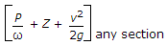 = total head, the work any section done on the flow system, if any
a. is added on the right side of the equation
b. is added on the left side of the equation
c. is ignored
d. none of these.
27. Discharge Q over a rectangular weir of length L and height H, is given by the equation
a. Q = 2/3 Cd√2g LH3/2
b. Q = 2/3 CdL H√2gH
c.
d. all the above.
28. A short tube mouthpiece will not run full at its outlet if the head under which the orifice works, is
a. less than 12.2 m of the water
b. more than 12.2 m of the water
c. equal of 12.2 m of water
d. none of these.
29. Hydrostatic pressure on a dam depends upon its
a. depth
b. shape
c. material
d. both (b) and (c).
30. When two layers of a fluid separated by dy move over the other with a difference of velocity dv, causes a shearing stress 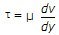, where μ is known as
a. absolute viscosity
b. dynamic viscosity
c. viscosity
d. all the above.
31. A pipe of 0.1 m2 cross sectional area suddenly enlarges to 0.3 m2 cross-sectional area. If the discharge of the pipe is 0.3 m3 /sec, the head loss is
a. 2/g m of water
b. g/2 m of water
c. 1g m of water
d. √g m of water.
32. Maximum efficiency of transmission of power through a pipe, is
a. 25%
b. 33.3%
c. 50%
d. 66.67%.
33. An ideal flow of a liquid obeys
a. Continuity equation
b. Newton's law of viscosity
c. Newton's second law of motion
d. dynamic viscosity law,
34. Euler's equation for motion of liquids, is given by
a. 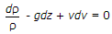
b. 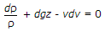
c. 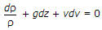
d. ρdp + gdz + vdv = 0
35. Reynold number is the ratio of initial force and
a. viscosity
b. elasticity
c. gravitational force
d. surface tension.
36. When a body is totally or partially immersed in a fluid, it is buoyed up by a force equal to
a. weight of the fluid displaced by the body
b. weight of the body and fluild displaced by the body
c. difference of weights of the fluid displaced and that of the body
d. none of these.
37. If D is the diameter of a pipe of length L and f is the coefficient of friction of pipe then diameter of the nozzle d is
a. 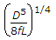
b. 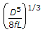
c. 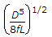
d. none of these.
38. If the total head of the nozzle of a pipe is 37.5 m and discharge is 1 cumec, the power generated is
a. 400 H.P.
b. 450 H.P.
c. 500 H.P.
d. 550 H.P.
39. The phenomenon occuring in an open channel when a rapidly flowing stream abruptly changes to a slowly flowing stream causing a distinct rise of liquid surface, is
a. water hammer
b. hydraulic jump
c. critical discharge
d. none of these.
40. In a circular pipe of length L and diameter d, a viscous liquid is flowing with a velocity v. The loss in head, is
a. 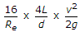
b. 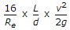
c. 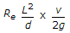
d. 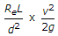
41. The horizontal component of the force on a curved surface is equal to
a. weight of liquid vertically below the curved surface
b. force on a vetical projection of the curved surface
c. product of pressure at its centroid and the area
d. weight of liquid retained by the curved area.
42. The radius of gyration of the water line of a floating ship is 4 m and its metacentric height is 72.5 cm. The period of oscillation of the ship, is
a. 2π
b. 3π
c. 4π
d. π/2
43. A pipe consisting of several pipes of varying diameters and lengths, may be replaced by an equivalent pipe of diameter D of length
a. 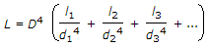
b. 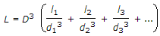
c. 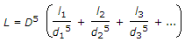
d. 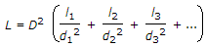
44. The Empirical formula 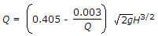 for discharge over large rectangular weirs, is known as
a. Francis formula
b. Bazin formula
c. Rehbook formula
d. Kutter's formula.
45. The diameter (d) of a nozzle fixed at the end of a pipe (diameter D, length L) for maximum energy, is
a. 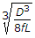
b. 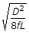
c. 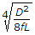
d. 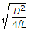
46. Pick up the correct statement regarding Borda's mouth piece running full from the following :
a. Theoretical velocity at the outlet is √2gH
b. Coefficient of velocity is 1/√2
c. Coefficient of contraction is 1
d. All the above.
47. Differential manometers are used to measure
a. pressure in water channels, pipes, etc.
b. difference in pressure at two points
c. atmospheric pressure
d. very low pressure.
48. A tank 4m x 3m x 2m containing an oil of specific gravity 0.83 is moved with an acceleration g/2 m sec2. The ratio of the pressures at its bottom when it is moving vertically up and down, is
a. 2
b. 3
c. 1/2
d. 1/3
49. The most familiar form of Bernoulli's equation, is
a. 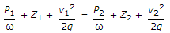
b. 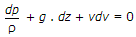
c.  = constant head
d. none of these.
50. Highest dam in India, is
a. Bhakra dam
b. Hirakund dam
c. Nagarjuna Sagar dam
d. Iddiki dam.

