**The slowness of punishment is fueled by decision mismatches**

**Authors:** George Dewey, MPH1, Hiroyasu Ando, BS1, Ryo Ikesu, MS1, Akihiro Nishi, MD, DrPH1-3*, XXX

**Affiliations:**

1 *Department of Epidemiology, University of California, Los Angeles Fielding School of Public Health, Los Angeles, CA 90095, United States;*

2 *California Center for Population Research, University of California, Los Angeles, Los Angeles, CA 90095, United States;*

3 *Bedari Kindness Institute, University of California, Los Angeles, Los Angeles, CA 90095, United States.*

*Correspondence to: Akihiro Nishi, M.D., Dr.P.H., Department of Epidemiology, UCLA Fielding School of Public Health, 650 Charles E Young Dr S, Los Angeles CA; Tel.: +1-310-206-7164; Fax: +1-310-206-6039.

**Acknowledgements:** We gratefully acknowledge support from the UCLA Fielding School of Public Health.

**Author contributions:** GD and AN designed the project. HA provided programming support. RI conducted data analysis and assisted in early manuscript preparation. All authors analyzed the findings and revised the manuscript.

**Conflict of interest:** AN is a consultant to Vacan, Inc. and obtained an honorarium from Taisho Pharmaceutical Co., Ltd., which had no role in the project.

**Data availability:** De-identified data and the complete analysis code will be made available under XXX journal’s data release policy upon acceptance of this manuscript.

**Abstract (194/250 words)**

Costly punishment – paying a cost to harm others – is a widely observed behavior across a variety of contexts in human social interactions. However, choosing to punish others lies in contrast to the breadth of evidence suggesting that humans are willingly and preferentially cooperative. Therefore, the specific role of punishment, especially in repeated interactions involving dynamic decisions, remains unclear. To explore this issue, we recruited human players and observed their decisions in two series of economic games with a punishment option in brief online network experiments, comprising a total of 1,484 unique players and 20,729 unique decision points. We show that choosing punishment resulted in considerably longer decision times than choosing either cooperation or defection across all our experimental settings. We also provide support for the hypothesis that decision conflicts drive increases in decision times, especially the role of mismatches between individuals’ own decision-making and the choices of their “social environment”. Our results show that choosing to punish when no punisher was present among one’s connections was associated with longer decision times, suggesting that even small incongruities between individual choices and the selections of their peers contribute to slower mental processing and additional internal conflict.

**Introduction**

Punishment is widely observed in modern human societies1-3. Punishment is costly: while the target of punishment incurs some cost, an alternative, generally lesser, cost must also be paid by the perpetrator. The dynamic balance between the costs to the punisher and the punished has been suggested to promote and sustain human cooperation4-6. However, as humans are thought to be willingly cooperative and altruistic, even to complete strangers7,8, it remains an evolutionary puzzle why punishment persists as a viable option in human interactions.

Seminal laboratory experiments suggested that punishment might serve to dissuade free riding – obtaining benefits while paying no costs - and encourage future cooperation5,6. However, these studies often restricted the number of choices available to participants, limiting interactions to one-shot instances or preventing participants from knowing what their peers did previously7. More recent studies have promoted that punishment offers a competitive outlet for humans to minimize differences in fitness between targets and perpetrators9-11, ultimately leading to more cooperation once the fitness gaps are reduced. Ultimately, it is probable that punishment is not fully explained by either of these two theoretical mechanisms, especially when evaluated in human social networks that model real-world, repeated interactions.

Prior research evaluating such repeated interactions suggests that humans must balance between cooperative and non-cooperative behavior and that reciprocity with one’s social environment shifts the balance between cooperation and non-cooperative behaviors like defection12,13. Additionally, behaviors that were concordant with the social environment (i.e., cooperation in a cooperative environment) were found to be faster than discordant behaviors12,14. These findings indicate that cooperation should be the dominant behavior when a majority of network members choose to cooperate and that decision conflicts – moments when responses that differ from the common choice in one’s social environment – are a driver of slow decisions15. However, these studies, like the laboratory experiments mentioned previously, did not allow participants to punish each other. Therefore, to address this gap in the literature, we aimed to evaluate how punishment emerged and persisted in an experimental network environment, if decision speeds aligned with the hypothesis of decision conflicts when punishment was a possible option, and if externally implementing a time limit could reduce the occurrence of punishment.

**Methods**

We implemented two series of repeated public goods game (PGG) involving human players embedded in dynamic social networks. In the first series (“Experiment A”), we introduced a punishment option to a previously-used network-based framework.16 Experiment A encompassed 50 social networks allotted to 50 games with 15 rounds each. Human players were given either a low or high allocation of in-game units and asked to interact with each other. At the start of each game round, players entered the *decision* phase, where they were given one of three options: cooperation (pay 50 units to give connected players 100 units), defection (pay nothing, not affecting others), and punishment (pay 50 units to deduct 100 units from connected players). No institutional punishment or sanctioning17 occurred. Once players were made their decisions, they were shown the decisions made by other connected players in that round. Next, players were allowed to update their network connections in the *rewiring* phase. The networks were then rearranged according to the player choices in the rewiring phase and the subsequent round began. At the end of all games, accumulated in-game wealth was converted to USD. Players were not informed that they would be compensated based on their in-game performance. We also recorded how long each player took to make each of their decisions; we began timing each decision once the screen appeared which allowed players to choose cooperation, defection, or punishment and ended the timer once one of the buttons was clicked.

In Experiment A, 745 unique players (mean: 14.9/game, range: 9-25/game) made 9,982 decisions of cooperation, defection, or punishment. Cooperation was chosen 4,878 times (49.44%, 95% CI: 48.39-50.50%), defection was chosen 4,336 times (43.95%, 95% CI: 42.89-45.00%), and punishment was chosen 562 times (6.60%, 95% CI: 5.55-7.66%). The mean degree (the number of connections a player had at any moment) in Experiment A was 5.91. At the end of 15 rounds, the mean accumulated wealth across all players was 1,584 in-game units (equivalent to USD 3.96).

In the second series of experiments (“Experiment B”), we randomized half of the games to enforce a 3-second time limit for each decision point while the other half of the games had no time limit. The games otherwise consisted of the two phases used in Experiment A, with participants allowed to choose either cooperation, defection, or punishment at each decision point. Games with the time limit (the time pressure condition, TP+) showed players a diminishing bar at the top of their game screen which showed the amount of time they had remaining to make their decision (**Figure 2**). In the games with no time limit (TP–), no such bar was shown. If players did not confirm their choice within the time limit, the system automatically repeated their decision from the past round. A visual demonstration of this user interface element is provided in the Supplementary Materials (**Figure S1**).

In Experiment B, 739 players (mean: 14.8/game, range: 8-20/game) made 10,747 decisions. Cooperation was chosen 4,185 times (39.28%, 95% CI: 38.29-40.29%), defection was chosen 5,790 times (54.35%, 53.35-55.36%), and punishment was chosen 679 times (6.37%, 5.38-7.38%). The mean degree in Experiment B was 5.72. At the end of 15 rounds, the mean accumulated wealth was 935 in-game units (equivalent to USD 2.11). In the TP+ sessions, punishment was chosen 338 times out of 5407 decisions (6.25%, 4.84-7.66%), while in the TP- sessions, punishment was chosen 341 out of 5247 decisions (6.50%, 5.09-7.93%).

|  |  |  |  |  |  |  |  |
| --- | --- | --- | --- | --- | --- | --- | --- |
| **Experiment** | **Year** | **Was a time limit imposed?** | **Cooperative decisions (%)** | **Defection decisions (%)** | **Punishment decisions (%)** | **Total game sessions** | **Total decisions** |
| A | 2018 | No | 4,878 (49.44) | 4336 (43.95) | 562 (6.60) | 50 | 9982 |
| B, TP- | 2023 | No | 2013 (38.36) | 2893 (55.13) | 341 (6.49) | 25 | 5247 |
| B, TP+ | 2023 | Yes | 2172 (40.17) | 2897 (53.58) | 338 (6.25) | 25 | 5407 |

**Table 1**. Summary characteristics of the two series of experiments. Experiment B was divided into two conditions: the TP- condition, with no time limit for player decisions, and the TP+ condition, with a strict 3 second time limit for each decision.

The structure of the games and the arrangement of players into networks meant that multiple observations were made for a single player across multiple rounds in a game session. We account for this hierarchical data structure using multilevel random intercepts models. While prior work12,18,19 utilized a log10-transformation when analyzing decision times because decision times are generally only left-bounded by zero, time data from the TP+ condition of our experiments would also be right-bounded by the time limit. As a result, we chose to omit the transformation to keep model estimates from limited and non-limited data on the same scale.

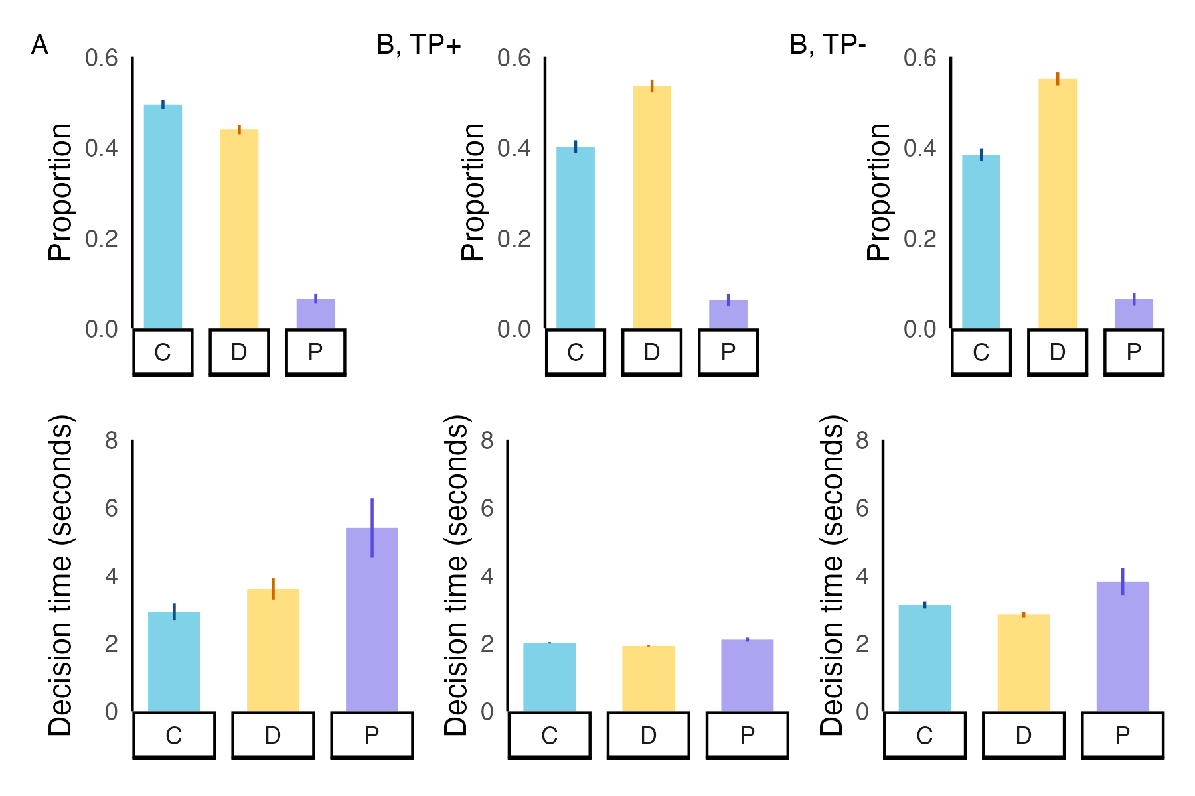

**Figure 1**. **Punishment is slow in all scenarios, even under time pressure.** The upper portion of the figure shows the distribution of behaviors in each experiment. Experiment B is divided into games with time pressure (B, TP+, center) and without time pressure (B, TP-, right). The lower portion of each panel shows the mean decision time for each setting. Error bars represent 95% confidence intervals of proportions or means.

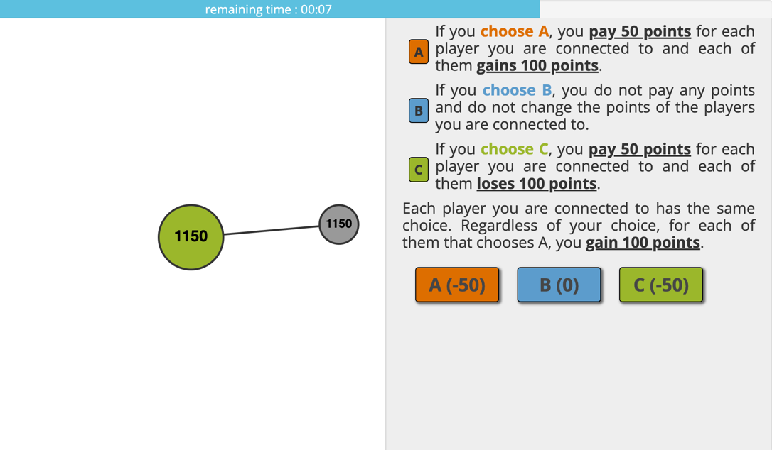

**Figure 2**. **Example screenshot of players’ perspective**. The active player is represented by the larger, central circle highlighted in green, while the grey circle represents a connected player in the same game session. In the TP+ setting (shown), a horizontal bar appeared on players’ screens showing the remaining time they had to make their decision. In the TP- setting, no time limit was implemented, and no bar appeared.

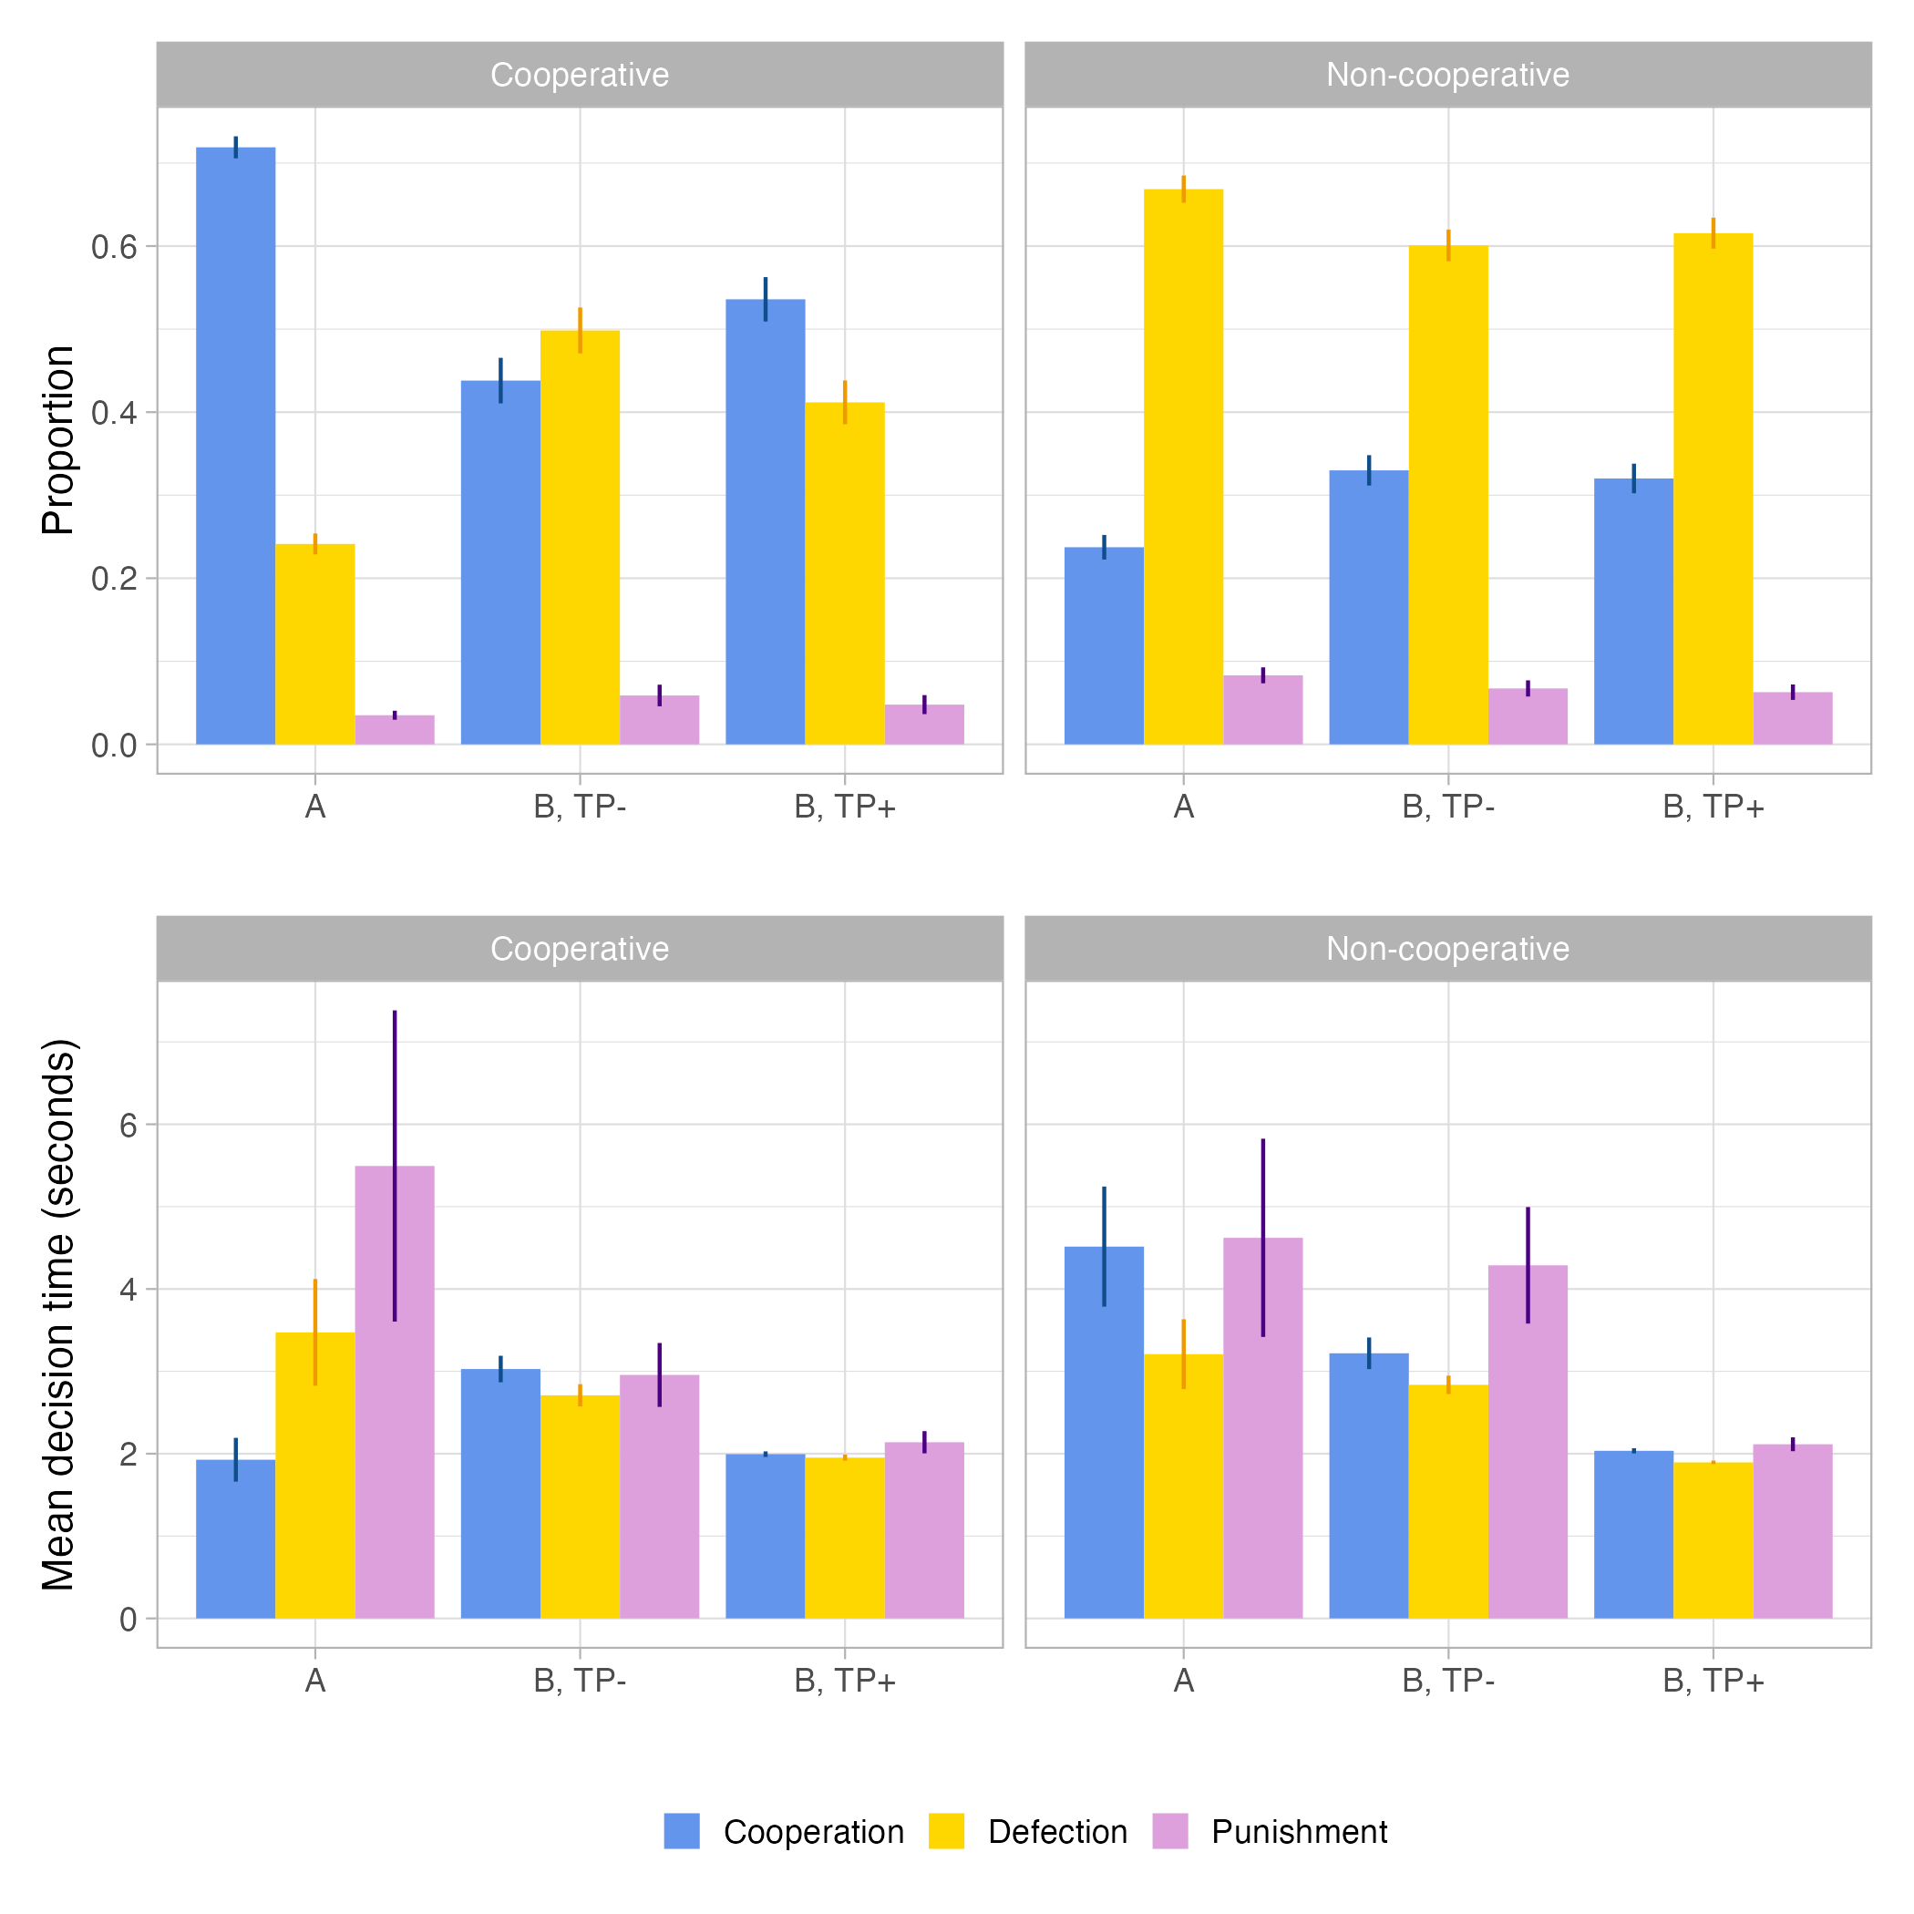

**Figure 3**. **Behavior distributions and mean decision times across all experimental conditions stratified by social environment.** Punishment was slowest after accounting for social environment across Experiment A and both TP- and TP+ conditions of Experiment B. Furthermore, punishment in a cooperative environment was slower than all other behaviors in 2 out of 3 conditions; in non-cooperative environments, cooperation was slower in all 3 conditions but not slower than punishment. Error bars indicate 95% confidence intervals of proportions or means.

**Results**

In both Experiments A and B, we found that players spent the most time before they chose to punish compared to when they chose to cooperate or defect (**Figure 1**). Overall, choosing punishment had a significant positive association with increased decision times compared to cooperation in both Experiment A (p = 0.0002, **Table S1**) and the TP- condition in Experiment B (p= 0.0019, **Table S1)**. Remarkably, this relationship also held even under the TP+ condition of Experiment B (p = 0.0001, **Table S1)**. However, as previous work12 indicated that players’ social environment influenced both the choices players would make in future rounds and how fast those decisions were made, we performed an additional set of analyses evaluating if punishment was slower than either cooperation or defection after stratifying the experimental data by social environment type.

We classified each decision into one of three categories based on the most prevalent behavior in the choosing player’s social environment: unknown (decisions in the first round or if the player had no neighbors in round *t-1*), cooperative (cooperator/neighbor ratio > 0.5 in round *t-1*), or non-cooperative (either defector/neighbor ratio > 0.5 or punisher/neighbor ratio > 0.5 in round *t-1*). We chose to aggregate environments where defection or punishment were dominant into one category because the overall rate of punishment in both Experiments A and B was low (about 6% in both). First, we evaluated if there were differences in the frequency of punishment across different social environments (**Figure 3, top**). In Experiment A, punishment made up 8.31% of decisions in non-cooperative environments, compared to 3.50% of decisions in cooperative environments (p < 0.001)*.* We did not see a significant difference in the proportion of punishment within the TP- condition in Experiment B. However, we observed a nearly significant difference under the TP+ condition of Experiment B: in non-cooperative environments, punishment comprised 6.28% of behaviors compared to 4.78% of behaviors in cooperative environments (p = 0.0658).

Second, we tested for associations within the three types of social environment between choosing punishment and longer decision times (**Figure 3, bottom**). We found that the significant positive relationship between choosing punishment and increased decision time did not consistently hold across different social environments and between our various experimental settings (**Table S2, Table S3)**. Specifically, we found that punishment was only significantly associated with increased decision time in cooperative environments in Experiment A (p < 0.0001) and in non-cooperative environments in the TP- condition of Experiment B (p = 0.0023).

We also conducted analyses that focused on the specific influence of punishers in social environments on decision time. We created a new classifier to compare decisions made after the choosing player was punished (e.g., they had a punisher in their social environment in round *t-1*) to decisions made without having been punished previously. Among decisions made without punishment in the previous round, there was a significant positive association between choosing punishment and increased decision time in Experiment A (p < 0.0001) and the TP+ condition of Experiment B (p = 0.0003) (**Table S4**). However, we only found a similar significant relationship in the TP- condition of Experiment B when analyzing only decisions made after being punished (p = 0.3565, Exp. A, p = 0.0012, Exp. B TP-, p = 0.0729, Exp. B TP+, **Table S5**) This suggests that players had more difficulty choosing to punish when they were not punished immediately prior to making their decision, suggesting that a behavior does not necessarily have to be dominant in players’ social environment to influence their decision-making speed.

Finally, we evaluated the effects of the imposed time limit on players’ decision-making. We found that the imposed time limit had no significant effect on the frequency of choosing to punish (p *=* 0.47) (**Table S6**). While the three-second limit was able to compress the actual time players took to make their decisions, the overall distribution of decision choices was not significantly affected. There are several implications of this finding. First, players were not inhibited from making decisions when they were presented the opportunity, even with a time limit present. Although a substantial proportion (1341 out of 5455 decisions in the TP+ condition, 24.58%) of players were unable to click an option in time, punishment was still a viable option, occurring at the same rate among actual decisions as in the TP- condition. Second, the slowness of punishment was reflected under time pressure both in the presence and absence of a punisher in the previous round, contradicting the reactive and deliberate dichotomy of dual process perspectives and providing support for a decision conflict approach to understanding players’ decision times when faced with multiple possible choices.

**Discussion**

Our results show that in a dynamic system of repeated interactions, punishment is slower than both cooperation and defection. We provide additional evidence that decision-making speeds are linked to the social environment in which they are made, especially when considering the presence or absence of a punisher: punishment decisions made without a punisher present took longer to process compared to cooperation decisions, while the presence of a punisher compressed decision times together. We also find that while the implementation of a time limit did not reduce the occurrence of punishment, punishment decisions remained the slowest among time-compressed decision times as compared to cooperation and defection.

Taken together, these findings have several implications. Given the extensive evidence of humans’ willingness and preference for cooperation20-22, we should intuitively believe cooperation to be more prevalent and faster than punishment. We find that while this belief would be generally correct, the relative difference in decision speed comparing cooperation and punishment is noticeably influenced by the social environment of the decision-maker. Even under the constraints of a three-second time limit, punishment was the slowest of the three behaviors; this difference was most pronounced when it was made without previous punishment.

However, we did not find that the time limit reduced the overall rate of punishment decisions. This is reflective of punishment’s persistence as a potential course of action in human cooperation, with a caveat: in our experimental setting, we did not measure players’ perception of their peers’ reputation. As recent work has found that the reputation of punishers decreases when they punish quickly, but when the punishment was slow, the punishers’ reputation instead increased,23 future work should carefully investigate the connections between the social environment, reputation, and decision times.

Furthermore, our results lend additional credence to the theory of decision conflicts15,24,25 as a key mechanism to understand differences in decision times. The presence of a single punisher in one’s social environment considerably influenced the difference in decision-making speed between cooperation and punishment, suggesting that even small shifts in the balance between one’s own behavioral considerations and those encouraged by social norms and trends result in changes to how fast (or slow) we process information before a decision.

In conclusion, our findings support previous studies that implicate reciprocity, rather than the specific types of behavior, as a major contributor to the variation in decision times observed in both experimental and field studies. We find that punishment is generally slower than either cooperation or defection and that time pressure alone is not sufficient to reduce the occurrence of punishment.

**References**

1 Henrich, J. *et al.* Costly Punishment Across Human Societies. *Science* **312**, 1767-1770 (2006). <https://doi.org:doi:10.1126/science.1127333>

2 Balliet, D. & Van Lange, P. A. Trust, punishment, and cooperation across 18 societies: A meta-analysis. *Perspectives on Psychological Science* **8**, 363-379 (2013).

3 Herrmann, B., Thöni, C. & Gächter, S. Antisocial Punishment Across Societies. *Science* **319**, 1362-1367 (2008). <https://doi.org:doi:10.1126/science.1153808>

4 Mathew, S. & Boyd, R. Punishment sustains large-scale cooperation in prestate warfare. *Proc Natl Acad Sci U S A* **108**, 11375-11380 (2011). <https://doi.org:10.1073/pnas.1105604108>

5 Fehr, E. & Gachter, S. Cooperation and Punishment in Public Goods Experiments. *The American Economic Review* **90**, 980-994 (2000).

6 Fehr, E. & Gächter, S. Altruistic punishment in humans. *Nature* **415**, 137-140 (2002). <https://doi.org:10.1038/415137a>

7 Raihani, N. J. & Bshary, R. Punishment: one tool, many uses. *Evolutionary Human Sciences* **1**, e12 (2019). <https://doi.org:10.1017/ehs.2019.12>

8 Raihani, N. J. & Bshary, R. Why humans might help strangers. *Front Behav Neurosci* **9**, 39 (2015). <https://doi.org:10.3389/fnbeh.2015.00039>

9 Raihani, N. J. & McAuliffe, K. Human punishment is motivated by inequity aversion, not a desire for reciprocity. *Biol Lett* **8**, 802-804 (2012). <https://doi.org:10.1098/rsbl.2012.0470>

10 Bone, J. E. & Raihani, N. J. Human punishment is motivated by both a desire for revenge and a desire for equality. *Evolution and Human Behavior* **36**, 323-330 (2015). <https://doi.org:10.1016/j.evolhumbehav.2015.02.002>

11 Deutchman, P., Bračič, M., Raihani, N. & McAuliffe, K. Punishment is strongly motivated by revenge and weakly motivated by inequity aversion. *Evolution and Human Behavior* **42**, 12-20 (2021). <https://doi.org:10.1016/j.evolhumbehav.2020.06.001>

12 Nishi, A., Christakis, N. A., Evans, A. M., O’Malley, A. J. & Rand, D. G. Social Environment Shapes the Speed of Cooperation. *Scientific Reports* **6**, 29622 (2016). <https://doi.org:10.1038/srep29622>

13 Rand, D. G. & Nowak, M. A. Human cooperation. *Trends Cogn Sci* **17**, 413-425 (2013). <https://doi.org:10.1016/j.tics.2013.06.003>

14 Castro Santa, J., Exadaktylos, F. & Soto-Faraco, S. Beliefs about others’ intentions determine whether cooperation is the faster choice. *Scientific Reports* **8**, 7509 (2018). <https://doi.org:10.1038/s41598-018-25926-3>

15 Diederich, A. Decision making under conflict: Decision time as a measure of conflict strength. *Psychonomic bulletin & review* **10**, 167-176 (2003).

16 Nishi, A., Shirado, H., Rand, D. G. & Christakis, N. A. Inequality and visibility of wealth in experimental social networks. *Nature* **526**, 426-429 (2015). <https://doi.org:10.1038/nature15392>

17 Gürerk, Ö., Irlenbusch, B. & Rockenbach, B. The Competitive Advantage of Sanctioning Institutions. *Science* **312**, 108-111 (2006). <https://doi.org:doi:10.1126/science.1123633>

18 Rand, D. G., Greene, J. D. & Nowak, M. A. Spontaneous giving and calculated greed. *Nature* **489**, 427-430 (2012).

19 Rand, D. G. *et al.* Social heuristics shape intuitive cooperation. *Nature communications* **5**, 3677 (2014).

20 Curioni, A. *et al.* Human adults prefer to cooperate even when it is costly. *Proceedings of the Royal Society B: Biological Sciences* **289**, 20220128 (2022). <https://doi.org:doi:10.1098/rspb.2022.0128>

21 Boyd, R. & Richerson, P. J. Culture and the evolution of human cooperation. *Philosophical Transactions of the Royal Society B: Biological Sciences* **364**, 3281-3288 (2009). <https://doi.org:doi:10.1098/rstb.2009.0134>

22 Henrich, J. & Muthukrishna, M. The Origins and Psychology of Human Cooperation. *Annual Review of Psychology* **72**, 207-240 (2021). <https://doi.org:10.1146/annurev-psych-081920-042106>

23 Maeda, K., Kumai, Y. & Hashimoto, H. Potential influence of decision time on punishment behavior and its evaluation. *Frontiers in Psychology* **13** (2022). <https://doi.org:10.3389/fpsyg.2022.794953>

24 Evans, A. M. & Rand, D. G. Cooperation and decision time. *Curr Opin Psychol* **26**, 67-71 (2019). <https://doi.org:10.1016/j.copsyc.2018.05.007>

25 Evans, A. M., Dillon, K. D. & Rand, D. G. Fast but not intuitive, slow but not reflective: Decision conflict drives reaction times in social dilemmas. *J Exp Psychol Gen* **144**, 951-966 (2015). <https://doi.org:10.1037/xge0000107>

**Supplementary Information**

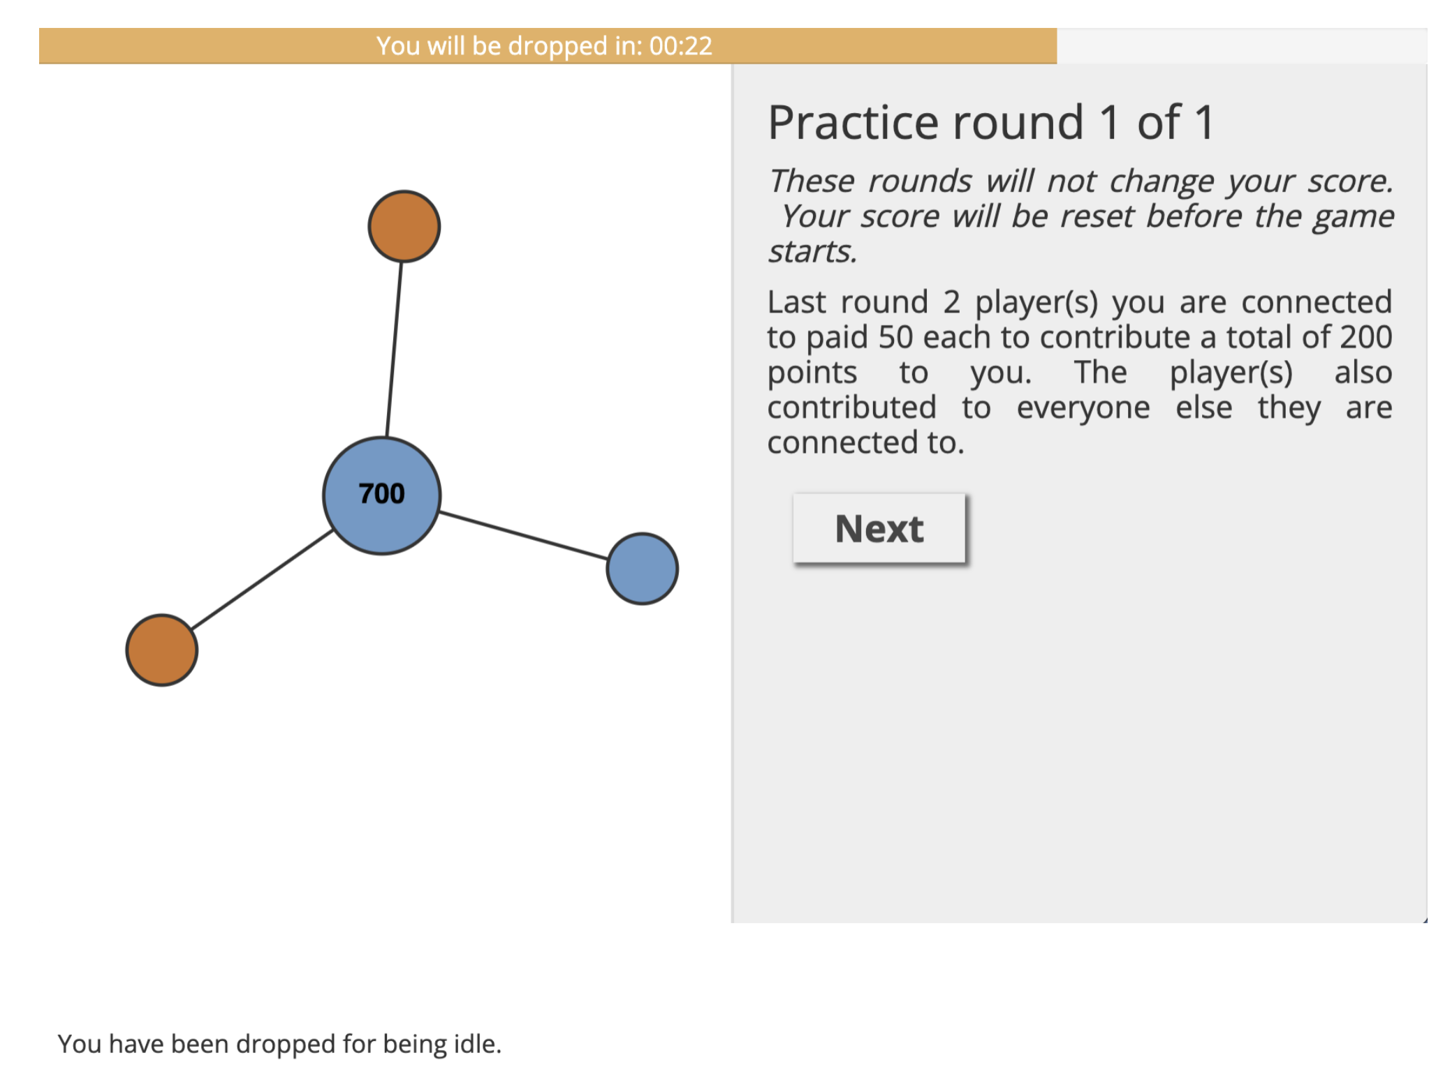

**Figure S1**. **Example message shown to dropped players in the time pressure condition.** Players in the TP+ condition who did not click on a button within the allotted time were first given a warning. If players did not click in two different rounds, they were dropped from future rounds of the experiment and were shown the message “You were dropped for being idle.”

|  |  |  |  |
| --- | --- | --- | --- |
|  | **Experiment A** | **Experiment B, TP-** | **Experiment B, TP+** |
| N | 9878 | 5247 | 4066 |
| **Fixed Effects** |  |  |  |
| Defection | 0.30179 (0.25441) [ns] | -0.273991 (0.106943) [p = 0.01048] | -0.051397 (0.01966) [p = 0.0089] |
| Punishment | 1.66993 (0.45919) [p = 0.000278] | 0.47002 (0.147547) [p = 0.00145] | 0.115546 (0.02799) [p = 0.000037] |
| Round | -0.23766 (0.02065) [p < 0.0001] | -0.020730 (0.006745) [p = 0.00213] | -0.006124 (0.00109) [p < 0.0001] |
| Intercept | 5.08635 (0.35869) [p < 0.0001] | 3.329949 (0.122798) [p < 0.0001] | 2.090189 (0.023485) [p < 0.0001] |
| **Random Effects** |  |  |  |
| Player-level variance | 17.73 (4.211) | 1.58559 (1.2592) | 0.07370 (0.27147) |
| Game-level variance | 2.84 (1.685) | 0.08172 (0.2859) | 0.00315 (0.05613) |
| Residual variance | 75.02 (8.661) | 4.38568 (2.0942) | 0.08420 (0.29018) |

**Table S1. Multilevel random intercepts models for decision times for all 3 experimental settings.** Standard errors for fixed effects and standard deviations for random effects are shown in parentheses. P-values are shown in square brackets.

|  |  |  |  |
| --- | --- | --- | --- |
|  | **Experiment A** | **Experiment B, TP-** | **Experiment B, TP+** |
| N | 4401 | 1252 | 1021 |
| **Fixed Effects** |  |  |  |
| Defection | 1.10868 (0.44070) [p = 0.00224] | -0.11398 (0.14448) [p = 0.431] | 0.018037 (0.038874) [p = 0.6429] |
| Punishment | 3.20706 (0.36236) [p = 0.00004143] | 0.04864 (0.23106) [p = 0.833] | 0.127288 (0.063257) [p = 0.0446] |
| Round | -0.13990 (0.03106) [p = 0.0000686] | -0.02480 (0.01182) [p = 0.036] | -0.007281 (0.002546) [p = 0.00433] |
| Intercept | 7.95239 (0.44070) [p < 0.0001] | 3.13139 (0.14608) [p < 0.0001] | 2.060753 (0.039760) [p < 0.0001] |
| **Random Effects** |  |  |  |
| Player-level variance | 15.482 (3.935) | 0.8126 (0.9014) | 0.070232 (0.26501) |
| Game-level variance | 3.186 (1.785) | 0.0000 (0.0000) | 0.005436 (0.07373) |
| Residual variance | 59.608 (7.7121) | 2.4181 (1.5550) | 0.083862 (0.28959) |

**Table S2: Multilevel random intercepts models for decisions times in cooperative environments.** Standard errors for fixed effects and standard deviations for random effects are shown in parentheses. P-values are shown in square brackets.

|  |  |  |  |
| --- | --- | --- | --- |
|  | **Experiment A** | **Experiment B, TP-** | **Experiment B, TP+** |
| N | 3142 | 2535 | 2021 |
| **Fixed Effects** |  |  |  |
| Defection | -0.51529 (0.46861) [p = 0.272] | -0.387843 (0.150963) [ p = 0.0103] | -0.093762 (0.026861) [p = 0.000499] |
| Punishment | 0.80128 (0.73294) [p = 0.274] | 0.655492 (0.222151) [p = 0.0032] | 0.108333 (0.038644) [p = 0.005106] |
| Round | -0.20991 (0.04303) [p = 0.0000012] | -0.004252 (0.011847) [p = 0.7197] | -0.004973 (0.001710) [p = 0.003676] |
| Intercept | 10.28749 (0.56993) [p < 0.00001] | 3.250264 (0.175940) [p < 0.00001] | 2.088884 (0.031403) [p = 0.003676] |
| **Random Effects** |  |  |  |
| Player-level variance | 19.66 (4.434) | 1.5678 (1.2521) | 0.073556 (0.27121) |
| Game-level variance | 1.47 (1.212) | 0.1299 (0.3604) | 0.004757 (0.06897) |
| Residual variance | 79.84 (8.936) | 5.3290 (2.3085) | 0.081484 (0.28545) |

**Table S3: Multilevel random intercepts models for decisions times in non-cooperative environments.** Standard errors for fixed effects and standard deviations for random effects are shown in parentheses. P-values are shown in square brackets.

|  |  |  |  |
| --- | --- | --- | --- |
|  | **Experiment A** | **Experiment B, TP-** | **Experiment B, TP+** |
| N | 6860 | 3438 | 2800 |
| **Fixed Effects** |  |  |  |
| Defection | 0.27807 (0.2993) [p = .353] | -0.225411 (0.117005) [p = 0.0542] | -0.0131252 (0.0052099) [p = 0.011852] |
| Punishment | 2.28317 (0.56877) [p = 0.00006032274985] | 0.249510 (0.166875) [p = 0.1350] | 0.0284076 (0.0076404) [p = 0.000205] |
| Round | -0.18451 (0.02619) [p = 0.00000000000204] | -0.007473 (0.008279) [p = 0.3668] | -0.0011626 (0.0003148) [p = 0.000226] |
| Intercept | 9.06650 (0.38593) [p < 0.00001] | 3.149230 (0.122602) [p < 0.00001] | 0.3077123 (0.0057605) [p < 0.0000001] |
| **Random Effects** |  |  |  |
| Player-level variance | 17.706 (4.208) | 1.587262 (1.25987) | 0.0041123 (0.06413) |
| Game-level variance | 2.278 (1.509) | 0.004274 (0.06537) | 0.0001007 (0.01004) |
| Residual variance | 72.850 (8.535) | 3.693330 (1.92180) | 0.0039845 (0.06312) |

**Table S4: Multilevel random intercepts models for decision times without a punisher present.** Standard errors for fixed effects and standard deviations for random effects are shown in parentheses. P-values are shown in square brackets.

|  |  |  |  |
| --- | --- | --- | --- |
|  | **Experiment A** | **Experiment B, TP-** | **Experiment B, TP+** |
| N | 2160 | 1434 | 1036 |
| **Fixed Effects** |  |  |  |
| Defection | 0.30017 (0.45395) [p = 0.509] | -0.37333 (0.16502) [p = 0.0240] | -0.0133220 (0.0074004) [p = 0.0723] |
| Punishment | 0.73432 (0.79973) [p = 0.359] | 1.29204 (0.27737) [p = 0.00000349] | 0.0208662 (0.0116047) [p = 0.0725] |
| Round | -0.18939 (0.04762) [p = 0.0000724] | -0.02479 (0.01459) [p =0.0896] | -0.0011896 (0.0005769) [p = 0.0395] |
| Intercept | 8.96280 (0.52250) [p < 0.00001] | 3.37543 (0.19568) [p < 0.00001] | 0.3097772 (0.0086881) [p < 0.000001] |
| **Random Effects** |  |  |  |
| Player-level variance | 16.352 (4.044) | 1.3539 (1.1636) | 0.0036479 (0.06040) |
| Game-level variance | 1.243 (1.115) | 0.1838 (0.4287) | 0.0003592 (0.01895) |
| Residual variance | 60.053 (7.749) | 3.9751 (1.9938) | 0.0040030 (0.06327) |

**Table S5: Multilevel random intercepts models for decision times with a punisher present.** Standard errors for fixed effects and standard deviations for random effects are shown in parentheses. P-values are shown in square brackets.

|  |  |
| --- | --- |
|  | **Experiment A** |
| N | 10747 |
| **Fixed Effects** |  |
| Time Pressure | 0.77967310 (0.39388998, 1.5432993) [p = 0.475] |
| Round | 0.97390199 (0.95276321, 0.9955098) [p = 0.018] |
| Intercept | 0.02494719 (0.01506121, 0.0413222) [p < 0.00001] |
| **Random Effects** |  |
| Player-level variance | 6.908 (2.6283) |
| Game-level variance | 0.641 (0.8006) |

**Table S6: Multilevel logistic random intercepts model for the effect of time pressure on the odds of punishment in Experiment B.** Estimates shown are exponentiated and represent odds ratios. 95% confidence intervals for fixed effects odds ratios and standard deviations of random effects are shown in parentheses. P-values are shown in square brackets.