**The slowness of punishment is fueled by decision mismatches**

**Authors:** George Dewey, MPH1, Hiroyasu Ando, BS1, Ryo Ikesu, MS1, Akihiro Nishi, MD, DrPH1-3*, XXX

**Affiliations:**

1 *Department of Epidemiology, University of California, Los Angeles Fielding School of Public Health, Los Angeles, CA 90095, United States;*

2 *California Center for Population Research, University of California, Los Angeles, Los Angeles, CA 90095, United States;*

3 *Bedari Kindness Institute, University of California, Los Angeles, Los Angeles, CA 90095, United States.*

*Correspondence to: Akihiro Nishi, M.D., Dr.P.H., Department of Epidemiology, UCLA Fielding School of Public Health, 650 Charles E Young Dr S, Los Angeles CA; Tel.: +1-310-206-7164; Fax: +1-310-206-6039.

**Keywords: Evolution of cooperation, punishment, decision conflict, decision time**

**Acknowledgements:** We gratefully acknowledge support from the UCLA Fielding School of Public Health.

**Author contributions:** GD and AN designed the project. HA provided programming support. RI conducted data analysis and assisted in early manuscript preparation. All authors analyzed the findings and revised the manuscript.

**Conflict of interest:** AN is a consultant to Vacan, Inc. and obtained an honorarium from Taisho Pharmaceutical Co., Ltd., which had no role in the project.

**Data availability:** De-identified data and the complete analysis code will be made available under XXX journal’s data release policy upon acceptance of this manuscript.

**Abstract (194/200 words)**

Costly punishment – paying a cost to harm others – is a widely observed behavior across a variety of contexts in human social interactions. However, choosing to punish others lies in contrast to the breadth of evidence suggesting that humans are willingly and preferentially cooperative. Therefore, the specific role of punishment, especially in repeated interactions involving dynamic decisions, remains unclear. To explore this issue, we recruited human players and observed their decisions in two series of economic games with a punishment option in brief online network experiments, comprising a total of 1,484 unique players and 20,729 unique decision points. We show that choosing punishment resulted in considerably longer decision times than choosing either cooperation or defection across all our experimental settings. We also provide support for the hypothesis that decision conflicts drive increases in decision times, especially the role of mismatches between individuals’ own decision-making and the choices of their “social environment”. Our results show that choosing to punish when no punisher was present among one’s connections was associated with longer decision times, suggesting that even small incongruities between individual choices and the selections of their peers contribute to slower mental processing and additional internal conflict.

**Introduction**

Punishment is widely observed in modern human societies [1-3]. Punishment is costly to both parties involved in the transaction: the punisher pays a cost to inflict damage upon others, while the harmed individuals incur penalties chosen by the punisher. The dynamic balance between the costs to the punisher and the harmed in punishing interactions has been suggested to promote and sustain human cooperation [4-6]. [4, 5]Seminal laboratory experiments suggested that punishment might serve to dissuade free riding - obtaining benefits while paying no costs - and encourage cooperation in future encounters [5, 6]. However, these studies often restricted the number of choices available to participants, limiting interactions to one-shot instances or preventing participants from knowing what their peers did previously [7]. More recent studies have promoted that punishment offers a competitive outlet for humans to minimize differences in fitness between targets and perpetrators [8-10], ultimately leading to more cooperation once the fitness gaps are reduced. It is probable that punishment is not fully explained by either of these two theoretical mechanisms, especially when evaluated in human social networks that model real-world, repeated interactions. Furthermore [7, 11]

One avenue into understanding the evolution of human cooperation that has been promoted is the connection between cooperation and decision times [12]. The correlation between decision time and the choices we make implicates the role of decision conflicts [13, 14] in driving the speed of decisions in different contexts: when people are presented with options that match their inclinations, they choose faster, but when options are numerous and do not match their preferences, their decisions are slower. An additional contributor to the effect of decision conflicts is the mismatch between our own preferences and the preferences of those around us – our “social environment.” Prior research suggests that reciprocity with one’s social environment shifts the balance between choosing cooperation and defection [15, 16]. Furthermore, behaviors that were concordant with the social environment (i.e., cooperation in a cooperative environment) were found to be faster than discordant behaviors [15, 17]. However, these studies, like the laboratory experiments mentioned previously, did not allow participants to punish each other. Adding the third dimension of punishment to the cooperation-defection axis further complicates an already complex set of evidence to sift through as people make their decisions.

We hypothesize that punishment will be slower than either cooperation or defection since it is generally rare [18], resulting in a baseline conflict that makes it harder for people to choose to punish. We also ask if external manipulation of decision times using time pressure can answer the question of the source of punishment’s slowness. If punishment is slow because it leads people to spend time to consider their choices, time pressure should reduce the occurrence of punishment; however, time pressure would be unable to limit people choosing punishment if slow decisions are mostly driven by decision conflicts. Therefore, to address this gap, we aimed to evaluate how punishment emerged and persisted in an dynamic social network environment with repeated interactions, if decision speeds aligned with the hypothesis of decision conflicts when punishment was given as an option, and to use implementation of a time limit to understand the relationships between cooperation, punishment, and decision times.

**Methods**

We implemented two series of repeated public goods game (PGG) involving human players embedded in dynamic social networks. Players were recruited from all over the world using Amazon Mechanical Turk (MTurk) in 2018 and 2023 and joined a session hosted on the Breadboard experimental platform [19]. In the first series, we introduced a punishment option to a previously-used network-based framework [20]. This series of experiments encompassed 50 social networks allotted to 50 games with 15 rounds each. Each network was generated by arranging each session’s players into a Erdős-Renyi random graph in which 30% of all possible ties were present. Players were asked to play two practice rounds to introduce them to the game format and layout of the elements within the experimental platform. Once these two practice rounds were completed, all players in the game were given either a low or high allocation of arbitrary in-game units and asked to interact with each other. Game sessions that did not recruit enough players from MTurk did not progress to the practice round stage and were closed to further entry.

At the start of each game round, players entered the decisionphase, where they were given one of three options: cooperation (the player pays 50 units to have all connected players gain 100 units), defection (pay nothing, not affecting others), and punishment (the player pays 50 units to have all connected players lose 100 units). No institutional punishment or sanctioning [21] occurred. In this network environment, no option was directly targeted as the same benefit (after choosing cooperation) or penalty (after choosing punishment) would be applied to all other connected players. Once players were made their decisions, they were shown the decisions made by other connected players in that round. Next, players were allowed to update their network connections in the rewiring phase. In this step, 30% of all possible ties in the network were randomly selected by the platform. For each extant tie, one player from the tie was chosen at random and asked if they wanted to break the tie. For each non-extant tie, both players in the potential tie were asked if they wanted to make a new connection; if both players agreed, the tie was completed and carried to the next game round. The networks were then rearranged according to the player choices in the rewiring phase and the subsequent round began. At the end of all games, accumulated in-game wealth was converted to USD. Players were not informed that they would be compensated based on their in-game performance. To calculate the time taken for each decision, we took the difference between the timestamp recording the appearance of the screen which allowed the player to choose between cooperation, defection, or punishment and the timestamp recording when the player clicked the button of their choice.

In the second series of experiments, we randomized half of the games to enforce a 3-second time limit for each decision point while the other half of the games had no time limit. The games otherwise consisted of the same two phases used in the first experimental series, with participants allowed to choose either cooperation, defection, or punishment at each decision point, followed by potential network rewiring. Games with the time limit (the time pressure condition, TP+) showed players a diminishing bar at the top of their game screen which showed the amount of time they had remaining to make their decision (**Figure 1)**. In the games with no time limit (TP–), no such bar was shown. If players did not confirm their choice within the time limit, the system automatically repeated their decision from the past round. A visual demonstration of this user interface element is provided in the Supplementary Materials (**Figure S1**).

|  |  |  |  |  |  |  |  |
| --- | --- | --- | --- | --- | --- | --- | --- |
| **Experiment** | **Year** | **Was a time limit imposed?** | **Cooperative decisions (%)** | **Defection decisions (%)** | **Punishment decisions (%)** | **Game sessions** | **Total decisions** |
| 1 | 2018 | No | 4,878 (49.44) | 4,336 (43.95) | 562 (6.60) | 50 | 9,982 |
| 2, TP- | 2023 | No | 2,013 (38.36) | 2,893 (55.13) | 341 (6.49) | 25 | 5,247 |
| 2, TP+ | 2023 | Yes | 2,172 (40.17) | 2,897 (53.58) | 338 (6.25) | 25 | 5,407 |

**Table 1**. Summary characteristics of the two series of experiments. Second series was divided into two conditions: the TP- condition, with no time limit for player decisions, and the TP+ condition, with a strict 3 second time limit for each decision.

Based on these classifications, we tested for associations within the three types of social environment between choosing punishment and logner decision times. an additional classifier g by comparing the frequency of each behavior in settings with and without the time limit.

The structure of the game sessions and the arrangement of players into networks meant that multiple observations were made for a single player across multiple rounds in each session. We account for this hierarchical data structure using multilevel random intercepts models, utilizing R version 4.2.3 [22] and the *lme4* statistical package. While prior work [15, 23, 24] utilized a log 10-transformation when analyzing decision times because decision times are generally only left-bounded by zero, time data from the TP+ condition of our experiments would also be right-bounded by the time limit. As a result, we chose to omit the transformation to keep model estimates from limited and non-limited data on the same scale.

**1.**

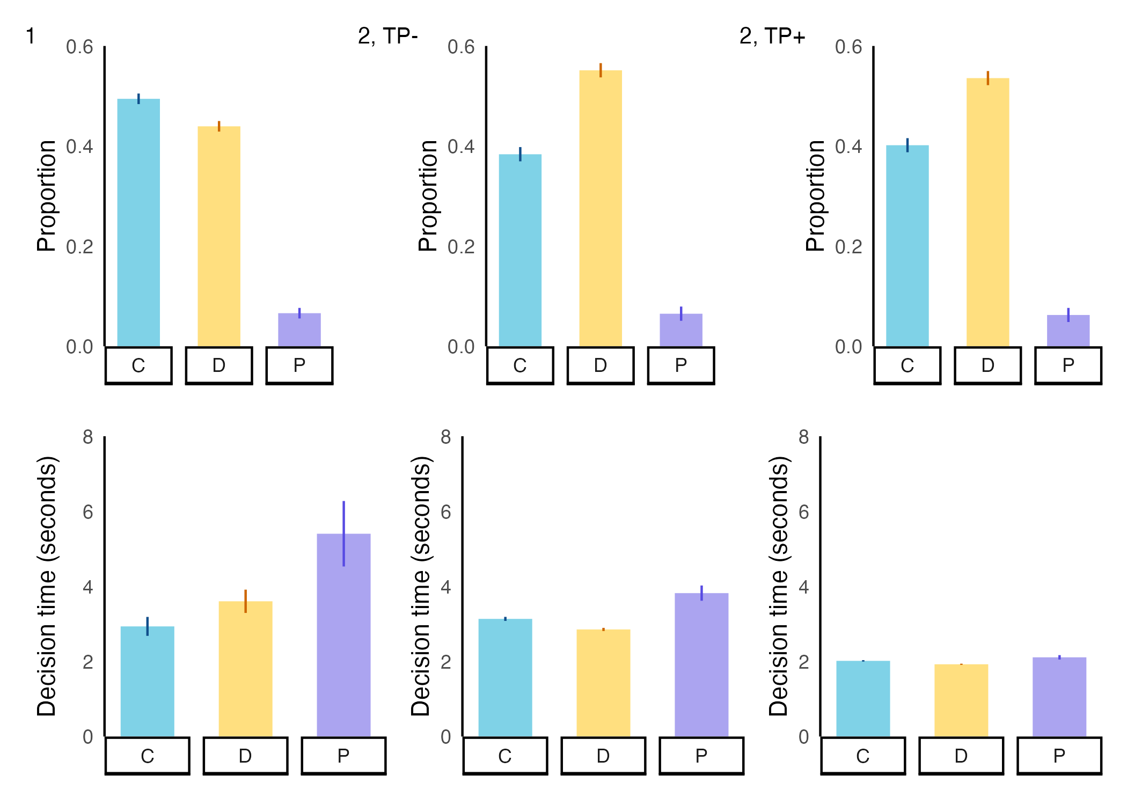

**2** (C: cooperation, D: defection, P: punishment)The second seriesof experiments was

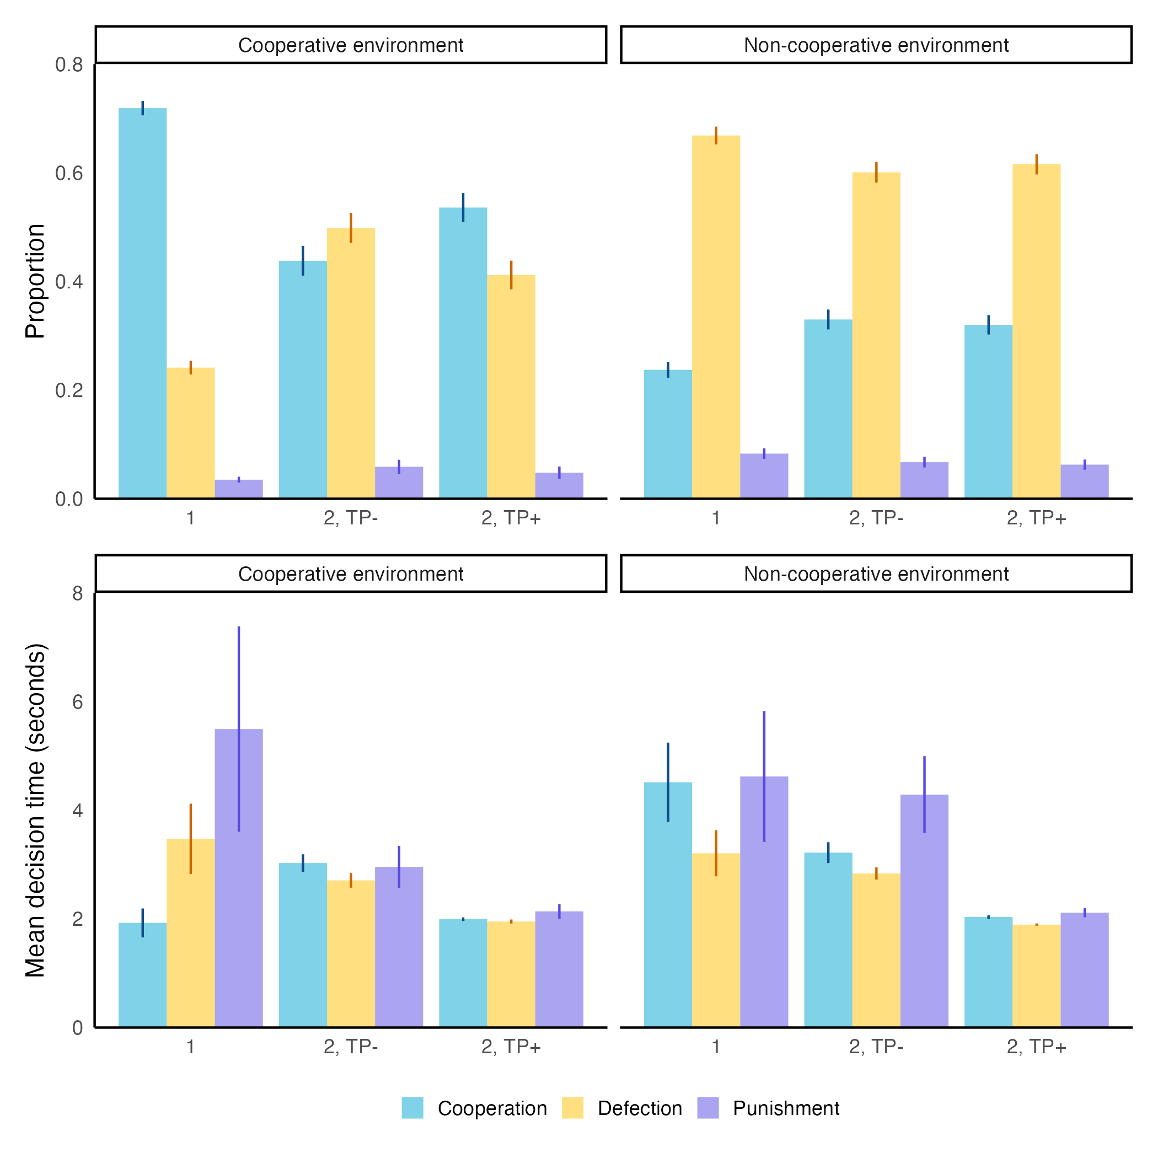

**Figure 3**. **Behavior distributions and mean decision times across all experimental conditions stratified by social environment.** Punishment was slowest after accounting for social environment across all experimental conditions. Punishment in a cooperative environment was slower than all other behaviors in 2 out of 3 conditions; in non-cooperative environments, cooperation was slower in all 3 conditions but not slower than punishment. Error bars indicate 95% confidence intervals of proportions or means.

**Results**

the first series, 19First series In the second series, 739 players (mean: 14.8/game, range: 8-20/game) made 10,747 decisions. Cooperation was chosen 4,185 times (39.28%, 95% CI: 38.29-40.29%), defection was chosen 5,790 times (54.35%, 53.35-55.36%), and punishment was chosen 679 times (6.37%, 5.38-7.38%). The mean degree in Second series was 5.72. At the end of 15 rounds, the mean accumulated wealth was 935 in-game units (equivalent to USD 0.47). In the TP+ sessions, punishment was chosen 338 times out of 5407 decisions (6.25%, 4.84-7.66%), while in the TP- sessions, punishment was chosen 341 out of 5247 decisions (6.50%, 5.09-7.93%).

In both series of experiments, we found that players spent the most time before they chose to punish compared to when they chose to cooperate or defect (**Figure 2**). Overall, choosing punishment had a positive association with increased decision times compared to cooperation in both the first series (p = 0.0002, **Table S1**) and the TP- condition of the second series (p= 0.0019, **Table S1)**. Remarkably, this relationship also held even under the TP+ condition of the second series (p = 0.0001, **Table S1)**.

We additionally evaluated if there were differences in the frequency of punishment across different social environments (**Figure 3, top**). In the first series, punishment made up 8.31% of decisions in non-cooperative environments, compared to 3.50% of decisions in cooperative environments (p < 0.0001)*.* We did not see a substantial difference in the proportion of punishment within the TP- condition of the second series. However, we observed a small difference in the frequency of punishment comparing cooperative and non-cooperative environments under the TP+ condition (p = 0.0658) (**Figure 3, bottom**). We found that the positive relationship between choosing punishment and increased decision time did not consistently hold across different social environments and between our various experimental settings (**Table S2, Table S3)**. Specifically, we found that punishment was only significantly associated with increased decision time in cooperative environments in the first series (p < 0.0001) and in non-cooperative environments in the TP- condition of the second series of experiments (p = 0.0023).

Among decisions made without punishment in the previous round, there was a significant positive association between choosing punishment and increased decision time in the first series (p < 0.0001) and the TP+ condition of the second series of experiments (p = 0.0003) (**Table S4**). However, we only found a similar significant relationship in the TP- condition of the second series when analyzing only decisions made after being punished (p = 0.3565, Exp. 1, p = 0.0012, Exp. 2 TP-, p = 0.0729, Exp. 2 TP+, **Table S5**). This suggests that players had more difficulty choosing to punish when they were not punished immediately prior to making their decision, implying that a behavior does not necessarily have to be dominant in players’ social environment to influence their decision-making speed.

We found that the imposed time limit had no substantial effect on the frequency of choosing to punish (p *=* 0.47) (**Table S6**). While the three-second limit was able to compress the actual number of seconds players took to make their decisions, the overall distribution of decision choices was not materially affected. There are several implications of this finding. First, players were not inhibited from making decisions when they were presented the opportunity, even with a time limit present. Although a substantial proportion (1341 out of 5455 decisions in the TP+ condition, 24.58%) of players were unable to click an option in time, punishment was still a viable option, occurring at the same rate among actual decisions as in the TP- condition. Second, the slowness of punishment was reflected under time pressure both in the presence and absence of a punisher in the previous round, contradicting the reactive and deliberate dichotomy of dual process perspectives and providing support for a decision conflict approach to understanding players’ decision times when faced with multiple possible choices.

**Discussion**

Our results show that in a dynamic system of repeated interactions, punishment is slower than both cooperation and defection. We provide additional evidence that decision-making speeds are linked to the social environment in which they are made, especially when considering the presence or absence of a punisher: punishment decisions made without a punisher present took longer to process compared to cooperation decisions, while the presence of a punisher compressed decision times together. We also find that while the implementation of a time limit did not reduce the occurrence of punishment, punishment decisions remained the slowest among time-compressed decision times as compared to cooperation and defection.

Taken together, these findings have several implications. Given the extensive evidence of humans’ willingness and preference for cooperation [25-27], we should intuitively believe cooperation to be more prevalent and faster than punishment. We find that while this belief would be generally correct, the relative difference in decision speed comparing cooperation and punishment is noticeably influenced by the social environment of the decision-maker. Even under the constraints of a three-second time limit, punishment was the slowest of the three behaviors; this difference was most pronounced when it was made without previous punishment.

However, we did not find that the time limit reduced the overall rate of punishment decisions. This is reflective of punishment’s persistence as a potential course of action in human cooperation, with a caveat: in our experimental setting, we did not measure players’ perception of their peers’ reputation. As recent work has found that the reputation of punishers decreases when they punish quickly, but when the punishment was slow, the punishers’ reputation instead increased, [28] future work should carefully investigate the connections between the social environment, reputation, and decision times.

Furthermore, our results lend additional credence to the theory of decision conflicts [12-14] as a key mechanism to understand differences in decision times. The presence of a single punisher in one’s social environment considerably influenced the difference in decision-making speed between cooperation and punishment, suggesting that even small shifts in the balance between one’s own behavioral considerations and those encouraged by social norms and trends result in changes to how fast (or slow) we process information before a decision.

In conclusion, our findings support previous studies that implicate reciprocity, rather than the specific types of behavior, as a major contributor to the variation in decision times observed in both experimental and field studies. We find that punishment is generally slower than either cooperation or defection and that time pressure alone is not sufficient to reduce the occurrence of punishment.

**References**

[1] Henrich, J., McElreath, R., Barr, A., Ensminger, J., Barrett, C., Bolyanatz, A., Cardenas, J.C., Gurven, M., Gwako, E., Henrich, N., et al. 2006 Costly Punishment Across Human Societies. *Science* **312**, 1767-1770. (doi:doi:10.1126/science.1127333).

[2] Balliet, D. & Van Lange, P.A. 2013 Trust, punishment, and cooperation across 18 societies: A meta-analysis. *Perspectives on Psychological Science* **8**, 363-379.

[3] Herrmann, B., Thöni, C. & Gächter, S. 2008 Antisocial Punishment Across Societies. *Science* **319**, 1362-1367. (doi:doi:10.1126/science.1153808).

[4] Mathew, S. & Boyd, R. 2011 Punishment sustains large-scale cooperation in prestate warfare. *Proc Natl Acad Sci U S A* **108**, 11375-11380. (doi:10.1073/pnas.1105604108).

[5] Fehr, E. & Gachter, S. 2000 Cooperation and Punishment in Public Goods Experiments. *The American Economic Review* **90**, 980-994.

[6] Fehr, E. & Gächter, S. 2002 Altruistic punishment in humans. *Nature* **415**, 137-140. (doi:10.1038/415137a).

[7] Raihani, N.J. & Bshary, R. 2019 Punishment: one tool, many uses. *Evolutionary Human Sciences* **1**, e12. (doi:10.1017/ehs.2019.12).

[8] Raihani, N.J. & McAuliffe, K. 2012 Human punishment is motivated by inequity aversion, not a desire for reciprocity. *Biol Lett* **8**, 802-804. (doi:10.1098/rsbl.2012.0470).

[9] Bone, J.E. & Raihani, N.J. 2015 Human punishment is motivated by both a desire for revenge and a desire for equality. *Evolution and Human Behavior* **36**, 323-330. (doi:10.1016/j.evolhumbehav.2015.02.002).

[10] Deutchman, P., Bračič, M., Raihani, N. & McAuliffe, K. 2021 Punishment is strongly motivated by revenge and weakly motivated by inequity aversion. *Evolution and Human Behavior* **42**, 12-20. (doi:10.1016/j.evolhumbehav.2020.06.001).

[11] Raihani, N.J. & Bshary, R. 2015 Why humans might help strangers. *Front Behav Neurosci* **9**, 39. (doi:10.3389/fnbeh.2015.00039).

[12] Evans, A.M. & Rand, D.G. 2019 Cooperation and decision time. *Curr Opin Psychol* **26**, 67-71. (doi:10.1016/j.copsyc.2018.05.007).

[13] Diederich, A. 2003 Decision making under conflict: Decision time as a measure of conflict strength. *Psychonomic bulletin & review* **10**, 167-176.

[14] Evans, A.M., Dillon, K.D. & Rand, D.G. 2015 Fast but not intuitive, slow but not reflective: Decision conflict drives reaction times in social dilemmas. *J Exp Psychol Gen* **144**, 951-966. (doi:10.1037/xge0000107).

[15] Nishi, A., Christakis, N.A., Evans, A.M., O’Malley, A.J. & Rand, D.G. 2016 Social Environment Shapes the Speed of Cooperation. *Scientific Reports* **6**, 29622. (doi:10.1038/srep29622).

[16] Rand, D.G. & Nowak, M.A. 2013 Human cooperation. *Trends Cogn Sci* **17**, 413-425. (doi:10.1016/j.tics.2013.06.003).

[17] Castro Santa, J., Exadaktylos, F. & Soto-Faraco, S. 2018 Beliefs about others’ intentions determine whether cooperation is the faster choice. *Scientific Reports* **8**, 7509. (doi:10.1038/s41598-018-25926-3).

[18] Rand, D.G. & Nowak, M.A. 2011 The evolution of antisocial punishment in optional public goods games. *Nature Communications* **2**, 434. (doi:10.1038/ncomms1442).

[19] McKnight, M.E. & Christakis, N.A. 2016 Breadboard: Software for Online Social Experiments. (ed. Y. University), 2 ed.

[20] Nishi, A., Shirado, H., Rand, D.G. & Christakis, N.A. 2015 Inequality and visibility of wealth in experimental social networks. *Nature* **526**, 426-429. (doi:10.1038/nature15392).

[21] Gürerk, Ö., Irlenbusch, B. & Rockenbach, B. 2006 The Competitive Advantage of Sanctioning Institutions. *Science* **312**, 108-111. (doi:doi:10.1126/science.1123633).

[22] R Core Team. 2022 R: A language and environment for statistical computing. (4.2.0 ed. Vienna, Austria, R Foundation for Statisical Computing.

[23] Rand, D.G., Greene, J.D. & Nowak, M.A. 2012 Spontaneous giving and calculated greed. *Nature* **489**, 427-430.

[24] Rand, D.G., Peysakhovich, A., Kraft-Todd, G.T., Newman, G.E., Wurzbacher, O., Nowak, M.A. & Greene, J.D. 2014 Social heuristics shape intuitive cooperation. *Nature communications* **5**, 3677.

[25] Curioni, A., Voinov, P., Allritz, M., Wolf, T., Call, J. & Knoblich, G. 2022 Human adults prefer to cooperate even when it is costly. *Proceedings of the Royal Society B: Biological Sciences* **289**, 20220128. (doi:doi:10.1098/rspb.2022.0128).

[26] Boyd, R. & Richerson, P.J. 2009 Culture and the evolution of human cooperation. *Philosophical Transactions of the Royal Society B: Biological Sciences* **364**, 3281-3288. (doi:doi:10.1098/rstb.2009.0134).

[27] Henrich, J. & Muthukrishna, M. 2021 The Origins and Psychology of Human Cooperation. *Annual Review of Psychology* **72**, 207-240. (doi:10.1146/annurev-psych-081920-042106).

[28] Maeda, K., Kumai, Y. & Hashimoto, H. 2022 Potential influence of decision time on punishment behavior and its evaluation. *Frontiers in Psychology* **13**. (doi:10.3389/fpsyg.2022.794953).

**Supplementary Information**

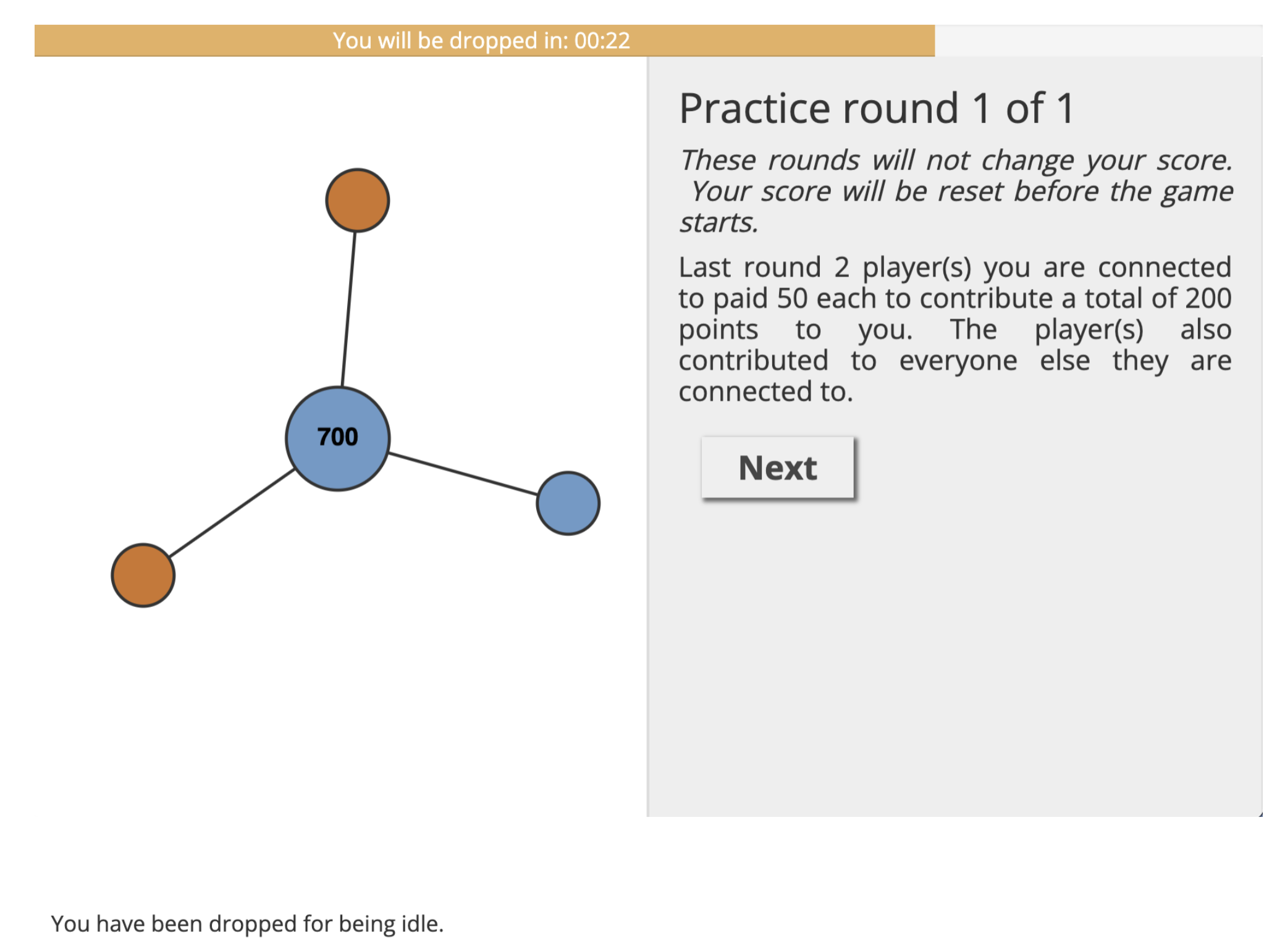

**Figure S1**. **Example message shown to dropped players in the time pressure condition.** Players in the TP+ condition who did not click on a button within the allotted time were first given a warning. If players did not click in two different rounds, they were dropped from future rounds of the experiment and were shown the message “You were dropped for being idle.”

|  |  |  |  |
| --- | --- | --- | --- |
|  | **First series** | **Second series, TP-** | **Second series, TP+** |
| N | 9,878 | 5,247 | 4,066 |
| **Fixed Effects** |  |  |  |
| Defection | 0.30179 (0.25441) [ns] | -0.273991 (0.106943) [p = 0.01048] | -0.051397 (0.01966) [p = 0.0089] |
| Punishment | 1.66993 (0.45919) [p = 0.000278] | 0.47002 (0.147547) [p = 0.00145] | 0.115546 (0.02799) [p = 0.000037] |
| Round | -0.23766 (0.02065) [p < 0.0001] | -0.020730 (0.006745) [p = 0.00213] | -0.006124 (0.00109) [p < 0.0001] |
| Intercept | 5.08635 (0.35869) [p < 0.0001] | 3.329949 (0.122798) [p < 0.0001] | 2.090189 (0.023485) [p < 0.0001] |
| **Random Effects** |  |  |  |
| Player-level variance | 17.73 (4.211) | 1.58559 (1.2592) | 0.07370 (0.27147) |
| Game-level variance | 2.84 (1.685) | 0.08172 (0.2859) | 0.00315 (0.05613) |
| Residual variance | 75.02 (8.661) | 4.38568 (2.0942) | 0.08420 (0.29018) |

**Table S1. Multilevel random intercepts models for decision times for all 3 experimental settings.** Standard errors for fixed effects and standard deviations for random effects are shown in parentheses. P-values are shown in square brackets.

|  |  |  |  |
| --- | --- | --- | --- |
|  | **First series** | **Second series, TP-** | **Second series, TP+** |
| N | 4,401 | 1,252 | 1,021 |
| **Fixed Effects** |  |  |  |
| Defection | 1.10868 (0.44070) [p = 0.00224] | -0.11398 (0.14448) [p = 0.431] | 0.018037 (0.038874) [p = 0.6429] |
| Punishment | 3.20706 (0.36236) [p = 0.00004143] | 0.04864 (0.23106) [p = 0.833] | 0.127288 (0.063257) [p = 0.0446] |
| Round | -0.13990 (0.03106) [p = 0.0000686] | -0.02480 (0.01182) [p = 0.036] | -0.007281 (0.002546) [p = 0.00433] |
| Intercept | 7.95239 (0.44070) [p < 0.0001] | 3.13139 (0.14608) [p < 0.0001] | 2.060753 (0.039760) [p < 0.0001] |
| **Random Effects** |  |  |  |
| Player-level variance | 15.482 (3.935) | 0.8126 (0.9014) | 0.070232 (0.26501) |
| Game-level variance | 3.186 (1.785) | 0.0000 (0.0000) | 0.005436 (0.07373) |
| Residual variance | 59.608 (7.7121) | 2.4181 (1.5550) | 0.083862 (0.28959) |

**Table S2: Multilevel random intercepts models for decisions times in cooperative environments.** Standard errors for fixed effects and standard deviations for random effects are shown in parentheses. P-values are shown in square brackets.

|  |  |  |  |
| --- | --- | --- | --- |
|  | **First series** | **Second series, TP-** | **Second series, TP+** |
| N | 3,142 | 2,535 | 2,021 |
| **Fixed Effects** |  |  |  |
| Defection | -0.51529 (0.46861) [p = 0.272] | -0.387843 (0.150963) [ p = 0.0103] | -0.093762 (0.026861) [p = 0.000499] |
| Punishment | 0.80128 (0.73294) [p = 0.274] | 0.655492 (0.222151) [p = 0.0032] | 0.108333 (0.038644) [p = 0.005106] |
| Round | -0.20991 (0.04303) [p = 0.0000012] | -0.004252 (0.011847) [p = 0.7197] | -0.004973 (0.001710) [p = 0.003676] |
| Intercept | 10.28749 (0.56993) [p < 0.00001] | 3.250264 (0.175940) [p < 0.00001] | 2.088884 (0.031403) [p = 0.003676] |
| **Random Effects** |  |  |  |
| Player-level variance | 19.66 (4.434) | 1.5678 (1.2521) | 0.073556 (0.27121) |
| Game-level variance | 1.47 (1.212) | 0.1299 (0.3604) | 0.004757 (0.06897) |
| Residual variance | 79.84 (8.936) | 5.3290 (2.3085) | 0.081484 (0.28545) |

**Table S3: Multilevel random intercepts models for decisions times in non-cooperative environments.** Standard errors for fixed effects and standard deviations for random effects are shown in parentheses. P-values are shown in square brackets.

|  |  |  |  |
| --- | --- | --- | --- |
|  | **First series** | **Second series, TP-** | **Second series, TP+** |
| N | 6,860 | 3,438 | 2,800 |
| **Fixed Effects** |  |  |  |
| Defection | 0.27807 (0.2993) [p = .353] | -0.225411 (0.117005) [p = 0.0542] | -0.0131252 (0.0052099) [p = 0.011852] |
| Punishment | 2.28317 (0.56877) [p = 0.00006032274985] | 0.249510 (0.166875) [p = 0.1350] | 0.0284076 (0.0076404) [p = 0.000205] |
| Round | -0.18451 (0.02619) [p = 0.00000000000204] | -0.007473 (0.008279) [p = 0.3668] | -0.0011626 (0.0003148) [p = 0.000226] |
| Intercept | 9.06650 (0.38593) [p < 0.00001] | 3.149230 (0.122602) [p < 0.00001] | 0.3077123 (0.0057605) [p < 0.0000001] |
| **Random Effects** |  |  |  |
| Player-level variance | 17.706 (4.208) | 1.587262 (1.25987) | 0.0041123 (0.06413) |
| Game-level variance | 2.278 (1.509) | 0.004274 (0.06537) | 0.0001007 (0.01004) |
| Residual variance | 72.850 (8.535) | 3.693330 (1.92180) | 0.0039845 (0.06312) |

**Table S4: Multilevel random intercepts models for decision times without a punisher present.** Standard errors for fixed effects and standard deviations for random effects are shown in parentheses. P-values are shown in square brackets.

|  |  |  |  |
| --- | --- | --- | --- |
|  | **First series** | **Second series, TP-** | **Second series, TP+** |
| N | 2,160 | 1,434 | 1,036 |
| **Fixed Effects** |  |  |  |
| Defection | 0.30017 (0.45395) [p = 0.509] | -0.37333 (0.16502) [p = 0.0240] | -0.0133220 (0.0074004) [p = 0.0723] |
| Punishment | 0.73432 (0.79973) [p = 0.359] | 1.29204 (0.27737) [p = 0.00000349] | 0.0208662 (0.0116047) [p = 0.0725] |
| Round | -0.18939 (0.04762) [p = 0.0000724] | -0.02479 (0.01459) [p =0.0896] | -0.0011896 (0.0005769) [p = 0.0395] |
| Intercept | 8.96280 (0.52250) [p < 0.00001] | 3.37543 (0.19568) [p < 0.00001] | 0.3097772 (0.0086881) [p < 0.000001] |
| **Random Effects** |  |  |  |
| Player-level variance | 16.352 (4.044) | 1.3539 (1.1636) | 0.0036479 (0.06040) |
| Game-level variance | 1.243 (1.115) | 0.1838 (0.4287) | 0.0003592 (0.01895) |
| Residual variance | 60.053 (7.749) | 3.9751 (1.9938) | 0.0040030 (0.06327) |

**Table S5: Multilevel random intercepts models for decision times with a punisher present.** Standard errors for fixed effects and standard deviations for random effects are shown in parentheses. P-values are shown in square brackets.

|  |  |
| --- | --- |
|  | **First series** |
| N | 10,747 |
| **Fixed Effects** |  |
| Time Pressure | 0.77967310 (0.39388998, 1.5432993) [p = 0.475] |
| Round | 0.97390199 (0.95276321, 0.9955098) [p = 0.018] |
| Intercept | 0.02494719 (0.01506121, 0.0413222) [p < 0.00001] |
| **Random Effects** |  |
| Player-level variance | 6.908 (2.6283) |
| Game-level variance | 0.641 (0.8006) |

**Table S6: Multilevel logistic random intercepts model for the effect of time pressure on the odds of punishment in the second experimental series.** Estimates shown are exponentiated and represent odds ratios. 95% confidence intervals for fixed effects odds ratios and standard deviations of random effects are shown in parentheses. P-values are shown in square brackets.