JUNE’S ASCENSION: Concept Document



# Table of Contents

1. Select the ‘References’ ribbon
2. Select ‘Table of Contents’
3. Select a ToC that fits your needs

# Synopsis

* Narrative overview
  + The game opens showcasing various aspects of a beautiful, opulent building. The sun is rising. The streets are clean and empty. Slowly, the camera pans downwards below the ground revealing a whole shanty town under the surface. It is beautiful in its own way. We see lots of people going about their lives. The camera continues to pan down until it reaches the very bottom. At the edge of a sewer canal is a sleepy tavern. Inside is our hero, June.
  + We learn through a conversation with the bartender that June’s mother has recently passed. Her mother’s loss was in vain. June is sure that there was medicine and technology in the surface that could have saved he mother, if only she had been brave enough to venture to get it. The bartender assures June that she is speaking nonsense. June herself would have surely died had she dared to go, the bartender says.
  + Drunk, June leaves the tavern only to be interrupted by a beggar outside. After donating some gold to the beggar (or not), the beggar complains that people are too complacent, and hints at the fact that more would be inspired to rise to the surface if only there was a brave enough hero to lead the charge. This is it! June decides she will be that hero!
* Environments
  + The Shanty Town: Shoddily put together. Improvised roofs and walls. Delicate. Overcrowded.
  + The Sewers: Ancient. Abandoned. Dangerous. Smelly. Maze like. Disorientating.
  + The Surface: Clean, vast. Opulent. Rich. Noble. Lots of white and gold.
* Gameplay overview
  + Platforming – Traversing Shanty Town:
  + Puzzle – Navigating The Ancient Sewers:
  + Combat -
    - Be specific about the medium-term goal and the complications that they present

# 

# Mission beats

|  |  |  |  |  |  |
| --- | --- | --- | --- | --- | --- |
| 1. Beat Name | | Difficulty: | 0/10 | Duration: | 00:00 |
| **What happens:** | Overview providing context and narrative | | | | |
| **Objective:** | How to accomplish the medium-term goal | | | | |
| **Location(s):** | Where the beat is going to take place | | | | |
| **Design goal:** | The design reasons behind your choices for this beat  What are you trying to achieve? | | | | |
|  | | | | | |
| 1. Beat Name | | Difficulty: | 0/10 | Duration: | 00:00 |
| **What happens:** | Overview providing context and narrative | | | | |
| **Objective:** | How to accomplish the medium-term goal | | | | |
| **Location(s):** | Where the beat is going to take place | | | | |
| **Design goal:** | The design reasons behind your choices for this beat  What are you trying to achieve? | | | | |
|  | | | | | |
| 1. Beat Name | | Difficulty: | 0/10 | Duration: | 00:00 |
| **What happens:** | Overview providing context and narrative | | | | |
| **Objective:** | How to accomplish the medium-term goal | | | | |
| **Location(s):** | Where the beat is going to take place | | | | |
| **Design goal:** | The design reasons behind your choices for this beat  What are you trying to achieve? | | | | |
|  | | | | | |
| 1. Beat Name | | Difficulty: | 0/10 | Duration: | 00:00 |
| **What happens:** | Overview providing context and narrative | | | | |
| **Objective:** | How to accomplish the medium-term goal | | | | |
| **Location(s):** | Where the beat is going to take place | | | | |
| **Design goal:** | The design reasons behind your choices for this beat  What are you trying to achieve? | | | | |
|  | | | | | |
| 1. Beat Name | | Difficulty: | 0/10 | Duration: | 00:00 |
| **What happens:** | Overview providing context and narrative | | | | |
| **Objective:** | How to accomplish the medium-term goal | | | | |
| **Location(s):** | Where the beat is going to take place | | | | |
| **Design goal:** | The design reasons behind your choices for this beat  What are you trying to achieve? | | | | |
|  | | | | | |

Note: Add/remove beats if needed

# Environments

### Name

Description

Location



### Name

Description

Location

### Name

Description

Location

### Name

Description

Location

Note: Add/remove environments if needed

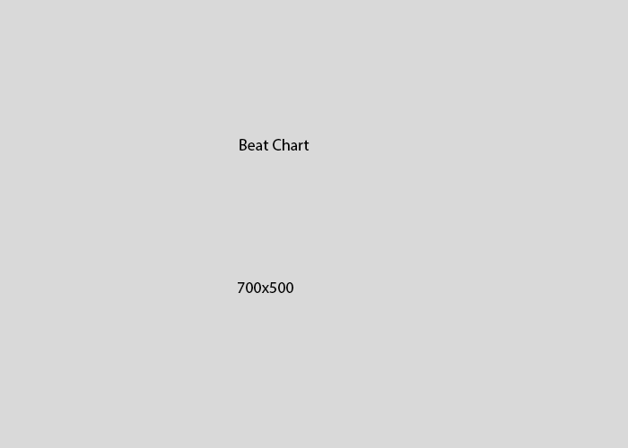Beat chart