==================================================================================

1. Write a Python program to convert kilometers to miles?

class kmToMile() :  
 km = float(input("Enter the kilometer value to convert it to mile: "))  
 print('%0.1f kilometers is equal to %0.1f miles' % (km, km * 0.621371))

**Output:**

Enter the kilometer value to convert it to mile: 10.3

10.3 kilometers is equal to 6.4 miles

==================================================================================

1. Write a Python program to convert Celsius to Fahrenheit?

class temperature_CtoF() :  
 c = float(input("Enter the temperature in Celsius to convert it to Fahrenheit: "))  
 f = (c * (9/5)) + 32  
 print('%0.1f Celsius is equal to %0.1f Fahrenheit' % (c, f))

**Output**

Enter the temperature in Celsius to convert it to Fahrenheit: 28

28.0 Celsius is equal to 82.4 Fahrenheit

==================================================================================

1. Write a Python program to display calendar?

import calendar  
  
  
class showYearCalendar():  
 print(calendar.calendar(2022, 2, 1, 6, 3))

**Output(screenshot)**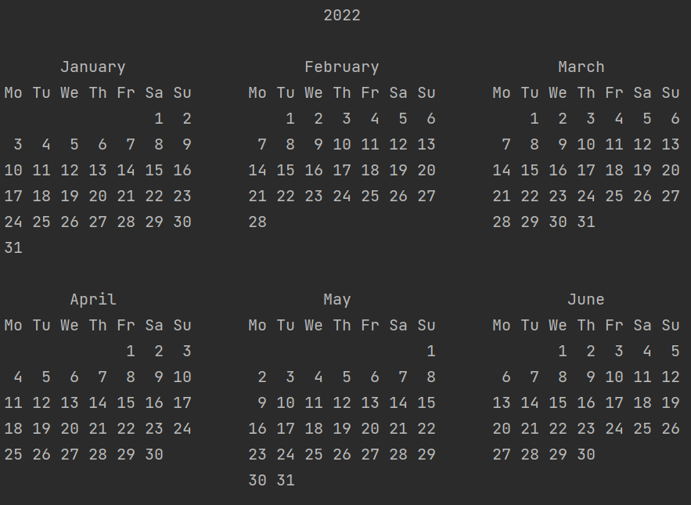

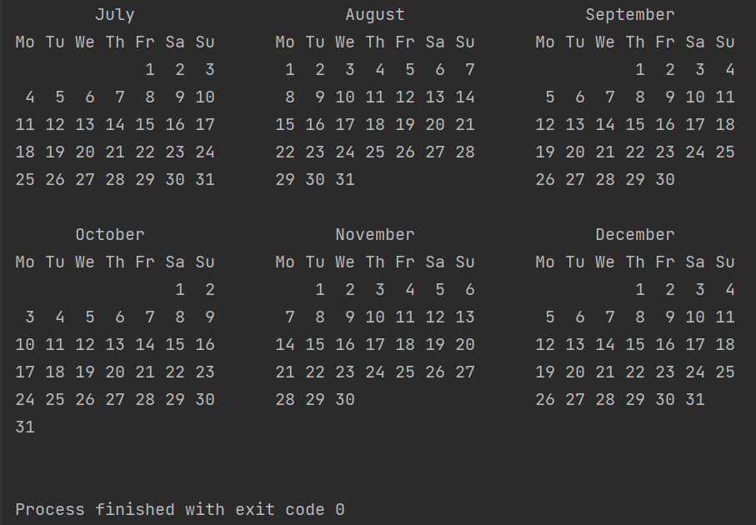

==================================================================================

1. Write a Python program to solve quadratic equation?

import cmath  
  
class solveQuadraticEquation() :  
 print("Standard quadratic equation is a x**2 + b x + c = 0")  
 a = float(input("Enter value for a: "))  
 b = float(input("Enter value for b: "))  
 c = float(input("Enter value for c: "))  
  
 # discriminant  
 d = (b**2) - (4*a*c)  
  
 # two solutions  
 sol1 = (-b-cmath.sqrt(d))/(2*a)  
 sol2 = (-b+cmath.sqrt(d))/(2*a)  
  
 print(f"The solutions for the quadratic equation {a}x**2 + {b}x + {c} are {sol1} and {sol2}")

**Output:**

Standard quadratic equation is a x**2 + b x + c = 0

Enter value for a: 2

Enter value for b: 1

Enter value for c: 3

The solutions for the quadratic equation 2.0x**2 + 1.0x + 3.0 are (-0.25-1.1989578808281798j) and (-0.25+1.1989578808281798j)

==================================================================================

1. Write a Python program to swap two variables without temp variable?

class swapWithoutTemp() :  
 a = int(input("Enter value1: "))  
 b = int(input("Enter value2: "))  
 print("----- Before swap -----")  
 print("Value1 is ", a)  
 print("Value2 is ", b)  
 a = a + b  
 b = a - b  
 a = a - b  
 print("-----After swap-----")  
 print("Value1 is ", a)  
 print("Value2 is ", b)

**Output:**

Enter value1: 40

Enter value2: 10

----- Before swap -----

Value1 is 40

Value2 is 10

-----After swap-----

Value1 is 10

Value2 is 40

==================================================================================