HW 5

Gaea Daniel

11/01/2017

knitr::opts_chunk$set(echo = TRUE)  
library(tidyverse)

## Loading tidyverse: ggplot2  
## Loading tidyverse: tibble  
## Loading tidyverse: tidyr  
## Loading tidyverse: readr  
## Loading tidyverse: purrr  
## Loading tidyverse: dplyr

## Conflicts with tidy packages ----------------------------------------------

## filter(): dplyr, stats  
## lag(): dplyr, stats

library(haven)  
  
#Load data  
help.spss <- read_csv("helpmkh.csv")

## Parsed with column specification:  
## cols(  
## .default = col_integer(),  
## racegrp = col_character(),  
## pcs = col_double(),  
## mcs = col_double(),  
## substance = col_character(),  
## pcs1 = col_double(),  
## mcs1 = col_double(),  
## pcs2 = col_double(),  
## mcs2 = col_double(),  
## pcs3 = col_double(),  
## mcs3 = col_double(),  
## pcs4 = col_double(),  
## mcs4 = col_double()  
## )

## See spec(...) for full column specifications.

data(help.spss)

## Warning in data(help.spss): data set 'help.spss' not found

#To access R-commander  
library(Rcmdr)

## Loading required package: splines

## Loading required package: RcmdrMisc

## Loading required package: car

##   
## Attaching package: 'car'

## The following object is masked from 'package:dplyr':  
##   
## recode

## The following object is masked from 'package:purrr':  
##   
## some

## Loading required package: sandwich

## Loading required package: effects

## Loading required package: carData

##   
## Attaching package: 'carData'

## The following objects are masked from 'package:car':  
##   
## Guyer, UN, Vocab

## lattice theme set by effectsTheme()  
## See ?effectsTheme for details.

## The Commander GUI is launched only in interactive sessions

library(splines)  
library(RcmdrMisc)  
library(car)  
  
#Mean center continuous variables   
help.spss$mcs_new <- with(help.spss, mcs-mean(mcs))  
help.spss$indtot_new <- with(help.spss, indtot-mean(indtot))  
help.spss$pss_fr_new <- with(help.spss, pss_fr-mean(pss_fr))  
  
#Linear regression model   
RegModel.3 <- lm(indtot_new~mcs_new+pss_fr_new, data=help.spss)  
summary(RegModel.3)

##   
## Call:  
## lm(formula = indtot_new ~ mcs_new + pss_fr_new, data = help.spss)  
##   
## Residuals:  
## Min 1Q Median 3Q Max   
## -26.732 -3.445 1.143 4.335 12.288   
##   
## Coefficients:  
## Estimate Std. Error t value Pr(>|t|)   
## (Intercept) -1.048e-15 3.075e-01 0.000 1.000000   
## mcs_new -2.007e-01 2.421e-02 -8.289 1.33e-15 ***  
## pss_fr_new -2.650e-01 7.780e-02 -3.406 0.000718 ***  
## ---  
## Signif. codes: 0 '***' 0.001 '**' 0.01 '*' 0.05 '.' 0.1 ' ' 1  
##   
## Residual standard error: 6.545 on 450 degrees of freedom  
## Multiple R-squared: 0.1664, Adjusted R-squared: 0.1627   
## F-statistic: 44.9 on 2 and 450 DF, p-value: < 2.2e-16

#"Effect plot"  
library(sjPlot)

## Warning in checkMatrixPackageVersion(): Package version inconsistency detected.  
## TMB was built with Matrix version 1.2.10  
## Current Matrix version is 1.2.11  
## Please re-install 'TMB' from source or restore original 'Matrix' package

m3f <- lm(indtot_new ~ pss_fr_new * mcs_new, data=help.spss)  
sjPlot::sjp.int(m3f, type="eff",  
 show.ci=TRUE,  
 facet.grid=TRUE)

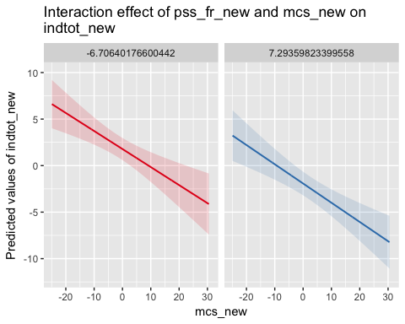 I am unable to run Levene's or Bartlett's Tests to test for homogeneity of variance because both variables are continuous.

#To make female variable a factor  
help.spss <- within(help.spss, {  
 female_factor <- factor(female, labels=c('male','female'))  
})  
names(help.spss) <- make.names(names(help.spss))  
  
#To check for homogeniety of variance for indtot and female  
with(help.spss, tapply(indtot_new, female_factor, var, na.rm=TRUE))

## male female   
## 41.66388 67.65138

leveneTest(indtot_new ~ female_factor, data=help.spss, center="mean")

## Levene's Test for Homogeneity of Variance (center = "mean")  
## Df F value Pr(>F)   
## group 1 9.5875 0.002081 **  
## 451   
## ---  
## Signif. codes: 0 '***' 0.001 '**' 0.01 '*' 0.05 '.' 0.1 ' ' 1

#Effect plot  
library(sjPlot)  
m3f <- lm(indtot_new ~ female * mcs_new, data=help.spss)  
sjPlot::sjp.int(m3f, type="eff",  
 show.ci=TRUE,  
 facet.grid=TRUE)

