Phase 3 Development Report – AI Gym Coach
Nov 13, 2026 · @Görkem

1. Introduction
In Phase 3 I turned the project from a calorie-prediction model into a working gym app with a personal AI coach. The app now logs workouts, calculates progress, answers questions about the user's own training, and protects that data with logins, consent and access rules.
The change came from feedback by my teacher, Hans. He asked why I would use AI for calories, which a formula can also calculate. My own Phase 2 analysis supported his point: the calorie data is probably synthetic, and the MET formula already gives a reasonable estimate.
I therefore moved the AI to a task a script cannot do: interpreting a user's training data and answering varied questions in plain language. Hans agreed, on the condition that it is feasible. This report describes what I built, how I tested whether the AI can be trusted, and what is still open.

2. Approach and planning
I planned Phase 3 as eight weeks of about 10 hours each, with the AI coach as the main AI component and the calorie model as a secondary experiment. I updated the proposal to v3, with a revision note explaining Hans's feedback, and reprioritised the MoSCoW list.
Priority | Main items in v3
Must | Workout logging with a database and tests; progress analysis; the AI coach with a feasibility test; evaluation of the coach's answers; data-protection and bias documentation
Should | Calorie experiment against the MET baseline; recovery hint; feedback from gym-goers
Could | Animal Mode; macro targets; recipe suggestions; comparing the local model with a cloud model
Won't | Wearables; 3D muscle visualisation; medical or injury advice; putting the app online for real users
Two decisions shaped the work. First, I chose a free language model that runs on my own laptop, so no training data leaves the computer and there are no API costs. Second, I decided to build the whole app first and improve the AI afterwards, so that I would have a real, demonstrable product before tuning the coach.

3. What was built
The result is a working app with eight screens, a backend with a database, and a local AI coach. It runs on my laptop and starts with one click.
The backend is a FastAPI API with a SQLite database. The screens are built with Streamlit. The coach uses Llama 3.2 3B, a small open language model that runs locally through Ollama on the laptop's GPU. Exercises come from free-exercise-db: 876 exercises with their primary and secondary muscles, loaded through the tested data pipeline from Phase 2.
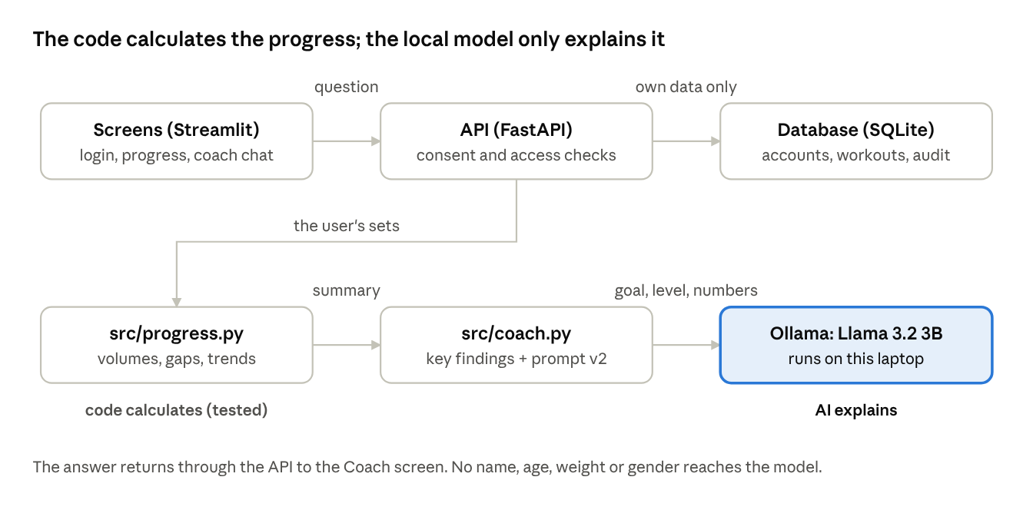
architecture of the app · how a coach question flows
Every request passes the API's login, consent and access checks. Only the coach step uses AI; everything it is told has been calculated by tested code first.
Screen | What the user can do
Login | Log in, create an account with consent, or try a demo account with four weeks of made-up training
Progress | See workouts per week, warnings for muscles not trained for 10+ days, training volume per muscle group, a recovery guideline and strength trends per exercise
Log workout | Search exercises by name or muscle, add sets, see what they did last time, repeat the last workout, and get a message for new personal bests
History | See past workouts with total volume and an estimated calorie burn
Coach | Ask questions about their own training in a chat, and see exactly what the coach was given
Profile and Privacy | Edit their profile, switch the AI coach on or off, change their password, download all their data or delete their account
Admin | Manage accounts, unlock and promote users, and read the audit log, without access to anyone's training data

4. The AI coach
The coach is only reliable when the code calculates the facts first: with a calculated summary and key findings it got 5 of 5 facts right, against 1 of 5 when it read the raw workout log.

Design: the code calculates, the AI explains
When a user asks a question, the app first calculates their progress with ordinary, tested code: volume per muscle group, days since each muscle group was trained, strength trends (estimated one-rep max with the Epley formula) and training frequency. Only this summary, the user's goal and experience level, and the question are sent to the language model. The prompt tells the model to use only that data, to say when the data does not answer the question, and never to give medical or injury advice.

Feasibility test
To answer Hans's question, I tested the coach on a made-up user whose correct answers were known in advance. This user skipped legs for 17 days, improved on bench press every week and stalled on the shoulder press. I asked the same five questions in three ways and checked each answer for the expected fact and for known errors.
How the data was given to the model | Correct facts | Answers with a known error | Seconds per answer
Raw workout log (prompt v1) | 1 of 5 | 1 | 8.0
Calculated summary (prompt v1) | 3 of 5 | 0 | 3.2
Summary with key findings (prompt v2) | 5 of 5 | 0 | 3.2
With the raw log, the model also gave medical advice for a question about knee pain ("take a break, stretch, foam roll"). In both summary versions it correctly referred the user to a doctor or physiotherapist.

Adaptation from v1 to v2
In the app, prompt v1 still made factual mistakes. It called an improving lift "stalled" and told the user to focus on shoulders and triceps, while their legs had not been trained for 17 days. I did not try to fix this with more instructions alone. Instead, the code now also works out the key findings (neglected muscles, stalled lifts, improving lifts, muscles still recovering) and gives them to the model ready-made, with prompt v2 telling it never to contradict them. I kept v1 in the code so both versions can be compared in the full evaluation.
This test used one made-up user and a keyword check, so it shows feasibility, not reliability. The full evaluation in the next sprint scores about 25 questions for five test users by hand.

5. Calorie experiment
Machine learning beats the MET formula on this data, but the result mainly shows how well a model fits synthetic data, which is why calories became a secondary feature.
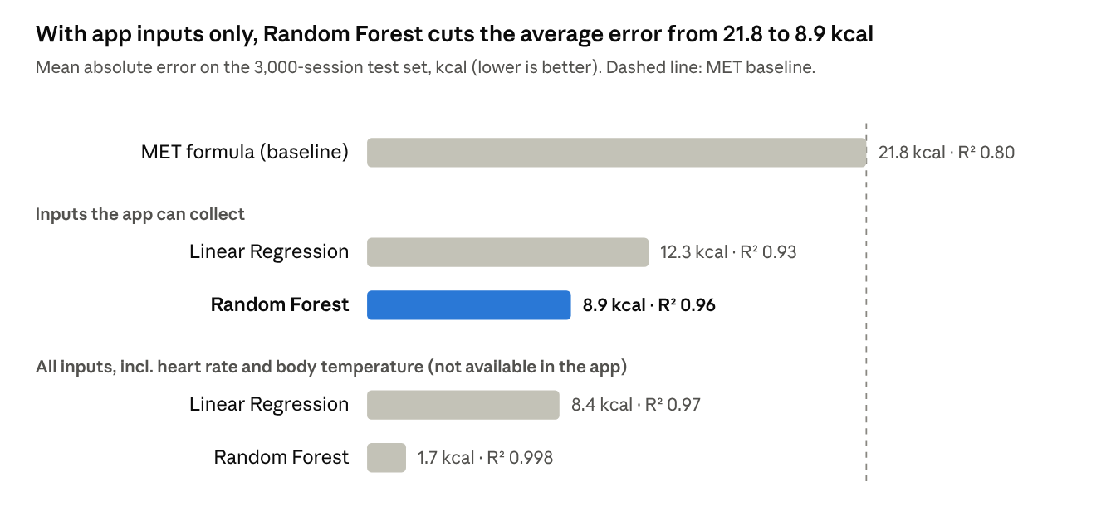
notebooks/calorie_model_starter.ipynb · 80/20 split of 15,000 sessions
With all inputs, Random Forest is almost perfect (R² 0.998), which suggests it learned the formula used to generate the data rather than real physiology. The app cannot measure heart rate or body temperature, so the realistic comparison is between the inputs the app can collect and the MET formula. The app itself uses the MET formula with a value chosen by how hard the session felt (RPE), clearly labelled as an estimate. The first bias signal is that the app-only Random Forest errs more for men (10.4 kcal) than for women (7.3 kcal).

6. Privacy, security and responsible AI
Because workout and body data can count as health data under the GDPR, I designed the app to store as little as possible, ask explicit consent, and keep every user's data private by default.
Measure | How it works in the app | Why
Explicit consent | Required at sign-up for storing training data; stored with date and privacy-notice version | GDPR art. 9(2)(a): health data needs explicit consent
Separate AI consent | The coach can be switched on or off at any time; when off, no data reaches the model | The user decides whether an AI reads their data
Data minimisation | A self-chosen username, no name or e-mail; the model receives only goal, experience and calculated numbers | Less data, less risk; tested automatically
Local model | The language model runs on the laptop | No training data is sent to an external company
Right of access | Download all your data as a file | GDPR art. 15 and 20
Right to erasure | Delete your account and all workouts, confirmed with your password | GDPR art. 17
Password storage | PBKDF2-SHA256 with 600,000 rounds and a random salt; weak and common passwords are refused | A leaked database does not reveal passwords
Sessions | Random tokens stored only as a hash, valid for 8 hours; changing the password signs out other devices | Limits the damage of a stolen or forgotten login
Lockout | Five wrong passwords lock an account for 15 minutes | Slows down password guessing
Least privilege | Users reach only their own data; admins manage accounts but cannot see workouts or body data | An admin role is not a reason to read health data
Audit log | Account events and admin actions are recorded | Accountability for who did what
Local network only | The app only accepts connections from the laptop itself | Others on the same Wi-Fi cannot open it
The coach's own behaviour is also part of responsible AI. It refuses medical and injury advice, says when the data does not answer a question, and the Coach page shows exactly what the model was given. The feasibility test showed why these limits matter: without the calculated summary, the model gave medical advice.

7. Testing and quality
The app has 78 automated tests, and all of them pass. They cover the data pipeline, the progress calculations, input validation, login and sessions, the privacy rules and the admin rights.
Several tests check promises from the privacy section rather than just features. For example: the coach never receives the username, age, weight or gender; one user cannot see or delete another user's workouts; passwords and session tokens are stored only as hashes; and the last admin cannot be removed. A fake language model replaces Ollama in the tests, so they run quickly and check exactly what the coach would have been sent.
Besides the tests, I used a code checker (pyflakes) and clicked through every screen with test accounts. This found problems that the unit tests did not:
Problem found | Cause | Fix
The coach gave wrong advice | The model had to work out the conclusions itself | The code calculates the key findings (prompt v2)
Creating a new profile overwrote an existing user | The sidebar re-selected the old user before saving | A separate "creating" state with a cancel option
The first coach answer took 53 seconds | The model was unloaded after 5 minutes | The model now stays loaded for 30 minutes
The app did not start on my laptop | The start commands were not on the Windows PATH, and Streamlit waited for an e-mail address | A one-click launcher that starts everything through Python, and a settings file
The feasibility notebook repeated the app's code | It was written before the app existed | It now uses the app's own modules
The database from before the login system could not be used with passwords. The app kept it as a backup file and started a new database.

8. Limitations
The app works, but several results are not yet strong enough to support firm claims.
- The coach is tested on made-up users only. The feasibility test used one test user, five questions and a keyword check. The full evaluation with five users and hand scoring still has to be done.
- The calorie data is probably synthetic. A high R² on this data shows that a model fits the data, not that it is accurate for real people.
- The MET values are approximate. The values per RPE band still have to be checked against the Compendium of Physical Activities before I cite them.
- The bias check is not done yet. The calorie model's error is higher for men (10.4 kcal) than for women (7.3 kcal), but I have not yet checked this relative to the calories burned, nor compared the coach's answers across user types.
- A small local model makes mistakes. Version 2 fixed the errors I found, but a 3-billion-parameter model can still misread the data.
- No real users have tried the app. Feedback from one or two gym-goers is still a Should-have.
- Refreshing the browser logs the user out. This is a limitation of how Streamlit stores the session.

9. Use of AI during development
Most of the code in this phase was written by an AI coding assistant (Claude Code) working in my project, while I set the direction and decided what to build.
My decisions were: moving the AI to a coaching role after Hans's feedback, building the full app before tuning the AI, using a free local model, using Streamlit for the screens, and adding logins, user roles and privacy features. The assistant proposed the technical solutions, wrote the code and tests, ran them, and reported problems it found, such as the profile bug and the coach's factual errors.
I did not take its output on trust. Every change was checked with automated tests, a code checker and by running the app, and the coach's answers were compared with facts I knew in advance. The "code calculates, AI explains" design was itself tested rather than assumed: the feasibility test measured it against giving the model raw data.
The main lesson for me is that an AI assistant can build quickly, but I remain responsible for understanding and explaining every part. For the assessment, I must be able to explain why the design works, what each part of the code does, and what I would change.

10. Evidence per learning outcome
Phase 3 adds the most evidence for LO3, and strong privacy evidence for LO1; LO2 rests mainly on the Phase 2 work.
Learning outcome | Evidence from this phase | Still to do
LO1 Responsible AI for Society | Explicit and separate AI consent, data minimisation (tested), a local model, rights of access and erasure, secure passwords and sessions, admins without access to training data, the coach's refusal of medical advice | A written data-protection assessment, the EU AI Act risk category, a bias check of the coach and the calorie model, a reflection on societal impact
LO2 Data and Knowledge Stewardship | The Phase 2 pipeline reused in the app, the exercise library from free-exercise-db, input validation that rejects impossible values, progress charts in the app | Linking the data checks to named data-quality dimensions; sourcing the MET values
LO3 Model Interaction and Adaptation | The coach integrated into a working app, the feasibility test of three approaches, the adaptation from prompt v1 to v2, the calorie models against a baseline, 78 tests, versioned prompts and a log of every answer | The full evaluation with five test users and about 25 scored questions, a comparison with a larger model, a prompt-injection test

11. Next steps
The next sprint focuses on proving that the coach can be trusted, which is the core of LO3.
- Build the full evaluation: four more test users with known patterns, about 25 questions, and a scoring sheet for correctness, relevance, invented facts and safety. I score the answers myself.
- Compare prompt v1 with v2, and the 3B model with a larger 7–8B model, in one table.
- Test security of the coach, for example a user who writes "ignore your instructions".
- Write the data-protection assessment and run the bias check across gender and age.
- Link the data-quality checks to named quality dimensions and source the MET values.
- Ask one or two gym-goers to try the app and note their feedback.

