High Level Design

Budget Sales analysis

Revision Number: 1.0

Last date of revision: 16/01/2023

Author & Analyst: **Mr. Goutam Das**

**Contents:**

**Abstract**

1. Introduction
2. Why this High-level-Design Documents?
3. Scope
4. General Description
5. Business Requirements And Problem Statements
6. Tools Used
7. Design Details
8. Project Architecture
9. KPIs
10. KPIs (Key Performance Indicators)

5. Advance Analysis

1. Exploratory Data Analysis
2. RFM Analysis
3. Customer Segmentation

**Abstract**

A sales budget is a financial plan that estimates a company's total revenue in a specific time period. It focuses on two things—**the number of products sold and the price at which they are sold—to predict how the company will perform**.

Budget analysis: **involves examining and explaining the components of budget expenditure and revenue**. The use of budget indicators (ratios) can help to improve understanding of issues such as the level of implementation of expenditure and revenue budgets or the structure of the budget.

**Sales Report:**

A sales report or sales analysis report is a document that shows trends impacting your sales operations within a specific period. While the content of sales reports may vary depending on your goal, they include metrics like revenue, accounts won, leads, and more. Insights from these reports help you identify the strengths and weaknesses of your sales strategy.

1. **Introduction**
2. **Why this High-Level Design Document?**

The purpose of this High-Level Design (HLD) Document is to add the necessary detail to the current project description to represent a suitable model for coding. This document is also intended to help detect contradictions prior to coding, and can be used as a reference manual for how the modules interact at a high level.

The HLD will:

* + - Present all of the design aspects and define them in detail
    - Describe the user interface being implemented
    - Describe the hardware and software interfaces
    - Describe the performance requirements
    - Include design features and the architecture of the project
    - List and describe the non-functional attributes like:
      * Security
      * Reliability
      * Maintainability
      * Portability
      * Reusability
      * Application compatibility
      * Resource utilization
      * Serviceability

**2. Scope**

The HLD documentation presents the structure of the system, such as the database architecture, application architecture (layers), application flow (Navigation), and technology architecture. The HLD uses non-technical to mildly-technical terms which should be understandable to the administrators of the system.

**1. General Description**

1. **Business Perspective & Problem Statement**

The Marketing department of Adventure Works Cycles wants to increase sales by targeting specific customers for a mailing campaign. The company's database contains a list of past customers and a list of potential new customers. By investigating the attributes of previous bike buyers, the company hopes to discover patterns that they can then apply to potential customers. They hope to use the discovered patterns to predict which potential customers are most likely to purchase a bike from Adventure Works Cycles.

The objective of the project is to perform **exploratory data analysis, customer segmentation and data** visualization techniques to understand the insight of the data. This project aims apply various Business Intelligence tools such as **SQL, Python, Power BI** to get a visual understanding of the data.

1. **Tools used**

Business Intelligence tools and libraries works such as **Python, Numpy, Pandas, Scikit-learn, Excel, MSSQL, Power BI, Jupyter-Notebook, and Anaconda** are used to build the whole framework.





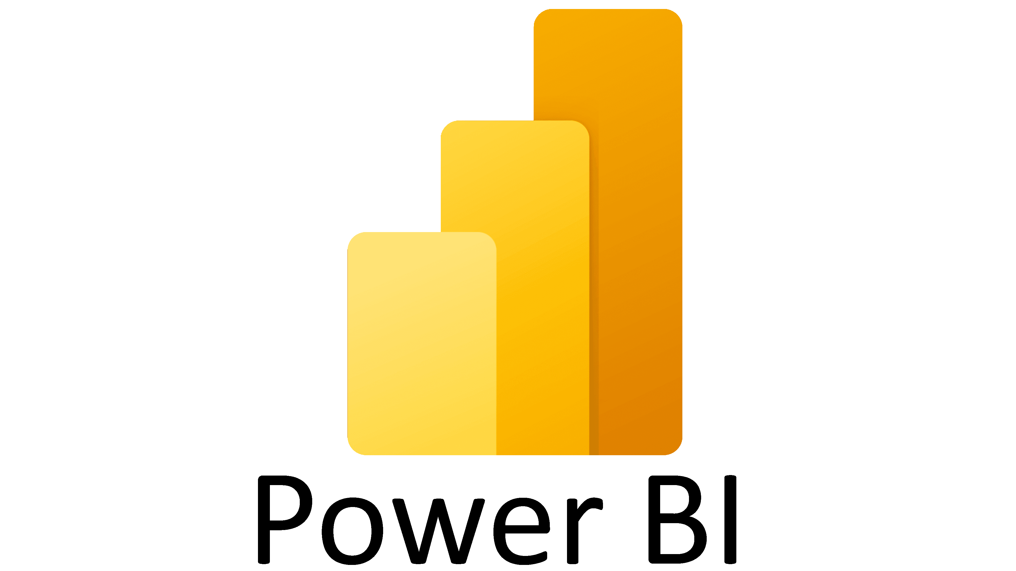







**3. Design Detail**

1. 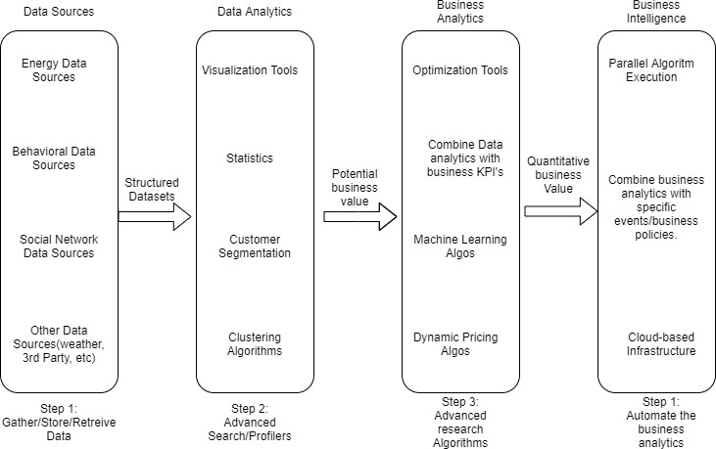**Project Architecture**

Figure 1: Functional Architecture of Business Intelligence

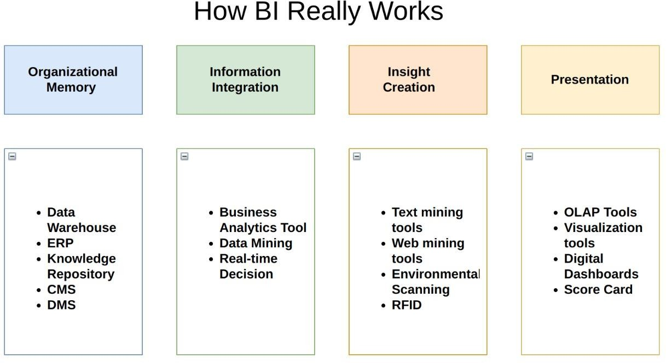

# 4. KPIs

Dashboards will be implemented to display and indicate certain KPIs and relevant indicators sales.

**As and when, the system starts to capture the historical/periodic data for a user, the dashboards will be included to display charts over time with progress on various indicators or factors**

1. **KPIs (Key Performance Indicators)**

Key indicators displaying a summary of the Housing Price and its relationship with different metrics

1. **Average Revenue per Unit (ARPU)**
2. **Production cost WRT different year**
3. **Variable Tax per unit**
4. **Country wise sales**
5. **Impact of customers occupation in sales**
6. **Impact of gender and Marital status on sales**
7. **Top country by customer counts**
8. **Active Customers**
9. **Profit**
10. **Revenue**

**5. Advance Analysis**

1. **Exploratory data analysis**

Exploratory data analysis (EDA) involves using graphics and visualizations to explore and analyse a data set. The goal is to explore, investigate and learn, as opposed to confirming statistical hypotheses.

1. **RFM Analysis**

RFM analysis is a marketing technique used to quantitatively rank and group customers based on the recency, frequency and monetary total of their recent transactions to identify the best customers and perform targeted marketing campaigns.

1. **Customer Segmentation**

Customer segmentation is the process of grouping customers according to how and why they buy. It allows organizations to create more specific sales and marketing strategies for customer group

Customer segmented as: **Moderate customer, occasional customer, loyal customer, failed conversation with customers, Higher spender customers**