Low Level Design

Budget Sales analysis

Revision Number: 1.0

Last date of revision: 16/01/2023

Author & Analyst: **Mr. Goutam Das**

**Contents:**

1. Introduction
2. Why this Low-Level-Design Documents?
3. Scope
4. Architectures
5. Architecture Description
6. Data Description
7. Requirements Gathering and Data Transformation
8. Creating the Master Table in SQL Server
9. Exploratory Data analysis in jupyter Notebook
10. RFM analysis and Clustering Using Kmeans from scikit-learn
11. Data insertion in Power bi
12. Creating Dashboards and reports

**Introduction**

**1.1 What is Low-Level design document?**

The goal of the LDD or Low-level design document (LLDD) is to give the internal logic design of the actual program code for the Budget sale analysis dashboard. LDD describes the class diagrams with the methods and relations between classes and programs specs. It describes the modules so that the programmer can directly code the program from the document.

1.2 Scope

Low-level design (LLD) is a component-level design process that follows a step-by-step refinement process. The process can be used for designing data structures, required software architecture, source code and ultimately, performance algorithms. Overall, the data organization may be defined during requirement analysis and then refined during data design work.

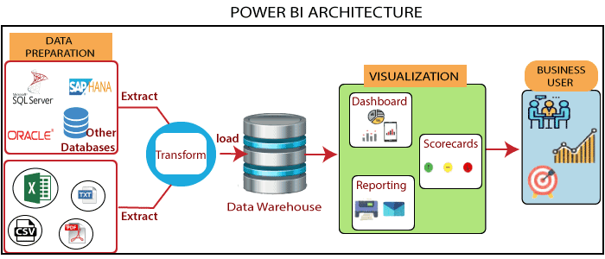**2. Architectures:**

1. Data Preparation

Preparing the stored data from different source systems or fact tables inside different DB, joining data as needed, transforming data according to the pre-decided business rules.

1. Extract and Transform Data:

Extract the data from DB as per the business requirements, transformer it before load in to power bi.

1. Visualization

Creating Different report and Dashboards using graphs, cards and other visualization tools as per the business understanding.

1. Deliver to Business users

Sharing the final reports to the Clients or Stock holders by mobile app or dashboards.

3. Architecture Description

1. Data Description

The Marketing department of Adventure Works Cycles wants to increase sales by targeting specific customers for a mailing campaign. The company's database contains a list of past customers and a list of potential new customers. By investigating the attributes of previous bike buyers, the company hopes to discover patterns that they can then apply to potential customers. They hope to use the discovered patterns to predict which potential customers are most likely to purchase a bike from Adventure Works Cycles.

**Requirements Gathering and Data Transformation**

**Creating the Master Table in SQL Server**

The Adventure-cycle Database contains 4 facts table

🡪Customer details

🡪Product details

🡪Sales details

🡪Location details

Creating a master table from this 4 facts table in SQL server by using quarry

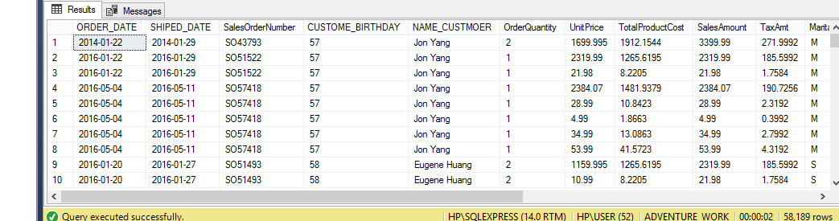

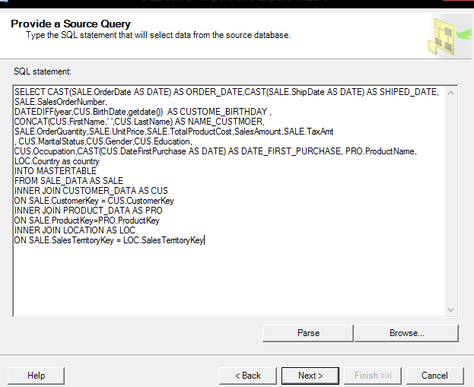Export the data from SQL server to local machine

**Exploratory Data analysis in jupyter Notebook**

### CUSTOMERS

1. Annual Income & product purchase relation
2. Most purchased order by customer name, Territory wise,
3. Female most ordered product vs male most order product
4. Gender , home owner matters in order purchasing
5. Education level and child and annual income relation.
6. Marital Status single and above 50 age purchase
7. Best age group people purchasing
8. Top annual income persons ordered product
9. Most ordered product customer name and there annual income
10. Partial high school vs bachelors’ income mean and who orders the more valued products.
11. People who bachelors & Clerical & Home owner & annual Income 40000

### SALES

1. Most ordered Product, category, subcategory
2. Most products orders region wise.

### DATE

1. Orders by year, month
2. peak days of orders from previous date data
3. pivot table of all the products month wise
4. how many peoples orders on their birthdate

### Other Visualization

1. Bar chart of all month’s sales in year wise.
2. Orders sales line chart of all three years.

### Dashboard of all time

1. Top 5 Products
2. Top 5 Category
3. Top 5 valuable Customer by sales amount.

**RFM analysis and Clustering Using Kmeans from scikit-learn**

RFM analysis

What is RFM Analysis? RFM analysis is a marketing technique used to quantitatively rank and group customers based on the recency, frequency and monetary total of their recent transactions to identify the best customers and perform targeted marketing campaigns.

Recency: How recently has the customer made a transaction?

Frequency: How frequently does the customer place an order?

Monetary: How much money has the customer spent on products?

Clustering:

***Clustering is the process of dividing the entire data into groups (also known as clusters) based on the patterns in the data.***

Kmeans:

K-means is a centroid-based algorithm, or a distance-based algorithm, where we calculate the distances to assign a point to a cluster. In K-Means, each cluster is associated with a centroid.

***The main objective of the K-Means algorithm is to minimize the sum of distances between the points and their respective cluster centroid.***

**Creating Dashboards and reports:**

