Examen « Croissance Économique mondiale»
Février 2008
Guillaume Daudin

Temps disponible : 3 heures

Calculatrice autorisée.
Documents autorisés : Une feuille de notes (manuscrites ou imprimées) recto-verso.
Vous pouvez rédiger en anglais ou en français.

1) Nous nous plaçons dans le cadre du modèle de Solow avec une fonction de production du type Cobb-Douglas.
Le pays 1 a un taux d’épargne de 5%. Le pays 2 a un taux d’épargne de 20%. L’état de la technique, le taux de croissance de la population et le taux de dépréciation du capital sont les mêmes dans les deux pays.
La rémunération du capital est égale, dans les deux pays, à 1/3 du produit total.
En supposant que la rémunération du capital est égale à sa productivité marginale, quel est le ratio du revenu d’équilibre de long terme par travailleur entre les deux pays ?
Quel serait-il si la rémunération du capital était égale à 2/3 du produit total ?

(3 points)

2) La régression de la table III porte sur la relation entre les exportations d’esclaves entre 1400 et 1900 et le revenu actual des pays africains. Elle est tirée de Nunn, Nathan. “The Long-Term Effects of Africa’s Slave Trades.” Quarterly Journal of Economics, 123 (2008).
- Sans utiliser la table V, que nous apprend cette régression ?
- En utilisant la table V, que nous apprend cette régression ?
- Est-ce que le lien de causalité est problématique ? Pourquoi ?

(3 points)

3) À l’aide de vos connaissances historiques et économiques, et dans la perspective du cours, faites une présentation critique du texte de Thorvaldur Gylfason qui se trouve à la fin de ce livret.

(14 points)

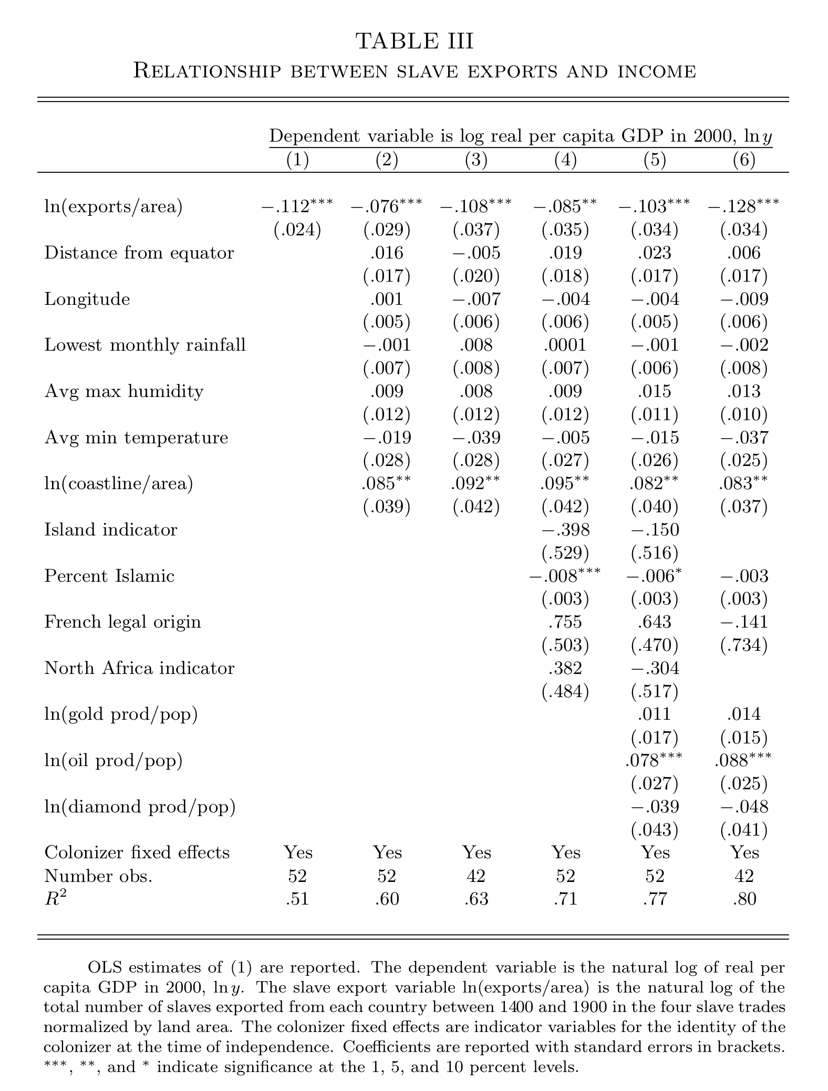
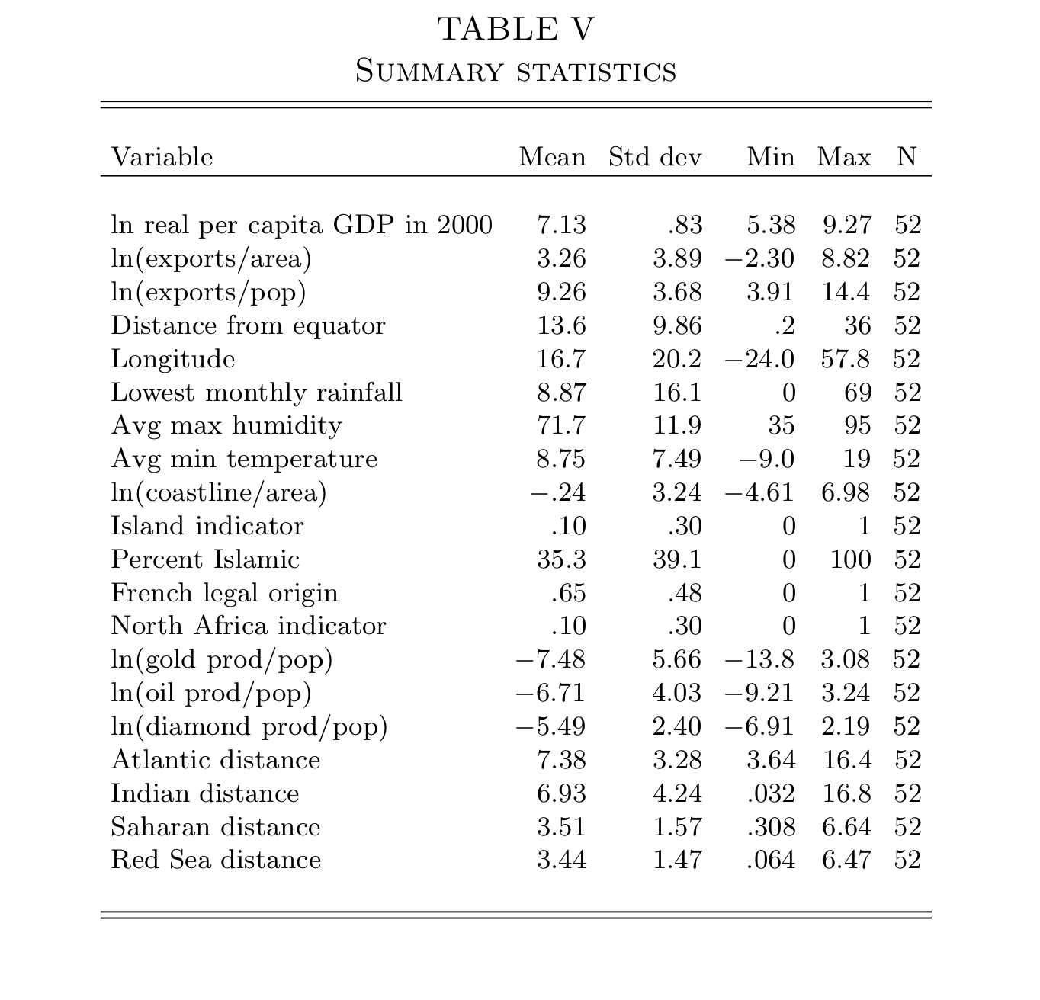

When Iceland was Ghana

Thorvaldur Gylfason (Professor of Economics, University of Iceland and CEPR Research Fellow)
Copyright VoxEU.org

Believe it or not: in 1901, Iceland’s per capita national output was about the same as that of Ghana today. Today, Iceland occupies first place in the United Nations’ ranking of material success according to the Human Development Index that reflects longevity, adult literacy, and schooling as well as the purchasing power of peoples’ incomes. Can Iceland’s rags-to-riches story be replicated in Africa and elsewhere in the developing world? If so, what would it take?

Grandmother-verifiable statistics

In 1901, my grandmother was twenty-four. She had six children, as was common in Iceland at the time, even if the average number of births per woman had decreased from almost six in the early 1850s to four around 1900, like in today’s Ghana. In fact, the number of births per woman in Iceland was four in 1960, so Iceland and Ghana are separated in this respect by a half-century or less. It took Ghana less than fifty years, from 1960 to date, to reduce the number of births per woman by three, from almost seven to four. It took Iceland a century and a half, from the late 1850s to date, to reduce the number of births per woman by three, from five to two (or 2.1 to be precise, the critical number that keeps the population unchanged in the absence of net immigration).

True, Ghana has made more rapid progress on the population front than many other African nations. The average number of births per woman in Sub-Saharan Africa has decreased from 6.7 in 1960, as in Ghana, to 5.3 in 2005. These averages, however, mask a wide dispersion in fertility across countries. Mauritius is down to two births per woman compared with almost six in 1960. Botswana is down to three, from seven in 1960. The women of Kenya, Tanzania, and Uganda now have five, six, and seven children each on average compared with eight, seven, and seven in 1960. (1)

Goodbye to short lives in large families

The point of this comparison of demographic statistics is that social indicators often provide a clearer view than economic indicators of important aspects of economic development. Moreover, several social indicators of health and education – fertility, life expectancy, literacy, and such – are readily available for most countries and in some cases reach farther back in time than many economic statistics. Fertility matters because most families with many children cannot afford to send them all to school and empower them to make the most of their lives. Families with fewer children – say, two or three – have a better shot at being able to offer a good education to every child, thus opening doors and windows that otherwise might remain shut. Reducing family size, therefore, is one of the keys to more and better education and higher standards of life. As Hans Rosling has pointed out very vividly, short lives in large families are no longer a common denominator in developing countries. (2)

Around the globe, including in many parts of Africa, there is a clear trend toward smaller families and longer lives. In Ghana, for example, life expectancy at birth has increased by more than three months per year since 1960, from 46 years in 1960 to 58 years in 2005. In Sub-Saharan Africa on average, all 48 countries included, life expectancy increased less rapidly, from 41 years in 1960 to 47 years in 2005. Average life expectancy is now on the rise again in Africa, having reached a peak of 50 years in the late 1980s and then decreased mostly on account of the HIV/AIDS epidemic.

Iceland’s economic history through African eyes

Let us now return to Iceland and briefly trace its economic history since 1901 through African eyes, as it were. In 1901, Iceland’s Gross Domestic Product (GDP) per capita was about the same as that of Ghana today, measured in international dollars at purchasing power parity. This observation, illustrated in Figure 1, follows from two simple facts:

1. Iceland’s per capita GDP has increased by a factor of fifteen since 1901, a mechanical consequence of an average rate of per capita output growth of 2.6% per year from 1901 to 2006;
2. In 2006, at USD 2,640 at purchasing power parity, Ghana’s per capita GDP was about one-fourteenth of Iceland’s per capita GDP of USD 36,560.

Figure 1. Through African Eyes: Iceland’s per capita output, 1901-2006 (2000 = 100)
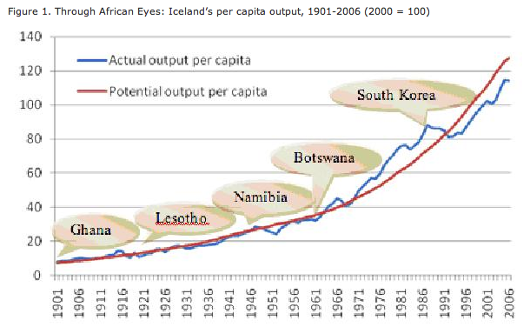

With the passage of time, Iceland’s economy grew. The uneven trajectory in the figure traces the ups and downs of Iceland’s actual per capita GDP, whereas the smooth one shows Iceland’s potential per capita output, conventionally estimated by a simple regression of actual per capita GDP on time, thus abstracting from business cycles. By 1920, Iceland’s per capita GDP had reached the level of today’s Lesotho. By 1945, Iceland had become Namibia and by 1960, Botswana. By 2006, Botswana’s per capita GDP had climbed to USD 12,250, one third of Iceland’s. Put differently, Iceland’s per capita GDP in 1960 was one third of what it is today, and its annual growth rate of 2.6% per year tripled the level of per capita GDP from 1960 to 2006. By 1985, leaving Africa behind, Iceland had become South Korea.

Piling up capital (and books)

How did Iceland do it? To make a long story short, upon achieving Home Rule in 1904, Iceland accumulated capital at a fairly rapid pace, all kinds of capital, for this is what capitalism in a mixed market economy is all about, plus hard work: physical capital through saving and investment, human capital through education and training, foreign capital through trade, financial capital through banking, and social capital by means of democracy, institution building, and equality. Natural capital also played a role, first rich fishing grounds offshore and later hydro power and geothermal energy, but the key to the successful harnessing of the country’s natural capital was its earlier accumulation of human capital. And human capital is probably the single most important key to Iceland´s growth performance, due to smaller families and steadily longer lives.

When Home Rule was achieved in 1904, most of Iceland’s impoverished population was already literate because literacy had been near universal since the end of the 18th century. Thus, Icelanders were well prepared for the modern age into which they were catapulted at the beginning of the 20th century. Not only is the general level of education made possible by near-universal literacy good for growth, but the social conditions – law abidance, for example – that make near-universal literacy possible are almost surely also good for growth. Exact measures of literacy in Iceland in 1900 are unavailable, but statistical information on the number of books published is available. In 1906, the number of books in Icelandic published per one thousand inhabitants was 1.6, which is more than in today’s Norway and Sweden. By 1966, the number of books published in Icelandic per one thousand inhabitants had climbed to 2.7, the current level in Denmark and Finland. By 2000, the figure for Iceland had risen to seven books published per one thousand inhabitants. It is possible that, with small editions of each book, small countries such as Iceland (population 300,000) have room for more titles. Nonetheless, these are impressive figures, and reading is good for growth (3)

Closing the gap

At the beginning of the 21st century, African societies face a twofold challenge. First, they must achieve near-universal literacy because education is the key to the accumulation of human capital as well as other types of capital and the key to growth-friendly management of natural capital. In 1970, 28% of adults in Sub-Saharan Africa knew how to read and write. By 1990, Africa’s literacy rate had increased to 51% and by 2006, to 61%. Youth literacy – that is, literacy among those between the ages of 15 and 24 – had risen to 73% in 2006. The literacy gap must be closed as quickly as possible, with no child left behind. With near-universal literacy, Ghana should be able increase its per capita GDP by a factor of fifteen – why not? – in three generations, or less, as Iceland did by practicing democracy and piling up capital of all kinds through education, trade, and investment. Other African countries should as well, though most have further to go than Ghana, whose per capita GDP in 2006 was twice that of Kenya and almost four times that of Malawi.

By now, fourteen out of 48 Sub-Saharan African countries have managed to reduce the number of births per woman below 4.3, Iceland’s 1960 figure. Some distances are shorter than they might seem.

Footnotes

1 All figures on output, fertility, and literacy cited in the text are taken from the World Bank‘s World Development Indicators 2007 except the historical figures on Iceland that are obtained from Statistics Iceland.

2 See the opening minutes of Rosling’s 2007 TED presentation, available at http://www.gapminder.org/video/talks/ted-2007---the-seemingly-impossible-is-possible.html

3 Canoy, Marcel F. M., Jan C. van Ours, and Frederick van der Ploeg, “The Economics of Books,” Chapter 21 in V. Ginsburgh and D. Throsby (eds.), Handbook of the Economics of Art and Culture, 2006, North-Holland, Amsterdam. Also available as CEPR Discussion Paper No. 4892, February 2005.

