DP 2024 Assignment 1: PCA and ICA

The test dataset contains 300 examples of control charts synthetically generated. It is available in the UCI Machine Learning Repository: Data Sets, with the file name “Synthetic Control Chart Time Series”. The original dataset contains six different classes. Only three different classes of control charts are used for the assignment, which are:
- Normal
- Cyclic
- Upward shift
The following figures show ten examples of each class:
(A) Normal; (B) Cyclic; (C) Upward shift
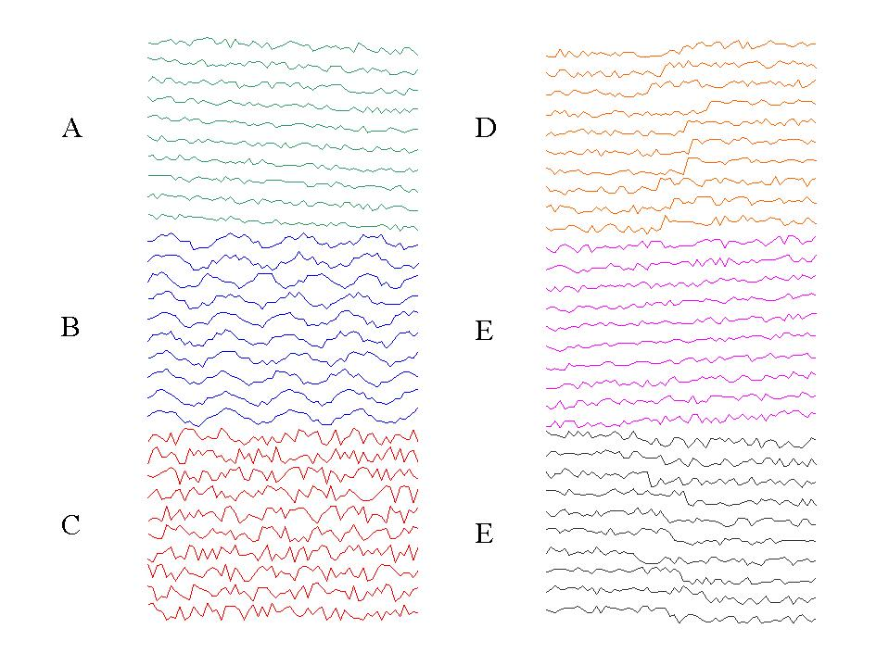

Data format
For assignment 1, we consider only 3 signal types: 1) Normal, 2) Cyclic and 3) Upward shift. The data is stored in an Excel file, 300 rows (number of samples), 60 columns (length of a time-series signal), with a single chart per line. The classes are organized as follows in the excel file: Homework 1_1.

1 - 100 Normal (class 1)
101-200 Cyclic (class 2)
201-300 Upward shift (class 3)

1. Signal separation
In the excel file: Homework 1_2, it contains three mixed process control signals as shown below. Use the PCA and ICA to separate the mixed signals, and identify individual classes of the three restored signals. Discuss and analyze the results, and compare the performance of PCA and ICA.

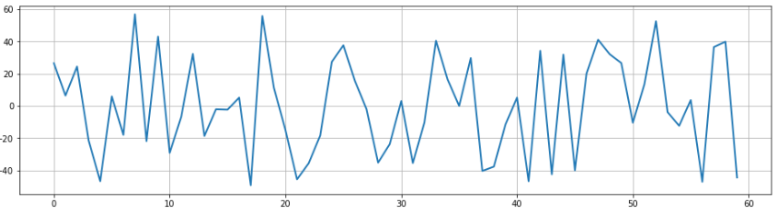
Mixed signal 1

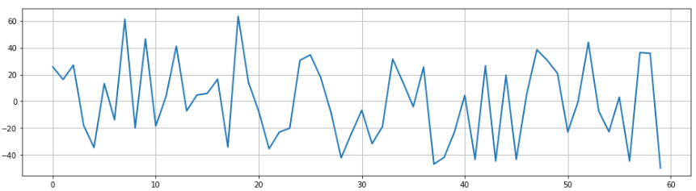
Mixed signal 2

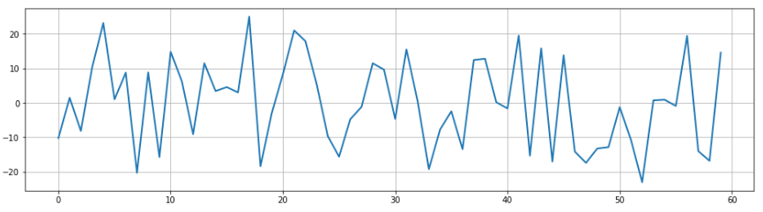
Mixed signal 3

2. Dimension reduction/ feature representation, and classification
Part 1: PCA
Each time-series sample is of length 60 (i.e., we may take them as 60 features). For the normal SPC data, calculate the eigenvectors from the training samples. Take the first 50 samples in the normal dataset as the training samples, and the remaining 50 samples as the testing samples.
Let the matrix formed by the row eigenvectors be E_{c} from the 50 normal training samples, which is of size 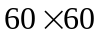.. The eigenvectors in E_{c} are arranged in decreasing order of the corresponding eigenvalues. Select K eigenvectors with the largest eigenvalues from E_{c} to form the sub-matrix 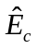, where K << 60. Given an unknown test sample x, calculate
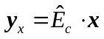 (size: 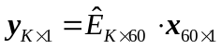)
We may consider 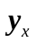 as a feature vector of a SPC signal x,

For anomaly detection, let 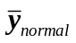 be the mean vector of normal training samples. The anomaly is detected as follows:
*Compute the distance 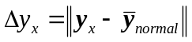 for a test sample x
For normal pattern, 50 samples are used for training, and other 50 samples are used for the test. All 100 samples of individual cyclic and upward-shift patterns are considered to be abnormal for the test.
*If 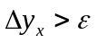, for some user-specified threshold , test sample x is an anomaly.
Evaluate the effect of K on the detection accuracy (e.g. K =5, 10 and 30.), and analyze the false positive (Type I error) and false negative (Type II error) rates with varying threshold .

Evaluate and compare the performance of the base-line process above with the following alternatives individually
A) Remove the first feature (corresponding to the largest eigenvalue) from the K projected components:
B) For the PCA anomaly detection task above, apply data normalization (e.g. z-score) to the SPC signals before you carry out the PCA operations.
C) For the signal separation task, apply smoothing (e.g. moving average or low-pass filtering) to reduce of noise in the time-series data, and observe the separated signals with PCA, and the anomaly detection result.

Part 2: ICA – Anomaly detection

For architecture I (# of bases = # of training samples) with input data matrix
X_{10x60} (10 training samples, each of length 60). The 10 training samples
are randomly selected from the 100 normal SPC signals.
X= 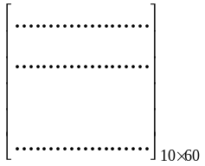 = 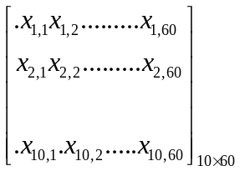
U_{10x60} = W_{10x10}X_{10x60}
U⁺_{60x10} = U^{T}_{60x10}(UU)⁻¹_{10x10}
b_{1x10} = x_{test, 1x60}U⁺_{60x10} (number of features = 10)

Training: input the training data matrix X_{10x60}
- Use the FastICA to find W_{10x10}, and then U_{10x60} = W_{10x10}X_{10x60}
- Calculate U⁺_{60x10}
Testing: for an unknown test sample x_{test}
- Calculate b_{1x10} = x_{test}U⁺
- Use b as the feature vector for x_{test}
- The anomaly detection for x_{test} is the same as the process in Part 1.

Note: You may evaluate the effect of varying number of training samples.
You may also carry out smoothing to the original SPC signals before you
apply ICA.

Due date: March 12th (no later than March 19th)

Note: You are encouraged to use ChatGPT or Gemini to assist with your homework

