Glen Browne

EE 476 - Professor Tsang

April 23, 2018

Recent Advancement in Fuzzy Logic:

Fuzzy Logic-Based Artificial Pancreas



Type I Diabetes, also known as “insulin-dependent Diabetes,” or “juvenile Diabetes,” results from the pancreas’ inability to produce enough insulin. Insulin is a critical hormone that regulates the amount of glucose in the blood. The presence of insulin in the blood triggers anabolic metabolism, or the conversion of glucose in the blood to muscle and fat. A lack of insulin prevents anabolic processes in the body, causing loss of muscle tissue and overall weight loss. The ratio of insulin to glucose level in the blood must be kept at a proper level to allow the body to function properly. A fuzzy-logic based automated insulin pump can be used to efficiently manage Type I Diabetes by monitoring the concentration of

glucose in the blood, and taking corrective action by introducing correct amounts of insulin into the blood when necessary.

Traditionally, a patient would measure their blood glucose concentration manually by pricking their finger with a sharp testing device. The testing device would read out the patients glucose level. Based on that information, the patient would decide whether or not to inject himself with insulin, and if insulin were required, the dosage to inject. An improvement upon this traditional method, fuzzy logic-based artificial pancreas devices have been developed to better manage diabetic symptoms. A fuzzy logic-based system automatically measures blood glucose levels periodically and automatically supplies the correct amount of insulin to the bloodstream.

The advantages of this fuzzy logic-based artificial pancreas over traditional methods of diabetes treatment are many: the patient doesn't have to worry about monitoring blood glucose concentration or injecting insulin because both of these processes are done automatically, and the correct amount of insulin is always supplied to ensure that food eaten by the patient is properly utilized by the body while preventing insulin overdose, which causes hypoglycemia.

Figure 1 - Artificial Pancreas Block Diagram

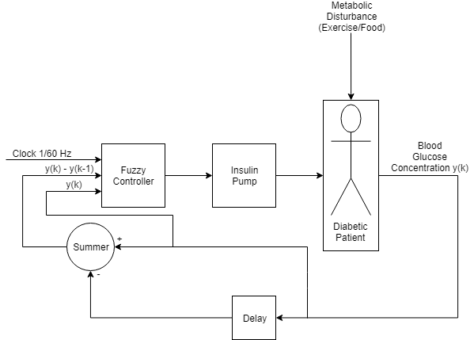

In this artificial pancreas system model, there are two inputs to the fuzzy controller: blood glucose concentration, and the change in blood glucose concentration since the last reading. These measurements are made at regular intervals of about 1 minute. Two input membership functions, one for blood glucose concentration, and one for the rate of change of blood glucose concentration, convert the crisp input measurements into fuzzy quantities. A set of fuzzy associative memory rules convert these fuzzy inputs to a fuzzy output. This fuzzy output is the amount of insulin to supply to the bloodstream. The fuzzy output is defuzzified into a crisp output via the centroid method.

Figure 2 - Fuzzy Controller

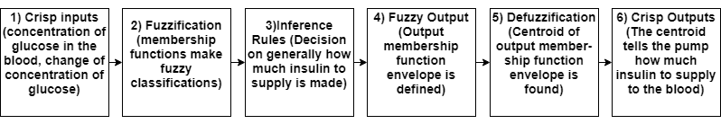

Blood glucose concentration is supposed to change based on two factors: firstly, the concentration should rise proportionally with carbohydrate intake, and secondly the concentration should decrease with catabolic activity such as exercise. The normal range of blood glucose concentration is from 4 to 7 millimoles of glucose liter of blood. The concentration should increase to as much as 9 millimoles per liter after a meal, and should fall to about 3 millimoles per liter following exercise. The membership function for input 1 is based on these facts. The membership function for input 2 is based on the rate at which blood glucose concentration is rising or falling. This second input is very useful because if concentration is already heading towards the desired level, no corrective action should be taken.

Based on these two inputs, the system can decide which action is appropriate: either to take no corrective action, or to administer a certain amount of insulin corresponding to previously constructed fuzzy associative memory rules. This output function is generalized for the average person’s total blood content of 5 liters, but can be tuned to a patient's individual blood content. The blood content of an individual can be determined by weight and body mass index, which takes into consideration height, body fat percentage and muscle mass percentage.

Table 1 - Fuzzy Associative Memory Table

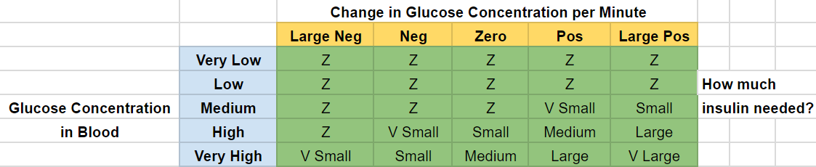

As seen in this fuzzy associative memory table, no insulin is required to be administered when blood glucose concentration is low or very low. When blood glucose concentration is from medium to very high, varying levels insulin need to be administered based on current concentration in the blood and the rate of change glucose in the blood.

INPUTS: Figure 3 - Input 1 Partitions

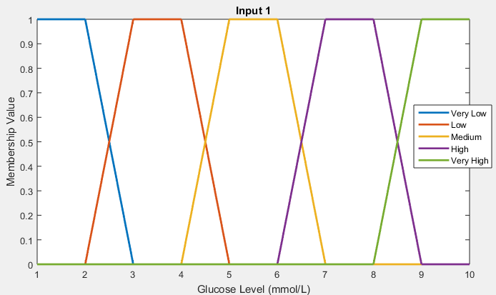

Glucose Concentration Membership Functions:

Very Low: 0-3 mmol/L

Low: 2-5 mmol/L

Medium: 4-7 mmol/L

High: 6-9 mmol/L

Very High: 8+ mmol/L

Figure 4 - Input 2 Partitions

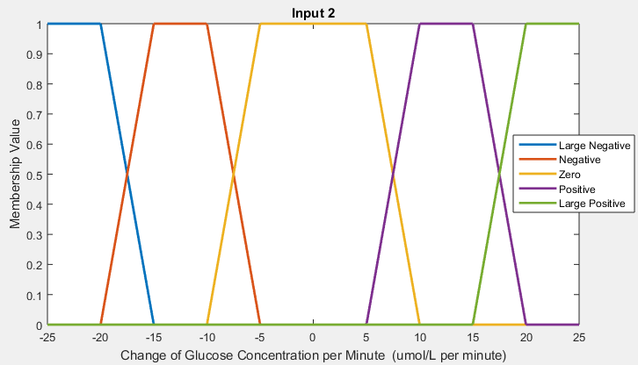

Derivative of Glucose Concentration

Membership Functions:

Large Negative: less than -15 umol/L per minute

Negative: -20 to -5 umol/L per minute

Zero: -10 to 10 umol/L per minute

Positive: 5 to 20 umol/L per minute

Large Positive: more than 15 umol/L per minute

OUTPUT: (With 5 Liters of blood in the body)

Amount of Insulin Pumped Membership Functions:

Very Small: 0.05-0.3 nmol

Small: 0.2-1.2 nmol

Medium: 1-4 nmol

Large: 3-9 nmol

Very Large: 8-11 nmol Figure 5 - Output Partitions

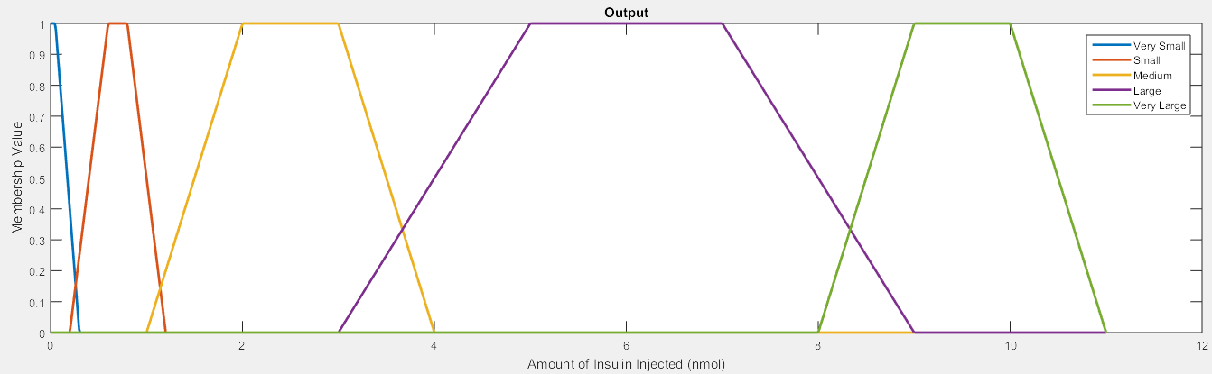

Figure 6 - Hypoglycemia-Free Patients with Artificial Pancreas vs Traditional Insulin Pump Therapy

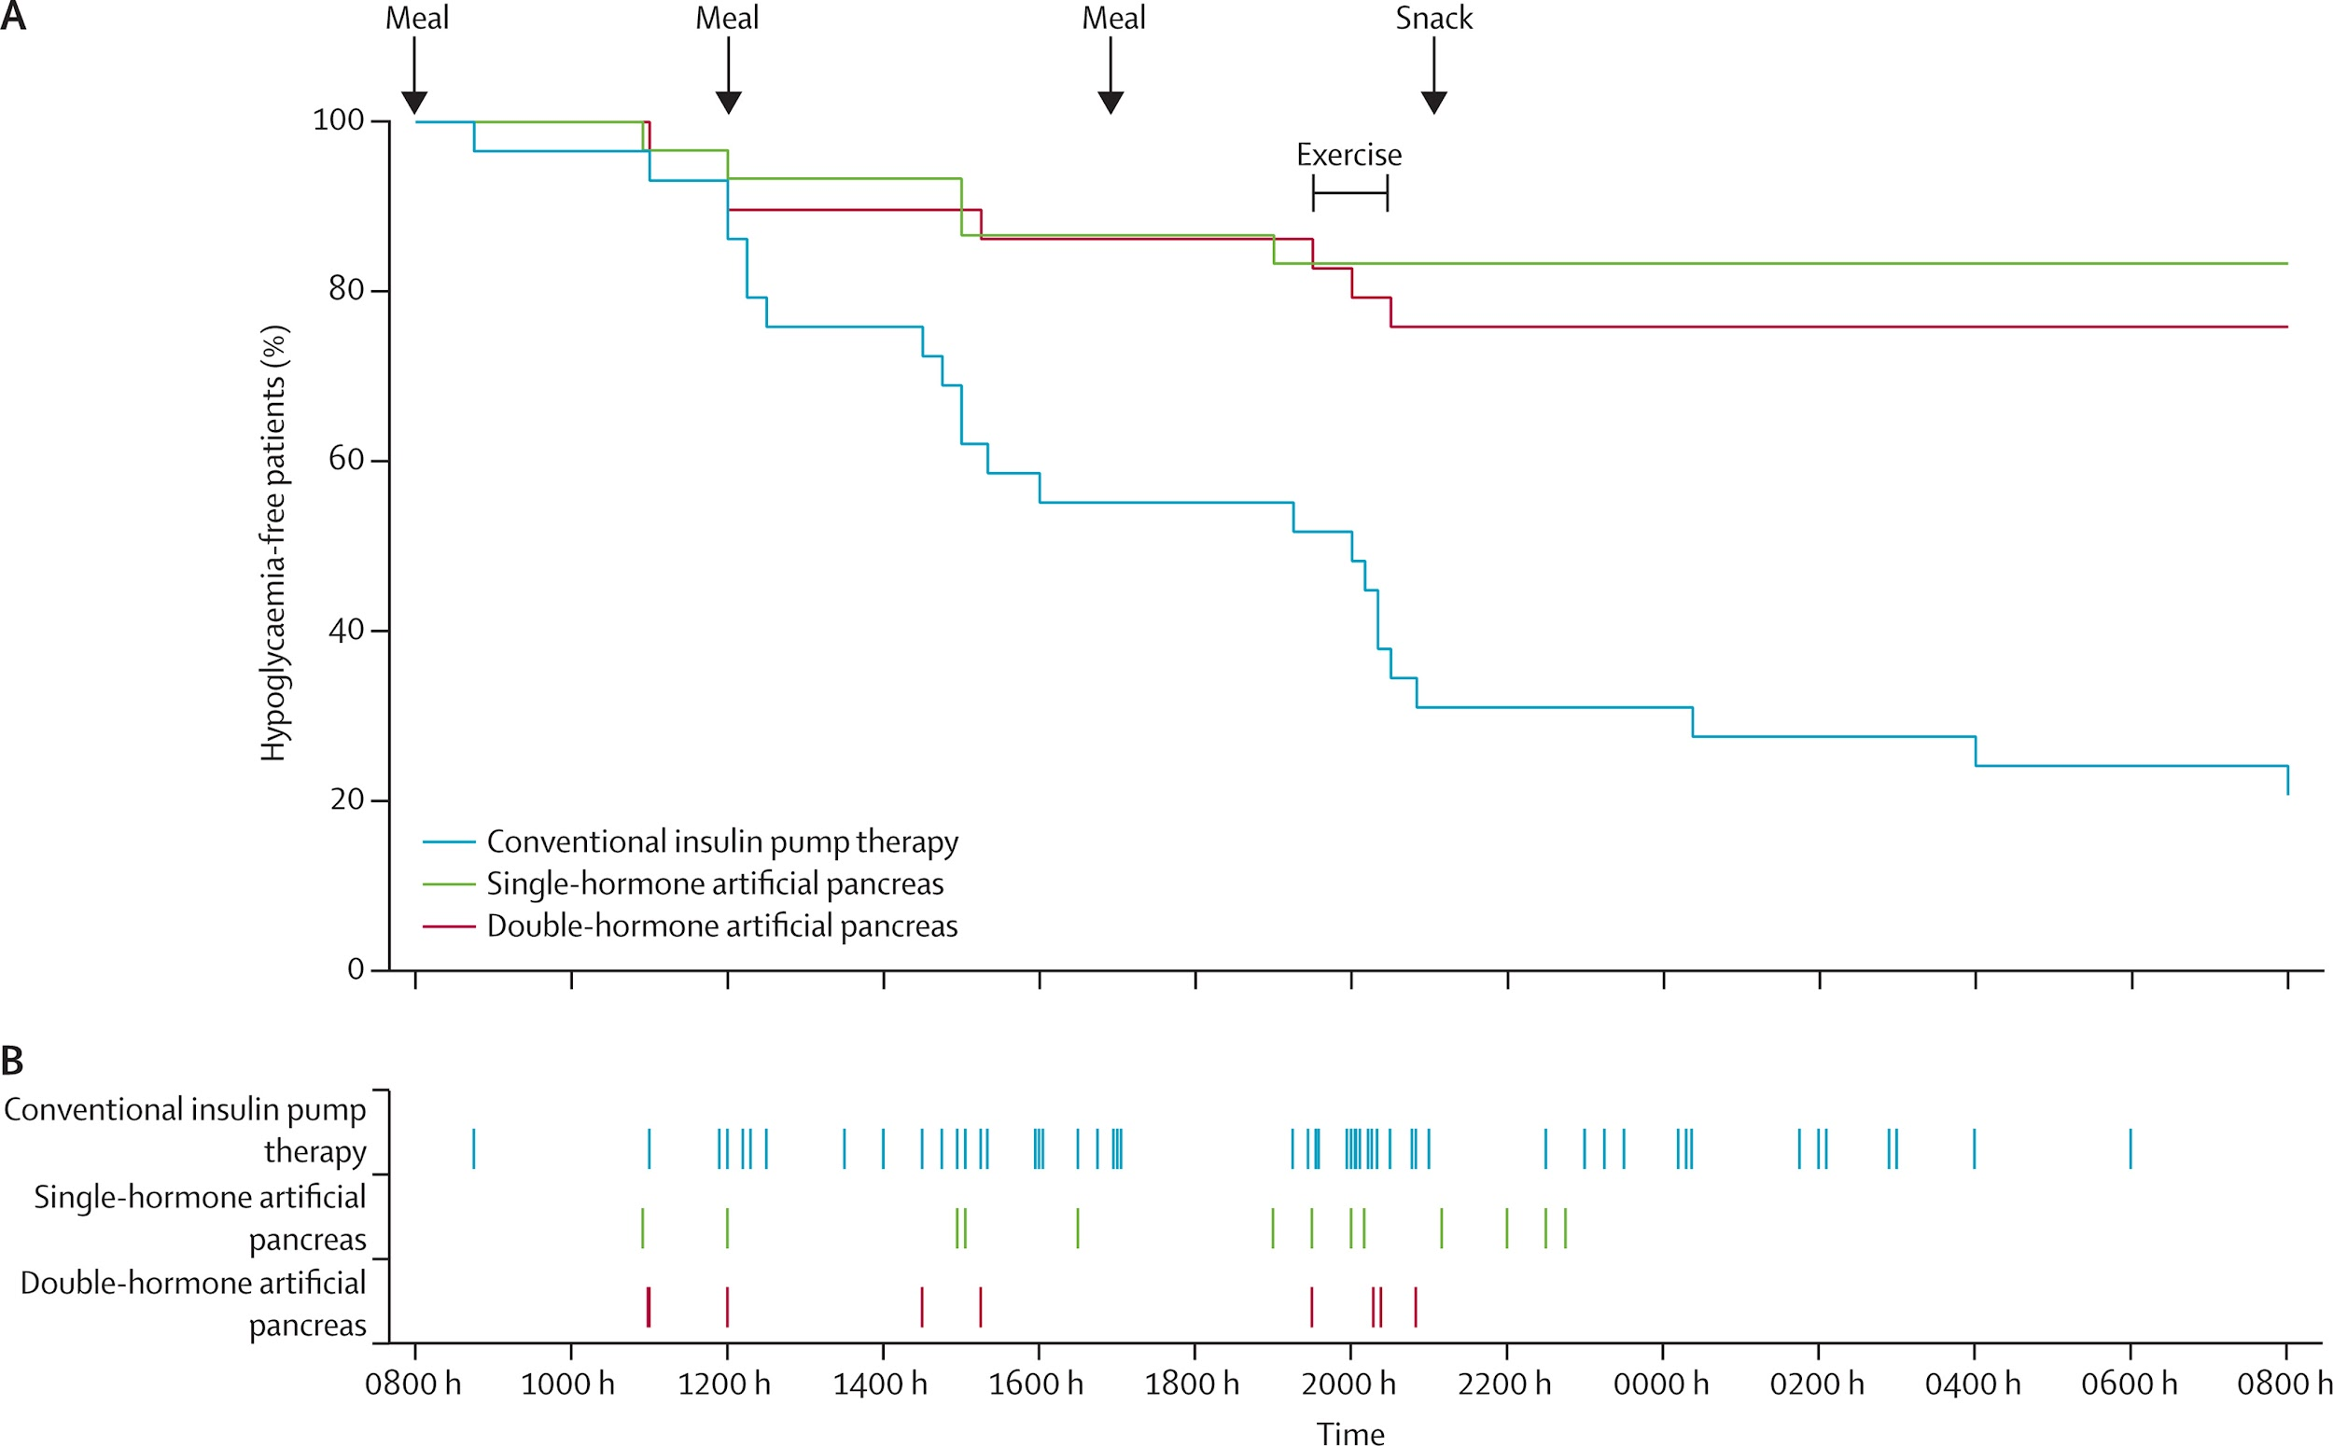

As seen in this 24 hour clinical study, which aims to measure efficacy of this artificial pancreas system against conventional insulin pump therapy, occurrences of hypoglycemia are greatly reduced using the fuzzy logic-based artificial pancreas compared to conventional insulin pump therapy. The system discussed in this paper is represented by the green line, while conventional insulin pump therapy is represented by the blue line. Other artificial pancreas models, which use both insulin and glucagon to regulate blood glucose levels are represented by the red line. Based on this graph, the single-hormone artificial pancreas system discussed in this paper is even more effective at managing type 1 diabetes symptoms than the double hormone artificial pancreas model.

In conclusion, a fuzzy logic-based artificial pancreas works better than conventional insulin therapy to treat Type I Diabetes. Not only is it hassle-free and automatic, saving time and worry, but it prevents overdosing on insulin, which leads to hypoglycemia and insulin resistance. Hyperglycemia, or high blood sugar, is effectively treated by both conventional and fuzzy logic-based means, but with conventional treatment, the patient frequently administers more insulin than is actually required. This fact is the main reason that a fuzzy logic-based Diabetes treatment surpasses its conventional counterpart in quality. This increased quality in treatment ultimately contributes to a better quality of life for the Type 1 Diabetes patient.

Sources:

<https://www.sciencedirect.com/science/article/pii/S2210832714000027>

<https://www.sciencedaily.com/releases/2017/06/170612115337.htm>

<https://ieeexplore.ieee.org/document/7336079/>

<https://www.researchgate.net/publication/308831217_Fuzzy_Logic_Controller_Applied_to_Brain_Emotional_Learning_Based_Model_of_Bipolar_Disorder_II>

<https://www.electronicproducts.com/Robotics/AI/How_researchers_are_using_AI_to_treat_bipolar_disorder_and_personalize_medicine.aspx>

<http://www.ijircce.com/upload/2015/september/135_36_A%20FUZZY.pdf>

<https://pdfs.semanticscholar.org/7e38/9b3e90d84ed00d80cd8e05369b2e01f73bf4.pdf>

<https://ieeexplore.ieee.org/document/6297296/>