DataLens Agent Report
Assignment 2: Intelligent Software Agent Prototype
GitHub repo | https://github.com/your-username/datalens-agent (replace after upload)
Agent type | CSV Data Analysis Agent
Model option | Optional Alibaba Cloud DashScope OpenAI-compatible API through local /api/llm proxy; default model qwen-plus
Fallback | Deterministic browser planner and tools run when no LLM key is configured or a request fails

1. System Design
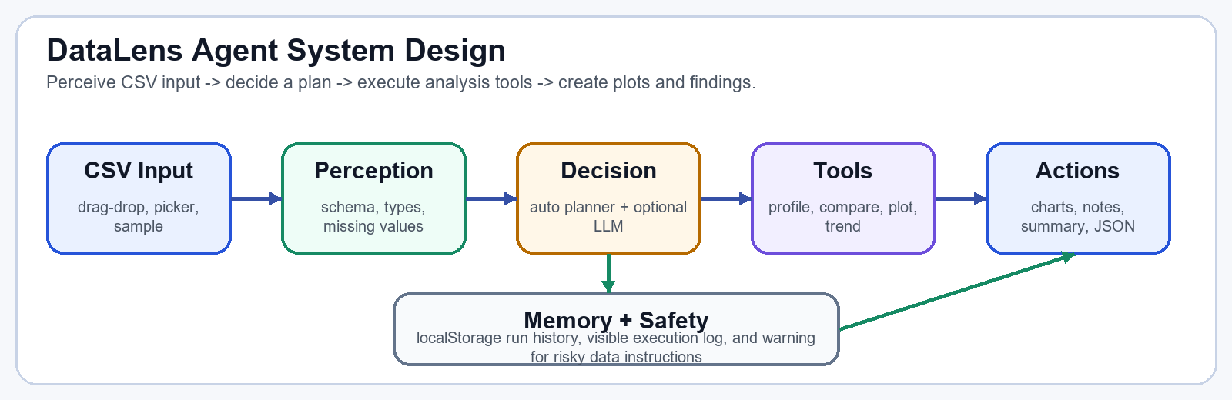
Figure 1. Agent loop: perceive input, select a plan, run analysis tools, and output plots plus findings.

Design explanation
- Perception: parse uploaded, pasted, or sample CSV data; infer numeric, categorical, and date fields; detect missing cells.
- Decision: auto-decision chooses analysis steps and chart types from the schema. Optional LLM mode refines the plan and final narrative via the local proxy.
- Tools and actions: run schema inspection, numeric profile, group comparison, relationship plots, missing checks, outlier scans, trend analysis, chart notes, summary, and JSON export.
- Memory and safety: store recent run events in localStorage and warn before proceeding when prompts appear to contain secrets or sensitive identifiers.
- Deployment: DataLensAgent.exe starts the local server and LLM proxy; the API key is pasted by the user and is not committed to Git.

2. Screenshots and System Behavior
The user loads a CSV by drag-drop, file picker, pasted text, or sample data, then runs the agent. With Agent auto-decision enabled, the agent automatically chooses analysis steps and chart types.
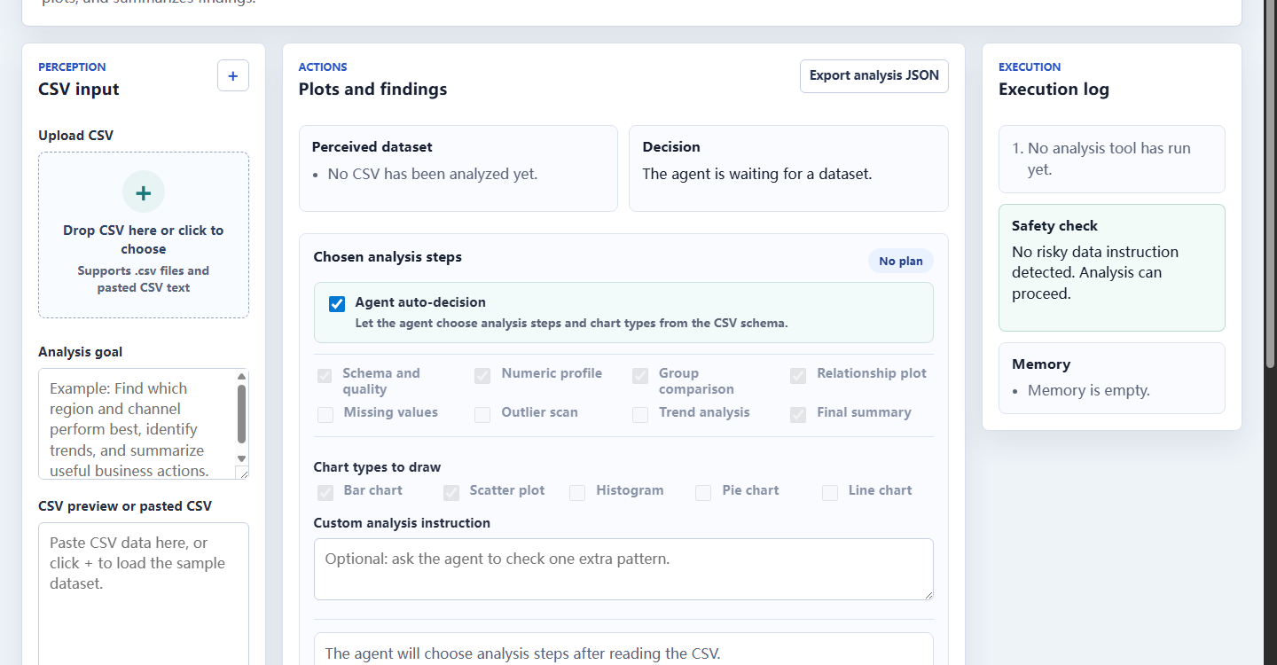
Figure 2. Current interface with plus upload, language switching, auto-decision, chart choices, and execution log.
Generated charts | Summary and memory
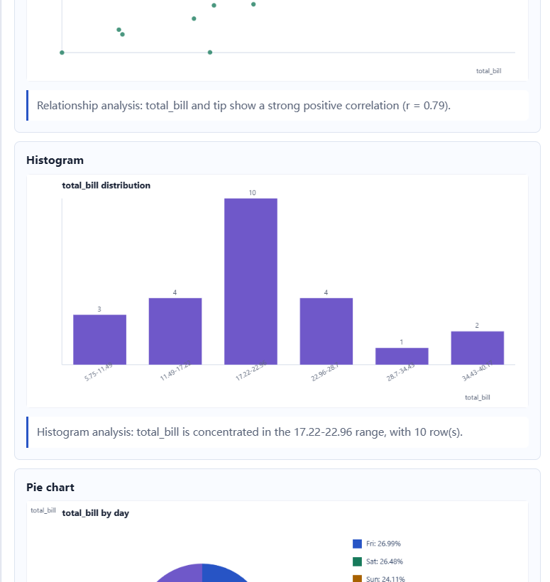 | 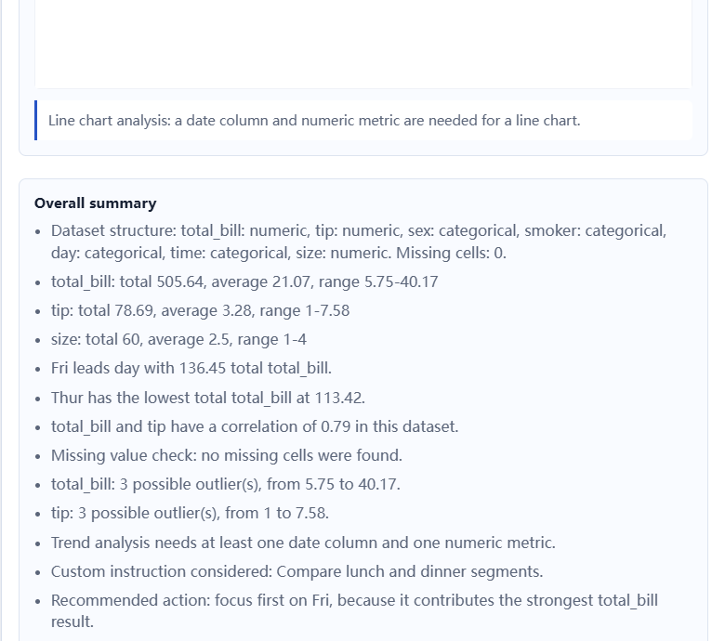

Behavior evidence
- Automatic analysis: the agent selects useful steps and plot types such as bar, scatter, histogram, pie, or line charts from detected columns.
- LLM support: the page calls /api/llm only; the proxy forwards to DashScope or another OpenAI-compatible endpoint configured with DATALENS_LLM_URL. Teachers can paste their own key and model.
- Reliable demo: if the LLM is unavailable, deterministic planning still executes and produces charts, chart-level explanations, a final summary, and an exportable JSON run record.
- Reproduction: double-click DataLensAgent.exe, open the local page, load data/tips.csv or data/iris.csv, optionally enable LLM mode, and click Run analysis agent.

