# Nginx+Tomcat配置

配置nginx文件:

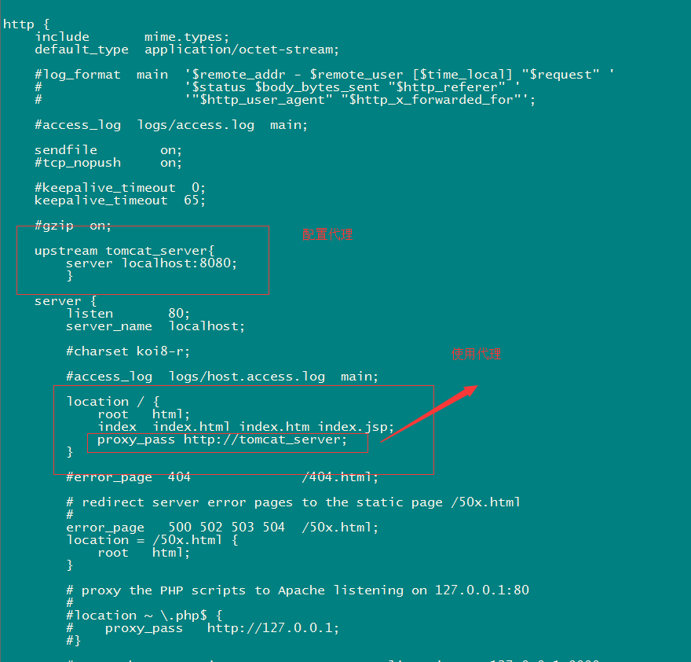

upstream tomcat_server{

server localhost:8080;

}

location / {

root html;

index index.html index.htm index.jsp;

proxy_pass http://tomcat_server;

}

配置Tomcat：

server.xml文件：

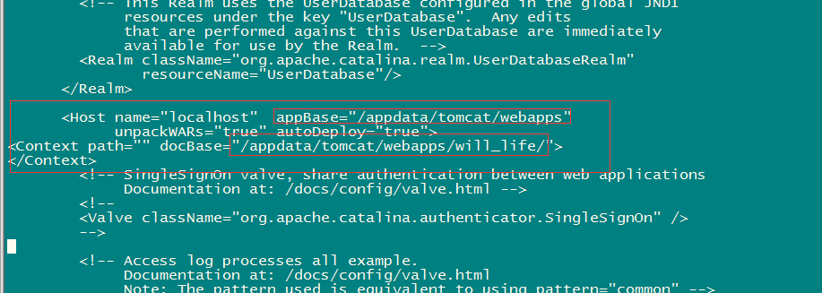

<Host name="localhost" appBase="/appdata/tomcat/webapps"

unpackWARs="true" autoDeploy="true">

<Context path="" docBase="/appdata/tomcat/webapps/will_life/">

</Context>

### 注：配置过后静态文件css|js|图片等加载失败问题；

在nginx里面配置过滤

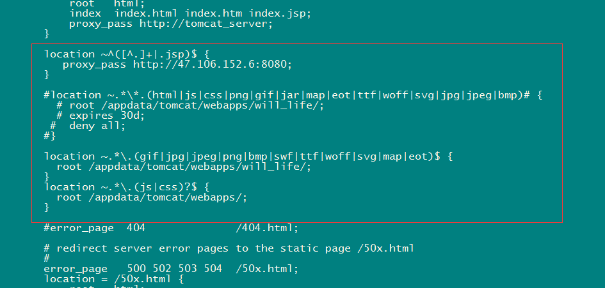

location ~^([^.]+|.jsp)$ {

proxy_pass http://47.106.152.6:8080;

}

location ~.*\.(gif|jpg|jpeg|png|bmp|swf|ttf|woff|svg|map|eot)$ {

root /appdata/tomcat/webapps/will_life/;

}

location ~.*\.(js|css)?$ {

root /appdata/tomcat/webapps/;

}