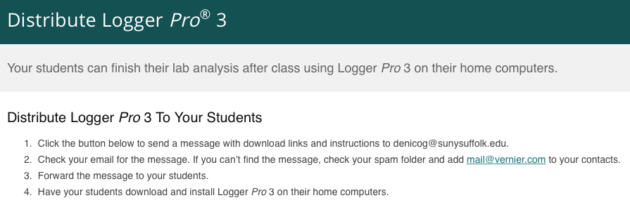



Here are links to download the software you requested from Vernier Software & Technology. After the file has downloaded to your computer, double-click the file to install the software.

LOGGER PRO DOWNLOADS  
  
     Windows 10, 8.1, 7  
     Logger Pro (latest version, currently 3.15)  
     Link: <http://www.vernier.com/d/uxp1j>

     macOS 10.13, 10.12, 10.11, 10.10  
     Logger Pro (latest version, currently 3.15)  
     Link: <http://www.vernier.com/d/r11hj>

     Detailed Instructions  
     For more details on how to download and install Logger Pro, see:  
     <http://www.vernier.com/til/2069/>

FOR OLDER COMPUTERS  
  
For Windows and Mac computers that are no longer receiving updates, you will need an older version of Logger Pro. If your version is not listed below, please contact us at support@vernier.com.  
  
     Windows 8  
     Link: <http://www.vernier.com/d/ltnb2>

Password: conservation  
  
     Windows XP and Vista  
     Link: <http://www.vernier.com/d/jhtla>

Password: climate  
  
     Mac OS X 10.9  
     Link: <http://www.vernier.com/d/iw0lt>

Password: experiment  
  
     Mac OS X 10.8  
     Link: <http://www.vernier.com/d/axe36>

Password: exploration  
  
     Mac OS X 10.7  
     Link: <http://www.vernier.com/d/ifudc>

Password: experiment

Glenda (Jan, 2018):

You’ve printed this file as a PDF, then selected “security options” and “require a password to open file”. The password to open the PDF version is galaxy