Assignment 6: Time Series Analysis

Gaby Garcia

# OVERVIEW

This exercise accompanies the lessons in Hydrologic Data Analysis on time series analysis

## Directions

1. Change “Student Name” on line 3 (above) with your name.
2. Work through the steps, **creating code and output** that fulfill each instruction.
3. Be sure to **answer the questions** in this assignment document.
4. When you have completed the assignment, **Knit** the text and code into a single pdf file.
5. After Knitting, submit the completed exercise (pdf file) to the dropbox in Sakai. Add your last name into the file name (e.g., “A06_Salk.html”) prior to submission.

The completed exercise is due on 11 October 2019 at 9:00 am.

# Setup

1. Verify your working directory is set to the R project file,
2. Load the tidyverse, lubridate, trend, and dataRetrieval packages.
3. Set your ggplot theme (can be theme_classic or something else)
4. Load the ClearCreekDischarge.Monthly.csv file from the processed data folder. Call this data frame ClearCreekDischarge.Monthly.

setwd("~/Desktop/Hydrologic Data Analysis/Hydrologic_Data_Analysis/Assignments")  
library(tidyverse)  
library(lubridate)  
library(trend)  
library(dataRetrieval)  
library(scales)

### Set GGPlot Theme

gabytheme <- theme_bw(base_size = 22) +   
 theme(plot.title=element_text(face="bold", size="29", color="IndianRed3", hjust=0.5),  
 axis.title=element_text(size=22, color="black"),  
axis.text = element_text(face="bold", size=18, color = "black"),   
panel.background=element_rect(fill="white", color="darkblue"),   
panel.border = element_rect(color = "black", size = 2),  
legend.position = "top", legend.background = element_rect(fill="white", color="black"),  
 legend.key = element_rect(fill="transparent", color="NA"))  
  
theme_set(gabytheme)

### Read in CSV

setwd("~/Desktop/Hydrologic Data Analysis/Hydrologic_Data_Analysis/Data/Processed")  
ClearCreekDischarge.Monthly<-read.csv("ClearCreekDischarge.Monthly.csv")

# Time Series Decomposition

1. Create a new data frame that includes daily mean discharge at the Eno River for all available dates (siteNumbers = "02085070"). Rename the columns accordingly.
2. Plot discharge over time with geom_line. Make sure axis labels are formatted appropriately.
3. Create a time series of discharge
4. Decompose the time series using the stl function.
5. Visualize the decomposed time series.

## Eno River Summary

EnoRiverSummary <- whatNWISdata(siteNumbers = "02085070")  
  
EnoRiverDischarge <- readNWISdv(siteNumbers = "02085070",  
 parameterCd = "00060", # discharge (ft3/s)  
 startDate = "",  
 endDate = "", statCd="00003")

### Rename columns

names(EnoRiverDischarge)[4:5] <- c("Discharge", "Approval.Code")  
class(EnoRiverDischarge$Date)

## [1] "Date"

# Initial Eno River Discharge over Time Plot

library(scales)  
EnoRiverPlot <-   
 ggplot(EnoRiverDischarge, aes(x = Date)) +  
 geom_line(aes(y=Discharge, color="#cd5555"), show.legend=FALSE) +  
 labs(title="Eno River Discharge over Time", x = "Year", y = expression("Discharge (ft"^3*"/s)")) +   
 theme(plot.title = element_text(margin = margin(b = -10), size = 12),   
 axis.title.x = element_blank())+  
 scale_y_continuous(breaks=seq(0,10000, by = 2000))+  
 scale_x_date(labels = date_format("%Y"), breaks = date_breaks("5 years"))+  
 gabytheme  
print(EnoRiverPlot)

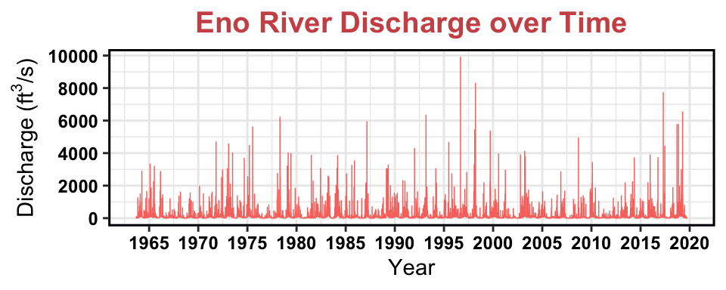 6. Plot discharge over time with geom_line. Make sure axis labels are formatted appropriately. 7. Create a time series of discharge 8. Decompose the time series using the stl function. 9. Visualize the decomposed time series.

### Check for data gaps

table(diff(EnoRiverDischarge$Date))

##   
## 1 39   
## 20451 1

There is one gap with 39 measurements.

## Determine Range of Data Gap

EnoDataGap<-seq(min(EnoRiverDischarge$Date), max(EnoRiverDischarge$Date), by=1)  
EnoDataGap[!EnoDataGap %in% EnoRiverDischarge$Date]

## [1] "2017-10-21" "2017-10-22" "2017-10-23" "2017-10-24" "2017-10-25"  
## [6] "2017-10-26" "2017-10-27" "2017-10-28" "2017-10-29" "2017-10-30"  
## [11] "2017-10-31" "2017-11-01" "2017-11-02" "2017-11-03" "2017-11-04"  
## [16] "2017-11-05" "2017-11-06" "2017-11-07" "2017-11-08" "2017-11-09"  
## [21] "2017-11-10" "2017-11-11" "2017-11-12" "2017-11-13" "2017-11-14"  
## [26] "2017-11-15" "2017-11-16" "2017-11-17" "2017-11-18" "2017-11-19"  
## [31] "2017-11-20" "2017-11-21" "2017-11-22" "2017-11-23" "2017-11-24"  
## [36] "2017-11-25" "2017-11-26" "2017-11-27"

Data gap between 10/21/2017 and 11/27/2017. Time series objects requires equispaced data.

## Remove data gap time period

EnoRiverDischargeNoGap<-filter(EnoRiverDischarge, Date<"2017-10-21")

# Replot Eno River Discharge Data w/o Gap

library(scales)  
EnoRiverPlotNoGap <-   
 ggplot(EnoRiverDischargeNoGap, aes(x = Date, y = Discharge)) +  
 geom_line(aes(y=Discharge, color="#cd5555"), show.legend=FALSE) +  
 labs(title="Eno River Discharge over Time", x = "Year", y = expression("Discharge (ft"^3*"/s)")) +   
 theme(axis.text.x=element_text(size=12))+  
 scale_y_continuous(breaks=seq(0,10000, by = 2000))+  
 scale_x_date(labels = date_format("%Y"), breaks = date_breaks("5 years"))+  
 gabytheme  
print(EnoRiverPlotNoGap)

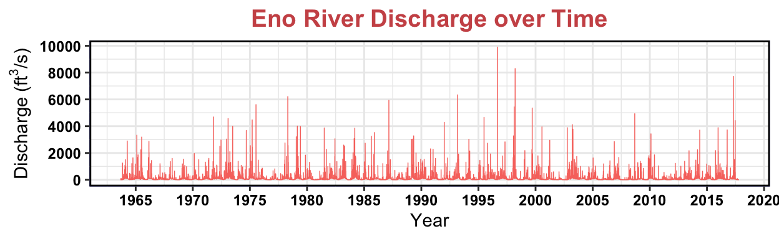

## Create Discharge Time Series

EnoRiver_ts <- ts(EnoRiverDischargeNoGap[[4]], frequency = 365)

## Decompose the Discharge Time Series

EnoRiver_Decomposed <- stl(EnoRiver_ts, s.window = "periodic")

# Visualize the decomposed Discharge Time Series

plot(EnoRiver_Decomposed)

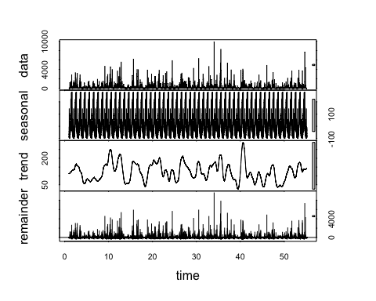

# Revisit Clear Creek Data

ClearCreekDischarge <- readNWISdv(siteNumbers = "06719505",  
 parameterCd = "00060", # discharge (ft3/s)  
 startDate = "",  
 endDate = "")  
names(ClearCreekDischarge)[4:5] <- c("Discharge", "Approval.Code")  
ClearCreek_ts <- ts(ClearCreekDischarge[[4]], frequency = 365)  
ClearCreek_Decomposed <- stl(ClearCreek_ts, s.window = "periodic")  
ClearCreek_Components <- as.data.frame(ClearCreek_Decomposed$time.series[,1:3]) ###Pull in the timeseries list to create a dataframe  
  
  
ClearCreek_Components <- mutate(ClearCreek_Components,  
 Observed = ClearCreekDischarge$Discharge,   
 Date = ClearCreekDischarge$Date) ##add in date so we can look at these over time  
plot(ClearCreek_Decomposed)

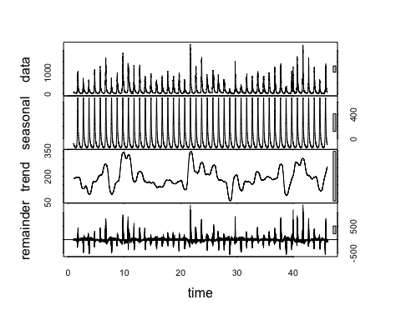

# Clear Creek Trend Plot

ClearCreek_ComponentsTrendPlot<-ggplot(ClearCreek_Components) +  
 geom_line(aes(y = Observed, x = Date), size = 0.25) +  
 geom_line(aes(y = trend, x = Date), color = "#c13d75ff") +  
 geom_hline(yintercept = 0, lty = 2) +  
 ylab(expression("Discharge (ft"^3*"/s)"))+  
 labs(title="Clear Creek Discharge Trend over Time")+  
 scale_x_date(date_breaks="5 years", date_labels="%Y")+  
 theme(axis.text.x=element_text(size=10))  
print(ClearCreek_ComponentsTrendPlot)

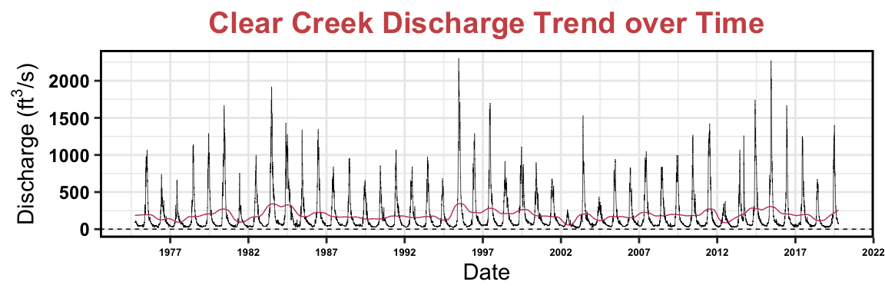

# Clear Creek Seasonal Plot

ClearCreek_ComponentsSeasonalPlot<-ggplot(ClearCreek_Components) +  
 geom_line(aes(y = Observed, x = Date), size = 0.25) +  
 geom_line(aes(y = seasonal, x = Date), color = "#c13d75ff") +  
 geom_hline(yintercept = 0, lty = 2) +  
 ylab(expression("Discharge (ft"^3*"/s)"))+  
 labs(title="Clear Creek Discharge Seasonality over Time")+  
 scale_x_date(date_breaks="5 years", date_labels="%Y")+  
 theme(axis.text.x=element_text(size=10))  
print(ClearCreek_ComponentsSeasonalPlot)

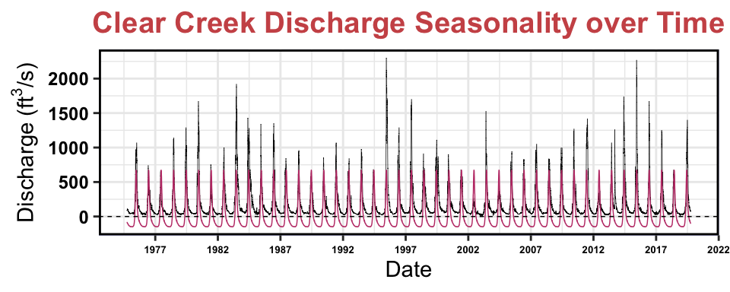

# Extract Eno River Components

EnoRiver_Components <- as.data.frame(EnoRiver_Decomposed$time.series[,1:3]) ###Pull in the timeseries list to create a dataframe  
  
  
EnoRiver_Components <- mutate(EnoRiver_Components,  
 Observed = EnoRiverDischargeNoGap$Discharge,   
 Date = EnoRiverDischargeNoGap$Date) ##add in date so we can look at these over time

Observed=discharge

# Eno River Trend Plot

EnoRiver_ComponentsTrendPlot<-ggplot(EnoRiver_Components) +  
 geom_line(aes(y = Observed, x = Date), size = 0.25) +  
 geom_line(aes(y = trend, x = Date), color = "#c13d75ff") +  
 geom_hline(yintercept = 0, lty = 2) +  
 ylab(expression("Discharge (ft"^3*"/s)"))+  
 labs(title="Eno River Discharge Trend over Time")+  
 scale_x_date(date_breaks="5 years", date_labels="%Y")+  
 theme(axis.text.x=element_text(size=10))  
print(EnoRiver_ComponentsTrendPlot)

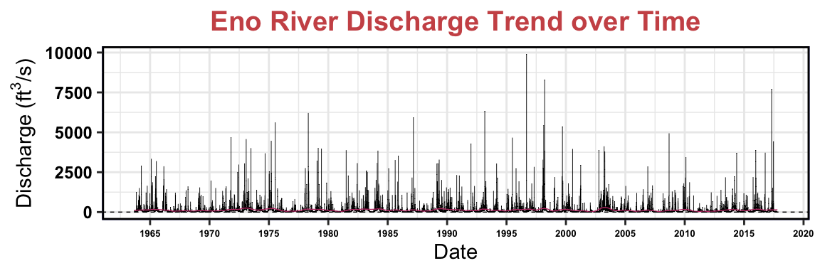

# Eno River Seasonality Plot

EnoRiver_ComponentsSeasonalPlot<-ggplot(EnoRiver_Components) +  
 geom_line(aes(y = Observed, x = Date), size = 0.25) +  
 geom_line(aes(y = seasonal, x = Date), color = "#c13d75ff") +  
 geom_hline(yintercept = 0, lty = 2) +  
 ylab(expression("Dischrrge (ft"^3*"/s)"))+  
 labs(title="Eno River Discharge Seasonality over Time")+  
 theme(axis.text.x=element_text(size=10))+  
 scale_x_date(date_breaks="5 years", date_labels="%Y")  
print(EnoRiver_ComponentsSeasonalPlot)

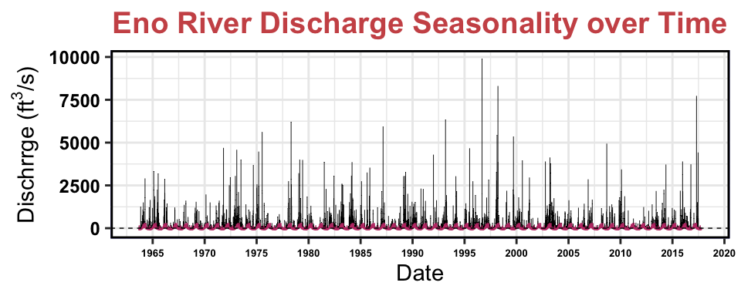

1. How do the seasonal and trend components of the decomposition compare to the Clear Creek discharge dataset? Are they similar in magnitude?

# Compare Trend Plots of Eno River and Clear Creek Using Plot_Grid function

library(cowplot)

##   
## ********************************************************

## Note: As of version 1.0.0, cowplot does not change the

## default ggplot2 theme anymore. To recover the previous

## behavior, execute:  
## theme_set(theme_cowplot())

## ********************************************************

##   
## Attaching package: 'cowplot'

## The following object is masked from 'package:lubridate':  
##   
## stamp

TrendPlotGrid<-plot_grid(EnoRiver_ComponentsTrendPlot, ClearCreek_ComponentsTrendPlot,   
 nrow = 2)   
print(TrendPlotGrid)

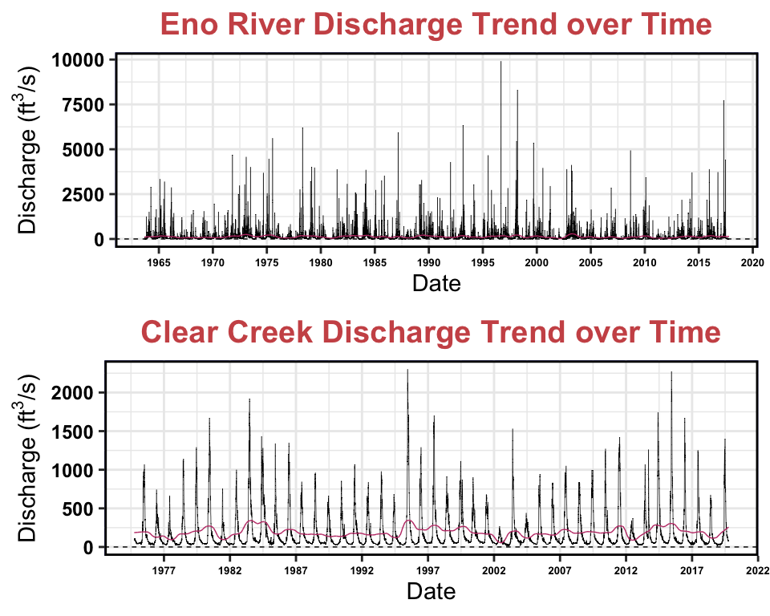

# Compare Seasonality Plots of Eno River and Clear Creek using Plot_Grid Function

library(cowplot)  
SeasonalityPlotGrid<-plot_grid(EnoRiver_ComponentsSeasonalPlot, ClearCreek_ComponentsSeasonalPlot,   
 nrow = 2)   
print(SeasonalityPlotGrid)

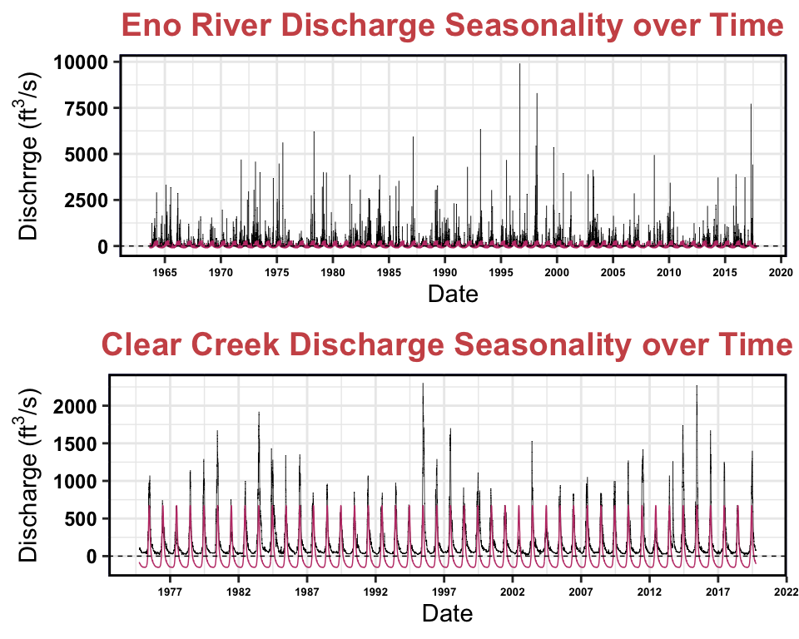

Seasonal: There is visible seasonality in both the Eno River and Clear Creek datasets. While the Clear Creek data features one large peak after the start of every year, the Clear Creek data has two seasonal peaks, as there is a smaller peak in between each larger peak. The peak of larger magnitude takes place in the

Trend: For both the Eno River and Clear Creek datasets, the trend peaks correspond to high river discharge events. It is worth noting that Eno River has a larger range in magnitude of river discharge (0.08-9900 cfs) than Clear Creek (12.0-2300 cfs), yet Eno River’s trend line has peaks of smaller magnitude than the Clear Creek trend line. The Eno River has more data points than the Clear Creek dataset. Both trend lines for Eno River and Clear Creek are always positive, although Eno River’s trend line remains close to 0.

# Trend Analysis

Research question: Has there been a monotonic trend in discharge in Clear Creek over the period of study?

1. Generate a time series of monthly discharge in Clear Creek from the ClearCreekDischarge.Monthly data frame. This time series should include just one column (discharge).
2. Run a Seasonal Mann-Kendall test on the monthly discharge data. Inspect the overall trend and the monthly trends.
3. Is there an overall monotonic trend in discharge over time? If so, is it positive or negative?
4. Are there any monthly monotonic trends in discharge over time? If so, during which months do they occur and are they positive or negative?

## Reflection

1. What are 2-3 conclusions or summary points about time series you learned through your analysis?
2. What data, visualizations, and/or models supported your conclusions from 12?
3. Did hands-on data analysis impact your learning about time series relative to a theory-based lesson? If so, how?
4. How did the real-world data compare with your expectations from theory?