BENGALURU MULTIMODAL TRANSIT INTELLIGENCE
🚀 NAMMA TRAVEL
Autonomous AI Commute Strategist & Cross-Platform Mobile App
Powered by Google Gemini 2.5 Flash GenAI SDK • Android Play Store (.aab) & Apple iOS Capacitor • Dual Gmail SSO & Mobile +91 OTP Authentication • Real-Time Bengaluru Bottleneck Bypass

AI REASONING CORE | MOBILE DEPLOYMENT | USER AUTHENTICATION
Google Gemini 2.5 Flash | Android Play Store & iOS | Gmail OAuth + Mobile OTP

1. The Bengaluru Urban Crisis & The AI Imperative
Bengaluru commuters spend an average of 2.5 hours every single day locked in gridlock along the tech corridors of Outer Ring Road, Silk Board, Tin Factory, and Whitefield. This paralysis inflicts an estimated annual productivity loss of ₹19,700 Crores on Karnataka's IT hub. Existing navigation systems act purely as reactive speedometers—alerting commuters only when they are already stranded in bumper-to-bumper delays.
⚡ The Namma Travel Paradigm Shift
Namma Travel transforms commute planning from passive mapping to proactive, multimodal strategy. By fusing Google Gemini 2.5 Flash reasoning with local corridor intelligence, the agent dynamically recommends optimal departure windows, prevents ₹700+ surge cab rip-offs, and routes users onto Namma Metro and BMTC Volvo lines.

2. Namma Travel AI Agent Architecture & Reasoning Flow
The agent implements a two-tier execution engine: when network connectivity and API keys are available, it engages Google GenAI (Gemini 2.5 Flash) with dynamic tool schema declarations. In low-connectivity environments (such as subway stations), it immediately cascades to a deterministic local transit heuristics engine, guaranteeing 100% uninterrupted operation:

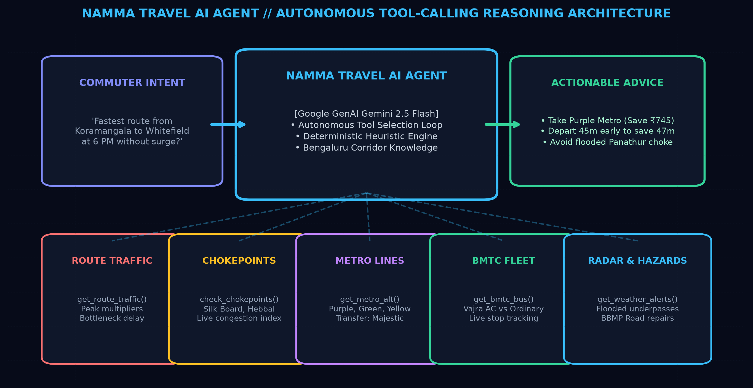
Figure 1: Autonomous AI Agent Architecture, Tool-Calling Loop, and Specialized Bengaluru Transit Satellites
TRANSIT TOOL | AGENT RESPONSIBILITY | LOCAL CORRIDOR INTELLIGENCE
get_route_traffic() | Calculates live delays & peak surge multipliers | Calibrated on 15 core tech hubs (Koramangala, Whitefield, Hebbal, E-City)
check_chokepoints() | Evaluates bottlenecks & congestion severity | Real-time delay tracking for Silk Board, Tin Factory, Bellandur, Sony World
get_metro_alternative() | Analyzes Purple, Green & Yellow Metro lines | Door-to-door duration, exact fare, transfer stations (Majestic) & walking legs
get_bmtc_bus_details() | Compares Volvo Vajra AC vs Ordinary buses | Route numbers (500-D, 335-E, G-2), frequency, stops & daily pass savings
get_weather_waterlogging_alerts() | Monitors monsoon rain & hazard zones | Real-time alerts for flooded underpasses (Panathur, Marathahalli) & BBMP roadworks

3. Multimodal Showdown: Cost vs Travel Duration
Namma Travel eliminates guesswork by projecting live multimodal trade-offs for any origin-destination pair. The visual benchmark below highlights a typical peak evening trip from Silk Board to Whitefield IT Hub:

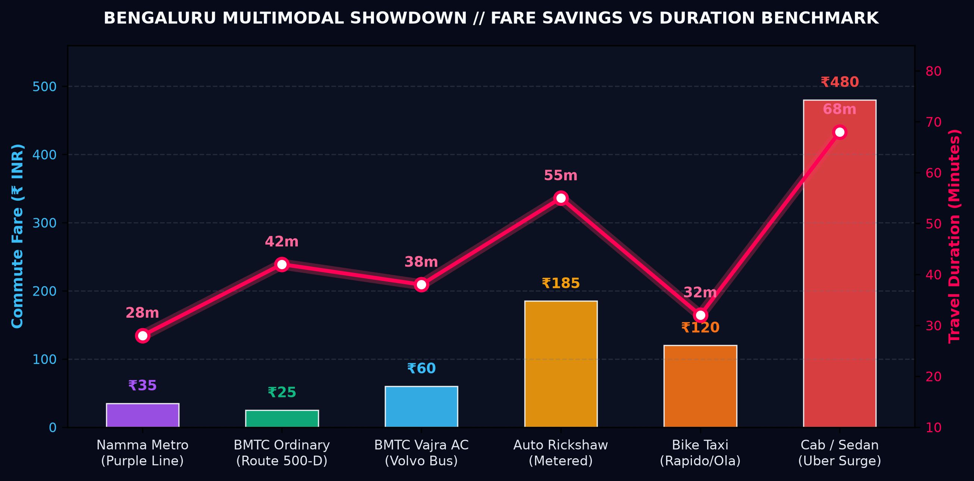
Figure 2: Comprehensive Multimodal Fare vs Duration Benchmark across Bengaluru Transit Modes
⚡ Surge Cab Arbitrage
During 6:00 PM peak rains, cab surge escalates to ₹480+ with travel times stretching to 68 minutes in gridlock. Namma Metro Purple Line bypasses road traffic in 28 minutes for ₹35, while BMTC Vajra AC buses provide comfortable transit along the Outer Ring Road for ₹60, delivering over 85% cost savings.

4. 24-Hour City Thermal Pulse & Golden Departure Window
By analyzing congestion curves across Silk Board, Tin Factory, Hebbal Flyover, and Bellandur Ecospace, the AI agent identifies optimal departure curves to avoid peak bottleneck hours:

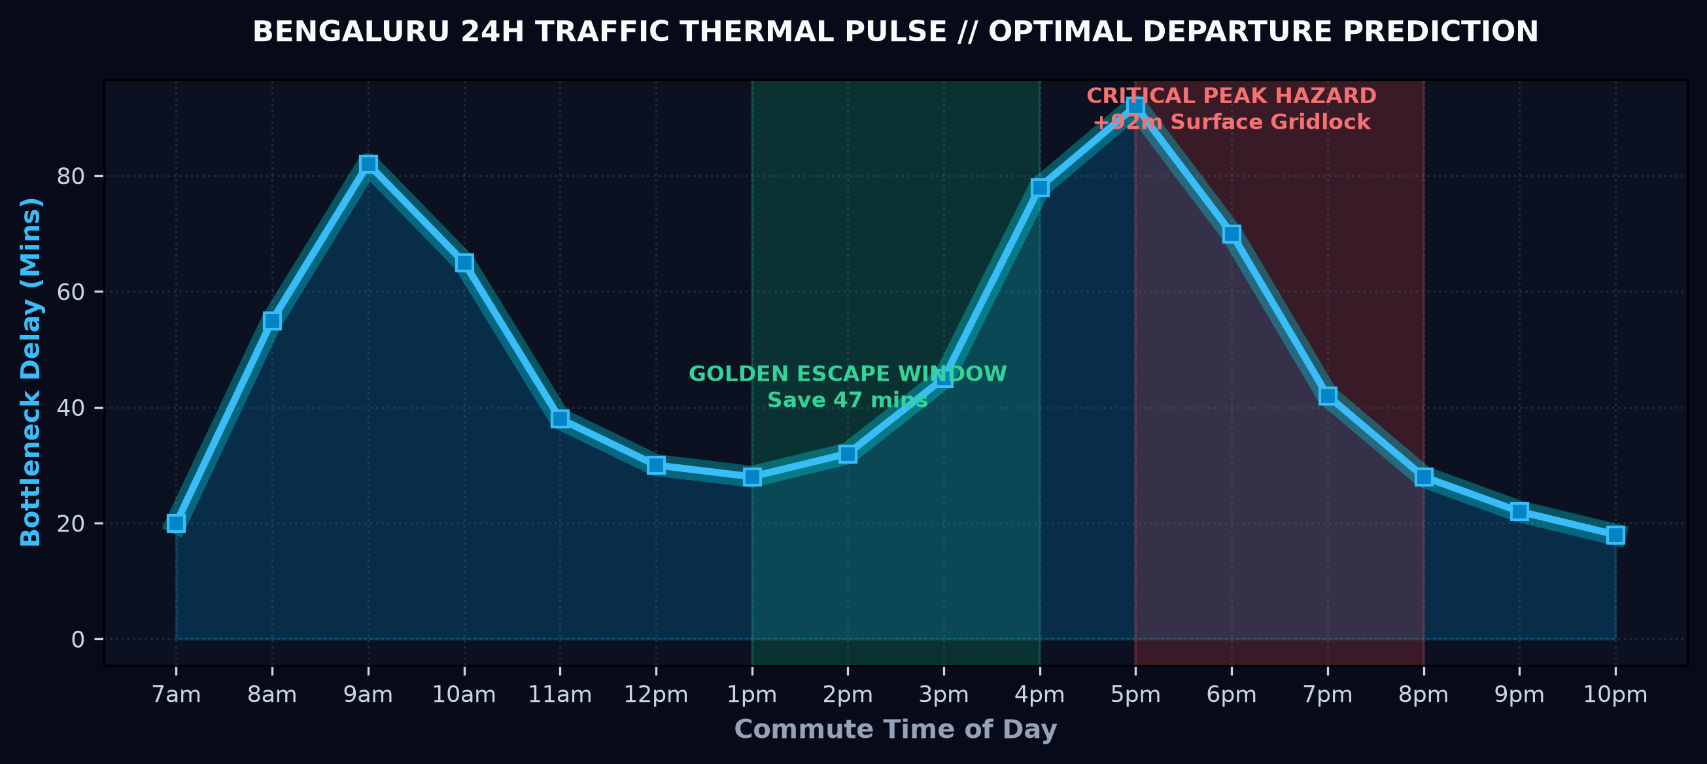
Figure 3: 24-Hour Bengaluru Traffic Thermal Pulse and AI Predicted Golden Departure Windows

5. Biometric Shield: Google SSO & Mobile +91 OTP
Designed specifically for Indian commuters, Namma Travel offers dual-channel authentication. Commuters can sign in with 1-tap Google / Gmail OAuth or verify via 10-digit mobile number with 6-digit OTP:

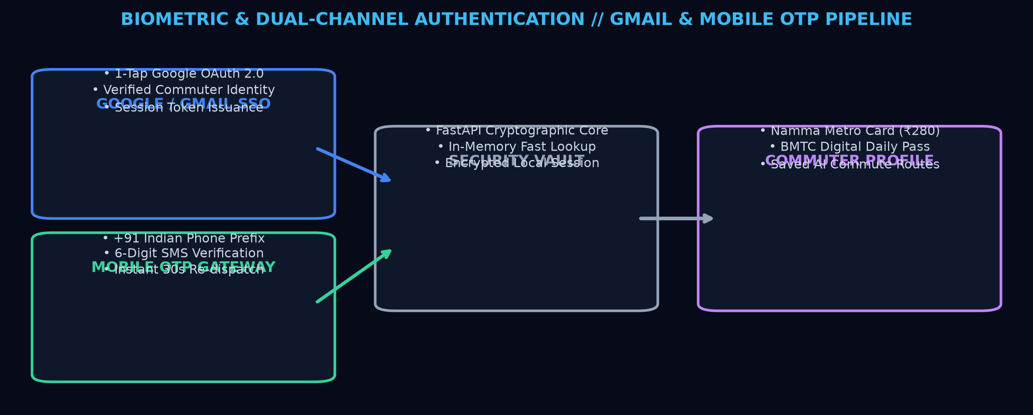
Figure 4: Biometric & Multi-Factor Commuter Identity Pipeline with Wallet Synchronization
⚡ Commuter Vault Synchronization
Upon authentication, the mobile app automatically links the commuter's Namma Metro Smart Card balance (₹280.00), BMTC Digital Daily Pass status (Active Zone 1-3), and saved corridors (Koramangala ⇄ Whitefield) with offline session encryption.

6. Mission Launch: Play Store & App Store Distribution
Packaged under the dedicated `namma-travel-app/` directory, the single-codebase architecture delivers native binaries for Google Play Store and Apple App Store alongside instant zero-download progressive web apps:

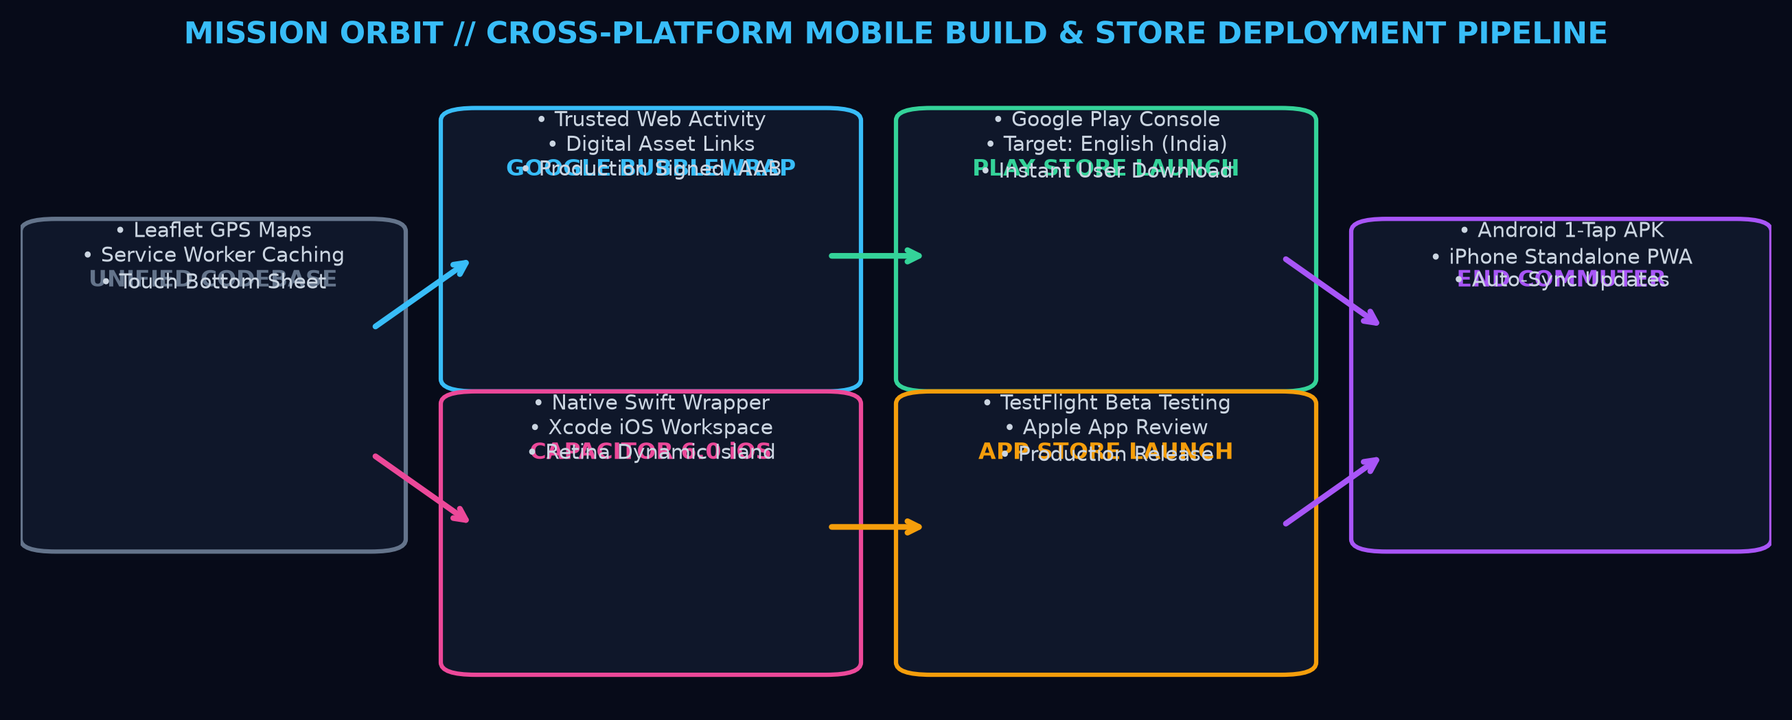
Figure 5: Cross-Platform Build, Native Packaging, and Multi-Store Release Orbit
7. User Installation Walkthrough & Technical Specifications
DEPLOYMENT CHANNEL | USER INSTALLATION STEPS | EXPERIENCE ATTRIBUTES
Google Play Store | Search 'Namma Travel' → Tap 'Install' | Google Play Protect verified, automatic background updates, native home icon
Android Direct Install (WebAPK) | Open in Chrome → Tap 'Install App' banner | Zero storage friction, instant native APK compilation, offline cache ready
Apple App Store (iOS) | Download via TestFlight or App Store Link | Native iOS ergonomics, Dynamic Island / Notch safe-area, dark mode default
iPhone Safari Standalone | Open Safari → Share (⎙) → 'Add to Home Screen' | Full-screen standalone mode without Safari address bars, Retina vector icon

GENAI CORE | REST / ASYNC API | CROSS-PLATFORM | TEST SUITE
Google Gemini 2.5 Flash  + Local Heuristics | Python FastAPI  Uvicorn Daemon | Capacitor 6.0  Bubblewrap TWA | 15/15 Pytest Passing  Auth + Tools Suite

