



北京海量数据技术股份有限公司

2020年8月

**PostgreSQL数据库常用监控指标**

**目 录**

1 文档说明 4

2 监控指标 4

2.1 会话连接数 4

2.2 缓存命中率 4

2.3 每秒事务数和DML元组数 5

2.4 等待事件 6

2.5 不记录log的对象 6

2.6 密码到期时间 7

2.7 长事务 7

2.8 当前执行的SQL 7

2.9 数据库空间大小 8

2.10 表空间使用量 9

2.11 大表监控 9

2.12 大索引监控 10

2.13 表碎片 10

2.14 索引碎片 14

2.15 流复制延迟 17

3 统计信息表 18

3.1 统计信息概览 18

3.2 pg_stat_database 18

3.3 pg_stat_user_tables 19

3.4 pg_stat_user_indexes 20

3.5 pg_statio_user_tables 20

3.6 pg_stat_bgwriter 20

3.7 pg_stat_replication 21

3.8 pg_stat_statements 21

3.9 pg_stat_replication 22

4 监控相关插件 23

4.1 pg_wait_sampling 23

4.2 pg_stat_kcache 23

4.3 pgcenter 23

4.4 pg_activity 23

# 文档说明

本文收录PostgreSQL多种监控指标，旨在为运维人员提供便利。

# 监控指标

(1)将exBase 安装包上传，并解压到根目录；

unzip exbase_environment_20190812.zip -d /exbase_environment

## 会话连接数

查看当前连接到数据库会话数，与运行连接的最大会话数

SELECT count(*) as current_conns,

current_setting('max_connections') as max_conns

FROM pg_stat_activity;

查看当前连接到数据库活跃会话与空闲会话数量，state='idle' 空闲会话，state in ('active','background') 活跃会话。

SELECT case when state is null then 'background' else state end,

count(*)

FROM pg_stat_activity group by state;

## 缓存命中率

数据库缓存命中率，一般而言都能达到90%以上，现在一般不作为数据库是否优化的参考指标。只有在命中率较低的情况下，才考虑是否缓存大小设置的不合理，或是业务模式导致数据共享率不高。

SELECT a.datname,

CAST(pg_database_size(a.datid)/1024/1024 AS NUMERIC(5, 2)) AS size_Mb,

CAST(blks_hit / (blks_read + blks_hit + 0.000001) * 100.0 AS NUMERIC(5, 2)) AS buffer_hint,

CAST(xact_commit / (xact_rollback + xact_commit + 0.000001) * 100.0 AS NUMERIC(5, 2)) AS success_trans

FROM pg_stat_database a

where datname not in ('template0','template1')

ORDER BY pg_database_size(a.datid) DESC;

## 每秒事务数和DML元组数

统计每个数据库中每秒增、删、改、查数据量。

tps:每个库的tps；

xact_commit:每个库每秒的提交数；

xact_rollback:每个库每秒的回滚数；

tup_retuen 对于表来说是全表扫描的行数，对于索引是通过索引⽅方法返回的索引行数，如果这个值数量明显⼤于tup_fetched，说明当前数据库存在⼤大量全表扫描的情况。 接近于1最好，表示走索引多；

blk_read_time 数据库中花费在读取⽂文件的时间，这个值较⾼高说明内存较⼩小，需要频繁的从磁盘中读⼊入数据⽂文件， 单位毫秒；

blk_write_time 数据库中花费在写数据⽂文件的时间，pg中脏⻚页一般都写⼊入page cache，如果这个值较⾼高，说明page cache较⼩小，操作系统的page cache需要更更积极的写⼊，单位毫秒。

select datname,xact_commit,xact_rollback,(xact_commit+xact_rollback) as tps,tup_returned,tup_fetched,case when tup_fetched+tup_returned=0 then 0 else round(tup_fetched::numeric/(tup_fetched+tup_returned),2) end as tablefullscan,tup_inserted,tup_updated,tup_deleted, blk_read_time,blk_write_time

from pg_stat_database

where datname not in ('template0','template1');

## 等待事件

记录每个数据库中的等待事件。

select datname,wait_event_type||'_'||wait_event,count(*)

from pg_stat_activity

where state in ('active', 'fastpath function call')

and pid<>pg_backend_pid()

group by datname,wait_event_type||'_'||wait_event;

## 不记录log的对象

unlogged table和hash index不记录XLOG, 无法使用流复制或者log shipping的方式复制到standby节点，如果在standby节点执行某些SQL，可能导致报错或查不到数据。 在数据库CRASH后无法修复unlogged table和hash index, 不建议使用。 PITR对unlogged table和hash index也不起作用。

select current_database(),t3.rolname,t2.nspname,t1.relname,pg_get_indexdef(t1.oid)

from pg_class t1,pg_namespace t2,pg_authid t3

where t1.relnamespace=t2.oid

and t1.relowner=t3.oid

and (t1.relpersistence=$$u$$ or(t1.relkind=$$i$$ and pg_get_indexdef(t1.oid) ~ $$USING hash$$));

## 密码到期时间

到期后, 用户将无法登陆, 记得修改密码, 同时将密码到期时间延长到某个时间或无限时间, alter role ... VALID UNTIL 'timestamp' .

select rolname,rolvaliduntil from pg_authid order by rolvaliduntil;

## 长事务

长事务过程中产生的垃圾, 无法回收, 建议不要在数据库中运行LONG SQL, 或者错开DML高峰时间去运行LONG SQL。

SELECT datname, usename, query, xact_start,

now() - xact_start xact_duration, query_start, now() - query_start query_duration, STATE

FROM pg_stat_activity WHERE STATE <>'idle' and now()-xact_start > interval '30 SECOND' ORDER BY xact_start;

## 当前执行的SQL

SELECT

procpid,

START,

now() - START AS lap,

current_query

FROM

(

SELECT

backendid,

pg_stat_get_backend_pid (S.backendid) AS procpid,

pg_stat_get_backend_activity_start (S.backendid) AS START,

pg_stat_get_backend_activity (S.backendid) AS current_query

FROM

(

SELECT

pg_stat_get_backend_idset () AS backendid

) AS S

) AS S

WHERE

current_query <> '<IDLE>'

ORDER BY

lap DESC;

procpid：[进程id](http://www.baidu.com/s?wd=%E8%BF%9B%E7%A8%8Bid&tn=44039180_cpr&fenlei=mv6quAkxTZn0IZRqIHckPjm4nH00T1YLrycvuyn3mWmvrjTLnhf10ZwV5Hcvrjm3rH6sPfKWUMw85HfYnjn4nH6sgvPsT6KdThsqpZwYTjCEQLGCpyw9Uz4Bmy-bIi4WUvYETgN-TLwGUv3EPjnzrHD4PWc1P1ckrHTsnW0Y)  
start：进程开始时间  
lap：经过时间  
current_query：执行中的sql  
取消正在执行的sql：SELECT pg_cancel_backend([进程id](http://www.baidu.com/s?wd=%E8%BF%9B%E7%A8%8Bid&tn=44039180_cpr&fenlei=mv6quAkxTZn0IZRqIHckPjm4nH00T1YLrycvuyn3mWmvrjTLnhf10ZwV5Hcvrjm3rH6sPfKWUMw85HfYnjn4nH6sgvPsT6KdThsqpZwYTjCEQLGCpyw9Uz4Bmy-bIi4WUvYETgN-TLwGUv3EPjnzrHD4PWc1P1ckrHTsnW0Y));

## 数据库空间大小

监控各个数据库占用磁盘空间的大小。

select datname,pg_database_size(datname)/1024/1024 as size_mb

from pg_database

where datname not in ('template0','template1')

group by datname;

## 表空间使用量

select pg_tablespace_size(spcname)/1024/1024 as "tablespace_total_usedmsize",spcname,pg_tablespace_location(oid)

from pg_tablespace where pg_tablespace_location(oid) != ''

select pg_tablespace_size(spcname)/1024/1024 as "tablespace_total_usedmsize",spcname,

case when pg_tablespace_location(oid) = '' then (select setting from pg_settings where name = 'data_directory')

else pg_tablespace_location(oid) end from pg_tablespace

## 大表监控

纪录大表占用空间的历史纪录，因为mvcc多版本模式需要考虑空间问题，确定是否需要vacuum。

select current_database(),table_name,pg_relation_size(table_schema||'.'||table_name) as size_bytes

from information_schema.tables

where table_schema not in ('pg_catalog', 'information_schema')

order by size_bytes desc

LIMIT 10;

## 大索引监控

SELECT current_database(),A.rolname,nspname,relname,

round(100 * pg_relation_size ( indexrelid ) / pg_relation_size ( indrelid )) / 100 AS index_ratio,

pg_size_pretty (pg_relation_size ( indexrelid )) AS index_size,

pg_size_pretty (pg_relation_size ( indrelid )) AS table_size

FROM pg_index I

LEFT JOIN pg_class C ON ( C.oid = I.indexrelid )

LEFT JOIN pg_namespace N ON ( N.oid = C.relnamespace )

LEFT JOIN pg_authid A ON ( C.relowner = A.oid )

WHERE nspname NOT IN ( 'pg_catalog', 'information_schema', 'pg_toast' )AND C.relkind = 'i'

AND pg_relation_size ( indrelid ) > 0

order by pg_relation_size(indexrelid) desc limit 10;

## 表碎片

根据浪费的字节数，设置合适的autovacuum_vacuum_scale_factor，大表如果频繁的有更新或删除和插入操作，建议设置较小的autovacuum_vacuum_scale_factor来降低浪费空间。同时还需要打开autovacuum, 根据服务器的内存大小，CPU核数，设置足够大的autovacuum_work_mem 或 autovacuum_max_workers 或 maintenance_work_mem, 以及足够小的 autovacuum_naptime。

同时还需要分析是否对大数据库使用了逻辑备份pg_dump，系统中是否经常有长SQL，长事务。这些都有可能导致膨胀。使用pg_reorg或者vacuum full可以回收膨胀的空间。

otta评估出的表实际需要页数, iotta评估出的索引实际需要页数。bs数据库的块大小，tbloat表膨胀倍数， ibloat索引膨胀倍数,，wastedpages表浪费了多少个数据块,，wastedipages索引浪费了多少个数据块；wastedbytes表浪费了多少字节， wastedibytes索引浪费了多少字节；

SELECT

current_database() AS db, schemaname, tablename, reltuples::bigint AS tups, relpages::bigint AS pages, otta,

ROUND(CASE WHEN otta=0 OR sml.relpages=0 OR sml.relpages=otta THEN 0.0 ELSE sml.relpages/otta::numeric END,1) AS tbloat,

CASE WHEN relpages < otta THEN 0 ELSE relpages::bigint - otta END AS wastedpages,

CASE WHEN relpages < otta THEN 0 ELSE bs*(sml.relpages-otta)::bigint END AS wastedbytes,

CASE WHEN relpages < otta THEN $$0 bytes$$::text ELSE (bs*(relpages-otta))::bigint || $$ bytes$$ END AS wastedsize,

iname, ituples::bigint AS itups, ipages::bigint AS ipages, iotta,

ROUND(CASE WHEN iotta=0 OR ipages=0 OR ipages=iotta THEN 0.0 ELSE ipages/iotta::numeric END,1) AS ibloat,

CASE WHEN ipages < iotta THEN 0 ELSE ipages::bigint - iotta END AS wastedipages,

CASE WHEN ipages < iotta THEN 0 ELSE bs*(ipages-iotta) END AS wastedibytes,

CASE WHEN ipages < iotta THEN $$0 bytes$$ ELSE (bs*(ipages-iotta))::bigint || $$ bytes$$ END AS wastedisize,

CASE WHEN relpages < otta THEN

CASE WHEN ipages < iotta THEN 0 ELSE bs*(ipages-iotta::bigint) END

ELSE CASE WHEN ipages < iotta THEN bs*(relpages-otta::bigint)

ELSE bs*(relpages-otta::bigint + ipages-iotta::bigint) END

END AS totalwastedbytes

FROM (

SELECT

nn.nspname AS schemaname,

cc.relname AS tablename,

COALESCE(cc.reltuples,0) AS reltuples,

COALESCE(cc.relpages,0) AS relpages,

COALESCE(bs,0) AS bs,

COALESCE(CEIL((cc.reltuples*((datahdr+ma-

(CASE WHEN datahdr%ma=0 THEN ma ELSE datahdr%ma END))+nullhdr2+4))/(bs-20::float)),0) AS otta,

COALESCE(c2.relname,$$?$$) AS iname, COALESCE(c2.reltuples,0) AS ituples, COALESCE(c2.relpages,0) AS ipages,

COALESCE(CEIL((c2.reltuples*(datahdr-12))/(bs-20::float)),0) AS iotta -- very rough approximation, assumes all cols

FROM

pg_class cc

JOIN pg_namespace nn ON cc.relnamespace = nn.oid AND nn.nspname <> $$information_schema$$

LEFT JOIN

(

SELECT

ma,bs,foo.nspname,foo.relname,

(datawidth+(hdr+ma-(case when hdr%ma=0 THEN ma ELSE hdr%ma END)))::numeric AS datahdr,

(maxfracsum*(nullhdr+ma-(case when nullhdr%ma=0 THEN ma ELSE nullhdr%ma END))) AS nullhdr2

FROM (

SELECT

ns.nspname, tbl.relname, hdr, ma, bs,

SUM((1-coalesce(null_frac,0))*coalesce(avg_width, 2048)) AS datawidth,

MAX(coalesce(null_frac,0)) AS maxfracsum,

hdr+(

SELECT 1+count(*)/8

FROM pg_stats s2

WHERE null_frac<>0 AND s2.schemaname = ns.nspname AND s2.tablename = tbl.relname

) AS nullhdr

FROM pg_attribute att

JOIN pg_class tbl ON att.attrelid = tbl.oid

JOIN pg_namespace ns ON ns.oid = tbl.relnamespace

LEFT JOIN pg_stats s ON s.schemaname=ns.nspname

AND s.tablename = tbl.relname

AND s.inherited=false

AND s.attname=att.attname,

(

SELECT

(SELECT current_setting($$block_size$$)::numeric) AS bs,

CASE WHEN SUBSTRING(SPLIT_PART(v, $$ $$, 2) FROM $$#"[0-9]+.[0-9]+#"%$$ for $$#$$)

IN ($$8.0$$,$$8.1$$,$$8.2$$) THEN 27 ELSE 23 END AS hdr,

CASE WHEN v ~ $$mingw32$$ OR v ~ $$64-bit$$ THEN 8 ELSE 4 END AS ma

FROM (SELECT version() AS v) AS foo

) AS constants

WHERE att.attnum > 0 AND tbl.relkind=$$r$$

GROUP BY 1,2,3,4,5

) AS foo

) AS rs

ON cc.relname = rs.relname AND nn.nspname = rs.nspname

LEFT JOIN pg_index i ON indrelid = cc.oid

LEFT JOIN pg_class c2 ON c2.oid = i.indexrelid

) AS sml order by wastedbytes desc limit 5;

## 索引碎片

如果索引膨胀太大, 会影响性能, 建议重建索引, create index CONCURRENTLY。

SELECT current_database() AS db, schemaname, tablename, reltuples::bigint AS tups, relpages::bigint AS pages, otta,

ROUND(CASE WHEN otta=0 OR sml.relpages=0 OR sml.relpages=otta THEN 0.0 ELSE sml.relpages/otta::numeric END,1) AS tbloat,

CASE WHEN relpages < otta THEN 0 ELSE relpages::bigint - otta END AS wastedpages,

CASE WHEN relpages < otta THEN 0 ELSE bs*(sml.relpages-otta)::bigint END AS wastedbytes,

CASE WHEN relpages < otta THEN $$0 bytes$$::text ELSE (bs*(relpages-otta))::bigint || $$ bytes$$ END AS wastedsize,

iname, ituples::bigint AS itups, ipages::bigint AS ipages, iotta,

ROUND(CASE WHEN iotta=0 OR ipages=0 OR ipages=iotta THEN 0.0 ELSE ipages/iotta::numeric END,1) AS ibloat,

CASE WHEN ipages < iotta THEN 0 ELSE ipages::bigint - iotta END AS wastedipages,

CASE WHEN ipages < iotta THEN 0 ELSE bs*(ipages-iotta) END AS wastedibytes,

CASE WHEN ipages < iotta THEN $$0 bytes$$ ELSE (bs*(ipages-iotta))::bigint || $$ bytes$$ END AS wastedisize,

CASE WHEN relpages < otta THEN

CASE WHEN ipages < iotta THEN 0 ELSE bs*(ipages-iotta::bigint) END

ELSE CASE WHEN ipages < iotta THEN bs*(relpages-otta::bigint)

ELSE bs*(relpages-otta::bigint + ipages-iotta::bigint) END

END AS totalwastedbytes

FROM (

SELECT

nn.nspname AS schemaname,

cc.relname AS tablename,

COALESCE(cc.reltuples,0) AS reltuples,

COALESCE(cc.relpages,0) AS relpages,

COALESCE(bs,0) AS bs,

COALESCE(CEIL((cc.reltuples*((datahdr+ma-

(CASE WHEN datahdr%ma=0 THEN ma ELSE datahdr%ma END))+nullhdr2+4))/(bs-20::float)),0) AS otta,

COALESCE(c2.relname,$$?$$) AS iname, COALESCE(c2.reltuples,0) AS ituples, COALESCE(c2.relpages,0) AS ipages,

COALESCE(CEIL((c2.reltuples*(datahdr-12))/(bs-20::float)),0) AS iotta -- very rough approximation, assumes all cols

FROM

pg_class cc

JOIN pg_namespace nn ON cc.relnamespace = nn.oid AND nn.nspname <> $$information_schema$$

LEFT JOIN

(

SELECT

ma,bs,foo.nspname,foo.relname,

(datawidth+(hdr+ma-(case when hdr%ma=0 THEN ma ELSE hdr%ma END)))::numeric AS datahdr,

(maxfracsum*(nullhdr+ma-(case when nullhdr%ma=0 THEN ma ELSE nullhdr%ma END))) AS nullhdr2

FROM (

SELECT

ns.nspname, tbl.relname, hdr, ma, bs,

SUM((1-coalesce(null_frac,0))*coalesce(avg_width, 2048)) AS datawidth,

MAX(coalesce(null_frac,0)) AS maxfracsum,

hdr+(

SELECT 1+count(*)/8

FROM pg_stats s2

WHERE null_frac<>0 AND s2.schemaname = ns.nspname AND s2.tablename = tbl.relname

) AS nullhdr

FROM pg_attribute att

JOIN pg_class tbl ON att.attrelid = tbl.oid

JOIN pg_namespace ns ON ns.oid = tbl.relnamespace

LEFT JOIN pg_stats s ON s.schemaname=ns.nspname

AND s.tablename = tbl.relname

AND s.inherited=false

AND s.attname=att.attname,

(

SELECT

(SELECT current_setting($$block_size$$)::numeric) AS bs,

CASE WHEN SUBSTRING(SPLIT_PART(v, $$ $$, 2) FROM $$#"[0-9]+.[0-9]+#"%$$ for $$#$$)

IN ($$8.0$$,$$8.1$$,$$8.2$$) THEN 27 ELSE 23 END AS hdr,

CASE WHEN v ~ $$mingw32$$ OR v ~ $$64-bit$$ THEN 8 ELSE 4 END AS ma

FROM (SELECT version() AS v) AS foo

) AS constants

WHERE att.attnum > 0 AND tbl.relkind=$$r$$

GROUP BY 1,2,3,4,5

) AS foo

) AS rs

ON cc.relname = rs.relname AND nn.nspname = rs.nspname

LEFT JOIN pg_index i ON indrelid = cc.oid

LEFT JOIN pg_class c2 ON c2.oid = i.indexrelid

) AS sml order by wastedibytes desc limit 5;

## 流复制延迟

关注流复制的延迟, 如果延迟非常大, 建议排查网络带宽, 以及本地读xlog的性能, 远程写xlog的性能。

select pg_xlog_location_diff(pg_current_xlog_location(),flush_location), * from pg_stat_replication;

# 统计信息表

## 统计信息概览

原文地址：<https://yq.aliyun.com/articles/697692>

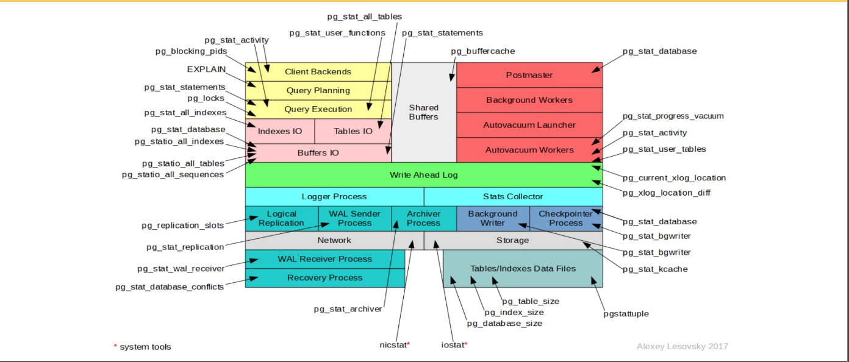

## pg_stat_database

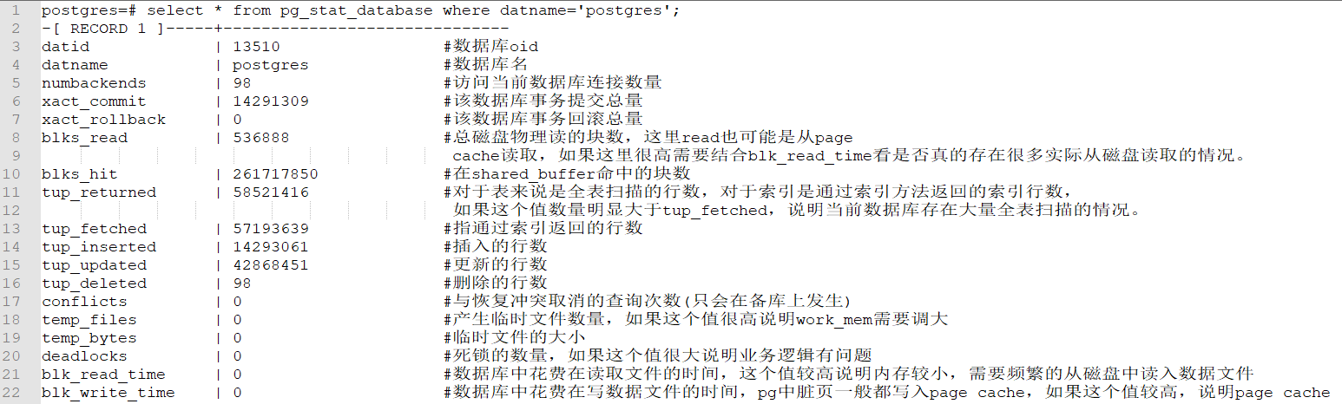

通过pg_stat_database我们就可以大概了解数据库的历史情况，比如看到tup_returned值远大于tup_fetched，说明数据库历史执行的sql很多都是全表扫描，说明存在很多没有走索引的sql，这时候可以结合pg_stat_statments来查找慢sql，也可以通过pg_stat_user_tables找到全表扫描次数和行数最多的表。通过看到tup_updated很高说明数据库有很频繁的更新，这个时候就需要关注一下vacuum相关的指标和长事务，如果没有及时进行垃圾回收会造成数据膨胀的比较厉害。如果temp_files较高的话说明存在很多的排序，hash，或者聚合这种操作，可以通过增大work_mem减少临时文件的产生，并且同时这些操作的性能也会有较大的提升。

## pg_stat_user_tables

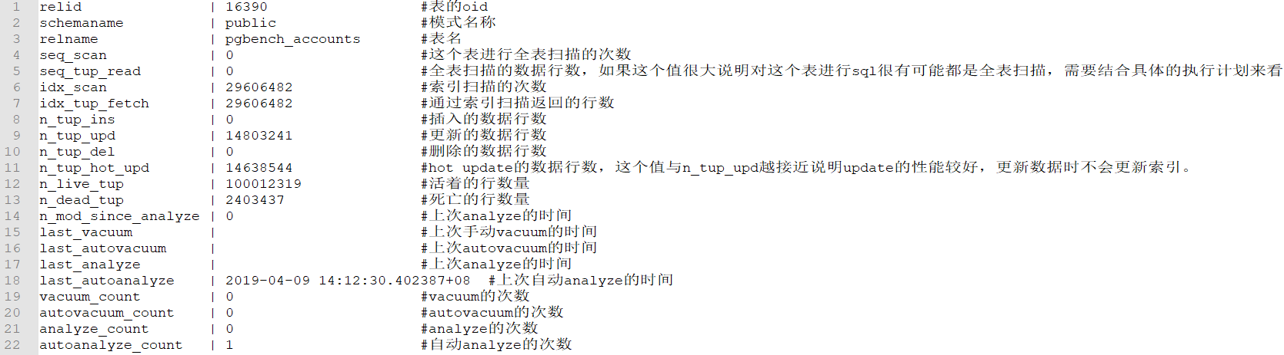

通过查询pg_stat_user_tables，可以基本清楚哪些表的全表扫描的次数较多，表中是插入还是更新，删除比较多。也可以了解当前表中垃圾数据的数量。

## pg_stat_user_indexes

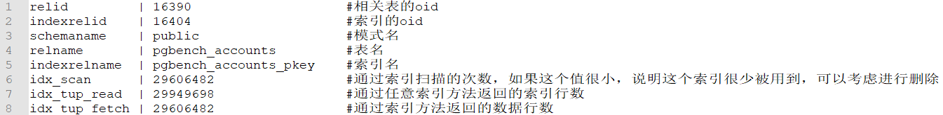

通过pg_stat_user_indexes可以知道当前数据库中哪些是用的很频繁的索引，哪些是无效索引，无效索引可以进行删除，可以减少磁盘空间的使用和提升insert，update，delete性能。

## pg_statio_user_tables

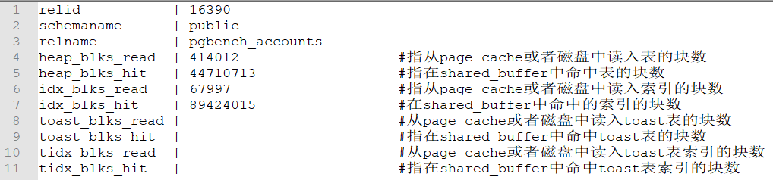

如果heap_blks_read，idx_blks_read很高说明shared_buffer较小，存在频繁需要从磁盘或者page cache读取到shared_buffer中。

## pg_stat_bgwriter

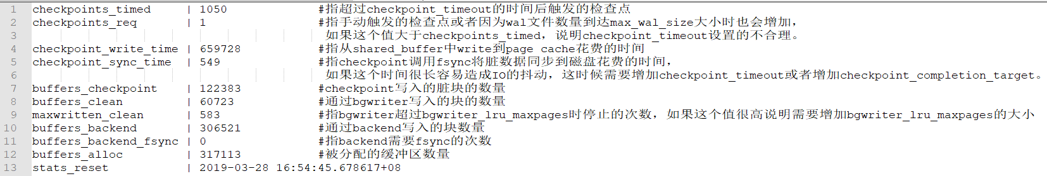

通过这个视图我们可以判断checkpoint以及max_wal_size的相关参数是否合理。也可以判断bgwriter相关的参数是否合理。

## pg_stat_replication

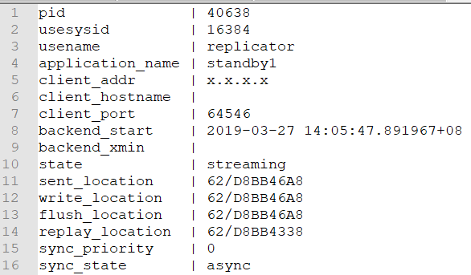

通过这个视图可以检查当前流复制的状态。检查备库replay的进度。

## pg_stat_statements

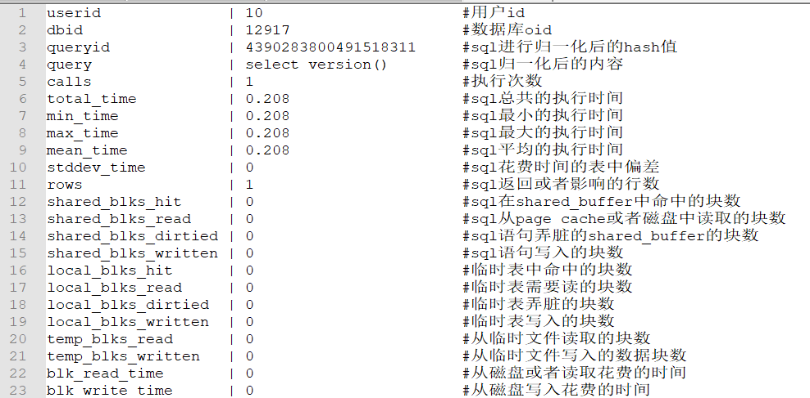

## pg_stat_replication

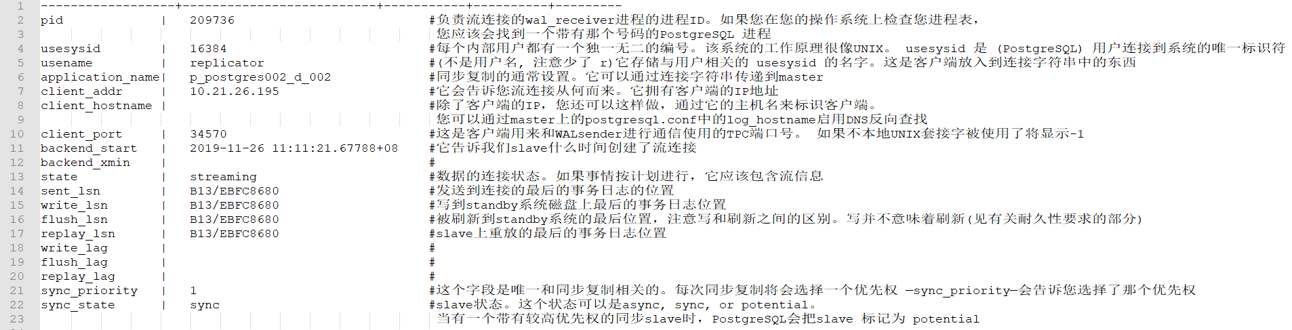

这个系统视图中每个记录只代表一个slave。因此，您看到谁处于连接状态，在做什么任务。pg_stat_replication也是检查slave是否处于连接状态的一个好方法。

# 监控相关插件

## pg_wait_sampling

可以收集数据库中产生的所有等待事件的信息，通过等待事件可以了解数据库的一些瓶颈，适合用于压测中发现性能瓶颈，平时也可以用于定位分析问题。

[https://github.com/postgrespro/pg_wait_sampling](https://yq.aliyun.com/go/articleRenderRedirect?url=https%3A%2F%2Fgithub.com%2Fpostgrespro%2Fpg_wait_sampling)

## pg_stat_kcache

可以获取些更底层的信息，从文件系统中读写花费的时间，cpu使用的时间等等，可以结合pg_stat_statements得到更多的信息。

[https://github.com/powa-team/pg_stat_kcache](https://yq.aliyun.com/go/articleRenderRedirect?url=https%3A%2F%2Fgithub.com%2Fpowa-team%2Fpg_stat_kcache)

## pgcenter

一个命令工具可以进行性能问题排查和分析，pgcenter结合pg内部的统计信息视图，方便快速查找和定位问题。

[https://github.com/lesovsky/pgcenter](https://yq.aliyun.com/go/articleRenderRedirect?url=https%3A%2F%2Fgithub.com%2Flesovsky%2Fpgcenter)

## pg_activity

监控pg系统状态的命令工具 [https://github.com/julmon/pg_activity](https://yq.aliyun.com/go/articleRenderRedirect?url=https%3A%2F%2Fgithub.com%2Fjulmon%2Fpg_activity)