Ι

autonomous car

Embedded Microprocessors Systems (ΗΡΥ 411)

Apostolopoulos Theodoros, Dialektakis George

## Introduction

During the second month of progress of our project our task was to extend the abilities of our “autonomous car” and to further familiarize ourselves with the technology we use. In the first milestone we programmed our robot to perform an evasion of an obstacle in front of it by simply detecting it and turning the other way. In this milestone we created a versatileprogram that allows the car to freely move through space and avoid any obstacles around itin the most non-trivial way.

## Materials

As far as the structural part of our car is concerned, there have been no changes since the previous time. However, afterthe tests we performed, we decided that we should remove the top gear that connects the ultrasonic sensor to the motor because it takes too much time to turn even a few degrees. For this part of the project this time was a minor delay that’s why we haven’t changed it yet, however the automatic parking system, which is our main goal, requires faster turning of the sensor and as a result a reconstruction of the structure is necessary.

*Important correction: we calculated the ratio of the gears that connect the wheels-rotation motor and that is 2/3 instead of 130 degrees of the motor for the maximum rotation of the front wheels.*

## Program

As far as the programming part of our project is concerned, unlike the first piece of code we presented, we benefited ourselves from the characteristics of Structured Programming and we set the foundations of our project in five major functions("**move**", "**rotateSonar**", "**rotatewheels**","**check**" and "**guide**"). The first three functions control the movement, the sensor-rotation and the wheels-rotation motors and they implement basic operations using classic NXT programming logic in combination with the measurements we made during the first milestone.

The most important functions were "**check**" and "**guide**" due to the fact that they are the ones responsible for the decision-making of the robot. After many changes in the way we interpreted our problem of avoiding the obstacles we decided that the sonar sensor would perform a check in a 90 degrees radius in front of it after its movement was interrupted by the detection of an object. If the sensor doesn't detect something within one meter in either side it moves towards the direction of the first available free space. Otherwise, if the whole area in front of it is blocked, it turns around. The “check” function is responsible to return the result of the sonar sensor when it reaches 45 and -45 degrees angle and according to its result the “guide” function guides the robot towards the correct direction according to a mapping system we created and that is listed below.

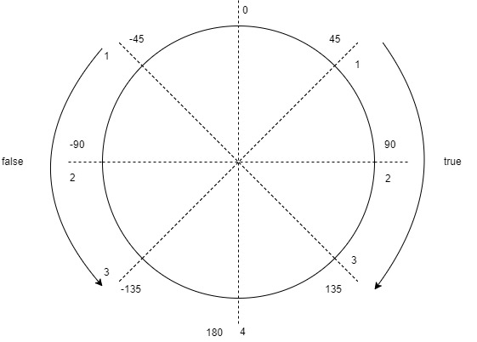

*Guidance model*

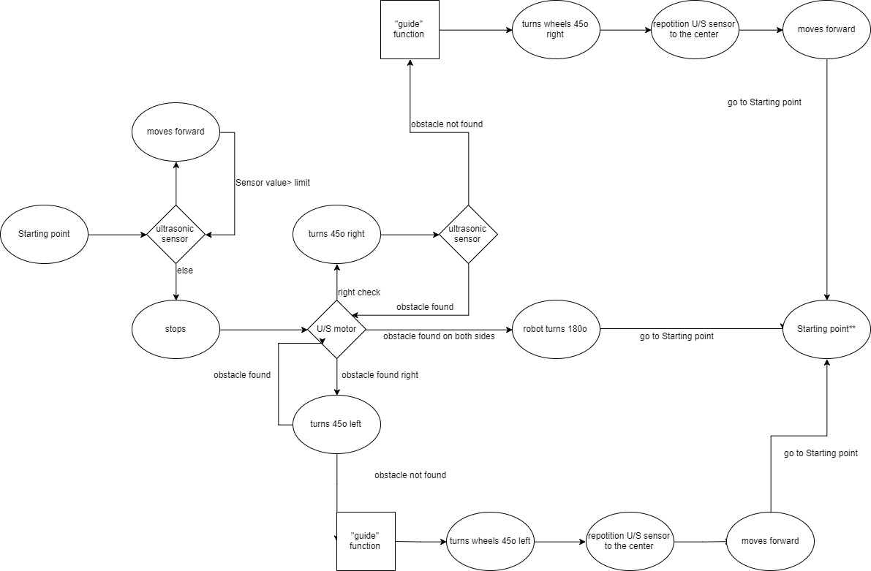

*Diagram of the main algorithm*

## Problems and Solutions

As it was mentioned and in the previous milestone, our basic problem was to get accommodated to the fact that we were writing code in a new environment with different rules. As a result, when we divided our code into separate functions many of them where fully functional when we executed them separately, however when they were followed by other functions everything was breaking down. Once again the cause of these malfunctions was the fact that at the end of some functions we didn’t restrict the running time of the motors. As a result, when we executed a function alone the motor wouldn’t continue working because the program ended thus adding difficulty to the debugging process. What is more, as far as hardware is concerned, we are still having trouble with the front wheels due to the fact that we are unable to align them using the Lego NXT technology and as a consequence we are having small misfires during our demos. Finally, before starting using rechargeable batteries, they used to be a huge problem as the NXT has high power consumption and typical batteries die after a few days of tests thus costing us a lot of money and causing unexpected misses of the sensor when battery was almost over.