Armstrong STMS MODBUS Register Mapping

25 August 2014

Prepared by:

3e Technologies International, Inc.

9715 Key West Avenue, Suite 500, Rockville, MD 20850

Tel 800-449-3384 Fax 301-670-6989

www.Ultra-3eTI.com

Revision History

|  |  |  |  |
| --- | --- | --- | --- |
| Date | Revision | Description | Author(S) |
| 18 August 2014 | -- | Initial Release | M. Zbarskiy |
| 25 August 2014 | A | Updated after review | M. Zbarskiy |
|  |  |  |  |

Table of Contents

1. Overview 1

2. 543ST1 MODBUS Register Mapping 3

3. 543A MODBUS Register Mapping 4

4. Published Item MODBUS Register Configuration 5

5. Gateway MCS MODBUS Register Configuration 6

5.1. Manual MODBUS Register Configuration 7

5.2. File MODBUS Register Configuration 9

List of Figures

Figure 1: STMS System Block Diagram 1

Figure 2: Manual Gateway MODBUS Register Configuration 7

Figure 3: Niagara MODBUS Registers 8

Figure 4: Gateway MODBUS Configuration File 9

List of Tables

Table 1: Niagara to Gateway MODBUS Register Mapping 2

Table 2: 543ST1 Input Registers 3

Table 3: 543A Input Registers 4

# Overview



Figure 1: STMS System Block Diagram

This document describes 545A Gateway MODBUS configuration for STMS system, so the MODBUS Client (Niagara) can retrieve published data. Only the published data is presented in MODBUS Input registers. The Device status, control, and alerts are not available.

There are two Device configuration types available on iMesh network:

543ST1 Device – monitoring Armstrong Steam Trap Sensor

543A Device – may be present in network to support multi-hop operation

|  |  |  |  |
| --- | --- | --- | --- |
| iMesh  Device Number | Niagara  Device Starting MODBUS Register Address | Gateway  Device Starting MODBUS Register Offset |  |
| 1 | 30001 | 0 |  |
| 2 | 30021 | 20 |  |
| 3 | 30041 | 40 |  |
| … | … | … |  |
| N | 30001 + N * 20 | N * 20 |  |

Table 1: Niagara to Gateway MODBUS Register Mapping

# 543ST1 MODBUS Register Mapping

The 543ST1 Device publishes five items and requires 15 MODBUS 16-bit Input registers, three registers per published item; twenty registers are reserved for Device

|  |  |  |  |  |
| --- | --- | --- | --- | --- |
| Published Item | Register Offset | Number of Registers | Data Format | Object ID |
| Battery Voltage in volts | 0 | 1 Field Status Register + 2 Data Registers | Float32 | 20 |
| Ambient Temperature in Celsius | 3 | 1 Field Status Register + 2 Data Registers | Float32 | 21 |
| Trap Status:  1 – OK  2 – Cold  3 – Open | 6 | 1 Field Status Register + 2 Data Registers | Unsigned Int32 | 22 |
| Pipe Temperature in Celsius | 9 | 1 Field Status Register + 2 Data Registers | Signed Int32 | 23 |
| Battery Left days | 12 | 1 Field Status Register + 2 Data Registers | Unsigned Int32 | 24 |

Table 2: 543ST1 Input Registers

# 543A MODBUS Register Mapping

The 543A Device publishes two items and requires 6 MODBUS 16-bit Input registers, three registers per published item; twenty registers are reserved for Device

|  |  |  |  |  |
| --- | --- | --- | --- | --- |
| Published Item | Register Offset | Number of Registers | Data Format | Object ID |
| Battery Voltage in volts | 0 | 1 Field Status Register + 2 Data Registers | Float32 | 20 |
| Ambient Temperature in Celsius | 3 | 1 Field Status Register + 2 Data Registers | Float32 | 21 |

Table 3: 543A Input Registers

# Published Item MODBUS Register Configuration

Each published Item shall be presented to MODBUS Registers as following:

< Item Register Offset>,<Number of 16-bit registers>,<Device EUI64>,<Application Process ID>,<Object ID>,<Attribute ID>,<Index 1>,<Index 2>,<Method ID>,<with Status Byte> where:

* <Item Register Offset> - MODBUS register offset
* <Number of 16-bit registers> - Always 3
* <Device EUI64> - Entered as 16-hexdigits string, e.g. 0022FF0000022D94
* <Application Process ID> - Always 2
* <Object ID> - See and
* <Attribute ID> - Always 1
* <Index 1> - Always 0
* <Index 2> - Always 0
* < Method ID> - Always 0
* < with Status Byte> - Always 1

# Gateway MCS MODBUS Register Configuration

Configuration of MODBUS registers can be done from Gateway MCS ‘MODBUS’ Web page.

# Manual MODBUS Register Configuration

User can configure each published item individually as shown on the . The example shows configuration settings for:

Device with EUI64 – 0022:FF00:0002:2D94

Published Item Object ID – 24, i.e. Battery Left in days

The published data will be placed in three (3) 16-bit registers, i.e. Gateway Registers with offsets – 12, 13, and 14 and available in Niagara registers with addresses 30013, 30014, and 30015 accordingly as seen on

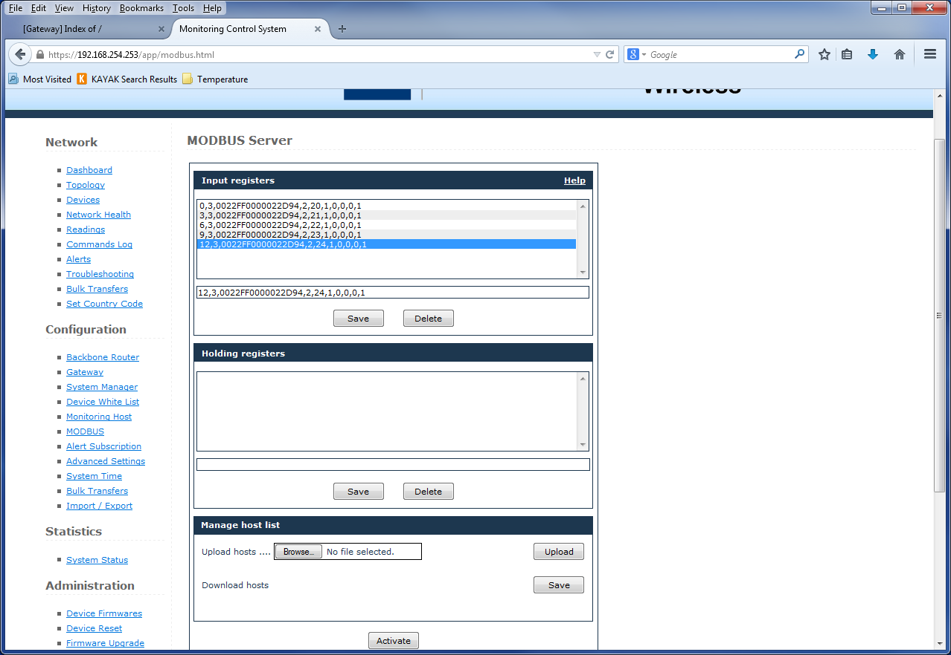

Figure 2: Manual Gateway MODBUS Register Configuration

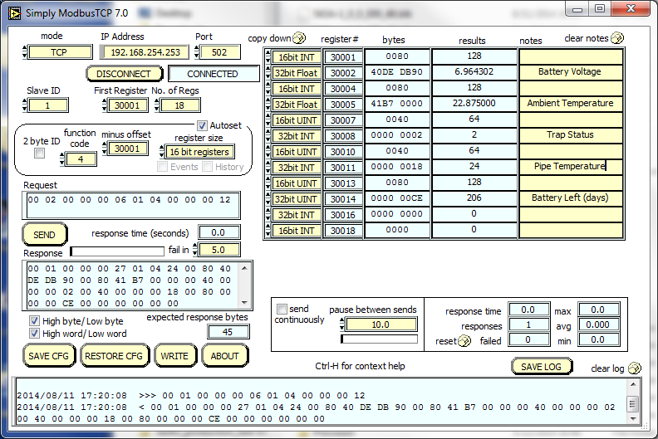

Figure 3: Niagara MODBUS Registers

# File MODBUS Register Configuration

User can save entered MODBUS configuration in the file, edit the file using text editor and upload modified MODBUS configuration back to the Gateway. The MODBUS Gateway configuration file format shown on , after User added configuration for 543A Device 0022:FF00:0002:2D98

The added Device published data available on Niagara registers with starting address 30021

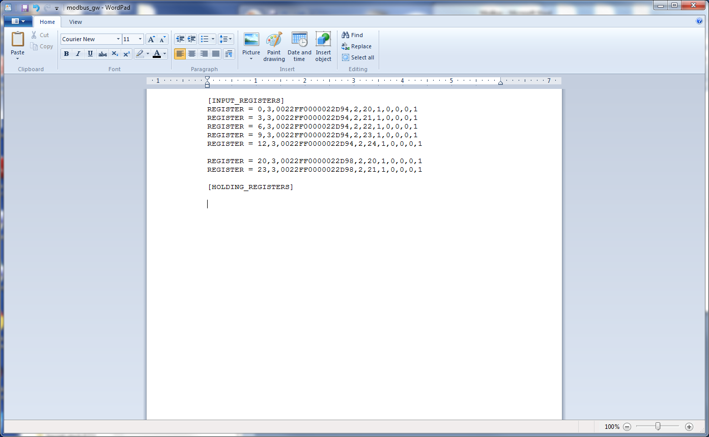

Figure 4: Gateway MODBUS Configuration File