Enrm summaries after increasing ngen
S1: D = 0.05 ; sigma = 200 m ; L0 = 2
S2: D = 0.0033 ; sigma = 3000 m ; L0 = 0.133
GA type | Values |  | En | Er | Em | En2
GA4 | Strata 1 | Strata 1 | 50 | 50 | 23 | 11
GA4 | Strata 1 | Strata 2 | 80 | 21 | 18 | 15
GA4 | Strata 2 | Strata 1 | 59 | 42 | 11 | 7
GA4 | Strata 2 | Strata 2 | 50 | 50 | 48 | 24
GA4 | Avg | Strata 1 | 66 | 35 | 1 | 1
GA4 | Avg | Strata 2 | 79 | 21 | 18 | 15
GA4 | Both | Strata 1 | 50 | 50 | 22 | 12
GA4 | Both | Strata 2 | 50 | 50 | 48 | 24
GA4 | Both (Max = T) | Strata 1 | 50 | 50 | 22 | 13
GA4 | Both (Max = T) | Strata 2 | 50 | 50 | 48 | 24
GA5 | Strata 1 | Strata 1 | 41 | 59 | 36 | 18
GA5 | Strata 1 | Strata 2 | 79 | 22 | 19 | 16
GA5 | Strata 2 | Strata 1 | 43 | 58 | 32 | 17
GA5 | Strata 2 | Strata 2 | 54 | 46 | 44 | 25
GA5 | Avg | Strata 1 | 64 | 36 | 3 | 2
GA5 | Avg | Strata 2 | 72 | 29 | 26 | 20
GA5 | Both | Strata 1 | 39 | 61 | 38 | 19
GA5 | Both | Strata 2 | 50 | 50 | 48 | 24
GA5 | Both (Max = T) | Strata 1 | 40 | 61 | 38 | 18
GA5 | Both (Max = T) | Strata 2 | 75 | 26 | 23 | 18

Realisations of the GA designs
GA4 and GA5 using strata 1 values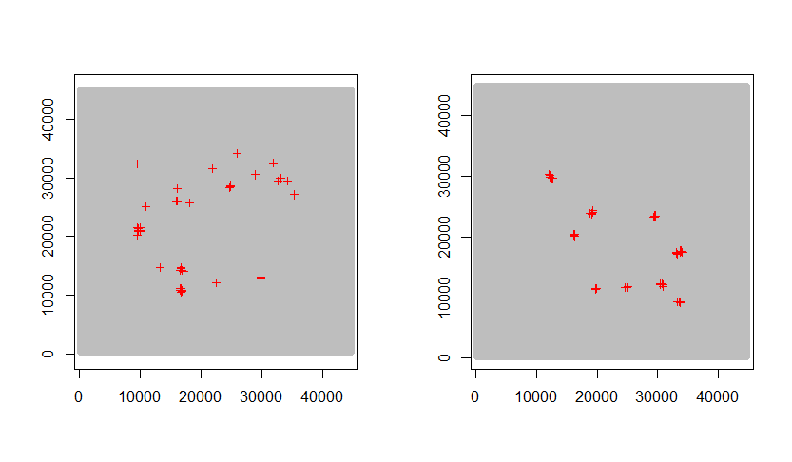
GA4 and GA5 using strata 2 values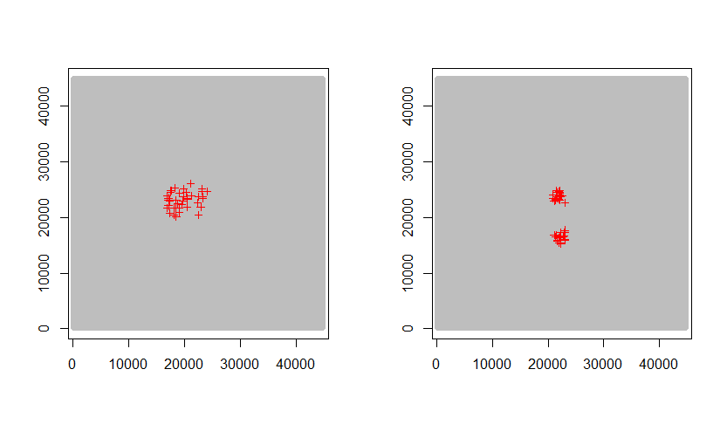

GA4 and GA5 using avg strata values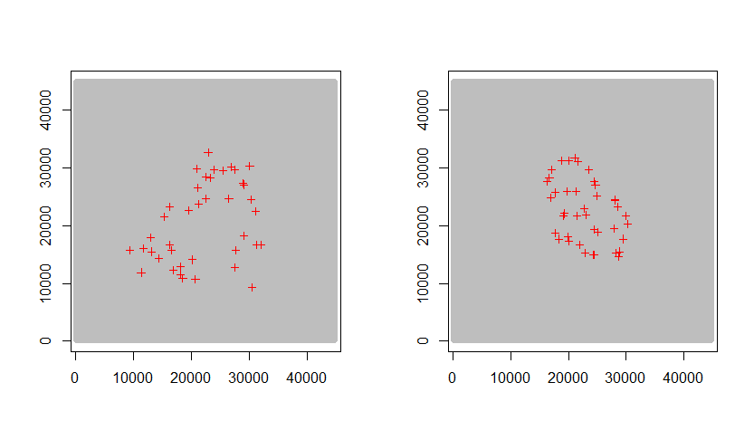
GA4 and GA5 using both sets of values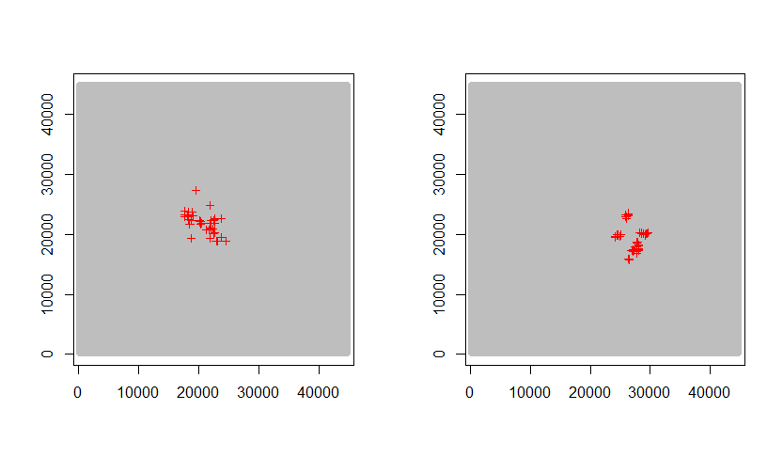

GA4 and GA45 using both sets of values and max min