GA designs
S1: D = 0.05 ; sigma = 200 m ; L0 = 2
S2: D = 0.0033 ; sigma = 3000 m ; L0 = 0.133
GA 4 algorithm (min(n,r))
Values |  | En | Er | Em
Strata 1 | Strata 1 | 55 | 46 | 16
Strata 1 | Strata 2 | 81 | 19 | 16
Strata 2 | Strata 1 | 61 | 40 | 7
Strata 2 | Strata 2 | 50 | 50 | 48
Avg Strata | Strata 1 | 65 | 35 | 1
Avg Strata | Strata 2 | 79 | 21 | 19
Both Strata | Strata 1 | 56 | 45 | 14
Both Strata | Strata 2 | 54 | 46 | 44
Both Strata (max) | Strata 1 | 55 | 45 | 15
Both Strata (max) | Strata 2 | 55 | 46 | 44

GA 5 algorithm (E(# caught at 2 or more))
Values |  | En | Er | Em
Strata 1 | Strata 1 | 58 | 42 | 11
Strata 1 | Strata 2 | 84 | 16 | 14
Strata 2 | Strata 1 | 61 | 39 | 7
Strata 2 | Strata 2 | 56 | 45 | 43
Avg Strata | Strata 1 | 65 | 35 | 1.6
Avg Strata | Strata 2 | 72 | 29 | 26
Both Strata | Strata 1 | 57 | 44 | 14
Both Strata | Strata 2 | 57 | 43 | 41
Both Strata (max) | Strata 1 | 57 | 43 | 13
Both Strata (max) | Strata 2 | 82 | 19 | 16

Realisations of the GA designs
GA4 and GA5 using strata 1 values
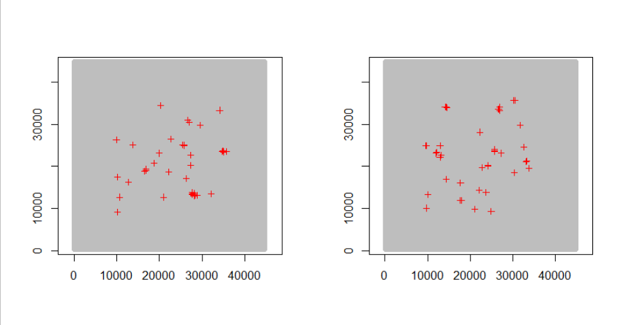
GA4 and GA5 using strata 2 values

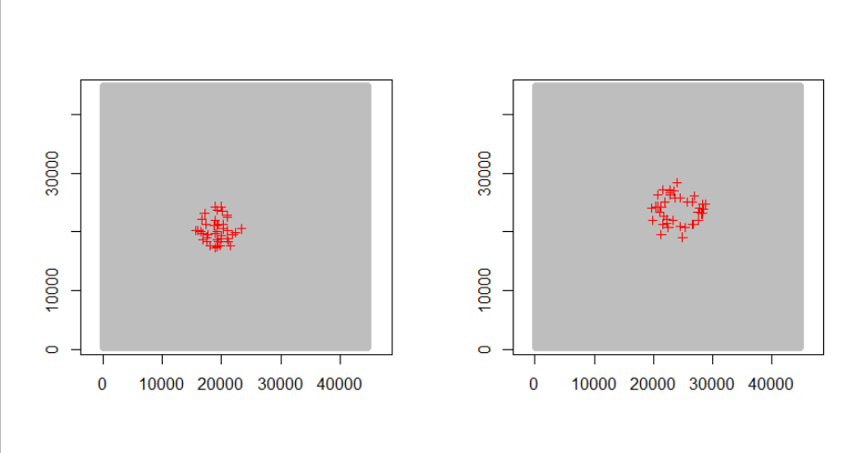

GA4 and GA5 using avg strata values
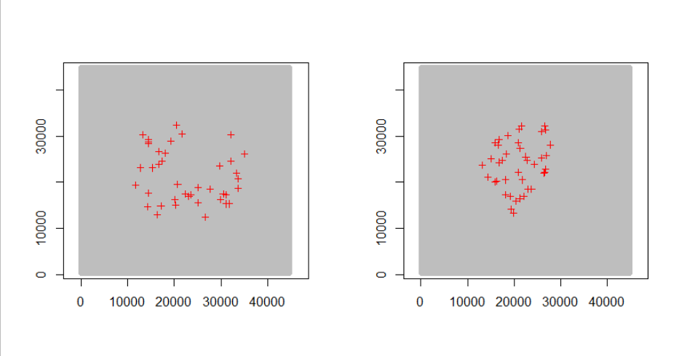
GA4 and GA5 using both sets of values
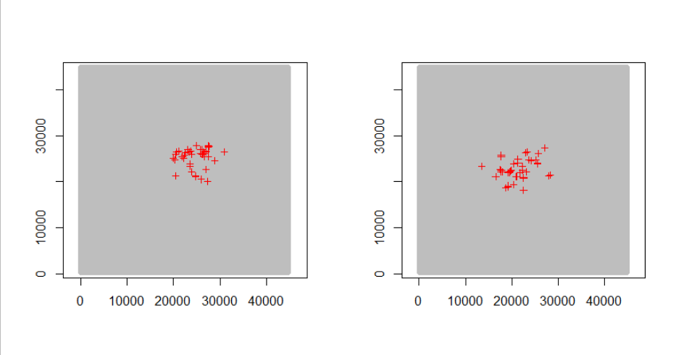
GA4 and GA45 using both sets of values and max min
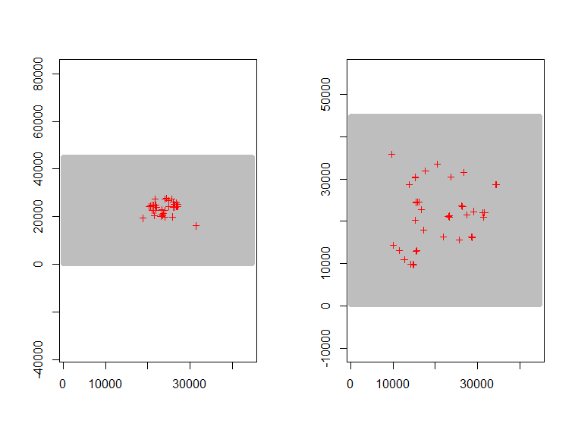
And now two realisations with higher values for ngen, note the first column is GA4 and the 2nd GA5. These are using strata 1 values:
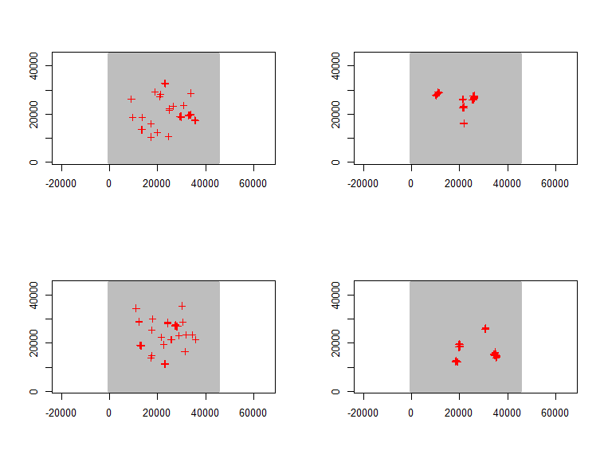
And using strata 2 values:
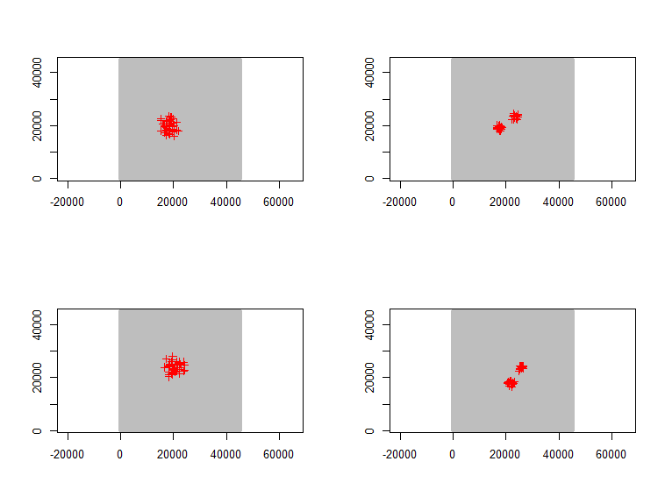
And Enrm values for the 1st of these realisations:
GA type | Values |  | En | Er | Em
GA4 | Strata 1 | Strata 1 | 50 | 50 | 23
GA4 | Strata 1 | Strata 2 | 78 | 23 | 20
GA4 | Strata 2 | Strata 1 | 61 | 39 | 6
GA4 | Strata 2 | Strata 2 | 50 | 50 | 48
GA5 | Strata 1 | Strata 1 | 38 | 62 | 40
GA5 | Strata 1 | Strata 2 | 66 | 35 | 33
GA5 | Strata 2 | Strata 1 | 44 | 57 | 31
GA5 | Strata 2 | Strata 2 | 54 | 46 | 44

