Sim results from 100 reps for the 15 fold diff scen
S1: D = 0.05 ; sigma = 200 m ; L0 = 2
S2: D = 0.0033 ; sigma = 3000 m ; L0 = 0.133
Grid design with 800 m spacing
Strata | D |  |  | L0 |  |  | Sigma
Strata | RB | RSE | RSE (SE) | RB | RSE | RSE (SE) | RB | RSE | RSE (SE) | Excl
S1 | 10.4% | 0.27 | 0.71 | 2.8% | 0.19 | 0.15 | -2.7% | 0.12 | 0.21 | 2
S2 | 6.6% | 0.50 | 0.48 | 4.2% | 0.19 | 0.15 | 8.9% | 0.33 | 0.90 | 15

GA Designs
GA4
Values |  | D |  |  | L0 |  |  | Sigma |  |  | excl
 |  | RB | RSE | RSE (SE) | RB | RSE | RSE (SE) | RB | RSE | RSE (SE)
S1 | S1 | % |  |  | % |  |  | %
S1 | S2 | % |  |  | % |  |  | %
S2 | S1
S2 | S2
Avg | S1
Avg | S2
Both | S1
Both | S2
Both (Max) | S1
Both (Max) | S2

GA5
Values |  | D |  |  | L0 |  |  | Sigma |  |  | excl
 |  | RB | RSE | RSE (SE) | RB | RSE | RSE (SE) | RB | RSE | RSE (SE)
S1 | S1 | 7.7% | 0.30 | 0.26 | 2.6% | 0.16 | 0.14 | -1.0% | 0.17 | 0.42 | 0
S1 | S2 | 3.8% | 0.27 | 0.44 | 5.2% | 0.22 | 0.16 | -1.0% | 0.15 | 0.22 | 0
S2 | S1 | 1.0% | 0.17 | 0.14 | -1.3% | 0.20 | 0.20 | 0.8% | 0.08 | 0.14 | 0
S2 | S2 | 4.3% | 0.30 | 0.26 | -3.7% | 0.20 | 0.,16 | 3.8% | 0.16 | 0.31 | 0
Avg | S1 | 57.3% | 0.62 | 0.82 | 2.7% | 0.18 | 0.17 | -11.3% | 0.27 | 0.45 | 9
Avg | S2 | 1.6% | 0.20 | 0.24 | -2.6% | 0.28 | 0.23 | 4.4% | 0.15 | 0.39 | 0
Both | S1 | 2.2% | 0.23 | 0.19 | 5.6% | 0.18 | 0.19 | -1.4% | 0.12 | 0.24 | 0
Both | S2 | 3.5 | 0.31 | 0.28 | 0.8% | 0.21 | 0.17 | 1.6% | 0.19 | 0.46 | 0
Both (Max) | S1 | 4.6% | 0.24 | 0.27 | -0.6% | 0.23 | 0.21 | -0.4% | 0.15 | 0.41 | 0
Both (Max) | S2 | 4.6% | 0.34 | 0.85 | 3.2% | 0.22 | 0.16 | 0.7% | 0.16 | 0.24 | 0

Realisations of the GA designs
GA4 and GA5 using strata 1 values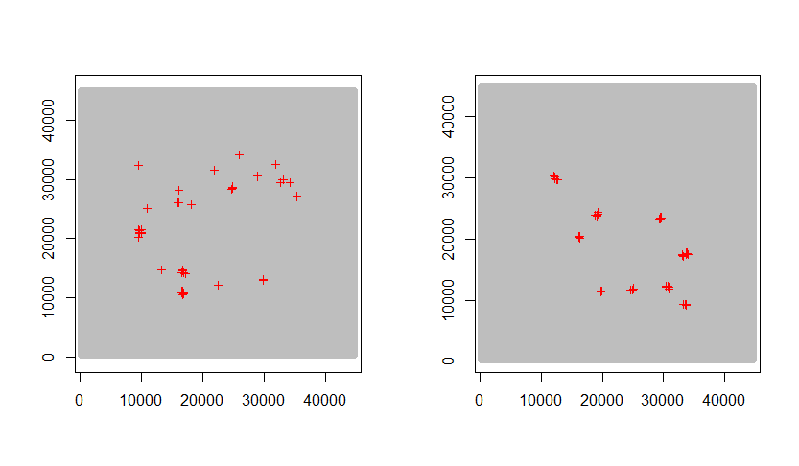
GA4 and GA5 using strata 2 values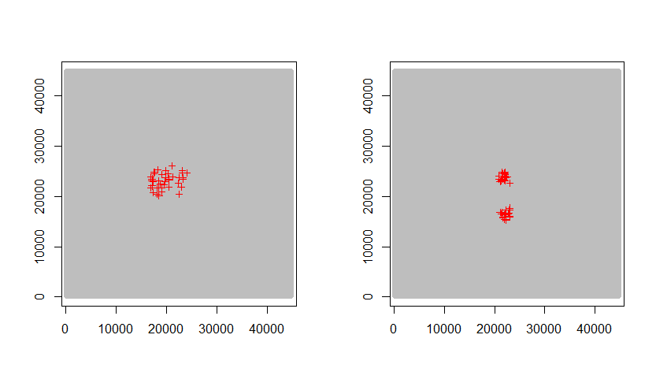

GA4 and GA5 using avg strata values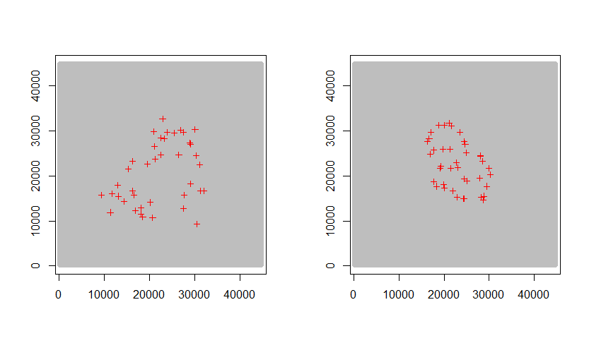
GA4 and GA5 using both sets of values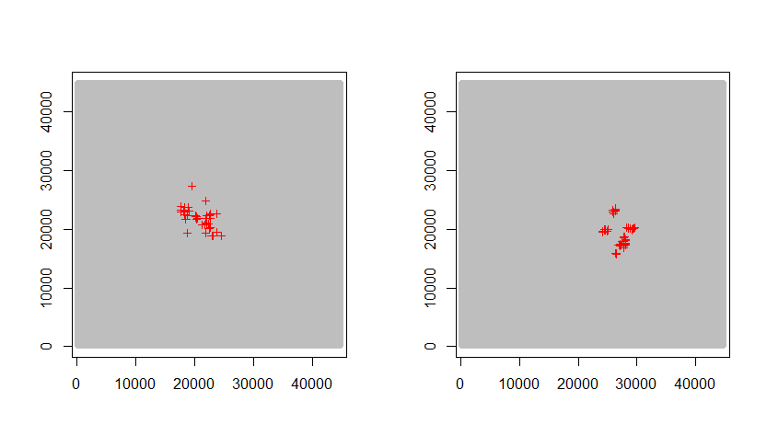

GA4 and GA45 using both sets of values and max min