Homework1

Gina Ditaranto

library("jpeg")  
library("patchwork")  
library("tidyverse")

## ── Attaching packages ─────────────────────────────────────── tidyverse 1.3.1 ──

## ✓ ggplot2 3.3.5 ✓ purrr 0.3.4  
## ✓ tibble 3.1.2 ✓ dplyr 1.0.7  
## ✓ tidyr 1.1.3 ✓ stringr 1.4.0  
## ✓ readr 1.4.0 ✓ forcats 0.5.1

## ── Conflicts ────────────────────────────────────────── tidyverse_conflicts() ──  
## x dplyr::filter() masks stats::filter()  
## x dplyr::lag() masks stats::lag()

penguin_gd <- read.csv('w02-penguins.csv')

head(penguin_gd)

## X species island bill_length_mm bill_depth_mm flipper_length_mm  
## 1 1 Adelie Torgersen 39.1 18.7 181  
## 2 2 Adelie Torgersen 39.5 17.4 186  
## 3 3 Adelie Torgersen 40.3 18.0 195  
## 4 4 Adelie Torgersen NA NA NA  
## 5 5 Adelie Torgersen 36.7 19.3 193  
## 6 6 Adelie Torgersen 39.3 20.6 190  
## body_mass_g sex year  
## 1 3750 male 2007  
## 2 3800 female 2007  
## 3 3250 female 2007  
## 4 NA <NA> 2007  
## 5 3450 female 2007  
## 6 3650 male 2007

peng_plot_gd <- ggplot(data = penguin_gd)+  
 geom_point(mapping = aes(bill_length_mm, flipper_length_mm,color=species,size=body_mass_g))  
peng_plot_gd

## Warning: Removed 2 rows containing missing values (geom_point).

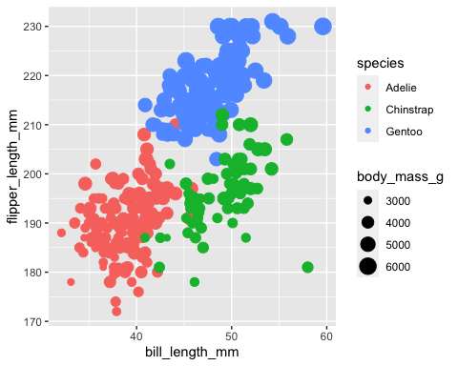

ppl_gd <- peng_plot_gd+labs(x="Bill Length",y="Flipper Length",  
 title = "Bill Length VS Flipper Length by mass and species")  
ppl_gd

## Warning: Removed 2 rows containing missing values (geom_point).

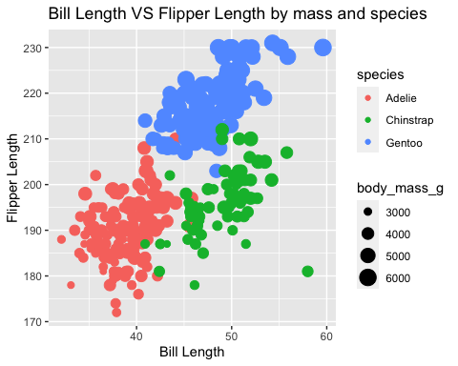

download.file("https://github.com/gditaranto/STA553/blob/main/30TB-PENGUINS04-mediumSquareAt3X.jpg?raw=true",  
 "penguin.jpg",  
 mode = "wb")  
  
my_image_pen<- readJPEG("penguin.jpg")   
raster.penguine <- as.raster(my_image_pen)

img_graph_gd <- ppl_gd +   
 inset_element(p = raster.penguine,  
 left = 0.01,  
 bottom = 0.65,  
 right = 0.20,  
 top = 0.95)   
img_graph_gd

## Warning: Removed 2 rows containing missing values (geom_point).

