ATT – My Sales For This Month

Abstract –

This web application display data forecast of sales of this month. The application consists of main page which display the table of data at the bottom div element and a radio button controller to control the table column display on the top div element. It uses AJAX, allows web pages to be updated asynchronously by exchanging small amounts of data with the server behind the scenes.

Description –

* Used HTML 5 for controllers
* Used CSS 3 for style sheet – Added rounded corners for My Sales For This Month header, CSS3 gradients for header.
* Created two div elements – one for top radio button controller, and bottom for table data display. Table data overflow will provide scroll bar and scrolling will move bottom table content not the top radio button div element.
* Click on radio button Prior will eliminate ‘Last 7 Days Var Arrows’ column from the table. Click on Current button will bring back this column.
* Create an XMLHttpRequest object for AJAX communication.
* Ajax, open(*method,url,async*) will send request to server, reads sales.json file and get response as responseText. Data is parsed to JSON object, tokenized, formatted and displayed on the HTML table.
* Column ‘Last 7 Days Var Arrows’ color value will determine the image display on first ‘KPI’ column and background color of % Attain column.
* Added more JSON data in order to display vertical scroll bar on HTML table.
* Used tomcat server to run the application – URL used for AJAX call is <http://localhost:8080/att/json/sales.json>

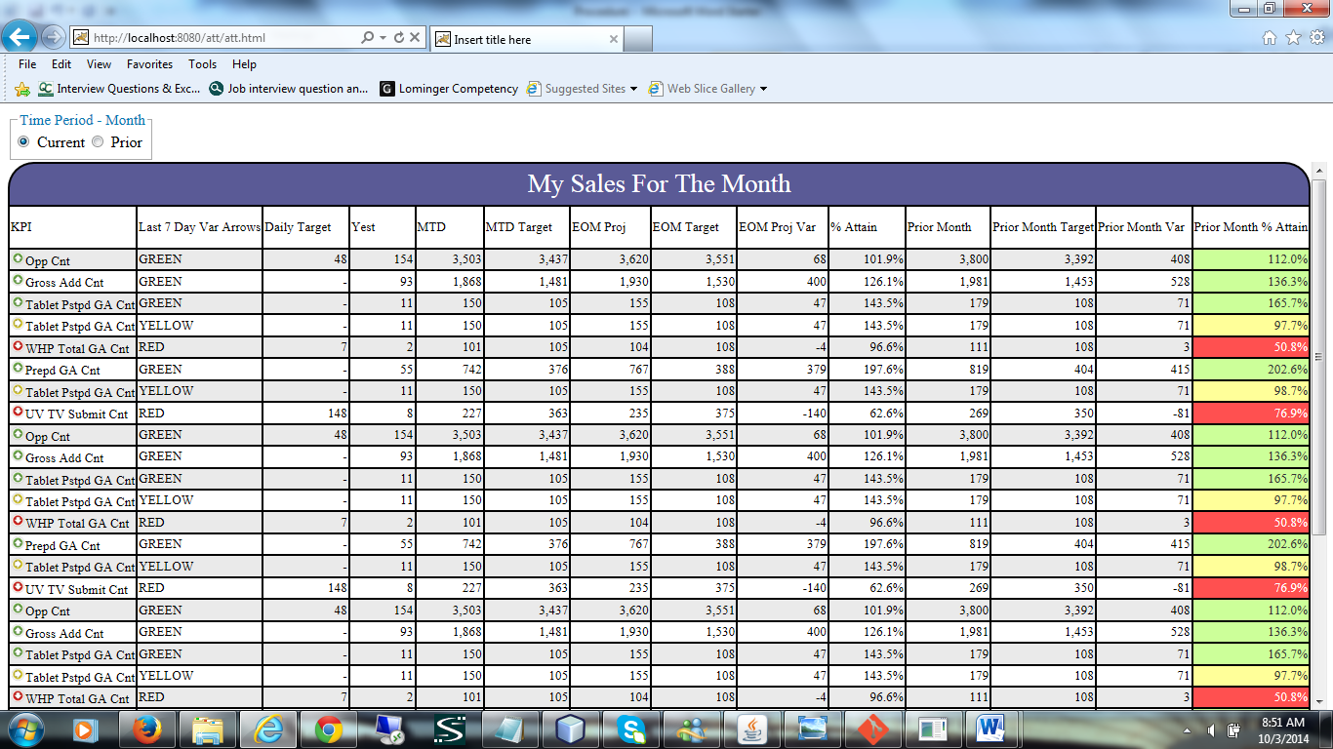

Figure 1 – On load display (default)

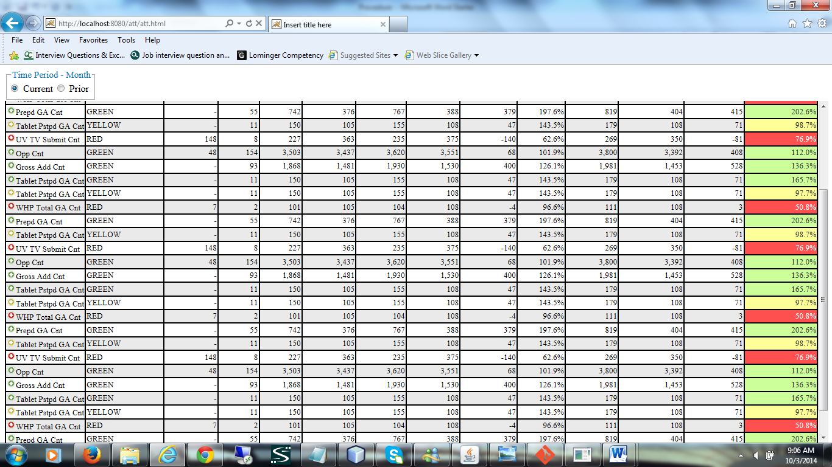

Figure 2 – On scroll bar action

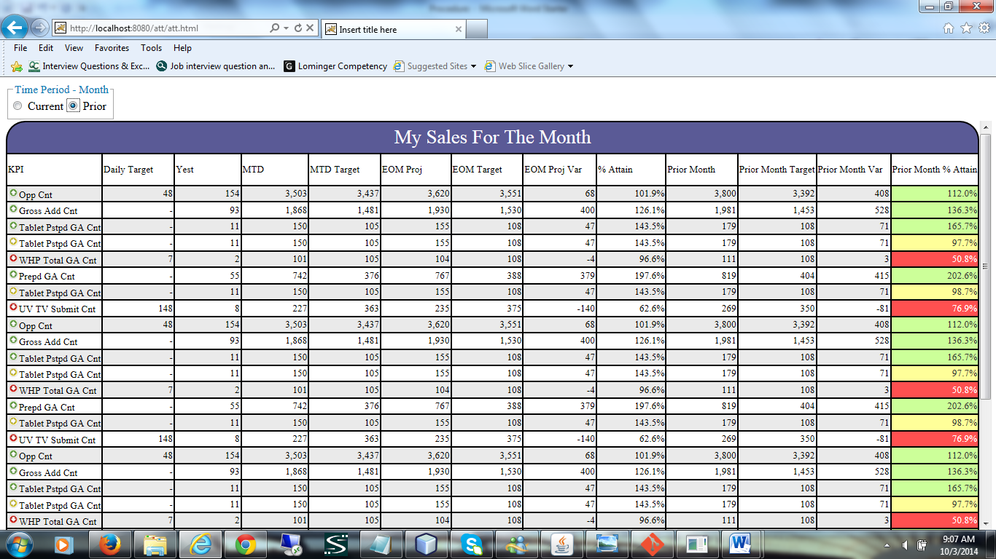

Figure 3 – Click on Prior radio button hides ‘Last 7 Days Var Arrows’ column