**HW 2 STAT-GEN**

Name: ____________________________ (Due Oct 8th in D2L)

**1) Effect of allele frequency in genetic and additive variance**

Using the formulae derived in class (also available in Ch 8 of the book) create plots with total genetic variance and additive variance (vertical axis) versus allele frequency (from 0.01 to 0.99, horizontal axis). Produce one plot for each of the following scenarios (each plot should have two curves, one for total genetic variance and one for additive variance):

a d

1.0 0.0

1.0 0.5

1.0 1.0

Summarize your conclusions in no more than three sentences.

**2) Linkage Disequilibrium**

Consider two loci (A,B) with two possible alleles at each loci (A/a, B/b). The frequency of allele A is 0.2, the frequency of allele B is 0.3, and the frequency of the AB gamete is 0.1.

**2.1) Using this information complete the table below.**

|  |  |  |
| --- | --- | --- |
| Gamete | **Expected Frequency**  **(under LE)** | **Observed Frequency** |
| AB |  |  |
| Ab |  |  |
| aB |  |  |
| ab |  |  |

**2.2) Compute, D, D’ and r-squared**

**2.3) Conduct a chi-square test to test H0: locus A and B are in linkage equilibrium, versus Ha: the two loci are in linkage disequilibrium** (report the chi-square statistics, the test-degree-of-freedom, and the p-value, assume n=100)

**2.4) Assuming random mating, computed the expected frequency, of each of the genotypes under HWE and Linkage Equilibrium**

|  |  |  |  |  |  |
| --- | --- | --- | --- | --- | --- |
| **Genotype** | **Expected Frequency** | **Genotype** | **Expected Frequency** | **Genotype** | **Expected Frequency** |
| AA BB |  | Aa BB |  | aa BB |  |
| AA Bb |  | Aa Bb |  | aa Bb |  |
| AA bb |  | Aa bb |  | aa bb |  |

**3) Compute ancestry and inbreeding for the following cases**

**3.1) First-cousins**



Coancestry(X,Y): __________

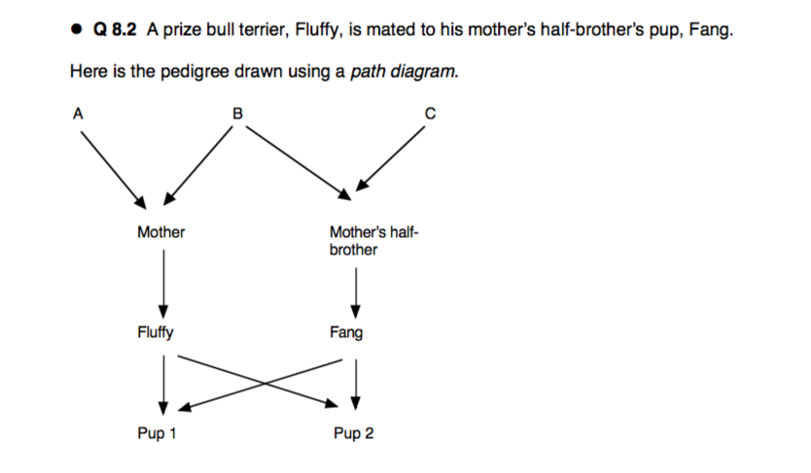

Inbreeding Pup 1: __________

Inbreeding Pup 2: __________ Coancestry(Pup1,Pup2): _________