AI기초와활용

2021315385

이건

**실습 1 : http://tensorflow-mnist.herokuapp.com/**

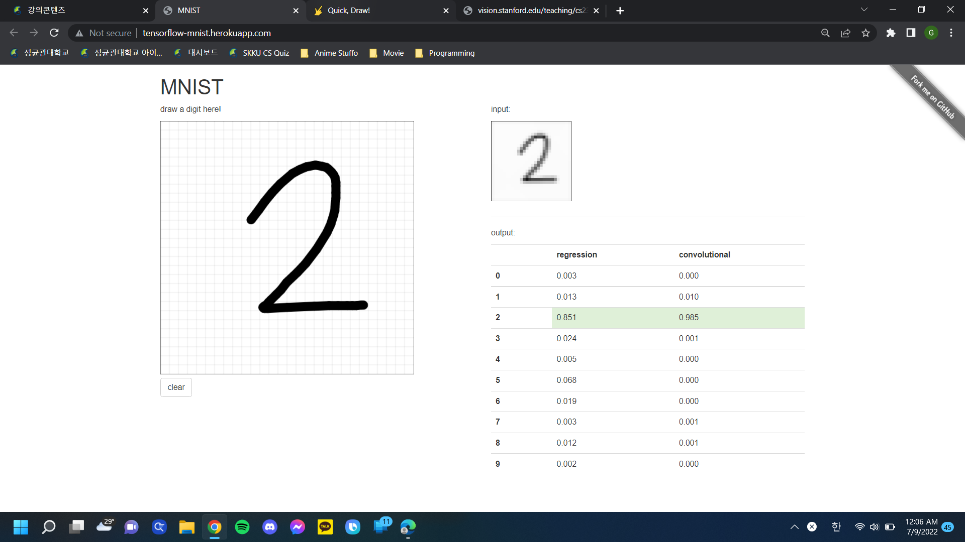

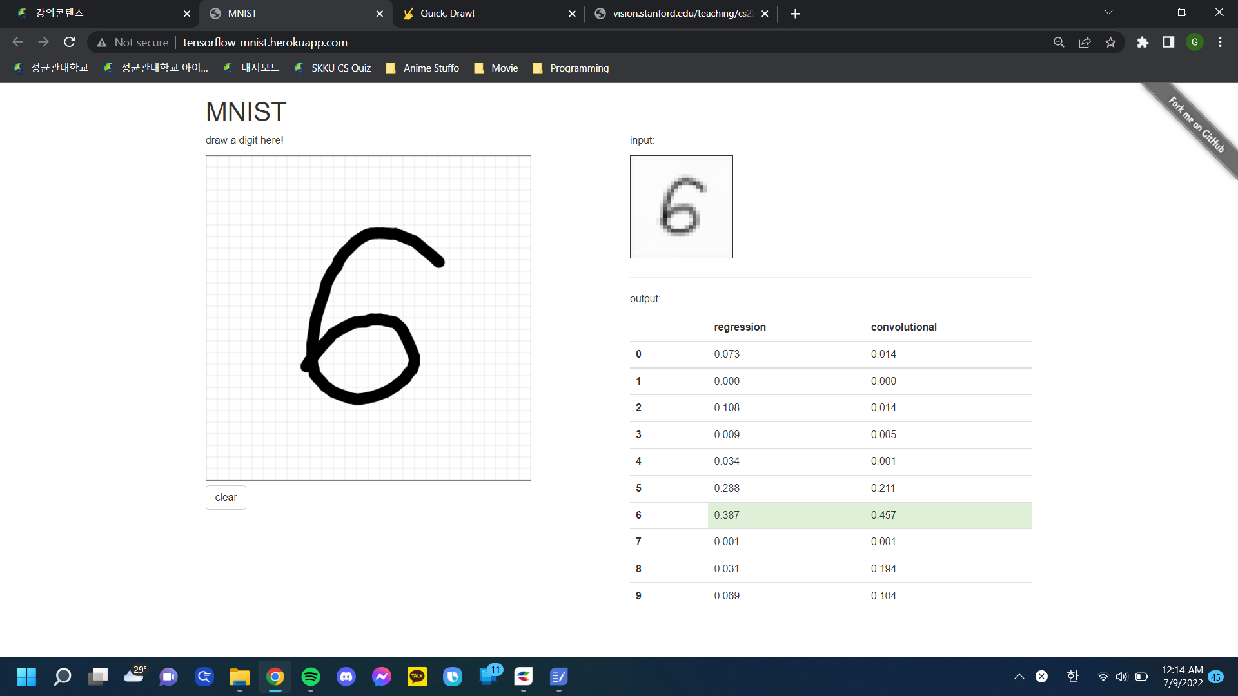

**실습 3 : https://quickdraw.withgoogle.com/?locale=ko**

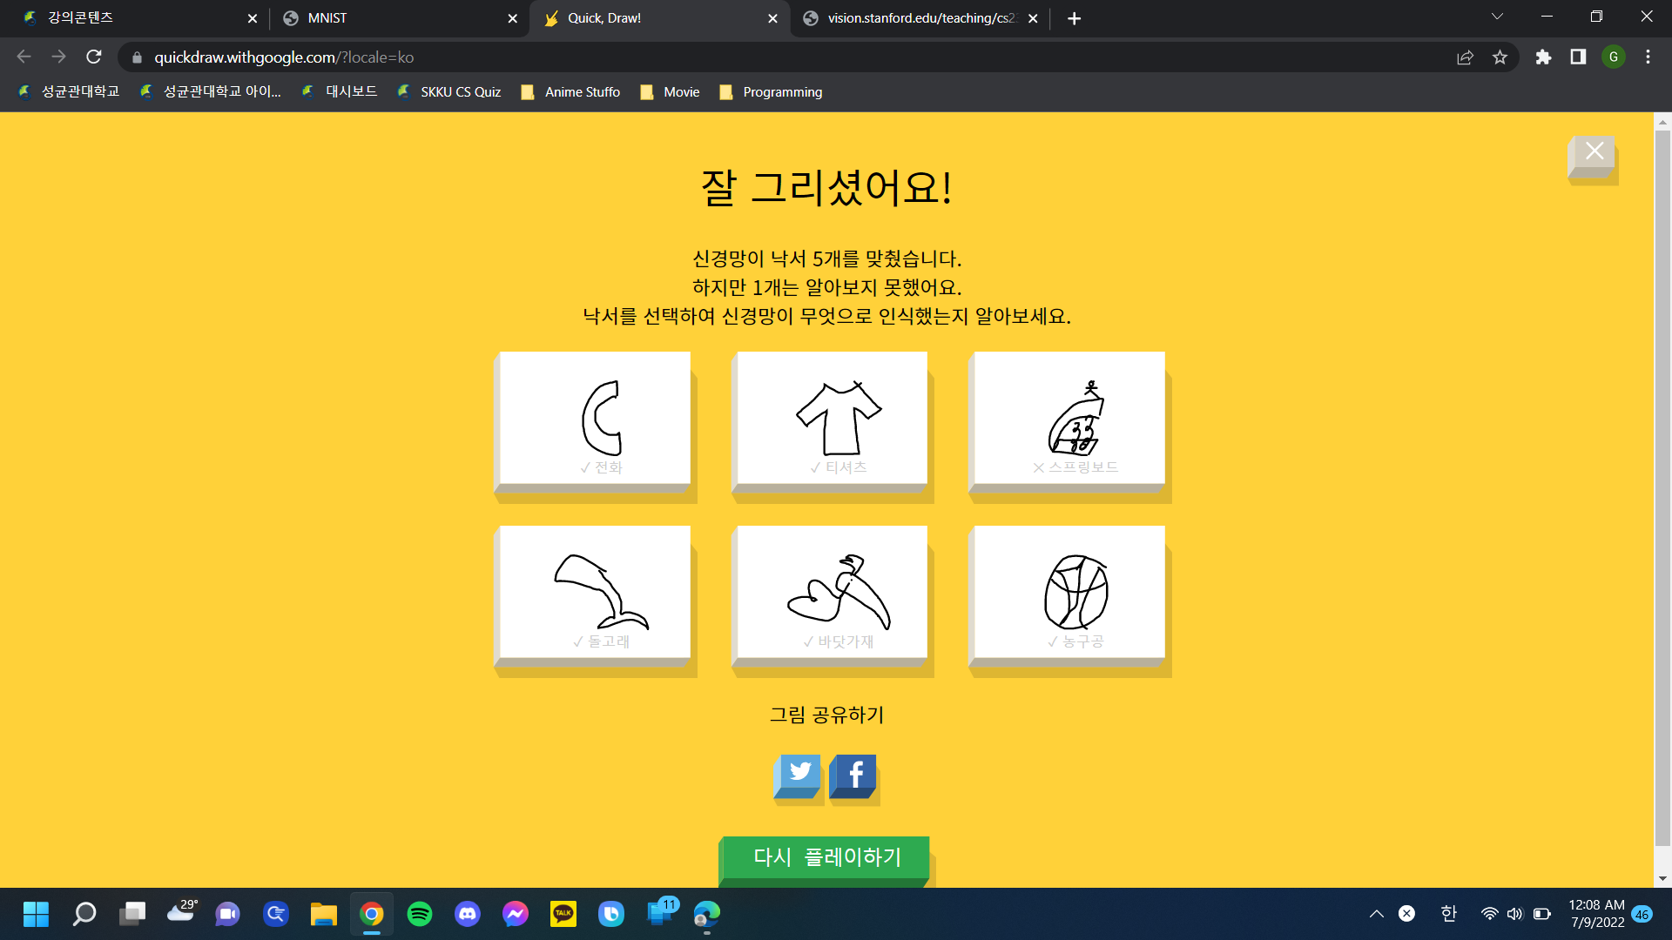

**실습 9 : http://vision.stanford.edu/teaching/cs231n-demos/knn/**

