Concept Sketch: Digital Audio Workspace

| Greg De La Torre  NMSU  Las Cruces, United States  gdlt5@nmsu.edu | 2nd Author Name  Affiliation  City, Country  e-mail address | 3rd Author Name  Affiliation  City, Country  e-mail address |
| --- | --- | --- |

# ABSTRACT

Permission to make digital/hard copy of part or all of this work for personal or classroom use is granted without fee provided that copies are not made or distributed for profit or commercial advantage, the copyright notice, the title of the publication and its date appear, and notice is given that copying is by permission of ACM. To copy otherwise, to republish, to post on servers, or to redistribute to lists requires prior specific permission and/or a fee.

UPDATED—27 February 2019. This sample paper describes the formatting requirements for SIGCHI conference proceedings, and offers recommendations on writing for the worldwide SIGCHI readership. Please review this document even if you have submitted to SIGCHI conferences before, as some format details have changed relative to previous years. Abstracts should be about 150 words and are required.

## Author Keywords

Authors’ choice; of terms; separated; by semicolons; commas, within terms only; this section is required.

## ACM Classification Keywords

## D.1.7 Visual Programming

# INTRODUCTION

This format is to be used for submissions that are published in the conference proceedings. We wish to give this volume a consistent, high-quality appearance. We therefore ask that authors follow some simple guidelines. You should format your paper exactly like this document. The easiest way to do this is to replace the content with your own material.

This document describes how to prepare your submissions using Microsoft Word on a PC or Mac. Specific instructions about accessing menu items in Word refer to the PC version of Word 2013.



Figure . Use high-resolution images, 300+ dpi, legible if printed in color or black-and-white. Number all figures and include captions below, using Insert, Caption.

## References and Citations

Use a numbered list of references at the end of the article, ordered alphabetically by last name of first author, and referenced by numbers in brackets [1,3,4].

| Objects | **Caption – pre-2002** | **Caption – 2003 and afterwards** |
| --- | --- | --- |
| Tables | Above | Below |
| Figures | Below | Below |

Table . Table captions should be placed below the table. We recommend table lines be 1 point, 25% black. Minimize use of unnecessary table lines.

Your references should be published materials accessible to the public. Internal technical reports may be cited only if they are easily accessible (i.e., you provide the address for obtaining the report within your citation) and may be obtained by any reader for a nominal fee. Proprietary information may not be cited. Private communications should be acknowledged in the main text, not referenced (e.g., “[Borriello, personal communication]”).

References should be in ACM citation format: <http://acm.org/publications/submissions/latex_style>. This includes citations to internet resources [1,4,8,1] according to ACM format, although it is often appropriate to include URLs directly in the text, as above.

# Concept

The heading of a section should be in Arial 9-point bold, all in capitals (Heading 1 style). Sections should not be numbered.

## Subsections

Headings of subsections should be in Arial 9-point bold with initial letters capitalized (Heading 2 style). For sub-sections and sub-subsections, a word like *the* or *of* is not capitalized unless it is the first word of the heading.

### Sub-subsections

Headings for sub-subsections should be in Arial 9-point italic with initial letters capitalized (Heading 3 style).

# Technologies

The heading of a section should be in Arial 9-point bold, all in capitals (Heading 1 style). Sections should not be numbered.

## Subsections

Headings of subsections should be in Arial 9-point bold with initial letters capitalized (Heading 2 style). For sub-sections and sub-subsections, a word like *the* or *of* is not capitalized unless it is the first word of the heading.

### Sub-subsections

Headings for sub-subsections should be in Arial 9-point italic with initial letters capitalized (Heading 3 style).

# Background

The heading of a section should be in Arial 9-point bold, all in capitals (Heading 1 style). Sections should not be numbered.

## Subsections

Headings of subsections should be in Arial 9-point bold with initial letters capitalized (Heading 2 style). For sub-sections and sub-subsections, a word like *the* or *of* is not capitalized unless it is the first word of the heading.

### Sub-subsections

Headings for sub-subsections should be in Arial 9-point italic with initial letters capitalized (Heading 3 style).

# Timeline

The heading of a section should be in Arial 9-point bold, all in capitals (Heading 1 style). Sections should not be numbered.

## Subsections

Headings of subsections should be in Arial 9-point bold with initial letters capitalized (Heading 2 style). For sub-sections and sub-subsections, a word like *the* or *of* is not capitalized unless it is the first word of the heading.

### Sub-subsections

Headings for sub-subsections should be in Arial 9-point italic with initial letters capitalized (Heading 3 style).

# FIGURES/CAPTIONS

Place figures and tables at the top or bottom of the appropriate column or columns, on the same page as the relevant text (see Figure 1). A figure or table may extend across both columns to a maximum width of two columns, or 17.78 cm (7 in.).

Captions should be Times New Roman 9-point bold (Caption style). They should be numbered (e.g., “Table 1” or “Figure 2”), centered, and placed beneath the figure or table. The words “Figure” and “Table” should be spelled out (e.g., “Figure” rather than “Fig.”) wherever they occur.

All figures should also include alt text for improved accessibility. In Word, right click the figure, and select Format Picture | Layout | Alt Text). Papers and notes may use color figures, which are included in the page limit; the figures must be usable when printed in black-and-white in the proceedings.

The paper may be accompanied by a short video figure up to five minutes in length. However, the paper should stand on its own without the video figure, as the video may not be available to everyone who reads the paper.

## Inserting Images

Occasionally MS Word generates larger-than-necessary PDF files when images inserted into the document are manipulated in MS Word. To minimize this problem, use an image editing tool to resize the image at the appropriate printing resolution (usually 300 dpi), and then insert the image into Word using Insert | Picture | From File.

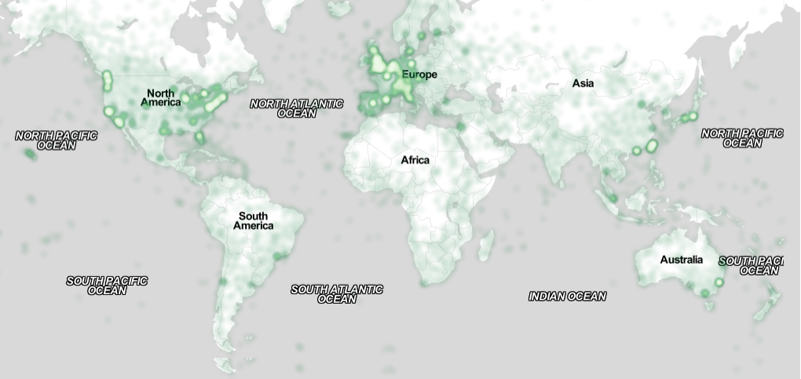

Figure . Sample of a wide figure. Be sure to place at the top or bottom of the page. Ensure that important information is legible in both black-and-white and color printing. Image: CC-BY-ND ayman on Flickr.

## Table Style

The text of tables will format better if you use the Table Text style (as in Table 1). If you do not use this style, then you may want to adjust the vertical spacing of the text in the tables. To adjust the spacing of text in a table in Word, use Home | Paragraph | Indents and Spacing. Generally, text in each field of a table will look better if it has equal amounts of spacing above and below it, as in Table 1. Table captions should be placed below the table. We recommend table lines be 1 point, 25% black. Minimize use of unnecessary table lines.

For improved accessibility, header rows of tables should be marked. In Word, right-click a header row, and select Table Properties | Row | Repeat as header…

# LANGUAGE, STYLE AND CONTENT

The written and spoken language of SIGCHI is English. Spelling and punctuation may use any dialect of English (e.g., British, Canadian, US, etc.) provided this is done consistently. Hyphenation is optional. To ensure suitability for an international audience, please:

* Write in a straightforward style.
* Try to avoid long or complex sentence structures.
* Use common and basic vocabulary (e.g., use the word “unusual” rather than the word “arcane”).
* Briefly define or explain all technical terms that may be unfamiliar to readers.
* Explain all acronyms the first time they are used in your text—e.g., “Digital Signal Processing (DSP)”.
* Explain local references (e.g., not everyone knows all city names in a particular country).
* Explain “insider” comments. Ensure that your whole audience understands any reference whose meaning you do not describe (e.g., do not assume that everyone has used an Android phone, or a particular application).
* Explain colloquial language and puns. Understanding phrases like “red herring” may require a local knowledge of English. Humor and irony are difficult to translate.
* Use unambiguous forms for culturally localized concepts, such as times, dates, currencies, and numbers (e.g., “1-5- 97” or “5/1/97” may mean 5 January or 1 May, and “seven o’clock” may mean 7:00 am or 19:00). For currencies, indicate equivalences: “Participants were paid ₩22, or roughly US$29.”
* Be careful with the use of gender-specific pronouns (*he*, *she*) and other gendered words (*chairman*, *manpower*, *man-months*). Use inclusive language that is gender-neutral (e.g., *she* *or* *he*, *they*, *s/he*, *chair*, *staff*, *staff-hours*, *person-years*). See the *Guidelines for Bias-Free Writing* for further advice and examples regarding gender and other personal attributes [9]. Be particularly aware of considerations around writing about people with disabilities.
* If possible, use the full (extended) alphabetic character set for names of persons, institutions, and places (e.g., Grønbæk, Lafreniére, Sánchez, Nguyễn, Universität, Weißenbach, Züllighoven, Århus, etc.). These characters are already included in most versions and variants of Times, Helvetica, and Arial fonts.

# Conclusion

It is important that you write for the SIGCHI audience. Please read previous years’ proceedings to understand the writing style and conventions that successful authors have used. State clearly what you have done, not merely what you plan to do, and explain how your work is different from previously published work, i.e., *the unique contribution that your work makes to the field*. Please consider what the reader will learn from your submission, and how they will find your work useful. If you write with these questions in mind, your work is more likely to be successful, both in being accepted into the conference, and in influencing the work of our field.

# ACKNOWLEDGMENTS

Sample text: We thank all the volunteers, and all publications support and staff, who wrote and provided helpful comments on previous versions of this document. Authors 1, 2, and 3 gratefully acknowledge the grant from NSF (#1234-2012-ABC). This is just an example.

# References format

References must be the same font size as other body text. References should be in alphabetical order by last name of first author. Example reference formatting for individual journal articles [3], articles in conference proceedings [7], books [9], theses [10], book chapters [11], an entire journal issue [6], websites [1,4], tweets [1], patents [5], and online videos [8] is given here. This formatting is a slightly edited version of the format automatically generated by the ACM Digital Library (http://dl.acm.org) as “ACM Ref”. More details of reference formatting are available at:

<http://www.acm.org/publications/submissions/latex_style>

Note that the Hyperlink style used throughout this document uses blue links; however, URLs that appear in the references section may appear in black.

# REFERENCES

1. @_CHINOSAUR. 2014. VENUE IS TOO COLD. #BINGO #CHI2016. Tweet. (1 May, 2014). Retrieved February 2, 2014 from https://twitter.com/_CHINOSAUR/status/461864317415989248
2. ACM. How to Classify Works Using ACM’s Computing Classification System. 2014. Retrieved August 22, 2014 from [http://www.acm.org/class/how_to_use.html](http://www.acm.org/class/how_to_use.html%20)
3. Ronald E. Anderson. 1992. Social impacts of computing: Codes of professional ethics. *Soc Sci Comput Rev* 10, 2: 453-469.
4. Anna Cavender, Shari Trewin, Vicki Hanson. 2014. Accessible Writing Guide. Retrieved August 22, 2014 from <http://www.sigaccess.org/welcome-to-sigaccess/resources/accessible-writing-guide/>
5. Morton L. Heilig. 1962. Sensorama Simulator, U.S. Patent 3,050,870, Filed January 10, 1961, issued August 28, 1962.
6. Jofish Kaye and Paul Dourish. 2014. Special issue on science fiction and ubiquitous computing. *Personal Ubiquitous Comput*. 18, 4 (April 2014), 765-766. <http://dx.doi.org/10.1007/s00779-014-0773-4>
7. Scott R. Klemmer, Michael Thomsen, Ethan Phelps-Goodman, Robert Lee, and James A. Landay. 2002. Where do web sites come from?: capturing and interacting with design history. In *Proceedings of the SIGCHI Conference on Human Factors in Computing Systems* (CHI '02), 1-8. <http://doi.acm.org/10.1145/503376.503378>
8. Psy. 2012. Gangnam Style. Video. (15 July 2012.). Retrieved August 22, 2014 from <https://www.youtube.com/watch?v=9bZkp7q19f0>
9. Marilyn Schwartz. 1995. *Guidelines for Bias-Free Writing.* Indiana University Press.
10. Ivan E. Sutherland. 1963. *Sketchpad, a Man-Machine Graphical Communication System*. Ph.D Dissertation. Massachusetts Institute of Technology, Cambridge, MA.
11. Langdon Winner. 1999. Do artifacts have politics? In *The Social Shaping of Technology* (2nd. ed.), Donald MacKenzie and Judy Wajcman (eds.). Open University Press, Buckingham, UK, 28-40.