**Installation**

This installation guide should enable you to install the dependencies for the Photo Logger application without the need for elevated privileges.

**Anaconda / Miniconda**

Anaconda is a powerful package management system for Python, and by default it installs over 100 data science packages.

You will install a stripped-down version of Anaconda called Miniconda, and then use it to install only the packages you need to run Photo Logger.

**Step 1. Download Miniconda**

Miniconda download page: <http://conda.pydata.org/miniconda.html>

Choose the down for Python 2.7, Windows, 32-bit installer:

<https://repo.continuum.io/miniconda/Miniconda2-latest-Windows-x86.exe>

**Step 2. Install Miniconda**

Double click on the .exe you downloaded to start the installation wizard.

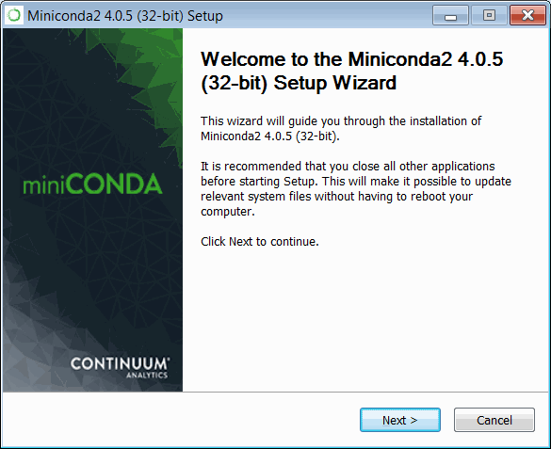

Accept the terms of the license….

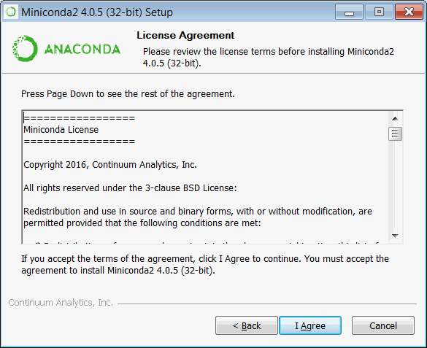

Install for: Just Me (installing for All Users requires admin privileges)…

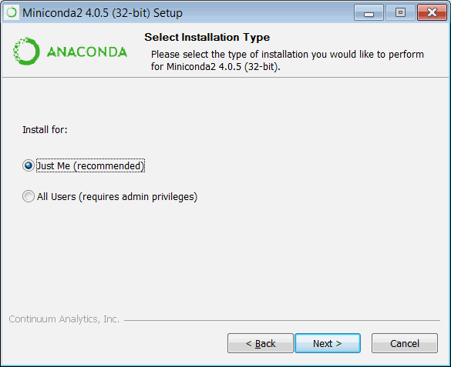

Choose an installation location, or accept the default (bear in mind that you will be navigating to this using the command line, so you may want to choose an installation location with a shorter, rather than longer, path).

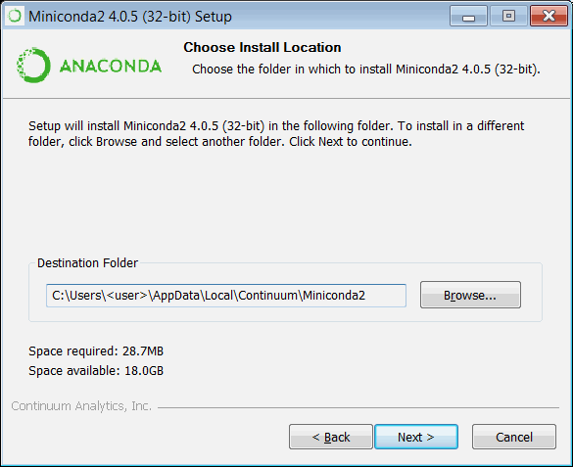

**Important!**: in Advanced Installation Options, be sure to uncheck both options. If you do not, it may interfere with using the version of Python installed by ArcGIS.

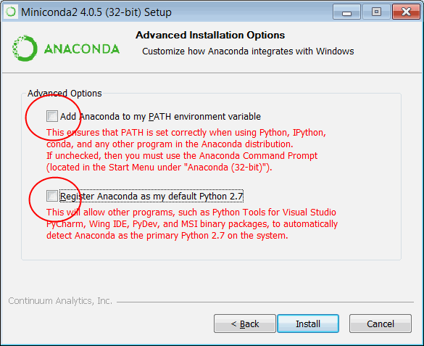

Click Next to finish the installation process.

If you need to remove Miniconda from your system, run the “Uninstall-Anaconda.exe” in the installation folder.

**Install Required Packages Using Miniconda**

To install Python packages, you will use the **conda** command-line tool, which is the core part of Miniconda.

**Step 1:**

Open up a command line console (Windows Start Menu > Search > cmd), and navigate to your Miniconda installation folder. If you accepted the default, it will be:

>cd C:\Users\<username>\AppData\Local\Continuum\Miniconda2

Otherwise, navigate to the folder you specified during the installation process.

**Step 2:**

Navigate to the Scripts folder (>cd Scripts).

**Step 3:**

These are the packages you need to install:

* wxpython -- provides GUI interface
* reportlab -- enables PDF creation
* PIL -- read/write images (e.g. JPGs) – **Note**: this is installed automatically when reportlab is installed
* pip -- alternate package manager
* piexif -- reads EXIF information from photos

For the first three packages, install using the conda command. When prompted to process, enter **y**:

> conda install wxpython

> conda install reportlab

> conda install pip

Anaconda does not have a piexif package, so you will use **pip** to install it:

> pip install piexif

**Step 4:**

Test that the packages installed properly

Navigate one folder level up to the installation directory again (>cd ..) and type **python**. The first line should start with “Python 2.7.11 |Continuum Analytics, Inc.| …” (see screenshot below).

At the prompt, try importing each package:

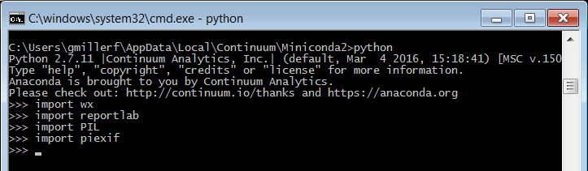

If there are no error messages, you have successfully installed all the required packages! Type **exit()** to exit the python prompt.

**Integrating ArcPy with the Miniconda environment**

You will be running Photo Logger using the version of Python installed by Miniconda, rather than the version installed by ArcGIS.

Next we need to make it possible for Python (the Miniconda version) to import the arcpy module.

To do this, copy this file:

C:\Python27\ArcGIS10.3\Lib\site-packages\Desktop10.3.pth

to this folder:

<Miniconda installation folder>\Lib\site-packages

To test, open up the Miniconda Python prompt again:

>>> import arcpy

If there are no error messages, you have been successful.

If you get this error message: "ImportError: No module named numpy", type **exit()** to exit the python prompt, and then type the following:

> setx PYTHONPATH “C:\Python27\ArcGIS10.3\Lib\site-packages”

Close and reopen the command line console, and repeat step 4. (You can also set the PYTHONPATH manually by going to the User Accounts control panel and click on “Change my environment variables”. Add (or remove) the PYTHONPATH variable to your User variables).

**Running the Photo Logger application**

To run the photo logger application, open a command-line console, and navigate to the Miniconda installation folder, e.g.:

> cd C:\Users\<username>\AppData\Local\Continuum\Miniconda2 [or substitute your installation path]

Type “python”, followed by the location and name of the Photo Logger script:

> python C:\some_directory_path\photo_logger_GUI.py