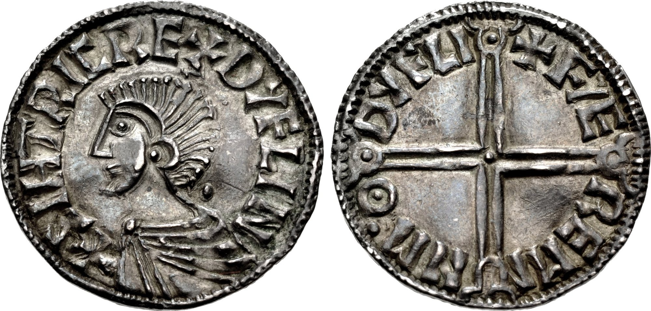

Early English Trading Patterns

*Early Medieval Coins of the Portable Antiquities Scheme (UK COINS)*

**Hypothesis:**

Network X is capable of representing complex spatial economic relationships, enhanced by Basemap visualization.

**Assumptions:**

“in the main, it seems reasonable to assume that the pattern of single finds is representative of the coin circulating in a given area at a given time.”

* Fitzwilliam Museum, Cambridge

**About Data:**

**Dataset**

* Single coin finds by metal detectorists
* Recorded in the Portable Antiquities Scheme - <https://finds.org.uk/>

**Data Manipulation:**

* Bipartite Correlation Matrix (created using RapidMiner) of Mint and Ruler to County
* Unipartite “Shared Assemblage” similarity among countries[1]

**Time periods chosen:**

* “Anglo-Saxon Trade:” 680-730 AD
* “Viking Invasions:” 780 - 850 AD
* “Unified England:” 970 - 1020 AD

**Advantages of Network Analysis:**

* *Visualization*: ease of interpretation of connections
* *Experimentation*: ease of modification of networks allows experimentation
* *Metrics*: community clusters, network robustness, etc.

**Examples of Business Application:**

**Sources**: product networks, distribution networks, customer social networks

**Understanding:**

Segmentation (network communities)

Key Players (dominant network nodes)

Information Spread (distribution of and dynamics of network)

**Python Package Utilized:**

Network X: a package for complex network analysis (<https://networkx.github.io/>)

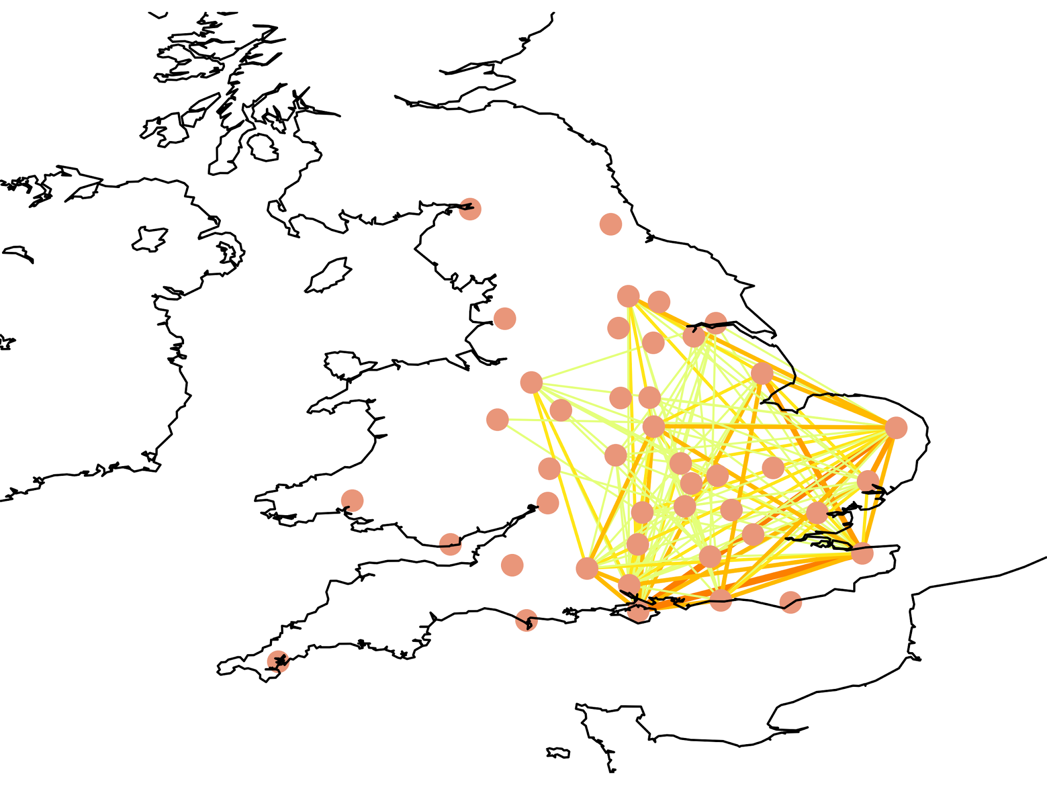

**England 970-1020 AD, Network of Single Coin Finds**

**Degree Centrality Top Nodes**

|  |  |  |
| --- | --- | --- |
| 680-730 AD | 780-850 AD | 920-1070 AD |
| Lincolnshire  Norfolk  Oxfordshire | Lincolnshire  Isle of Wright  Hertfordshire  Hampshire | Norfolk  Isle of Wright  Kent  Hampshire |
| *Base network* | *Network significantly more integrated than before* | *More hierarchical, but also weaker degree* |

**Conclusions:**

Initially, while England has many interconnections, they are weak, and the stronger ties are divided along among the political boundaries of Northumbria, East Anglia, Mercia, and Wessex. As the Vikings invasions begin in 790, the north coast becomes particularly central. Interestingly, the earlier invasions come with a peak of economic movement, but after another century of sporadic war, dominant nodes are more settled with the entire network more connected than it was in pre-Viking times.

**Technology Viability:**

Network X is a strong tool for network analysis. However, its matplotlib-based visualizations are a particular weakness. As visualization is often a key part of sharing network findings, users are advised to consider further Python packages for visualization (like Graph-tool) or different network software like Gephi or Pajek.

**References:**

<https://eprints.soton.ac.uk/365460/1/Brughmans_2014_ARC.pdf>

A thesis on a similar topic covering 1066 AD and on:

<http://etheses.dur.ac.uk/7314/1/Kelleher_thesis.pdf>

1. Process modeled on the paper, *The Small World of the Vikings: Networks in Early Medieval Communication and Exchange* by Søren Michael Sindbæk