Outputs:

2.

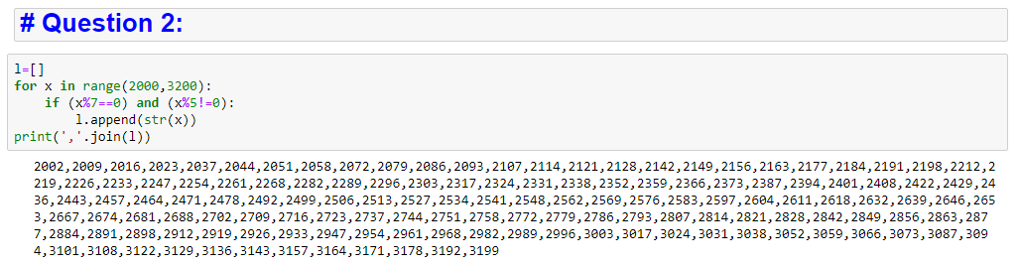

3.

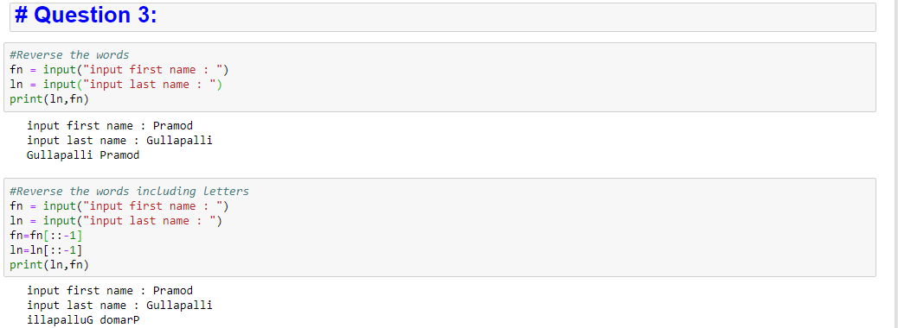

4.

