# **Buenos Aires**

## **Real estate investments in areas near metro stations**

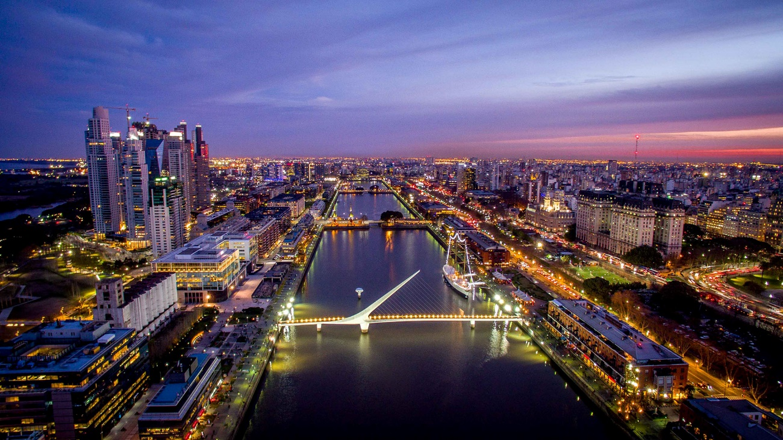

Gustavo D. Pessat

May 2, 2020

# Introduction

## Background

A strategic vision is necessary for the development of real estate businesses considering that cities are currently forced to adapt at a rate and scale never before experienced, with enormous pressure to lower carbon emissions in response to climate change, the speed of change economic and growing expectations of quality of life.

Urban change in cities of emerging economies is made even faster by demographic, social and economic changes.

Growth in urban development will be influenced, among other factors, by:

- Investments in infrastructure to unlock and update new urban areas;

- Adoption of urban technology and smart city solutions to improve quality of life, business efficiency, and city management.

- Infrastructure developments to improve inclusion and transition to a low carbon environment;

- In order to achieve long-term sustainability, circular economy and micro mobility approaches are adopted;

- Creation of new spaces, so that new life and work patterns can be incorporated, growth in areas of high experience, densification oriented to transport and sustainable development.

### Commune

The City of Buenos Aires is organized in 15 Communes. These are decentralized political and administrative management units that, in some cases, cover more than one neighborhood.

The Communes have exclusive and concurrent powers with the City Government. Among the first are the maintenance of secondary roads and green spaces, the administration of its heritage, the legislative initiative and the preparation of its budget and government program.

Each commune has a government body made up of the Communal Board and its President. In addition, each Commune has an Advisory Council made up of representatives of neighborhood non-governmental entities, political parties, networks and other forms of organization with interests or actions in the territorial area of ​​the Commune. This Council advises the Community Board and can also, among other issues, channel demands, present proposals and define priorities.

The decentralization in communes is part of a world trend that includes the most important cities in the world such as Barcelona, ​​New York, San Pablo and Mexico.

### Subway network infrastructure

The Metro is a good incentive to think about investing in a property, this because, if the property purchased for leasing is in the vicinity of or near a metro station, the capital gain of the department will increase due to this means of transportation. enhances connectivity and speed to reach most points in the capital, especially the points where the workforce is concentrated.

For this reason, the closer a home is to a metro station, the easier it is for its inhabitants to be able to easily move around the city. This makes these properties have a much higher demand, and therefore their prices are also higher.

Thanks to the fact that it guarantees predictable frequencies and travel times without the increasing traffic congestion, people want to live, work or study near the Metro. Therefore, it is not surprising the real estate interest in areas with good access to this means of transport.

The client looking for an apartment prefers to be closer to the Metro line. This applies more to a segment of smaller apartments for young couples, young professionals, and people living alone. Consolidated families prefer larger houses or apartments that are more comfortable for family life, such as condos with spaces to play and close to schools.

The Buenos Aires Subway is the subway network of the City of Buenos Aires, made up of six lines - A, B, C, D, E and H - with a total length of 62.8 km (of which 56.7 km are for commercial service) 3 and 90 stations in operation.

The network is currently made up of six lines named with letters - from A to E and H - and identified with colors, which represent some 54.7 km of roads for commercial services. The entire network is underground, there being no section at level or viaduct.

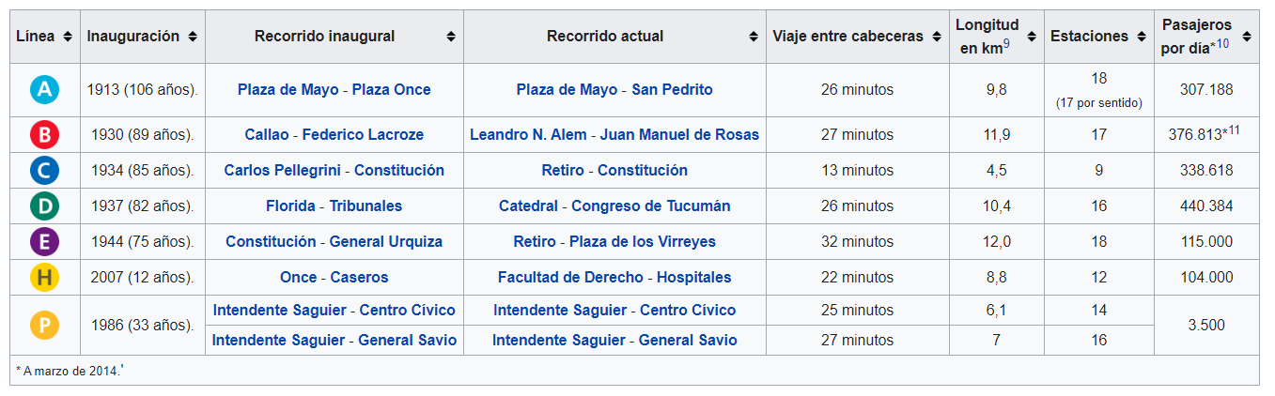

## 1.2 Problem

Investments in real state in Buenos Aires (in the same way as in large cities) generate an attractive income and store of value.

As real state investors we want to determine the most appropriate area to invest in the purchase of an apartment to offer to rent in the city of Buenos Aires, considering that it is located near a metro station.

We want to carry out a segmentation of the areas surrounding the metro station in the federal capital in order to compare and decide according to the urban infrastructure and nearby shops.

Segmenting this areas of interest (areas near the metro station) will allow us to make a decision taking into account the similarities and differences in the characteristics of each area.

# 2. Data Acquisition and Cleaning

We must acquire and process geographic information, this aspect is key and central to study cities and social dynamics (it makes the map one of the most important visualization tools that we can use in this case).

In order to clustering and segmenting areas, I’ll use mainly geospatial data to retrieve information from foursquare to identify areas which can be similar to the objective investment.

We will use datasets with information provided by the Buenos Aires city government (see <https://data.buenosaires.gob.ar/dataset> ), in particular geospatial information in geojson format.

I’ll download csv files containing metro station geospatial information and with that information we will obtain venues data from foursquare.

Some additional reference data is also obtained by doing web scrapping

All the information obtained (mainly from dataset with geospatial information will be imported as pandas dataframe, so it is necessary to solve some nested tags.

I’ll use one hot encoding (a process by which categorical variables are converted so Machine Learning algorithms can do a better prediction).