[Title] Document Loader Input Example
[Subtitle] This document serves as a comprehensive example of an input for PDF, and DOCX Loader.
[Paragraph] To comprehend the functionality of the Loaders available within our internal SDK, it is crucial to furnish comprehensive input and output examples for each Loader. These document serve as essential references that illustrate how each Loader interprets and processes different document elements. To ensure a thorough understanding, the input examples should encompass a wide range of document components, including :

- Header
- Title
- Subtitle
- Heading
  - Heading 1
  - Heading 2
  - Heading 3, etc
- Paragraph
- Table
- Multiple Column layout
- Footer
- Footnotes
- Endnote
- Image
- Hyperlink
- List

These examples not only facilitate developers in effectively utilizing the Loaders but also ensure consistency and accuracy in document processing. By providing such diverse input examples, we empower users to harness the full potential of our SDK and seamlessly integrate it into their projects.

[Heading 1] Table Example
It is important to understand that the forms and structures of tables in documents vary significantly. Therefore, in this document, we will provide several examples of different table types. The aim is to illustrate how various table formats can be accommodated and processed by our software or SDK.

[Heading 2] Table Variation 1: Standard Table
Table 1. Caption for Standard Table
Keterangan | Online | BI-FAST | LLG | RTGS
Melalui Cabang BCA* | - | Rp 2.500 | Rp 2.900 | Rp 30.000
Melalui m-BCA** | Rp 6.500 | Rp 2.500 | - | -
Melalui Internet Banking dan myBCA | Rp 6.500 | Rp 2.500 | Rp 2.900 | Rp 25.000

[Heading 2] Table Variation 2: Merged Cell Table
Table 2. Caption for Merged Cell Table
Jenis Transaksi | Paspor Blue | Paspor Gold | Paspor Platinum
Melalui ATM BCA
Tarik Tunai | Rp 10.000.000 | Rp 75.000.000 | Rp 10.000.000
Transfer antar Rekening BCA | Rp 50.000.000 |  | Rp 100.000.000
Transfer antar Rekening BCA (ke rekening valas) |  |  | Rp 100.000.000
Transfer antar Bank | Rp 15.000.000 | Rp 20.000.000 | Rp 25.000.000

[Heading 2] Table Variation 2: Have Missing Border Table
Table 3. Caption for Missing Border Table 1
Jenis Transaksi | Paspor Blue | Paspor Gold | Paspor Platinum
Tarik Tunai | Rp 10.000.000 | Rp 75.000.000 | Rp 10.000.000
Transfer antar Rekening BCA | Rp 50.000.000 |  | Rp 100.000.000
Transfer antar Rekening BCA (ke rekening valas) |  |  | Rp 100.000.000
Transfer antar Bank | Rp 15.000.000 | Rp 20.000.000 | Rp 25.000.000
Table 4. Caption for Missing Border Table 2
Jenis Transaksi | Paspor Blue | Paspor Gold | Paspor Platinum
Melalui ATM BCA
Tarik Tunai | Rp 10.000.000 | Rp 10.000.000 | Rp 10.000.000
Transfer antar Rekening BCA (ke rekening valas) | Rp 50.000.000 | Rp 75.000.000 | Rp 100.000.000
Transfer antar Bank | Rp 15.000.000 | Rp 20.000.000 | Rp 25.000.000

[Heading 1] Image Example
This dummy document provide 2 sample Image within the Document.

[Heading 2] Image 1: What is Artificial Intelligence
This image was retrieved from this link.
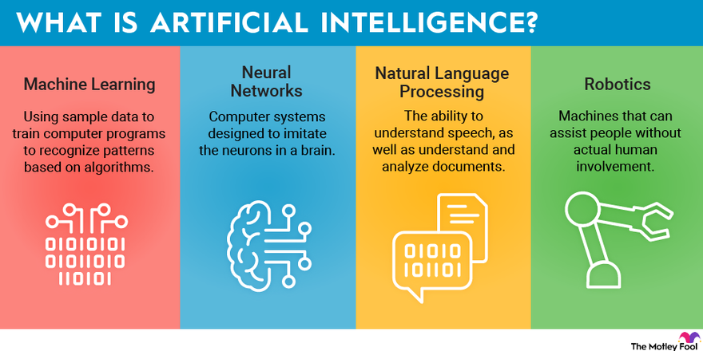
Figure 1. Image 1 Captions

[Heading 2] Image 2: The Working-Age Poor
This image was retrieved from this link.
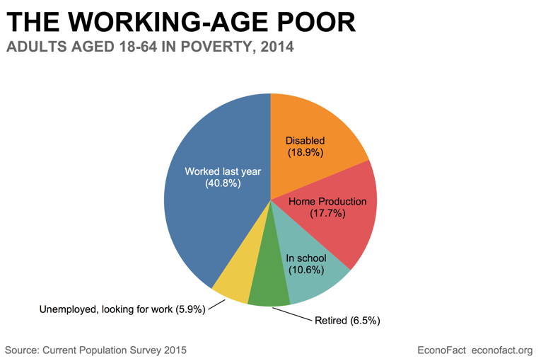
Figure 2. The Working-Age Poor

[Footnote] This is Footnote Document Example
[Footnote] F. N. E. This is Footnote Document Example
[Endnote] This is Endnote Example
[Endnote] E. N. This is Endnote Example

